Supplementary Data

Genomic and transcriptomic plasticity in treatment-naïve ovarian cancer

Marlous Hoogstraat^{1,2,8}, Mirjam S. de Pagter^{3,8}, Geert A. Cirkel^{1,2,8}, Markus J. van Roosmalen³, Timothy T. Harkins⁴, Karen Duran³, Jennifer Kreeftmeijer³, Ivo Renkens³, Petronella O. Witteveen¹, Clarence C. Lee⁴, Isaac J. Nijman^{2,3}, Tanisha Guy³, Ruben van ’t Slot³, Trudy N. Jonges⁵, Martijn P. Lolkema^{1,2}, Marco J. Koudijs^{1,2}, Ronald P. Zweemer⁶, Emile E. Voest^{1,2}, Edwin Cuppen^{2,3,7,9} and Wigard P. Kloosterman^{3,9}

¹Department of Medical Oncology, University Medical Center Utrecht, Heidelberglaan 100, 3584 CX Utrecht, The Netherlands
²Center for Personalized Cancer Treatment, Universiteitsweg 100, 3584 CG Utrecht, The Netherlands
³Department of Medical Genetics, University Medical Center Utrecht, Universiteitsweg 100, 3584 CG Utrecht, The Netherlands

⁴Life Technologies, Carlsbad, CA, USA
⁵Department of Pathology, University Medical Center Utrecht, Universiteitsweg 100, 3584 CG Utrecht, The Netherlands
⁶Department of Reproductive Medicine and Gynaecology, Division Woman and Baby, University Medical Center Utrecht, Universiteitsweg 100, 3584 CG Utrecht, The Netherlands

⁷Hubrecht Institute, KNAW and University Medical Center Utrecht, Uppsalalaan 8, 3584 CT Utrecht, The Netherlands
⁸Equal contribution
⁹Correspondence: w.kloosterman@umcutrecht.nl; e.cuppen@hubrecht.eu
Tel: +31 88 7568082
Fax: +31 88 7568479

Running title: Evolution of epithelial ovarian cancer
Keywords: Genomic heterogeneity, ovarian cancer, gene expression, cancer evolution, genome sequencing.

Figures:

Supplementary figure 1.
Histological staining of representative sections of tumor samples from each patient.

Supplementary figure 2.
Size distribution of mate-pair libraries per patient.

Supplementary figure 3.
PCR genotyping of breakpoints predicted by mate-pair sequencing.

Supplementary figure 4.
Breakpoints overlapping with FANCD2, ERBB4 and ESR1 lead to RNA expression differences.

Supplementary figure 5.
Clustering of samples per patient of SNP array, RNA sequencing and mate-pair sequencing data for patient 1 (left), 2 (middle) and 3 (right).

Supplementary figure 6.
TSC1 splice site mutation leading to truncation of the TSC1 transcript in patient 3.

Supplementary figure 7.
Confirmed in-frame gene fusions predicted using mate-pair sequencing.

Tables:

Supplementary table 1.
Description of tumor sampling sites, histopathological estimates of sample tissue components and computational measurements of tumor percentages.

Supplementary table 2.
Analysis performed per sample per patient.

Supplementary table 3.
Sequencing statistics.
Separate excel sheet.

Supplementary table 4.
Somatic breakpoints predicted based on mate-pair sequencing.
Separate excel sheet.

Supplementary table 5.
Single nucleotide changes detected in patients 1 – 3.
Separate excel sheet.

Supplementary table 6.
Differentially expressed genes and pathways.
Separate excel sheet.

Supplementary table 7.
Large copy number changes exhibiting differential presence among biopsies
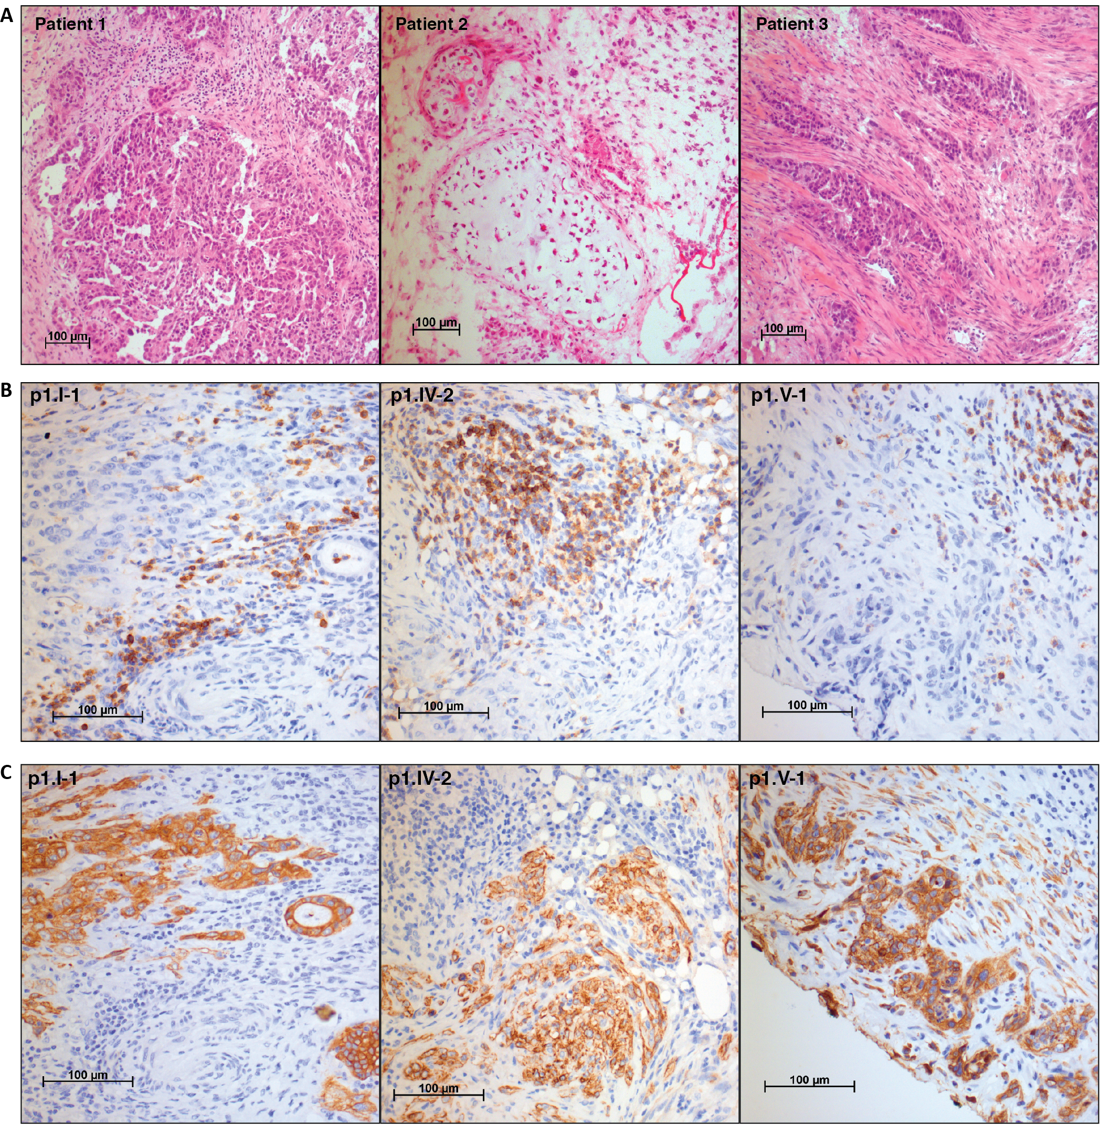

Supplementary figure 1. Histological stainings of representative sections of tumor samples from each patient. (A) Hematoxylin and Eosin (H&E) staining of a representative section of a tumor sample as obtained from each patient. A central pathologist reviewed all slides. Patient 1: Moderate to poorly differentiated serous adenocarcinoma, metastatic sample p1.II-1. Patient 2: Carcinosarcoma with heterologous cartilage component, metastatic sample p2.VI-1. Patient 3: Poorly differentiated serous adenocarcinoma, primary tumor sample p3.III-1. (B) CD45 staining of patient 1 samples indicative for lymphocyte infiltration. No significant differences in proportion of CD45 positive cells was observed between primary and metastatic samples. (C) Cytokeratin AE1/AE3 staining of patient 1 samples for epithelial tumor components within samples illustrative for their heterogeneous composition.

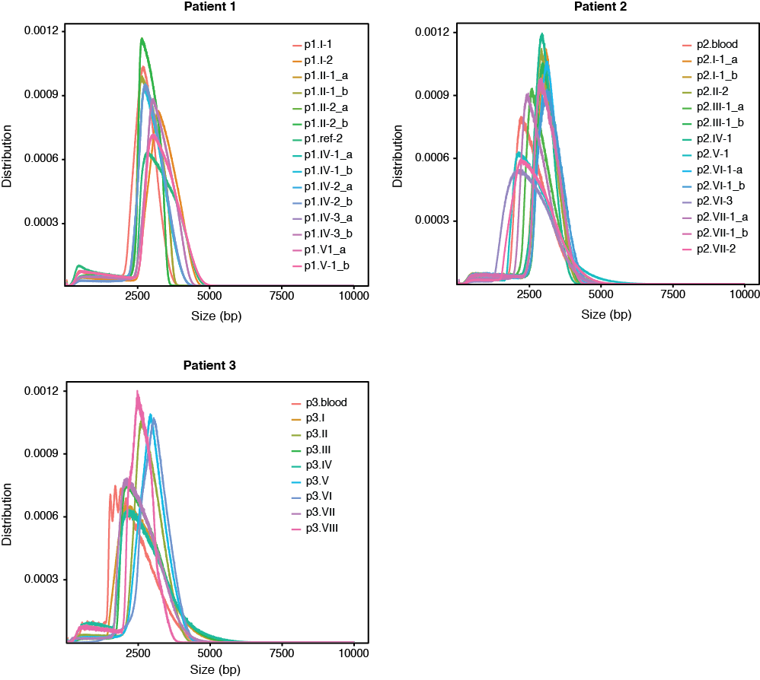

Supplementary Figure 2. Insert size distribution of mate-pair libraries per patient.

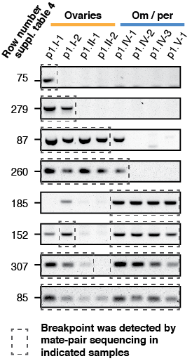

Supplementary Figure 3. PCR genotyping results for a respresentative subset of breakpoints detected in patient 1. Numbers indicate the row number of the corresponding breakpoint in Supplementary table 1. Dashed boxes indicate samples in which the breakpoint was detected by mate-pair sequencing.

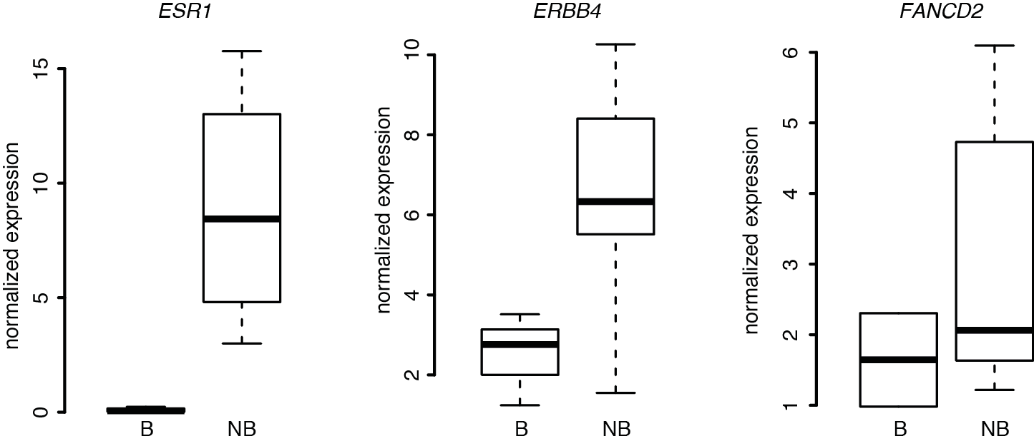
Supplementary Figure 4. Genomic breakpoints overlapping with FANCD2, ERBB4 and ESR1 lead to sample-specific RNA expression differences in patient 2. B, expression in samples with rearrangement breakpoint. NB, expression in samples without rearrangement breakpoint. For FANCD2, samples with breakpoint were VI1 and VI2. For ESR1, samples with breakpoint were II2, VI3, VI1, IV1, I1. For ERBB4 samples with breakpoint were III1, II2, VI3, IV1, I1.

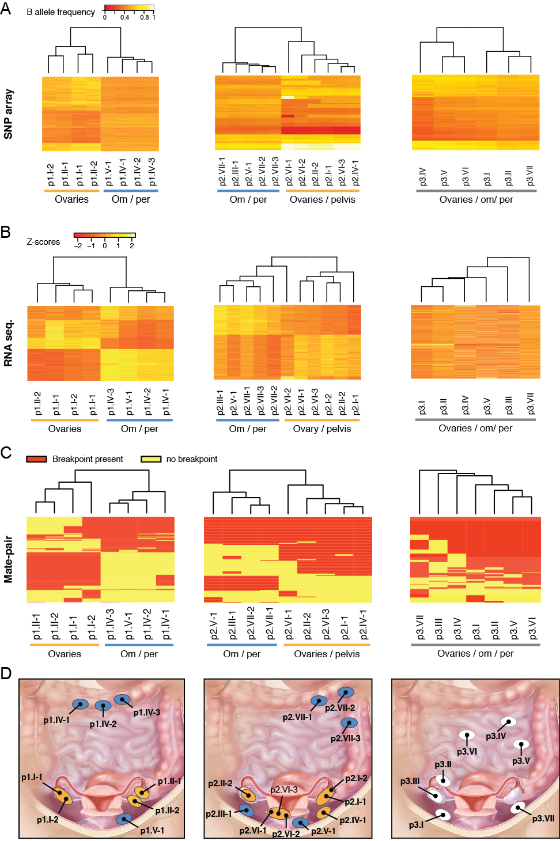 Supplementary figure 5. Clustering of samples per patient of SNP array, RNA sequencing and mate-pair sequencing data for patient 1 (left), 2 (middle) and 3 (right). (A) Unsupervised hierarchical clustering of differential allele frequencies derived from SNP genotyping arrays analysis of biopsies per patient. (B) Unsupervised clustering based on Poisson Mixed Models of differentially expressed genes in patient 1, 2 and 3 respectively. Expression differences are depicted as Z-scores for each gene. Sample p3.VI was left out of the analysis because of suboptimal sequencing results. (C) Heat map and clustering analysis of the detected somatic breakpoints per patient. Rows represent breakpoints, red and yellow bars indicate the presence (red) or absence (yellow) of the breakpoint in a sample. (D) Biopsy locations per patient. Ellipses indicate physically separated tumors; black dots represent biopsy locations. Ellipses are not indicative for tumor size. For patient 1 and 2, ellipses are colored according to the corresponding branch derived from the SV analysis. Patient 1: ovaries (orange), om/per (blue), patient 2: ovaries/pelvis (orange), om/per (blue). Illustration © 2010 Terese Winslow, U.S. Govt. has certain rights.

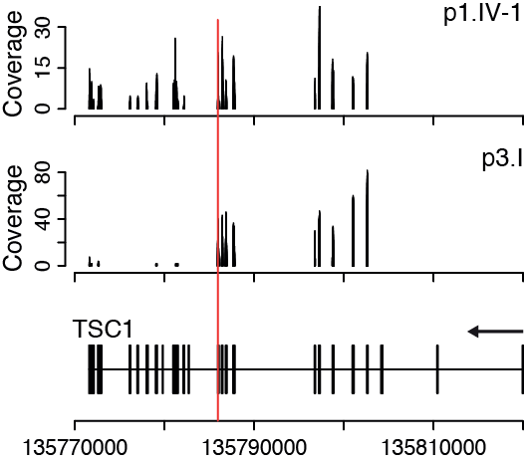

Supplementary figure 6. Normalized read counts for coding regions in TSC1 derived from RNA sequencing data of samples p1.IV-1 (top panel) and p3.I (middle panel). Sample p3.I contains a splice site mutation (red line), which is detected in all patient 3 samples and leads to truncation of the TSC1 transcript.

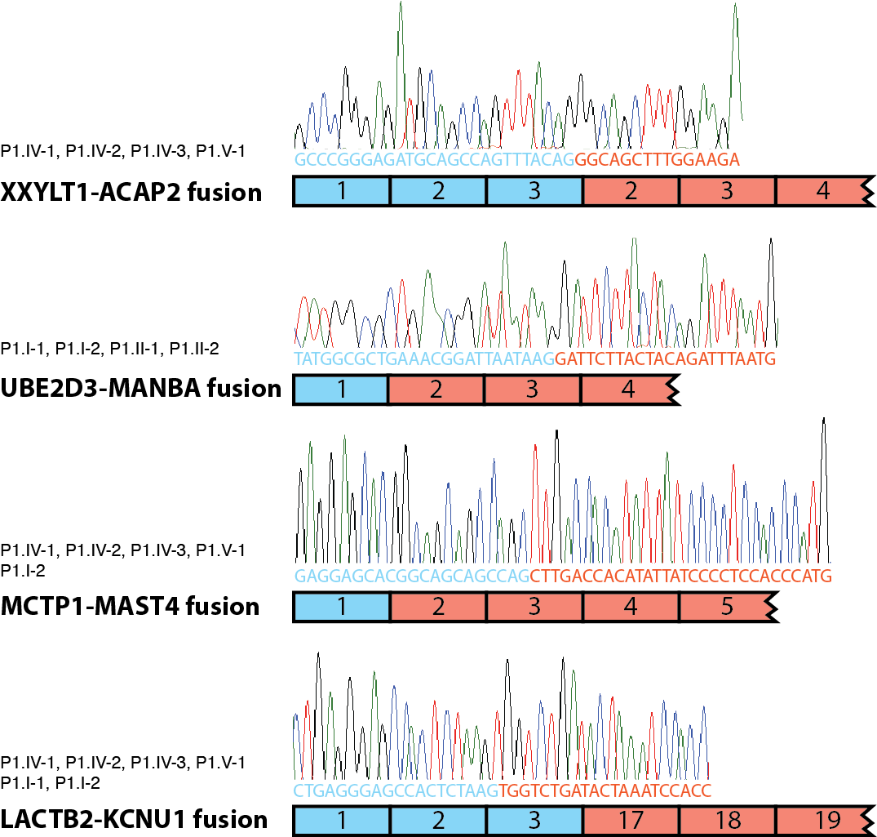

Supplementary figure 7. In frame fusion transcripts resulting from genomic rearrangements in patient 1. The fusion genes were predicted based on mate-pair sequencing in the indicated samples and verified using RT-PCR. The numbering indicates exon numbers for the following transcripts: CCDS43188 (XXYLT1), CCDS33924 (ACAP2), CCDS3660 (UBE2D3), CCDS3658 (MANBA), CCDS34203 (MCTP1), CCDS (MAST4), CCDS6208 (LACTB2), CCDS55220 (KCNU1).

Supplementary table 1. Description of tumor sampling sites, histopathological estimates of sample tissue components and computational measurements of tumor purity.
Sample | Description/localization | Pathological determination |  |  |  | Tumor (%) calculated by Nexus ASCAT³ | Tumor (%) est. by max allele frequency³
Sample | Description/localization | Necrosis (%)* | Stromal  components (%)* | Immune cell  infiltration* | Tumor (%)* | Tumor (%) calculated by Nexus ASCAT³ | Tumor (%) est. by max allele frequency³
Patient 1
p1.I-1 | Right ovary | 0 | 30 | Very Low | 70 | 63 | 77
p1.I-2 | Right ovary | 0 | 40 | Low | 60 | 26 | 33
p1.II-1 | Left ovary | 0 | 30 | Moderate | 70 | 23 | 37
p1.II-2 | Left ovary | <10 | 20 | Moderate | 80 | 44 | 64
p1.IV-1 | Omental lesion,transverse colon | 50 | 30 | Moderate | 30 | 12 | 16
p1.IV-2 | Omental lesion,transverse colon | 30 | 40 | Moderate | 40 | 12 | 19
p1.IV-3 | Omental lesion,transverse colon | <10 | 30 | Moderate | 70 | 11 | 18
p1.V-1 | Peritoneal metastasis, attached to omentum, left lower pelvic region | 0 | >90 | Low | <10 | NA¹ | 10
Patient 2
p2.I-1 | Left ovary, sample from tumor core | 20 | 20 | Very Low | 60 | 83 | 100
p2.I-2 | Left ovary, sample from tumor peripheral zone | <10 | 20 | Very Low | 80 | NA² | 75
p2.II-2 | Right ovary, sample from tumor core | 10 | 50 | Very Low | 50 | 82 | 90
p2.III-1 | Peritoneal metastasis, right pelvic region | 10 | 10 | Low | 80 | 26 | 38
p2.IV-1 | Peritoneal metastasis, left pelvic region | 0 | 50 | Low | 50 | 90 | 85
p2.V-1 | Peritoneal metastasis on bladder | 0 | 20 | Very Low | 80 | 30 | 37
p2.VI-1 | Lesser pelvis, sample from peripheral zone | 0 | 30 | Very Low | 70 | 89 | 91
p2.VI-2 | Lesser pelvis, sample from peripheral zone | 0 | 20 | Very Low | 80 | 85 | 60
p2.VI-3 | Lesser pelvis, sample from tumor core | <10 | 40 | Very Low | 60 | 90 | 83
p2.VII-1 | Omental lesion, adipose tissue infiltrated with tumor cells | 0 | 50 | Low | 50 | 22 | 27
p2.VII-2 | Omental lesion, adipose tissue infiltrated with tumor cells | 0 | 40 | Low | 60 | 67 | 22
p2.VII-3 | Omental lesion, adipose tissue infiltrated with tumor cells | 0 | 40 | Very Low | 60 | 36 | 12
Patient 3
p3.I | Peritoneal metastasis, right lower pelvic region | <10 | 60 | Low | 40 | 25 | 50
p3.II | Right fallopian tube | <10 | 40 | Very Low | 60 | 20 | 33
p3.III | Right ovary | <10 | 90 | Very Low | 10 | NA¹ | 17
p3.IV | Sample of mesenteric lesion, left upper abdominal region | <10 | 20 | Very Low | 80 | 34 | 43
p3.V | Omental lesion, left abdominal region | 10 | 20 | Very Low | 80 | 30 | 45
p3.VI | Omental lesion | <10 | 20 | Very Low | 80 | 27 | 43
p3.VII | Peritoneal metastasis, left pelvic region | <10 | 30 | Very Low | 70 | 20 | 36
* estimated percentages on Hematoxylin and Eosin (H&E) stained slides by central pathologist, percentages are rounded off to the nearest ten.
¹ Too little information to make a reliable estimation
² No SNP-array data available
³ For several samples, a difference in tumor purity is observed between the pathological estimations and the ASCAT calculations. This is probably partly due to the fact that the sections assessed by pathology are not the same as the sections used for DNA and RNA isolation.

Supplementary table 2. Analyses performed per sample
Analysis | SNP | Mate- | Cancer | Comprehensive | RNA
method | array | pair | mini genome | Cancer Panel | sequencing
Patient 1
p1.I-1 | + | + | + | + | +
p1.I-2 | + | + | + | + | +
p1.II-1 | + | + | + | + | +
p1.II-2 | + | + | + | + | +
p1.IV-1 | + | + | + | + | +
p1.IV-2 | + | + | + | + | +
p1.IV-3 | + | + | + | + | +
p1.V-1 | + | + | + | + | +
p1.ref-1 | + | - | - | - | +
p1.ref-2 | + | + | + | + | +
p1.blood | - | -* | - | - | -
Total | 9 | 9 | 9 | 9 | 9
Patient 2
p2.I-1 | + | + | + | + | +
p2.I-2 | - | - | - | - | +
p2.II-2 | + | + | + | + | +
p2.III-1 | + | + | + | + | +
p2.IV-1 | + | + | + | + | -
p2.V-1 | + | - | + | - | +
p2.VI-1 | + | + | + | + | +
p2.VI-2 | + | - | + | - | +
p2.VI-3 | + | - | + | + | +
p2.VII-1 | + | + | + | + | +
p2.VII-2 | + | - | + | + | +
p2.VII-3 | + | - | + | + | +
p2.ref | + | + | - | - | +
p2.blood | - | + | + | + | -
Total | 13 | 11 | 12 | 10 | 12
Patient 3
p3.I | + | - | + | + | +
p3.II | + | + | + | + | +
p3.III | + | - | + | + | +
p3.IV | + | - | + | + | +
p3.V | + | + | + | + | +
p3.VI | + | + | + | + | +
p3.VII | + | - | - | - | +
p3.ref | + | + | + | + | +
p3.blood | - | + | + | - | -
Total | 8 | 9 | 7 | 7 | 8
* Validations of mate-pair data by PCR and Sanger sequencing have been performed using this sample

Supplementary Table 7. Large copy number changes exhibiting differential presence among biopsies
Chromosome | Start | Stop | Type | Size | Patient
2 | 206243184 | 234527108 | loss | 28283924 | p1
2 | 234527109 | 243199373 | loss | 8672264 | p1
4 | 24560115 | 26446342 | loss | 1886227 | p1
4 | 93348184 | 94322607 | loss | 974423 | p1
4 | 167230967 | 181366547 | loss | 14135580 | p1
3 | 1665082 | 10036483 | loss | 8371401 | p2
3 | 114754869 | 137814649 | loss | 23059780 | p2
3 | 148115763 | 161516806 | loss | 13401043 | p2
4 | 29386105 | 31158108 | loss | 1772003 | p2
5 | 49000000 | 52532471 | loss | 3532471 | p2
5 | 56166567 | 58889858 | loss | 2723291 | p2
5 | 102178958 | 106849597 | loss | 4670639 | p2
4 | 31158109 | 33000000 | gain | 1841891 | p2
4 | 35000000 | 39761474 | gain | 4761474 | p2

