Supplemental Material

Highly efficient gene knockout in mice and zebrafish with RNA-guided endonucleases

Young Hoon Sung^{1,5}, Jong Min Kim^{2,5}, Hyun-Taek Kim^{3,5}, Jaehoon Lee¹, Jisun Jeon¹, Young Jin¹, Jung-Hwa Choi³, Young Ho Ban¹, Sang-Jun Ha¹, Cheol-Hee Kim³, Han-Woong Lee^{1,4∗}, and Jin-Soo Kim^{2∗}

¹Department of Biochemistry, College of Life Science and Biotechnology, Yonsei University, Seoul 120-749
²National Creative Research Initiatives Center for Genome Engineering and Department of Chemistry, Seoul National University, Seoul 151-747
³Department of Biology, Chungnam National University, Daejeon 305-764
⁴Yonsei Laboratory Animal Research Center, Yonsei University, Seoul 120-749, Republic of Korea.
⁵These authors contributed equally to this work.
∗Corresponding Authors: J.S.K (jskim01@snu.ac.kr) and H.W.L (hwl@yonsei.ac.kr)

Table of Contents
Supplemental Figure 1. Generation of sgRNAs against exon 2 of the mouse Foxn1 gene.
Supplemental Figure 2. Foxn1 gene knockout in mouse embryos by intra-cytoplasmic injection of Cas9 mRNA and Foxn1-sgRNA.
Supplemental Figure 3. RGEN-induced Foxn1 gene knockout in mice.
Supplemental Figure 4. Foxn1 gene disruption in mouse embryos using the recombinant Cas9 protein: Foxn1-sgRNA complex.
Supplemental Figure 5. Toxicities of Cas9 protein complexed with mitfa-specific sgRNA in zebrafish embryos.
Supplemental Figure 6. Targeted indel mutations induced by Cas9 protein complex at mitfa and GFP reporter gene.
Supplemental Figure 7. Induction of somatic mitfa mutations by the Cas9 protein complex.
Supplemental Figure 8. Analysis of off-target activity of Foxn1-RGEN.
Supplemental Figure 9. Defective immune cell populations in PBMC from a bi-allelic Prkdc mutant founder #47.
Supplemental Figure 10. Germ-line transmission of the mutant alleles found in Foxn1 mutant founder #108.
Supplemental Table 1. Genotypes of Foxn1 mutant mice.
Supplemental Table 2. Genotypes of Prkdc mutant mice.
Supplemental Table 3. DNA sequences of Foxn1 mutant alleles identified from a subset of T7E1-positive mutant founders.
Supplemental Table 4. DNA sequences of Prkdc mutant alleles.
Supplemental Table 5. Oligonucletide for preparation of in vitro RNA transcription template.
Supplemental Table 6. Primer sequences used in T7E1 assay and fPCR analysis.
Supplemental Table 7. Primers used for amplification of off-target sites.

A
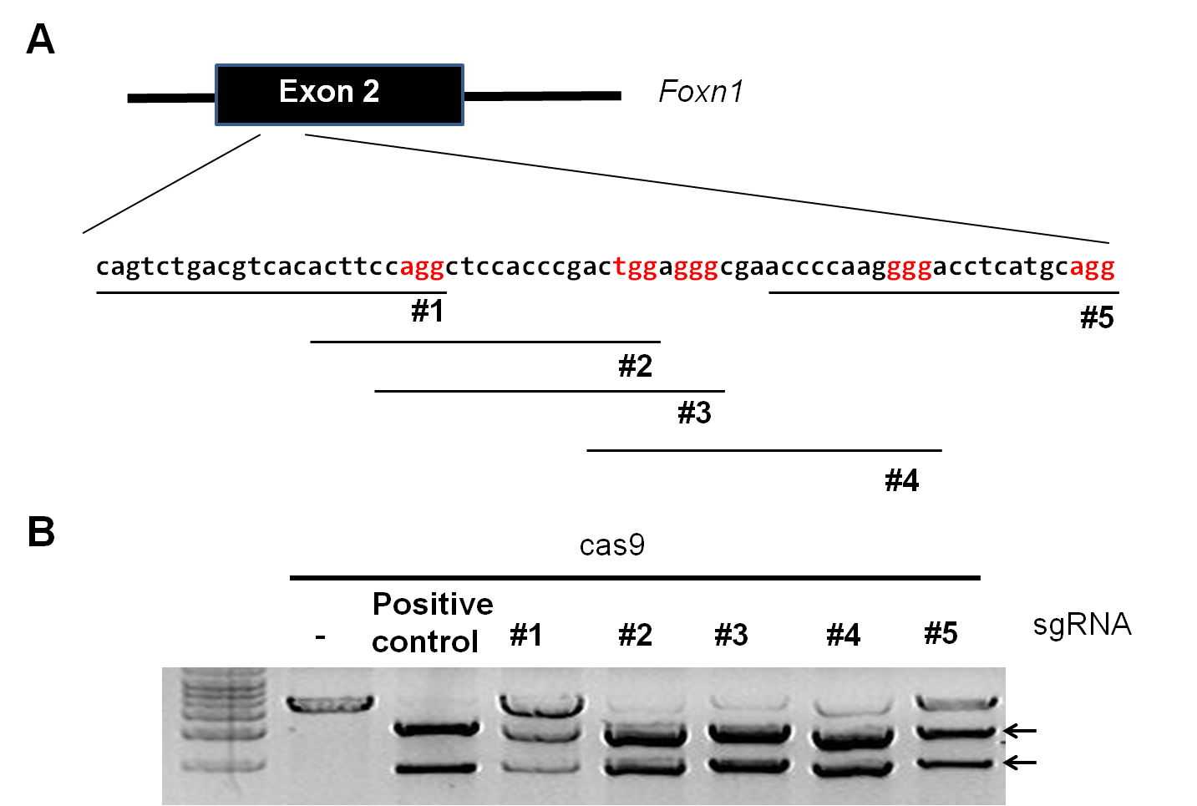

B
Supplemental Figure 1. Generation of sgRNAs targeted to exon 2 of the mouse Foxn1 gene. (A) RGEN target sites in the mouse Foxn1 gene. PAMs are shown in red letters, and targets are denoted by black lines. (B) In vitro cleavage assays evaluating Foxn1-sgRNAs complexed with recombinant Cas9 protein against a linearized plasmid containing target sequences as a substrate. Arrows indicate bands cleaved by RGEN.

A
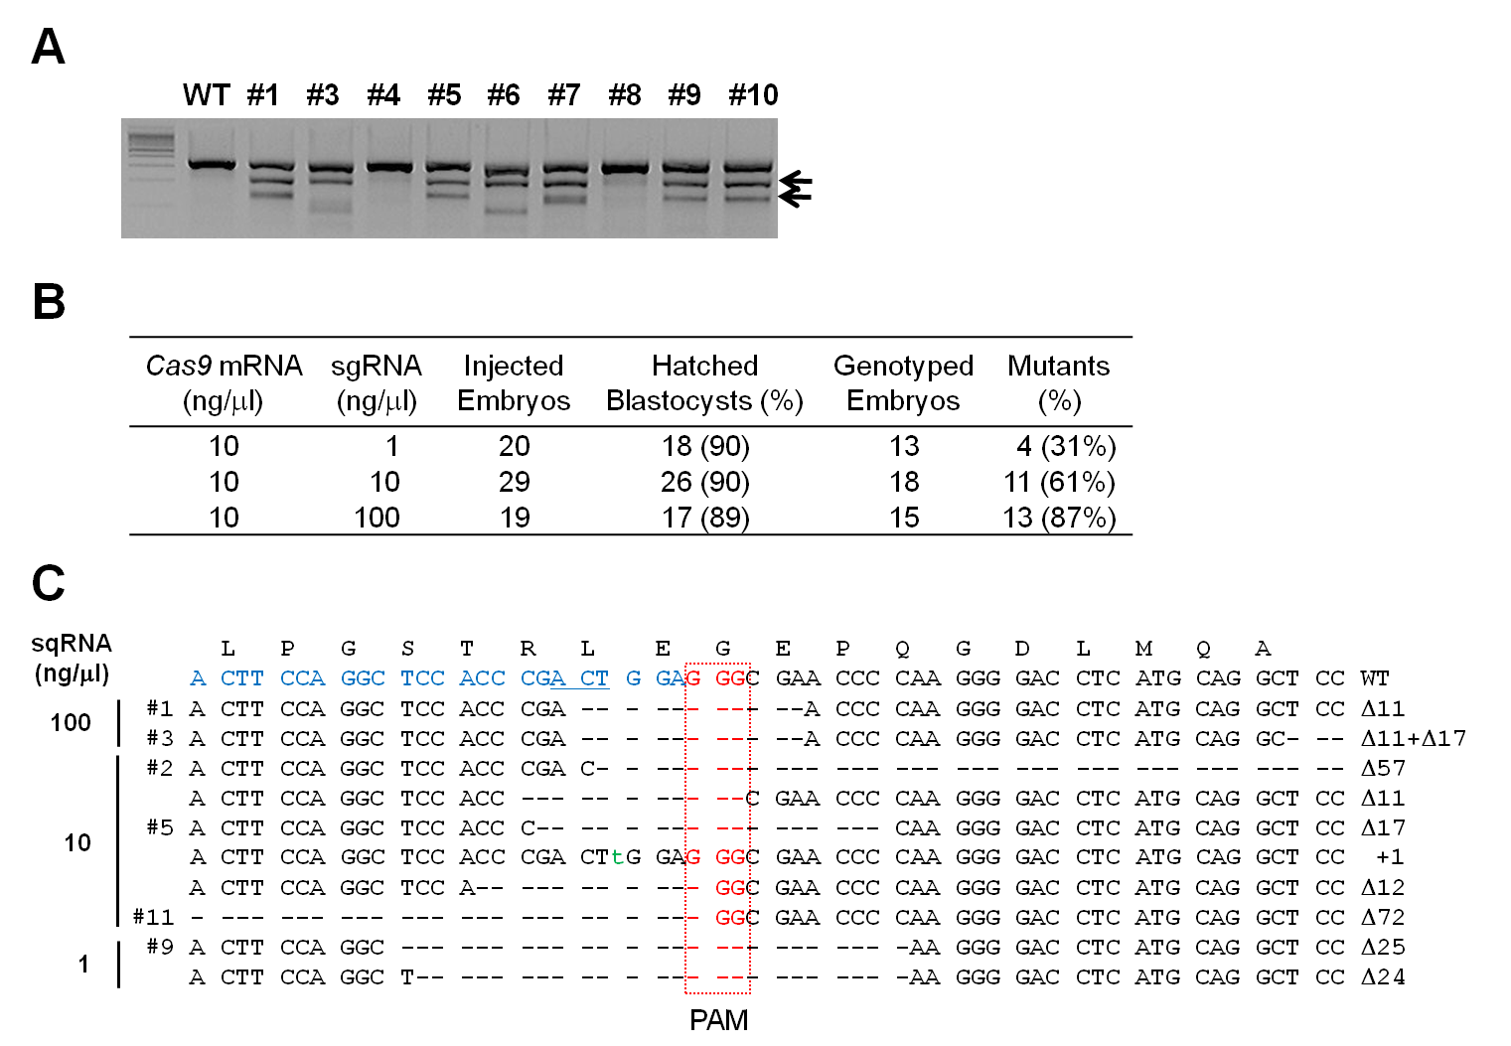
B
C
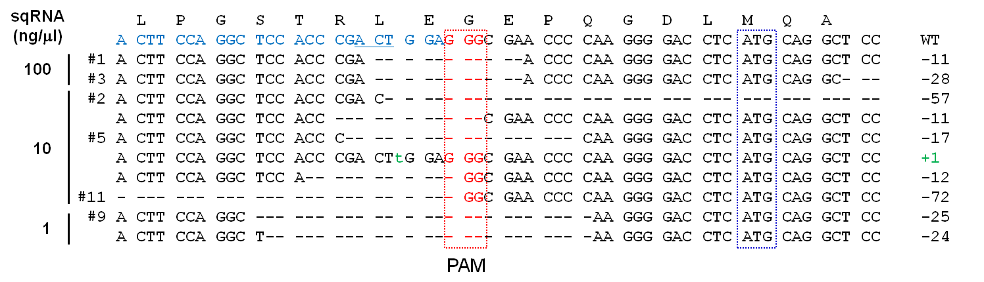

Supplemental Figure 2. Foxn1 gene knockout in mouse embryos by intra-cytoplasmic injection of Cas9 mRNA and Foxn1-sgRNA. (A) A representative result of a T7E1 assay monitoring the mutation rate after injecting the highest dose. Arrows indicate bands cleaved by T7E1. (B) A summary of T7E1 assay results. Mutant fractions among in vitro cultivated embryos obtained after intra-cytoplasmic injection of the indicated RGEN doses are indicated. The percentages were calculated using the number in the column to its left as the denominator. (C) DNA sequences of Foxn1 mutant alleles identified from a subset of T7E1-positive mutant embryos. The target sequence of the wild-type allele is denoted in blue.
A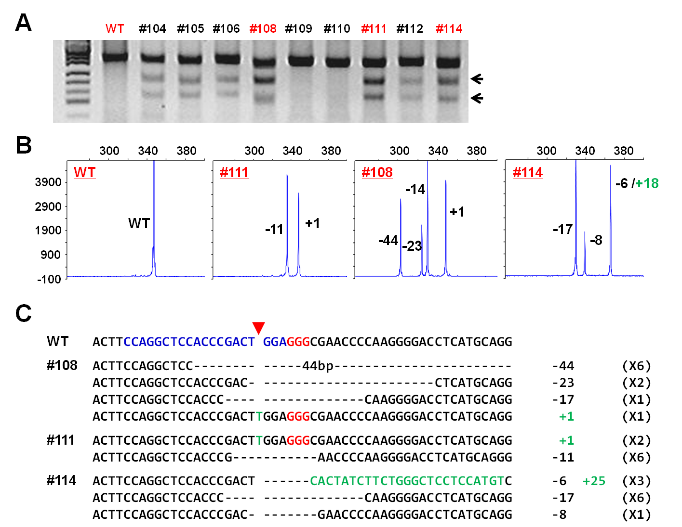
B
C

Supplemental Figure 3. RGEN-induced Foxn1 gene knockout in mice. (A) Representative T7E1 assays demonstrating gene-disrupting efficiencies of Cas9 mRNA plus Foxn1-specific sgRNA that were delivered via intra-cytoplasmic injection into one-cell stage mouse embryos. Numbers indicate independent founder mice generated from the highest dose. Arrows indicate bands cleaved by T7E1. (B) fPCR analysis showing mosaic mutations in the founder mice. (C) DNA sequences of mutant alleles observed in these Foxn1 mutant founders.

A
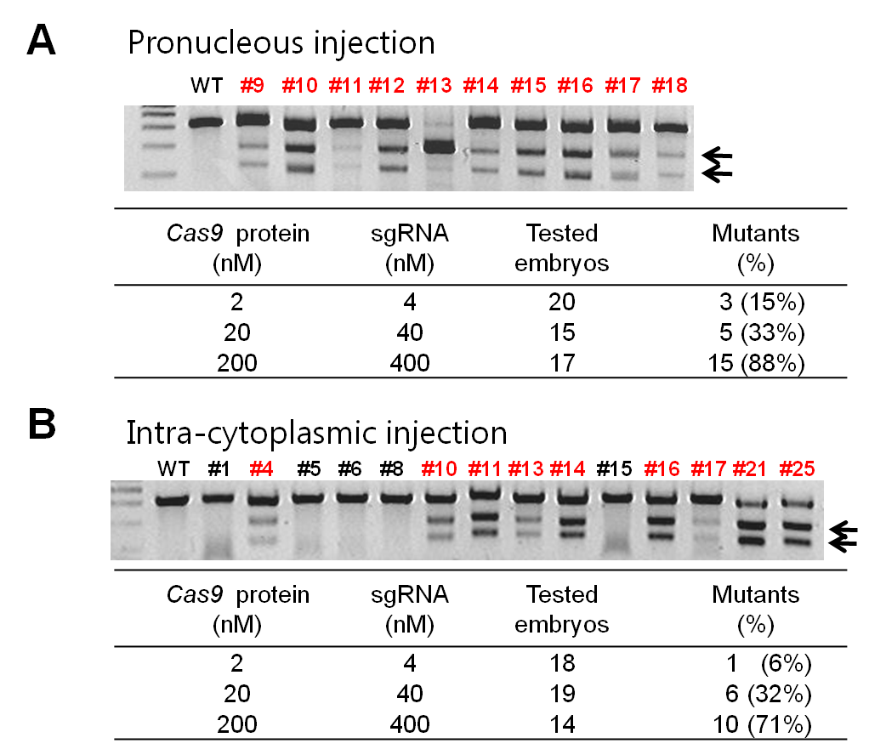
B
C
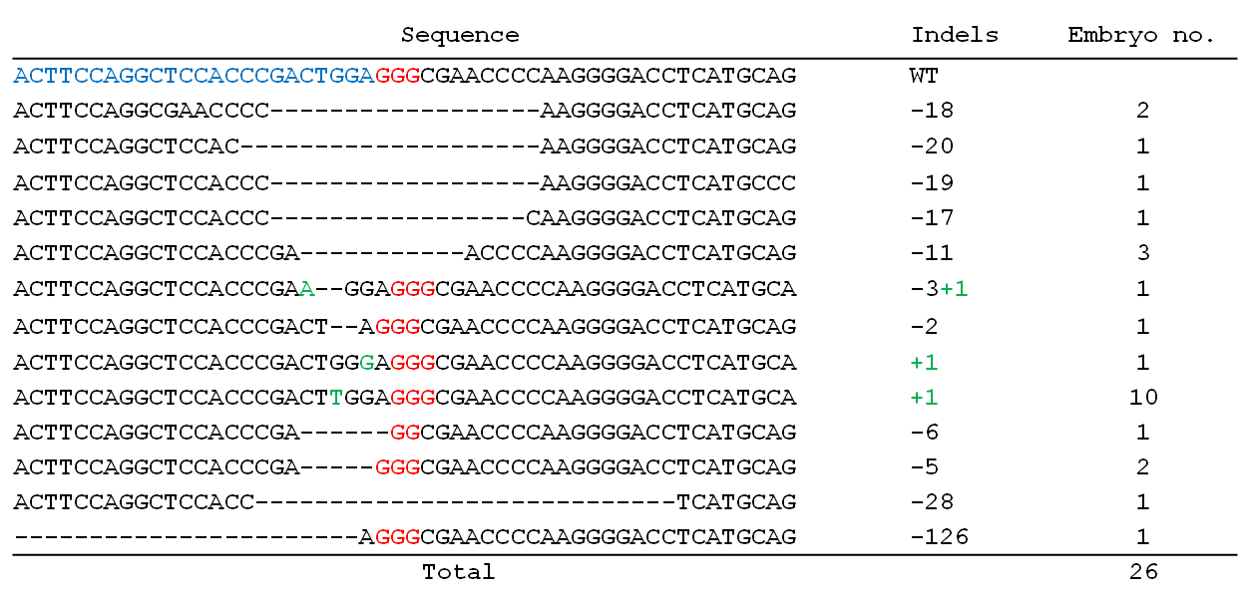
Supplemental Figure 4. Foxn1 gene disruption in mouse embryos using the recombinant Cas9 protein: Foxn1-sgRNA complex. (A and B) Representative T7E1 assay results and their summaries. Embryos were cultivated in vitro after they underwent pronuclear (A) or intra-cytoplasmic (B) injection. Numbers in red indicate T7E1-positive mutant founder mice. (C) DNA sequences of Foxn1 mutant alleles identified from the in vitro cultivated embryos that were obtained by the pronucleus injection of recombinant Cas9 protein: Foxn1-sgRNA complex at the highest dose. The target sequence of the wild-type allele is denoted in blue.

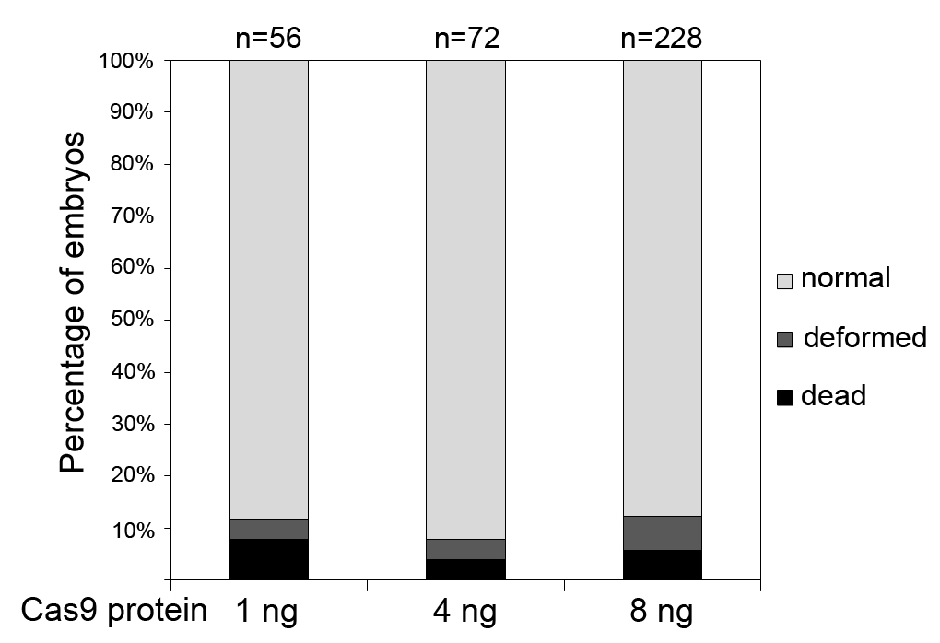
Supplemental Figure 5. Toxicities of Cas9 protein complexed with mitfa-specific sgRNA in zebrafish embryos. The Cas9 protein-sgRNA complex was microinjected into one-cell stage embryos with concentration of 1 ng, 4 ng, or 8 ng per embryo. After one day of injection, the number of normal, deformed, or dead embryos was scored.

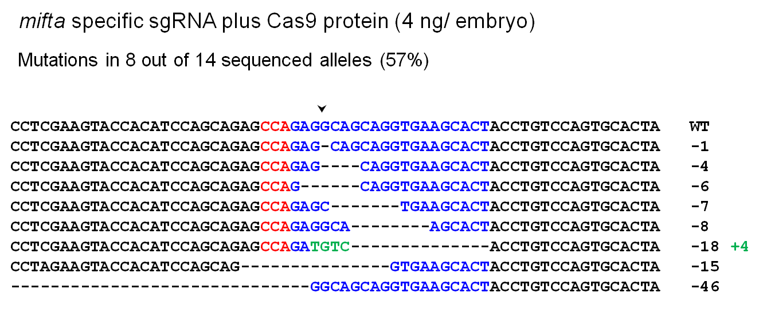
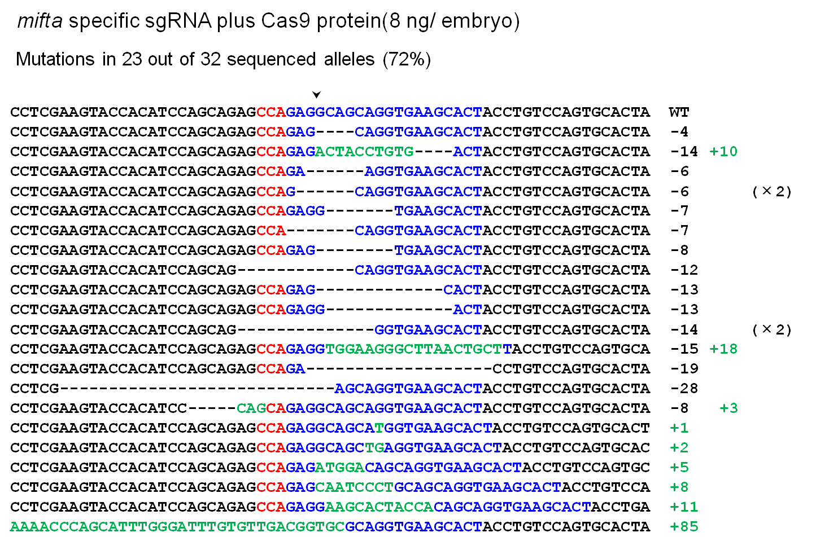
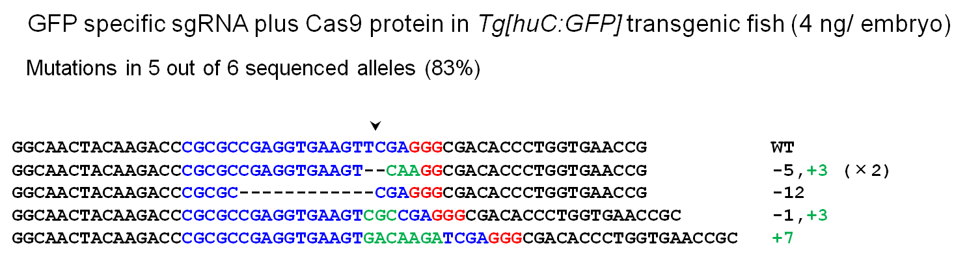
Supplemental Figure 6. Targeted indel mutations induced by Cas9 protein complex at mitfa and GFP reporter gene. The wild-type sequence is shown at the top, and target site in blue, and the PAM motif in red; Inserted bases highlighted as green. The column on the right indicates the number of inserted or deleted bases. Arrowheads indicate the expected RGEN cleavage site.

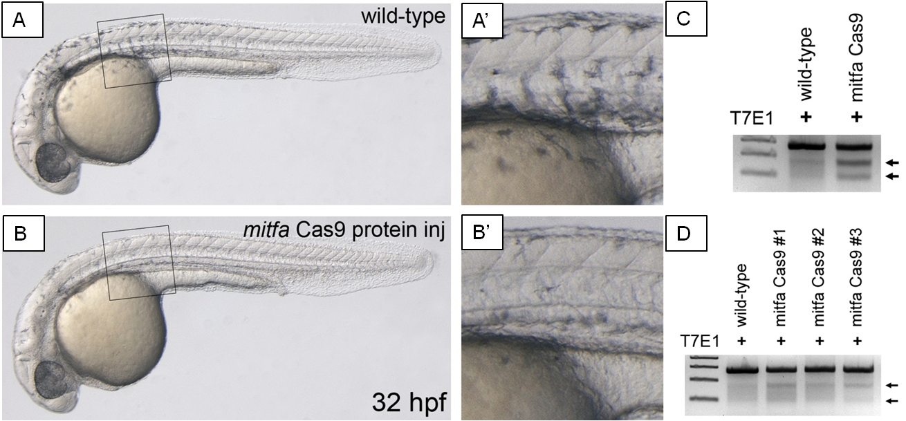
Supplemental Figure 7. Induction of somatic mitfa mutations by the Cas9 protein complex. (A) Un-injected wild-type embryo at 32 hpf. (B) Injection of mitfa Cas9 protein complex causes a defect in melanocyte development. (A’) and (B’) is a high-magnification in black box in (A) and (B), respectively. (C) T7E1 assay of wild-type (A) or mitfa Cas9 protein (B)-injected embryo. (D) T7E1 assay of mitfa Cas9 protein-injected one-month old embryos. The somatic mitfa mutations remain constant in Cas9 protein-injected embryos (#1-#3) by one-month. Arrows indicate the cleavage bands by T7E1.

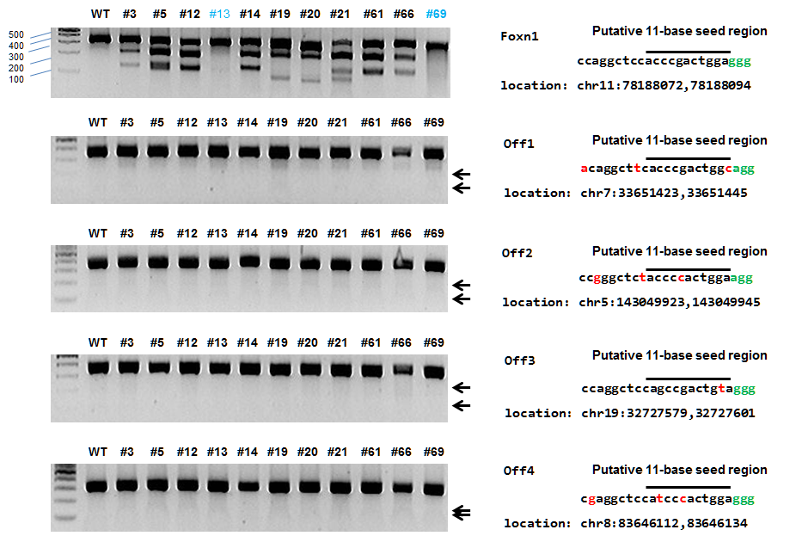

Supplemental Figure 8. Analysis of off-target activity of Foxn1-RGEN. T7E1 assays were conducted using DNA from the indicated Foxn1 mutant founders. The Foxn1 gene and putative off-target sites bearing 1~3-bp mismatches that were selected with bowtie 0.12.9 (25) were examined. Homozygous mutants or bi-allelic mutants containing large insertion are shown in blue (Table S1), mismatched bases in red, and PAM in green; black lines indicate putative 11-bp seed regions.

A
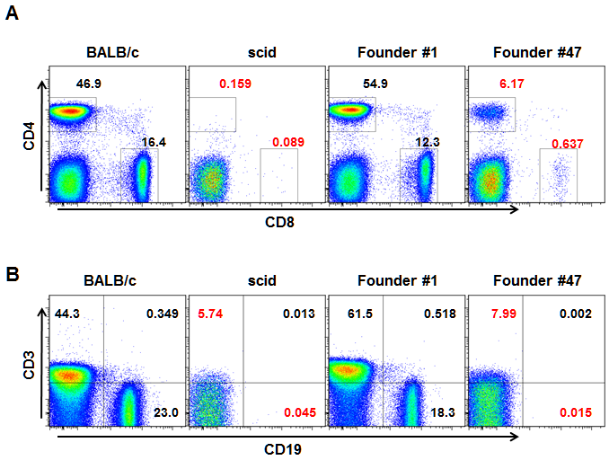
B

Supplemental Figure 9. Defective immune cell populations in PBMC from a bi-allelic Prkdc mutant founder #47. (A) Frequency of CD4⁺ and CD8⁺ T cells. (B) Frequencies of T cells (CD3⁺) and B cells (CD19⁺). The abnormal frequencies of immune cells were denoted in red. BALB/c and scid mice, positive and negative controls for B and T lymphocytes, respectively; Founder #1, mosaic mutation (Δ115/Δ3+2/+1/wild-type); founder #47, bi-allelic mutation (Δ14/ +455).

A
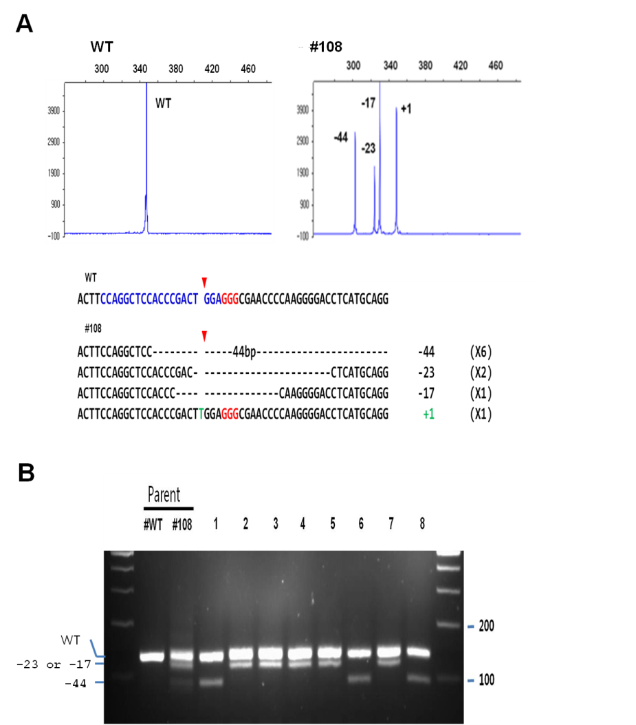
B

Supplemental Figure 10. Germ-line transmission of the mutant alleles found in Foxn1 mutant founder #108. (A) fPCR results of wild-type and the founder mice (upper panel) and the sequences of mutant alleles (lower panel). (B) PCR genotyping of F₁ progenies derived from crossing Foxn1 founder #108 and wild-type FVB/NTac. Note the segregation of the mutant alleles found in Foxn1 founder #108 in the progenies. The number of occurrences of the sequences is shown in parentheses.
Supplemental Table 1. Genotypes of Foxn1 mutant mice.
Founder NO. | sgRNA (ng/μl) | Genotyping Summary | Detected alleles
58* | 1 | not determined | -11
19 | 100 | bi-allelic | -60/+1
20 | 100 | bi-allelic | -67/Δ19
13 | 100 | bi-allelic | -18/+455
32 | 10 | bi-allelic | -13/-15+1
115 | 10 | bi-allelic | -18/Δ5
111 | 10 | bi-allelic | -11/+1
110 | 10 | Homozygote | -8/-8
120 | 10 | Homozygote | +2/+2
69 | 100 | Homozygote | -11/−11
81 | 100 | Heterozygote | +1/WT
55 | 1 | Mosaic | -18/-1/+1/+3
56 | 1 | Mosaic | -127/-41/-2/+1
127 | 1 | Mosaic | -18/+1/WT
53 | 1 | Mosaic | -11/-5/-4+1/WT
27 | 10 | Mosaic | -17/-5/WT
29 | 10 | Mosaic | -18/-20+1/+1
95 | 10 | Mosaic | -18/-14/-8/Δ4
108 | 10 | Mosaic | +1/-17/-23/Δ44
114 | 10 | Mosaic | -17/-8/-6+25
124 | 10 | Mosaic | -11/-15+2/+1
126 | 10 | Mosaic | -17/Δ2+3/Δ12+6
12 | 100 | Mosaic | -30/-28/-17/+1
5 | 100 | Mosaic | -28/-11/-2+6/+1
14 | 100 | Mosaic | -17/-11/-10
21 | 100 | Mosaic | -127/-41/-2/-6+25
24 | 100 | Mosaic | -17/+1/WT
64 | 100 | Mosaic | -31/-21/+1/WT
68 | 100 | Mosaic | -17/-11/+1/WT
79 | 100 | Mosaic | -22/-5/+2/WT
61 | 100 | Mosaic | -21+4/-6/+1/+9
66** | 100 | Mosaic | -17/-8/-11+6/+1/WT
3 | 100 | Mosaic | -11/-8/+1
Underlined alleles were sequenced.
Alleles in red, detected by sequencing, but not by fPCR.
*only one clone sequenced.
**Not determined by fPCR.

Supplemental Table 2. Genotypes of Prkdc mutant mice.
Founder no. | sgRNA (ng/μl) | Genotyping Summary | Detected alleles
7* | 250 | not determined | -21/WT
4 | 250 | bi-allelic | -21/+1
47 | 250 | bi-allelic | -14/ +455
37 | 50 | Heterozygote | +2/WT
39 | 50 | Heterozygote | +3/WT
70 | 50 | Heterozygote | -11/WT
71 | 50 | Heterozygote | -12/WT
72 | 50 | Heterozygote | -12/WT
90 | 50 | Heterozygote | -2/WT
53 | 100 | Heterozygote | -10/WT
67 | 100 | Heterozygote | -2/WT
8 | 250 | Heterozygote | +2/WT
14 | 250 | Heterozygote | -6/WT
16 | 250 | Heterozygote | -8/WT
17 | 250 | Heterozygote | -21/WT
23 | 250 | Heterozygote | -13/WT
44 | 250 | Heterozygote | -2/WT
45 | 250 | Heterozygote | -21/WT
48 | 250 | Heterozygote | -7/WT
76 | 50 | Mosaic | +1/+2/WT
80 | 50 | Mosaic | -4/-4+252/WT
81 | 50 | Mosaic | -4/-12/WT
85 | 50 | Mosaic | -21/-3+1/WT
86 | 50 | Mosaic | -4/+1/WT
33 | 100 | Mosaic | -4/+2/WT
54 | 100 | Mosaic | -7+28/-12+30/WT
64 | 100 | Mosaic | -3+97/-4/WT
66 | 100 | Mosaic | -3/+1/WT
55 | 100 | Mosaic | -7/-6+2/WT
1 | 250 | Mosaic | -115/-3+2/+1/WT
5 | 250 | Mosaic | -4/+5/+9/WT
11 | 250 | Mosaic | -2/+2/WT
12 | 250 | Mosaic | -14/+1/WT
15 | 250 | Mosaic | -5+1/+7/+12/WT
18 | 250 | Mosaic | -1+32/-4/WT
25 | 250 | Mosaic | -269/-61/WT
26 | 250 | Mosaic | -6+2/-2/WT
50 | 250 | Mosaic | -13/-2/-1/WT
51 | 250 | Mosaic | -15/Δ12/-4
Underlined alleles were sequenced.
Alleles in red, detected by sequencing, but not by fPCR.
*Not determined by fPCR.
Supplemental Table 3. DNA sequences of Foxn1 mutant alleles identified from a subset of T7E1-positive mutant founders.
ACTTCCAGGCTCCACCCGACTGGAGGGCGAACCCCAAGGGGACCTCATGCAGG | del+ins | # | Founder mice
ACTTCCAGGC-------------------AACCCCAAGGGGACCTCATGCAGG | -19 | 1 | 20
ACTTCCAGGC------------------GAACCCCAAGGGGACCTCATGCAGG | -18 | 1 | 115
ACTTCCAGGCTCC---------------------------------------- | -60 | 1 | 19
ACTTCCAGGCTCC---------------------------------------- | -44 | 1 | 108
ACTTCCAGGCTCC---------------------CAAGGGGACCTCATGCAGG | -21 | 1 | 64
ACTTCCAGGCTCC------------TTAGGAGGCGAACCCCAAGGGGACCTCA | -12+6 | 1 | 126
ACTTCCAGGCTCCACC----------------------------TCATGCAGG | -28 | 1 | 5
ACTTCCAGGCTCCACCC---------------------CCAAGGGACCTCATG | -21+4 | 1 | 61
ACTTCCAGGCTCCACCC------------------AAGGGGACCTCATGCAGG | -18 | 2 | 95, 29
ACTTCCAGGCTCCACCC-----------------CAAGGGGACCTCATGCAGG | -17 | 7 | 12, 14, 27, 66, 108, 114, 126
ACTTCCAGGCTCCACCC---------------ACCCAAGGGGACCTCATGCAG | -15+1 | 1 | 32
ACTTCCAGGCTCCACCC---------------CACCCAAGGGGACCTCATGCA | -15+2 | 1 | 124
ACTTCCAGGCTCCACCC-------------ACCCCAAGGGGACCTCATGCAGG | -13 | 1 | 32
ACTTCCAGGCTCCACCC--------GGCGAACCCCAAGGGGACCTCATGCAGG | -8 | 1 | 110
ACTTCCAGGCTCCACCCT-------------------GGGGACCTCATGCAGG | -20+1 | 1 | 29
ACTTCCAGGCTCCACCCG-----------AACCCCAAGGGGACCTCATGCAGG | -11 | 1 | 111
ACTTCCAGGCTCCACCCGA----------------------ACCTCATGCAGG | -22 | 1 | 79
ACTTCCAGGCTCCACCCGA------------------GGGGACCTCATGCAGG | -18 | 2 | 13, 127
ACTTCCAGGCTCCACCCCA-----------------AGGGGACCTCATGCAGG | -17 | 1 | 24
ACTTCCAGGCTCCACCCGA-----------ACCCCAAGGGGACCTCATGCAGG | -11 | 5 | 14, 53, 58, 69, 124
ACTTCCAGGCTCCACCCGA---------–GACCCCAAGGGGACCTCATGCAGG | -10 | 1 | 14
ACTTCCAGGCTCCACCCGA-----GGGCGAACCCCAAGGGGACCTCATGCAGG | -5 | 3 | 53, 79, 115
ACTTCCAGGCTCCACCCGAC-----------------------CTCATGCAGG | -23 | 1 | 108
ACTTCCAGGCTCCACCCGAC-----------CCCCAAGGGGACCTCATGCAGG | -11 | 1 | 3
ACTTCCAGGCTCCACCCGAC-----------GAAGGGCCCCAAGGGGACCTCA | -11+6 | 1 | 66
ACTTCCAGGCTCCACCCGAC--------GAACCCCAAGGGGACCTCATGCAGG | -8 | 2 | 3, 66
ACTTCCAGGCTCCACCCGAC-----GGCGAACCCCAAGGGGACCTCATGCAGG | -5 | 1 | 27
ACTTCCAGGCTCCACCCGAC––GTGCTTGAGGGCGAACCCCAAGGGGACCTCA | -2+6 | 2 | 5
ACTTCCAGGCTCCACCCGACT------CACTATCTTCTGGGCTCCTCCATGTC | -6+25 | 2 | 21, 114
ACTTCCAGGCTCCACCCGACT----TGGCGAACCCCAAGGGGACCTCATGCAG | -4+1 | 1 | 53
ACTTCCAGGCTCCACCCGACT--TGCAGGGCGAACCCCAAGGGGACCTCATGC | -2+3 | 1 | 126
ACTTCCAGGCTCCACCCGACTTGGAGGGCGAACCCCAAGGGGACCTCATGCAG | +1 | 15 | 3, 5, 12, 19, 29, 55, 56, 61, 66, 68, 81, 108, 111, 124, 127
ACTTCCAGGCTCCACCCGACTTTGGAGGGCGAACCCCAAGGGGACCTCATGCA | +2 | 2 | 79, 120
ACTTCCAGGCTCCACCCGACTGTTGGAGGGCGAACCCCAAGGGGACCTCATGC | +3 | 1 | 55
ACTTCCAGGCTCCACCCGACTGGAG(+455)GGCGAACCCCAAGGGGACCTCC | +455 | 1 | 13

Supplemental Table 4. DNA sequences of Prkdc mutant alleles.
TTGGTTTGCTTGTGTTTATCCGGAAGTCGCTTAGCATTGAGGACGTAAGTATGAT | del+ins | # | founders
TTGGTTT--------------GGAAGTCGCTTAGCATTGAGGACGTAAGTATGAT | -14 | 1 | 47
TTGGTTT-----------TCCGGAAGTCGCTTAGCATTGAGGACGTAAGTATGAT | -11 | 1 | 70
TTGGTTTG---------------AAGTCGCTTAGCATTGAGGACGTAAGTATGAT | -15 | 1 | 51
TAGGTTTG------------TCCGTGTCGTTTGGCATGGAGGACGTTCAACGGAA | -12+30 | 1 | 54
TTGGTTTG----TGTTTATCCGGAAGTCGCTTAGCATTGAGGACGTAAGTATGAT | -4 | 1 | 81
TTGGTTTGC------------GGAAGTCGCTTAGCATTGAGGACGTAAGTATGAT | -12 | 1 | 72
TTGGTTTGCTT---------------------AGCATTGAGGACGTAAGTATGAT | -21 | 4 | 4, 7, 17, 85
TTGGTTTGCTT-------------AGTCGCTTAGCATTGAGGACGTAAGTATGAT | -13 | 1 | 23
TTGGTTTGCTT--------CCGGAAGTCGCTTAGCATTGAGGACGTAAGTATGAT | -8 | 1 | 16
TTGGTTTGCTT------TGATCCGGAAGTCGCTTAGCATTGAGGACGTAAGTATG | -6+2 | 1 | 26
TTGGTTTGCTTG-----AATCCGGAAGTCGCTTAGCATTGAGGACGTAAGTATGA | -5+1 | 1 | 15
TTGGTTTGCTT-------------------------------------------- | -61 | 1 | 25
TTGGTTTGCTTGT------------------------------------------ | -115 | 1 | 1
TTGGTTTGCTTGT--------------CGCTTAGCATTGAGGACGTAAGTATGAT | -14 | 1 | 12
TTGGTTTGCTTGT-//–ATCCGGAAGTCGCTTAGCATTGAGGACGTAAGTATGAT | -4+252 | 1 | 80
TTGGTTTGCTTGTG---ATCCGGAAGTCGCTTAGCATTGAGGACGTAAGTATGAT | -3 | 1 | 66
TTGGTTTGCTTGTGT------------CGCTTAGCATTGAGGACGTAAGTATGAT | -12 | 2 | 71, 81
TTGGTTTGCTTGTGT-------CGCTTAGCATTGGGGACGCTCAATTGAAGAAGT | -7+28 | 1 | 54
TTGGTTTGCTTGTGT----CCGGAAGTCGCTTAGCATTGAGGACGTAAGTATGAT | -4 | 3 | 33, 64, 86
TTGGTTTGCTTGTGT---GTCCGGAAGTCGCTTAGCATTGAGGACGTAAGTATGA | -3+1 | 1 | 85
TTGGTTTGCTTGTGT---CTTCCGGAAGTCGCTTAGCATTGAGGACGTAAGTATG | -3+2 | 1 | 1
TTGGTTTGCTTGTGT--ATCCGGAAGTCGCTTAGCATTGAGGACGTAAGTATGAT | -2 | 1 | 44
TTGGTTTGCTTGTGT-ACATATCCGTGTACATATCCGTGTACAGTACATATCCGG | -1+32 | 1 | 18
TTGGTTTGCTTGTGTT-/-CCGGAAGTCGCTTAGCATTGAGGACGTAAGTATGAT | -3+97 | 1 | 64
TTGGTTTGCTTGTGTT--TCCGGAAGTCGCTTAGCATTGAGGACGTAAGTATGAT | -2 | 1 | 26
TTGGTTTGCTTGTGTT/ATCCGGAAGTCGCTTAGCATTGAGGACGTAAGTATGAT | -1+220 | 1 | 47
TTGGTTTGCTTGTGTTT--CCGGAAGTCGCTTAGCATTGAGGACGTAAGTATGAT | -2 | 2 | 50, 67
TTGGTTTGCTTGTGTTTA------AGTCGCTTAGCATTGAGGACGTAAGTATGAT | -6 | 1 | 14
TTGGTTTGCTTGTGTTTAATCCGGAAGTCGCTTAGCATTGAGGACGTAAGTATGA | +1 | 1 | 1
TTGGTTTGCTTGTGTTTTATCCGGAAGTCGCTTAGCATTGAGGACGTAAGTATGA | +1 | 3 | 12, 66, 86
TTGGTTTGCTTGTGTTTCATCCGGAAGTCGCTTAGCATTGAGGACGTAAGTATGA | +1 | 2 | 4, 76
TTGGTTTGCTTGTGTTTTTATCCGGAAGTCGCTTAGCATTGAGGACGTAAGTATG | +2 | 1 | 76
TTGGTTTGCTTGTGTTTCCATCCGGAAGTCGCTTAGCATTGAGGACGTAAGTATG | +2 | 1 | 8
-----------------------------CGCTTAGCATTGAGGACGTAAGTATG | -269 | 1 | 25

Supplemental Table 5. Oligonucletide for preparation of in vitro RNA transcription template.
RNA Name | Direction | Sequence (5' to 3')
Foxn1 #1 sgRNA | F | GAAATTAATACGACTCACTATAGGCAGTCTGACGTCACACTTCCGTTTTAGAGCTAGAAATAGCAAGTTAAAATAAGGCTAGTCCG
Foxn1 #2 sgRNA | F | GAAATTAATACGACTCACTATAGGACTTCCAGGCTCCACCCGACGTTTTAGAGCTAGAAATAGCAAGTTAAAATAAGGCTAGTCCG
Foxn1 #3 sgRNA | F | GAAATTAATACGACTCACTATAGGCCAGGCTCCACCCGACTGGAGTTTTAGAGCTAGAAATAGCAAGTTAAAATAAGGCTAGTCCG
Foxn1 #4 sgRNA | F | GAAATTAATACGACTCACTATAGGACTGGAGGGCGAACCCCAAGGTTTTAGAGCTAGAAATAGCAAGTTAAAATAAGGCTAGTCCG
Foxn1 #5 sgRNA | F | GAAATTAATACGACTCACTATAGGACCCCAAGGGGACCTCATGCGTTTTAGAGCTAGAAATAGCAAGTTAAAATAAGGCTAGTCCG
Prkdc #1 sgRNA | F | GAAATTAATACGACTCACTATAGGTTAGTTTTTTCCAGAGACTTGTTTTAGAGCTAGAAATAGCAAGTTAAAATAAGGCTAGTCCG
Prkdc #2 sgRNA | F | GAAATTAATACGACTCACTATAGGTTGGTTTGCTTGTGTTTATCGTTTTAGAGCTAGAAATAGCAAGTTAAAATAAGGCTAGTCCG
Prkdc #3 sgRNA | F | GAAATTAATACGACTCACTATAGGCACAAGCAAACCAAAGTCTCGTTTTAGAGCTAGAAATAGCAAGTTAAAATAAGGCTAGTCCG
Prkdc #4 sgRNA | F | GAAATTAATACGACTCACTATAGGCCTCAATGCTAAGCGACTTCGTTTTAGAGCTAGAAATAGCAAGTTAAAATAAGGCTAGTCCG
eGFP sgRNA | F | GAAATTAATACGACTCACTATAGGCGCGCCGAGGTGAAGTTCGAGTTTTAGAGCTAGAAATAGCAAGTTAAAATAAGGCTAGTCCG
sgRNA Reverse | R | AAAAAAAGCACCGACTCGGTGCCACTTTTTCAAGTTGATAACGGACTAGCCTTATTTTAAC
mitfa crRNA | F | GAAATTAATACGACTCACTATAGGAGTGCTTCACCTGCTGCCTCGTTTTAGAGCTATGCTGTTTTG
mitfa crRNA | R | CAAAACAGCATAGCTCTAAAACGAGGCAGCAGGTGAAGCACTCCTATAGTGAGTCGTATTAATTTC
TracrRNA | F | GAAATTAATACGACTCACTATAGGAACCATTCAAAACAGCATAGCAAGTTAAAATAAGGCTAGTCCG
TracrRNA | R | AAAAAAAGCACCGACTCGGTGCCACTTTTTCAAGTTGATAACGGACTAGCCTTATTTTAACTTGCTATG
ª F, forward; R, reverse
^{b} Sequences complementary to target DNA are shown in blue. The T7 promoter sequence is underlined.

Supplemental Table 6. Primer sequences used in T7E1 assay and fPCR analysis.

Gene | Direction | Sequence(5' to 3')
Foxn1 | F1 | GTCTGTCTATCATCTCTTCCCTTCTCTCC
Foxn1 | F2 | TCCCTAATCCGATGGCTAGCTCCAG
Foxn1 | R1 | ACGAGCAGCTGAAGTTAGCATGC
Foxn1 | R2 | CTACTCAATGCTCTTAGAGCTACCAGGCTTGC
Prkdc | F1 | GACTGTTGTGGGGAGGGCCG
Prkdc | F2 | GGGAGGGCCGAAAGTCTTATTTTG
Prkdc | R1 | CCTGAAGACTGAAGTTGGCAGAAGTGAG
Prkdc | R2 | CTTTAGGGCTTCTTCTCTACAATCACG
eGFP | F | CAAGGGCGAGGAGCTGTTCACC
eGFP | R | CGGCCATGATATAGACGTTGTGG
mitfa | F | GTAGAATGTGAGCTTATTGGCGT
mitfa | R | TCTCACAGTTGAGGGTGAGAAGG

Supplemental Table 7. Primers used for amplification of off-target sites.

Gene | Notation | Direction | Sequence(5' to 3')
Foxn1 | off 1 | F | CTCGGTGTGTAGCCCTGAC
Foxn1 | off 1 | R | AGACTGGCCTGGAACTCACAG
Foxn1 | off 2 | F | CACTAAAGCCTGTCAGGAAGCCG
Foxn1 | off 2 | R | CTGTGGAGAGCACACAGCAGC
Foxn1 | off 3 | F | GCTGCGACCTGAGACCATG
Foxn1 | off 3 | R | CTTCAATGGCTTCCTGCTTAGGCTAC
Foxn1 | off 4 | F | GGTTCAGATGAGGCCATCCTTTC
Foxn1 | off 4 | R | CCTGATCTGCAGGCTTAACCCTTG
Prkdc | off 1 | F | CTCACCTGCACATCACATGTGG
Prkdc | off 1 | R | GGCATCCACCCTATGGGGTC
Prkdc | off 2 | F | GCCTTGACCTAGAGCTTAAAGAGCC
Prkdc | off 2 | R | GGTCTTGTTAGCAGGAAGGACACTG
Prkdc | off 3 | F | AAAACTCTGCTTGATGGGATATGTGGG
Prkdc | off 3 | R | CTCTCACTGGTTATCTGTGCTCCTTC
Prkdc | off 4 | F | GGATCAATAGGTGGTGGGGGATG
Prkdc | off 4 | R | GTGAATGACACAATGTGACAGCTTCAG
Prkdc | off 5 | F | CACAAGACAGACCTCTCAACATTCAGTC
Prkdc | off 5 | R | GTGCATGCATATAATCCATTCTGATTGCTCTC
Prkdc | off 6 | F1 | GGGAGGCAGAGGCAGGT
Prkdc | off 6 | F2 | GGATCTCTGTGAGTTTGAGGCCA
Prkdc | off 6 | R1 | GCTCCAGAACTCACTCTTAGGCTC

