Supplementary Material

Random Replication of the Inactive X Chromosome
Amnon Koren, Steven A. McCarroll

Figure S1. Cell lines used in this study.

Figure S2. Detailed replication profiles of the active and inactive X chromosomes.
The active (red) and inactive (blue) X chromosome copies are shown for the three female cell lines. Vertical green shaded areas are regions in which we have increased the read coverage to 4-11 fold per allele in order to provide higher resolution replication profiles. The replication patterns at the regions with increased read coverage were consistent with those seen for the rest of the X chromosome, i.e. consistent replication timing among females for the Xa but random, inconsistent replication of the Xi (with the exception of the 8Mb region on the distal short arm). The correlations between Xa replication timing of the different females for the non-pseudoautosomal high coverage regions was on average r=0.72, while the correlations for the Xi were significantly lower, r=0.44 on average, and the average correlations between the Xa and Xi were r=0.49.

Figure S3. Statistical analysis of the replication properties of evolutionary strata.

Mean and standard errors of the data from Figure1D are shown for each stratum. The PAR2 region is too short (<0.3Mb) to derive any conclusions regarding its replication time or structure on the Xi relative to the Xa (see Figures 1D and S2). Our observation of variability of Xi replication among individuals may explain previously contradictory findings regarding whether the XIST locus is replicated earlier on the Xi (from which it is exclusively expressed; Boggs and Chinault, 1994; Torchia and Migeon, 1995) or the Xa (Gartler et al., 1999; Xiong et al., 1998); indeed, in our data XIST replicated earlier on the Xi in one of the cell lines but not the others (Figure 1D). No other regions beyond the 8Mb distal short arm region, including other regions of escaping genes, showed any indication of organized replication or of earlier replication on the Xi relative to the Xa.

Figure S4. The gradual increase in replication randomness along S phase can explain the random replication of the Xi.

We specifically looked at autosomal autocorrelation (as in Figure 3) for the time range that parallels the time when the Xi replicates, and for an equal amount of data centered on the mean Xa replication time. The difference between these two time ranges was similar to the differences between the Xa and Xi (see Figure 2B). Data for the YRI samples were less reliable due to an overall lower read depth (Koren et al., 2012).

Table S1. Number of reads available for the X chromosome in each sample.
 | G1 paternal | G1 maternal | S paternal | S maternal
NA19240 | 113800 | 135261 | 99895 | 140470
NA12878 | 63716 | 69583 | 114006 | 142934
NA12892 | 59476 | 60068 | 111877 | 120698

Note: for NA12892, the numbers in the ‘paternal’ columns refer to the transmitted copy of the chromosome, and the numbers in the ‘maternal’ columns to the non-transmitted copy of the chromosome.

Supplementary references
Boggs BA, Chinault AC. 1994. Analysis of replication timing properties of human X-chromosomal loci by fluorescence in situ hybridization. Proceedings of the National Academy of Sciences 91 6083-6087

Gartler SM, Goldstein L, Tyler-Freer SE, Hansen RS. 1999. The Timing of XIST Replication: Dominance of the Domain. Human Molecular Genetics 8 1085-1089

Koren A, Polak P, Nemesh J, Michaelson JJ, Sebat J, Sunyaev SR, McCarroll SA. 2012. Differential Relationship of DNA Replication Timing to Different Forms of Human Mutation and Variation. The American Journal of Human Genetics 91:1033-1040

Torchia BS, Migeon BR. 1995. The XIST locus replicates late on the active X, and earlier on the inactive X based on FISH DNA replication analysis of somatic cell hybrids. Somat Cell Mol Genet 21:327-333

Xiong Z, Tsark W, Singer-Sam J, Riggs AD. 1998. Differential replication timing of X-linked genes measured by a novel method using single-nucleotide primer extension. Nucleic Acids Research 26 684-686

Figure S1
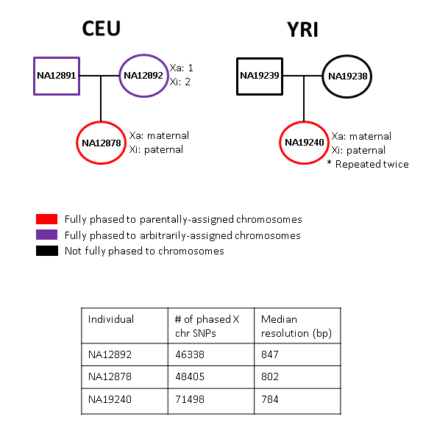

Figure S2
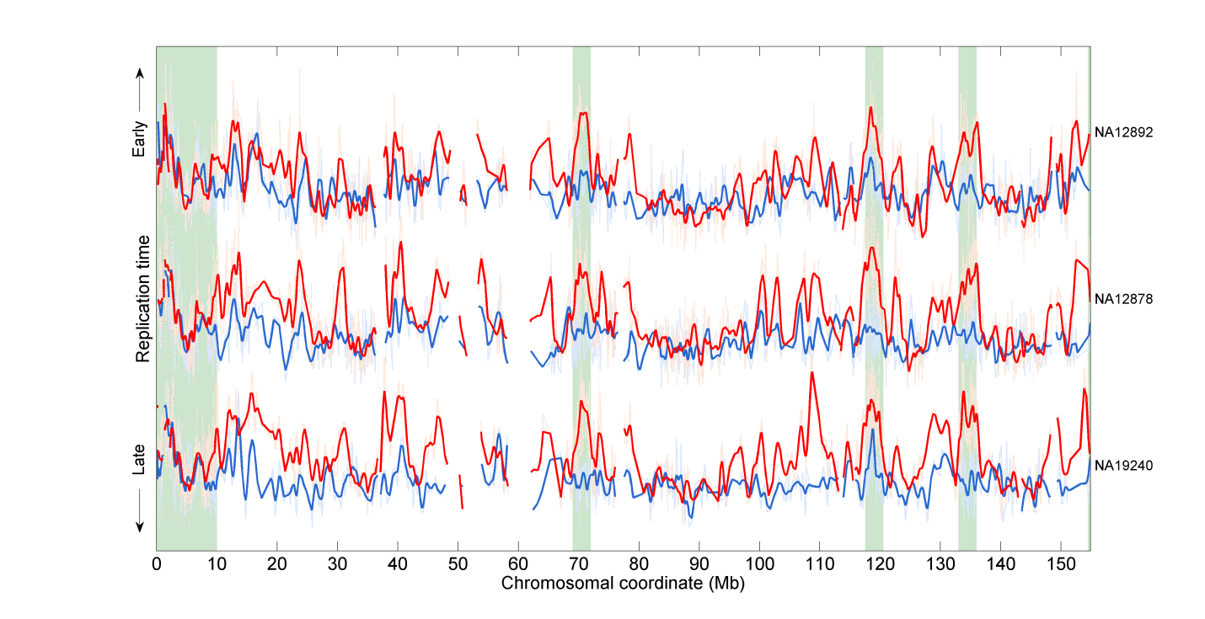

Figure S3

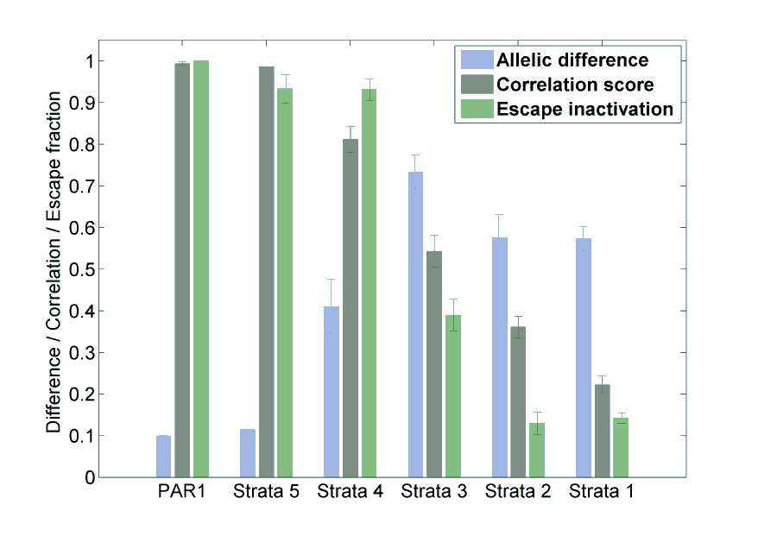

Figure S4

