Supplementary information

Glossary:

Retroduplication – a reverse transcribed copy of mRNA integrated into a genome.

Parent gene or simply parent – a full-length gene, whose mRNA was transcribed to yield a retroduplication.

Novel retroduplication – a retroduplication existing in a personal genome but not found in the reference genome. Note that the parent gene can have a novel retroduplication even if there already exists a known retroduplication for this gene in the reference genome. In such a case, the parent gene is predicted to have more copies of the retroduplication than is present in the reference genome.

Retroduplication variant (RDV) – presence or absence of retroduplications in individual genomes. RDV can be described in terms of parent genes that give rise to variable retroduplications.

Correlation of expression data with cell cycle using Bar-Joseph’s data

In addition to the Whitfield et al. data set, we utilized a different source of data to analyze the correlation of gene expression with cell cycle (Bar-Joseph et al. 2008). This study analyzed gene expression in primary human foreskin fibroblasts and revealed additional as well as the same cycling genes as in the HeLa cell line (Whitfield et al. 2002). However, assignment of genes to a particular cell cycle phase was less precise, which complicates our analysis and makes correlations less pronounced. For example, genes expressed at M and G1 phases could not be distinguished and were described as M/G1. We reasoned that, out of four distinct phase assignments (G2, G2/M, M/G1, and G1/S), assignment to G2/M phases represent genes with peak expression closest to cell division. We tested those genes for statistical enrichment for retroduplications.
For this, we downloaded a set of 480 cycling genes from SI Table 5 of Bar-Joseph et al. Locus ids for 437 of those genes could be mapped to ENSEMBL ids, and this is the dataset of genes we worked with. Only three of these genes are found in our set of RDVs and only ten have recent retroduplications (more than 97% identity to parent) in the reference genome. However, none of those subsets show significant enrichment for genes assigned to G2/M phases, perhaps, due to small sample size and/or imprecise phase assignment. In contrast, the subset of those 437 genes showed a pronounced tendency for more retroduplications per gene in the reference genome as genes are expressed closer to cell division. And genes with peaking expression at G2/M phases generate 2.1 times more retroduplications and are different in the distribution of the number of retroduplications per gene (p-value = 0.0057 by t-test) than genes with peaking expression at other phases of cell cycle (Figure S32). This result is consistent with the one obtained when using Whitfield et al. data.

Cell cycle expression as a predictor for retroduplication

Previously, it was observed that gene expression levels could be used as predictors for the probability of a retroduplication event. Our hypothesis, that genes expressed at or around cell division have a higher chance of retroduplication, suggests that gene expression patterns throughout the cell cycle can be a better predictor than gene expression levels alone. However, to our knowledge, there are no data with absolute gene expression levels across cell cycle phases for most of the genes in human genome. That is why, as a proof of concept, we consider weighted average gene expression across all cell cycle phases (i.e., expression of unsynchronized cells) as a predictor. Weights were determined based on which cell cycle phase a gene was assigned. Namely, for each cycle phase we calculated weight as an average number of retroduplications generated per gene, e.g., we assign weight ~1.26 for M/G1 phase (see Figure 3). Then for each periodic gene assigned to a particular cell cycle phase we weight its expression by the weight of the phase.

For consistency with other analyses (see main text) we utilized a dataset of 565 genes periodically expressed during the HeLa cell cycle (Whitfield et al. 2002; Gauthier et al. 2010). Absolute gene expression values were obtained from two replicate RNA-seq experiments carried out by the ENCODE project (files: wgEncodeCaltechRnaSeqHelas3R2x75Il200GeneGencV3cRep1V3.gtf.gz and wgEncodeCaltechRnaSeqHelas3R2x75Il200GeneGencV3cRep2V3.gtf.gz). We randomly selected half of the genes in the dataset and used them to calculate the weights, while the remaining half was utilized to calculate Pearson’s rank correlations of per gene weighted and unweighted expression with the number of retroduplications. We performed one thousand such calculations per replica.

For the first replica, we observed higher correlation values in 684 cases (p-value = 3.9e-32 by binomial test) when utilizing weighted expressions. For the second replica, we observed higher correlation values in 564 cases (p-value = 2.9e-5 by binomial test) when utilizing weighted expressions. Therefore, we demonstrated that knowing gene expression cell cycle phase improves the prediction of retroduplications.

Estimating average distance between clustered reads around retroduplication insertion point
Let L be the average insert distance between pairs of reads in the sequencing library. Let n be the number of reads in a cluster indicative of the retroduplication insertion. We further make the reasonable assumption that reads are equidistantly distributed in the range L downstream and upstream from the insertion point. Then two mapped reads in the cluster that have no mapped reads in between would have the average distance of d=2L/(n – 1). Now for each read let’s sum the pairwise distance to all other reads left from it. For the very left (k = 1) read this sum will be zero. For second left (k = 2) this sum will be d. Generally, for each read indexed k, when counted from the left, the sum can be written as k(k-1)/2. So, the total distance between reads in the cluster will be $D=\sum_{k=1}^{n}{\frac{k\left(k-1\right)}{2}}d$, which can be rewritten as
$$D=\frac{d}{2}\left(\sum_{k=1}^{n}{k^{2}}-\sum_{k=1}^{n}{k}\right)=\frac{d}{2}\left(\frac{n\left(n+1\right)\left(2n+1\right)}{6}-\frac{n\left(n+1\right)}{2}\right)=\frac{d}{6}n(n+1)(n-1)$$
Total number of pairwise distance between n reads is $N=\frac{n(n-1)}{2}$, resulting in average distance between reads in a cluster as follows
$$<D>=\frac{D}{N}=\frac{d}{3}\left(n+1\right)=\frac{2L}{3}\frac{(n+1)}{(n-1)}.$$

Supplementary sequences

Target site duplication (is in green)
PolyA (is in blue)
Retroduplication (is in bold)
Old Alu? (is in red)

>CDC27 NW_001841138.1,gi|157702221:542363-546266
CAGAGTCTGCAGGGTAAAGAAGTCATTCTGGCTCGGCCTCCCCCATCCCCTGGTAACTGGTGAGTTTAAA
TGAGGCCAGGCTGGCTGGGCCAGAGCTCCTACGGCGGGGAGGGGGGTTGGCAGGGTGGGGGGGTTGCCTG
AGGCACTGCAGAAAGTGGGTCTGAGCCTCGAGGATGATGGTGCTGCAGGAACCCGTCCAGGCTGCTATAT
GGCAAGCACTAAACCACTATGCTTACCGAGATGGGGTTTTCCTCGCAGAACACCTTCATGCAGAAGTACA
CTCAGAAGAAGCCATGTTTTTACTGGCGACCTGTTCTTACCGCCCAGGAAAGGCCTATAAAGCATATAGA
CTCTTGAAAGGACACAGTTGTCCTACACCGCAATGAAAATACCTGCTTGCAAAATGTTGTGTTGATCTCA
GCAAGCTTGCAGAAGGGGAACAATCTTATCTGGTGGAGTGTTTAATAAGCAGAAAAGTCATGATGATATT
GTTACTGAGTTTGGTGATTCAGCTTGCTTTCCCCTTCCATTGTTGGGACATGTATATTGCAAGACAGATT
GGCTTGCCAAAGGATCAGAATGTGACCGAAAGAGGCTTAGTTTAAATCCTTTCCTCTGGTATCCCTTTGA
ATCATTATGTGAAATAGGTGAAAAGCCAGATCCTGACCAAACGTTTAAATTCACATCTTTACAGAACTTT
AGCAACTGTCTGCCCAACTCTTGCACAACACAAGTACCTAATCATAGTTTATGTCACAGACAGCCTGAGA
CCATTCTTACGGAAACACCCCAGGACACAACTGAATTAAACAGATTGAATTTAGAATCTTCCAATTCAAA
GTACTCCTTGAATACAGATTCCCCAGTGTCTTCTATTGATTCAGCGTAATTTCACCTGATACTGTCCCAC
TGGGAACAGGAACTTCCATATTATCTAAACAGGTTCAAAATAAACCAAAAACTGGTCGAAGTTTATTAGG
AGGACCAGGAGATCTTAGTCCATTAACCCCAAGTTTTGGGATTTTGCCATTAGAAACCCCAAGTCCTGGA
GATGGATCCTATTTACAAAACTACACTAATATACCTTCTGAAATTGAGGTGCCATCCACCGGAGCCCCTT
CAAAAAAGTCTGTTGCCAGAATTGGCCAAACTGGAGCAAAGTCTGTCTTCTCACAGAGTGGAAATAGACG
AGAGGTAACTCCAATTCTTGCACAAACAGAAAGTTCTGGTCCATAAATAAGTACAACACCTCAGGTATTG
AGCCCCACTATGACATCTCCCCCAAATGCACTGCCTCGAAGAAATTCAAGACTCTTTACTAGTGACAGTT
TCCCAACCAAGGAGAATAGGAAGAAATTAAAAATGAAGTTTCCACCTAAAATCTCAAACAGAAAAACAAA
AAGTAAAACTAATAAAGGAGGAATAACTCAACCTAACATAAATGATGGCCTGGAAATTACAAAATTGGAC
TCTTCCATTATTTCAGAAGGGAAAATATCCACAATCACACCTCAGATTCAGGCTTTTAATCATAAAAAAC
AGCAGCAGAAGGCTTGATGAGCCTTTTTCATGAAAGGGTGAAAGGTTATTTAGCTTTGTGTTCATACCAC
TGCAAAGAAGCTATAAATATTTTGAGCCATCTACCTTCTCACCACTACAATACTGGTTGGGTACTGTGCC
AAATTGGAAGGGTCTATTTTGAACTTTCAGAGTACATACAAGCTGAAAGAATATTCTCAGAGGTTAGAAG
GACTGAGAATTATAGAGTCGAAGGCATGGAAATCTAGTCTACAACATTTTGGCATCTTCAAAAAGATGTT
GTTCTTTCAGTTATGTCAAAAGACTTAACAGATGTGGATAAAAATTCACCAGAGGCCTGATGTGCTTCAG
GGAACTGTTTCAGTTTGCAACGGGAACACGATATTGCAATTAAATTCTTCCAGAGAGCTATCCAAGTGGA
TCCAAATTATGCTTATGTCTATACTCTATTAGGGCGAGAGTTTGTCTTAACTGAAGAATTGGACAAAGTA
TTAGCTTGTTTTTGAAATGCTATCAGAGTCAATCCTAGACATTGTAATGCACGGTAAGTGGTAATGAAGT
GTAAAGACAAAGTCTTGTTGATGGTGCTTGTAGTCACTAATTTTTCTTGTTAGATAGCTCTTTATTGTCA
TGAATTTGGTTACTAATACTTAGGCATGGTACATACTAGTAAATAACTTCAAACTAACATGTTTTTTTAT
GAAATGTATGTCTTTAACAAACTCTTCAGTTAACTAATGATAATAGAATACCAGATCCTTATACTCAACA
GTTTCAGTCTTCTACCACAATTTTGCAGACACTGTAGTTGTGTTTTGTTTGTTTGTTTGCTTGTTTAGTT
TTGTTACTTGATTTATTACTTTTTCTTCGAACACAGAAATGGTGATTGGGACAAAAAGTGCTTGGGAAAT
TGGAAAGGAATAGCATAATTCACTTATTGGATAATAGGAAAAAAACACTGAAAAAATTCACTAGTTGCTG
CTTTTTGACAGTGTTCCAGTTTATTGAGTTACTATTAAGAACTTAGTATACTCTTTTATTTAGCAGTATC
TCTGTTTTCCTTTTTTTACTTGTGTATAAGTAGACACATAGGAAATTACTATCCAGGTCATATTGTTATC
AACTGAATAACATACGAAAAAGTTTGGTCCTACATCTGCCTCAACACCATACTTACTGTTGACATTTATT
GTATTTTTCTGGACTGACTTAAAAGTTTAAATATGAAGAGAAGGCCAGGCATGGTGGTTCATGCCTCTCA
TCCCAGCACTTTGGGAGGCCGAGGCGGGCAGATCACAAGGTCAAGAGATTGAGACCATCCTGTCCAGCAT
GGTGAAACCTCGTCTCTATTAAAAGTATAAAAATTAGCTGGCCATGGTGGCGGGCGCCTGTAGTCCCAGC
TACTCAGGAGGCTGAGGCAGGAGAATCGCTTGAACCTGGGAAGTGGAGGTTGCAGTGAGCCAAGATTATG
CCATTGCACTCCAGCCTGGGTGACAGAGTGAAACGCTGTCTCAAGAAAAAAATTAAATAAATAAATAAAT
AAATAAATAAATAAATAAATATCAAGAGAAAGTATAATTCTGAAGTCATAACTCTGTGGAAGCTTTTTTG
TCAGATACGGTTATCTTTGGGGTTAATTATTATAGGAGTTGAGTTTTAACATTTGATTTGCTTCTAAATC
TGAAGCATTATATTGCTAAAACATTTTTTGATTTGTGAATATGTTGTTTAATGGATTATATCTCATTTTG
CAGTAGTAGTTGCAGTGTCTGAAAGATTGCCAAAAAAATAGTGCTAGCTTTTGCTGACAAATGTAACAAT
CACCTTACCAATACTGCCTTCTCTTCTGATAGCTATGTTTTCCATAATACTTTAAGAACTCAGTTCTTCA
TAAGACTTGTGTTGTTTTTGCTTTTTTCCCAAGTCTGATTGATCCTTGTGTTGTTGTTTTTTAAAAGTGT
ATTGTCTGTTCAGCTATTCCGCAGGAGTCACATTCTTAAGAACCTTAACCATATCAAAAATTGTGTTTAA
AGGAGGATTATTCAGATTGGCCAGCTTTTACTAGGAGGAGTTTAAATGCTGACATATTTAGGTAACTCTA
AATACTGAGCAACTTTATTCTAACTACAAAATAGATAGCCTTTCTTTTGTTTTCACTTTCACTATCATTA
GCACCGTGTTTAATACCTTTTCTTCATCTATAACACAATTATAACGATATATAAAGCCACTCAAATAAAG
CAGATATATCGTGCTTTAAAAAAAAAAAGAAATTAAAAAAAGAAGTCATTATGTGGCACACAACGAGGTG
TGACTCGAATCTAGAATCTCCAGTGAAAACCAATGAAACAGGGTCAAACCCCGT
Target site duplication (is in green)
PolyA (is in blue)
Retroduplication (is in bold)

>AP3S1 NW_001838324.1,gi|157697725:182622-183872
TATCATTAAAAATTATGTTTGGGAGTGCGCGCGGGCGCGTGCGGGAGGGGGCGGGTGGGGAAGGATCGCA
GGCGAGATTACGAGGCAGGCGAGGCTCGCGCGCCCGCCCCCGCCCTGGCCCCCAGTGCCCACCCGGTCGG
CCCGGCACAGCCATGATCAAGGCGATCCTAATCTTCAACAACCACGGGAAGCCGCGGCTCTCCAAGTTCT
ACCAGCCCTACAGTGAAGATACACAACAGCAAATCATCAGGGAGACTTTCCATTTGGTATCTGAGATGAA
AATGTTTGTAATTTCCTAGAAGGAGGATTATTAATTGGAGGATCTGACAACAAACTGATTTATAGACATT
ATGCAACGTTATATTTTGTCTTCTGTGTGGATTCTTCAGAAAGTGAACTTGGCATTTTAGATCTAATTCA
AGTATTTGTGGAAACATTAGACAAATGTTTTGAAAAGGTCTGTGAGCTGGATTTGATTTTCCATGTAGAC
AAGGTTCACAATATTCTTGCAGAAATGGTGATGGGGGGAATGGTATTGGAGACAAATATGAATGAGATTG
TTACACAAATTGATGCACAAAATAAGCTGGAAAAATCTGAGGCTGGCTTAGCAGGAGCTCTAGCCCGTGC
TGTATCAGCTGTAAAGAATATGAATCTTCCTGAGATCCCAAGAAATATTAACATTGGTGACATCAGTATA
AAAGTGCCAAACCTGCCCTCTTTTAAATAAAAATGTAAAAAGGCCACTCCCAGGTAAAATCCAGGGGGAA
GAGTCATCTAAGTTTACCATGCAGTTGTTTACCAAAAATAGAGAAGGAGAGTCTTAACTTTTGCTCTTGG
ATTTAAGTCAAGGTACTGTATAGAAGTTGTGTAAAATCAGTATGAAAGTTCAATGTTGCTGTTCTTGCTC
AGTGATTTTAAAGAAATTGAGTAGTTCCTATGTGATTTTTTTTTCTTTTCTAAACTGCATTCCTGTGCCC
ACCTACGGCATGCCTCTATGTATTGGCTACTACAGTGTTTTAAAAAGTGTTTCAGATATTTCTCTAATTA
TGTACAACCTAAAATGTTGGTGTTTTGTATGGATCACAAGTGCAGCATTCCTTAATTCCTTCTGCTATAT
GTCACACAATTGTTATTTAAAGAACCAAGTATGTATTGCATGAAAACATTATGACCTTTTTCTCTTATTT
AAATAAACTCCAAGGTAACTGGACTTCTAAAAAAAAAAAAGATTATGTTTAAGATTAATCT

Target site duplication (is in green)
PolyA (is in blue)
Retroduplication (is in bold)

> TDG NW_001838064.2,gi|157812193:3175933-3179118
TCAGACCTCAGCTGAAAATCATCTACTCAGGGGGGTCCGTGGGGGACGGTAGAAGCCTGGAGGAGGAGCT
TGAGTCCAGCCACTGTCTGGGTACTGCCAGCCATCGGGCCCAGGTCTCTGGGGTTGTCTTACCGCAGTGA
GTACCACGCGGTACTACAGAGACCGGCTGCCCGTGTGCCTGGCAGGTGGAGCCGCCCGCATCAGCGGCCT
CGGGGAATGGAAGCGGAGAACGCGGGCAGCTATTCCCTTCAGCAAGCTCAAGCTTTTTATACGTTTCCAT
TTCAACAACTGATGGCTGAAGCTCCTAATATGGCAGTTGTGAATGAACAGCAAATGCCAGAAGAAGTTCC
AGCCCCAGCTCCTGCTCAGGAACCAGTGCAAGAGGCTCCAAAAGGAAGAAAAAGAAAACCCAGAACAACA
GAACCAAAACAACCAGTGGAACCCAAAAAACCTGTTGAGTCAAAAAAATCTGGCAAGTCTGCAAAATCAA
AAGAAAAACAAGAAAAAAATTACAGACACATTTAAAGTAAAAAGAAAAGTAGACCGTTTTAATGGTGTTT
CAGAAGCTGAACTTCTGACCAAGACTCTCCCCGATATTTTGACCTTCAATCTGGACATTGTCATTATTGG
CATAAACCCGGGACTAATGGCTGCTTACAAAGGGCATCATTACCCTGGACCTGGAAACCATTTTTGGAAG
TGTTTGTTTATGTCAGGGCTCAGTGAAGTCCAGCTGAACCATATGGATGATCACACTCTACCAGGGAAGT
ATGGTATTGGATTTACCAACATGGTGGAAAGGACCACGCCCGGCAGCACAGATCTCTCCAGTAAAGAATT
TCGTGAAGGAGGACGTATTCTAGTACAGAAATTACAGAAATATCAGCCACGAATAGCAGTGTTTAATGGA
AAATGTATTTATGAAATTTTTAGTAAAGAAGTTTTTGGAGTAAAGGTTAAGAACTTGGAATTTGGGCTTC
AGCCCCATAAGATTCCAGACACAGAAACTCTCTGCTATGTTATGCCATCATCCAGTGCAAGATGTGCTCA
GTTTCCTCGAGCCCAAGACAAAGTTCATTACTACATAAAACTGAAGGACTTAAGAGATCAGTTGAAAGGC
ATTGAACGAAATATGGACGTTCAAGAGGTGCAATATACATTTGACCTACAGCTTGCCCAAGAGGATGCAA
AGAAGATGGCTGTTAAGGAAGAAAAATATGATCCAGGTTATGAGGCAGCATATGGTGGTGCTTACGGAGA
AAATCCATGCAGCAGTGAACCTTGTGGCTTCTCTTCAAATGGGCTAATTGAGAGCGTGGAGTTAAGAGGA
GAATCAGCTTTCAGTGGCATTCCTAATGGGCAGTGGATGACCCAGTCATTTACAGACCAAATTCCTTCCT
TTAGTAATCACTGTGGAACACAAGAACAGGAAGAAGAAAGCCATGCTTAAGAATGGTGCTTCTCAGCTCT
GCTTAAATGCTGCAGTTTTAATGCAGTTGTCAACAAGTAGAACCTCAGTTTGCTAACTGAAGTGTTTTAT
TAGTATTTTACTCTAGTGGTGTAATTGTAATGTAGAACAGTTGTGTGGTAGTGTGAACCGTATGAACCTA
AGTAGTTTGGAAGAAAAAGTAGGGTTTTTGTATACTAGCTTTTGTATTTGAATTAATTATCATTCCAGCT
TTTTATATACTATATTTCATTTATGAAGAAATTGATTTTCTTTTGGGAGTCACTTTTAATCTGTAATTTT
AAAATACAAGTCTGAATATTTATAGTTGATTCTTAACTGTGCATAAACCTAGATATACCATTATCCCTTT
TATACCTAAGAAGGGCATGCTAATAATTACCACTGTCAAAGAGGCAAAGGTGTTGATTTTTGTATATGAA
GTTAAGCCTCAGTGGAGTCTCATTTGTTAGTTTTTAGTGGTAACTAAGCGTAAACTCAGGGTTCCCTGAG
CTATATGCACACTCAGACCTCTTTGCTTTACCAGTGGTGTTTGTGAGTTGCTCAGTAGTAAAAACTGGCC
CTTACCTGACAGAGCCCTGGCTTTGACCTGCTCAGCCCTGTGTGTTAATCCTCTAGTAGCCAGTTAACTA
CTCTGGGGTGGCAGGTTCCAGAGAATGCAGTAGACCTTTTGCCACTCATCTGTGTTTTACTTGAGACATG
TAAATATGATAGGGAAGGAACTGAATTTCTCCATTCATATTTATAACCATTCTAGTTTTATCTTCCTTGG
CTTTAAGAGTGTGCCATGGAAAGTGATAAGAAATGAACTTCTAGGCTAAGCAAAAAGATGCTGGAGATAT
TTGATACTCTCATTTAAACTGGTGCTTTATGTACATGAGATGTACTAAAATAAGTAATATAGAATTTTTC
TTGCTAGGTAAATCCAGTAAGCCAATAATTTTAAAGATTCTTTATCTGCATCATTGCTGTTTGTTACTAT
AAATTAAATGAACCTCATGGAAAGGTTGAGGTGTATACCTTTGTGATTTTCTAATGAGTTTTCCATGGTG
CTACAAATAATCCAGACTACCAGGTCTGGTAGATATTAAAGCTGGGTACTAAGAAATGTTATTTGCATCC
TCTCAGTTACTCCTGAATATTCTGATTTCATACGTACCCAGGGAGCATGCTGTTTTGTCAATCAATATAA
AATATTTATGAGGTCTCCCCCACCCCCAGGAGGTTATATGATTGCTCTTCTCTTTATAATAAGAGAAACA
AATTCTTATTGTGAATCTTAACATGCTTTTTAGCTGTGGCTATGATGGATTTTATTTTTTCCTAGGTCAA
GCTGTGTAAAAGTCATTTATGTTATTTAAATGATGTACTGTACTGCTGTTTACATGGACGTTTTGTGCGG
GTGCTTTGAAGTGCCTTGCATCAGGGATTAGGAGCAATTAAATTATTTTTTCACGGGACTGTGTAAAGCA
TGTAACTAGGTATTGCTTTGGTATATAACTATTGTAGCTTTACAAGAGATTGTTTTATTTGAATGGGGAA
AATACCCTTTAAATTATGACGGACATCCACTAGAGATGGGTTTGAGGATTTTCCAAGCGTGTAATAATGA
TGTTTTTCCTAACATGACAGATGAGTAGTAAATGTTGATATATCCTGTAAAAAAAAAAAAAAAAAAAAGA
AAATCATCTACTCAGTGCTGCCTTCTTTGACCACCT

Target site duplication (is in green)
PolyA (is in blue)
Retroduplication (is in bold)

>CBX3 NW_001838214.2,gi|157812273:3018021-3019876
TAGCCATTTTATTTTAAAAATATTTCCTGACTTCGGATGTGGCTTGAGCTGTAGGCGCGGAGGGCCGGAG
ACGCTGCAGACCCGCGACCCGGAGCAGCTCGGAGGCGGTGAATAATAGCTCTTCAAGTCTGCAATAAAAA
ATGGCCTCCAACAAAACTACATTGCAAAAAATGGGAAAAAAACAGAATGGAAAGAGTAAAAAAGTTGAAG
AGGCAGAGCCTGAAGAATTTGTCGTGGAAAAAGTACTAGATCGACGTGTAGTGAATGGGAAAGTGGAATA
TTTCCTGAAGTGGAAGGGATTTACAGATGCTGACAATACTTGGGAACCTGAAGAAAATTTAGATTGTCCA
GAATTGATTGAAGCGTTTCTTAACTCTCAGAAAGCTGGCAAAGAAAAAGATGGTACAAAAAGAAAATCTT
TATCTGACAGTGAATCTGATGACAGCAAATCAAAGAAGAAAAGAGATGCTGCTGACAAACCAAGAGGATT
TGCCAGAGGTCTTGATCCTGAAAGAATAATTGGTGCCACAGACAGCAGTGGAGAATTGATGTTTCTCATG
AAATGGAAAGATTCAGATGAGGCAGACTTGGTGCTGGCGAAAGAGGCAAATATGAAGTGTCCTCAAATTG
TAATTGCTTTTTATGAAGAGAGACTAACTTGGCATTCTTGTCCAGAAGATGAAGCTCAATAATTGTTCAC
ATTGTTTTTTTATATATATTTATATATATATATAAAAATTGGGTCTTAGATTTTGATTTACTAGTGTGAC
AAAATAACTACATCCTAATGAAAATCAAGTTTGATATGTTTGTTTTGAAAGTAGCGTTGGAAGAGTTGTT
GGGGGTTTTTTGCATCCATAGCACTGGTTACTTTGAACAAATAAATAAAAGCTTTCTGTAGTTGCTTCCT
TTATCAGAAAAGAACATTTGATACCATGGTATATCATTTCCTCTTCATTAAAGAACAGCTTTTCTAAATG
TTGGGGGAAATGTCCATAGTCATTACTCAGTCAAAACTTGTGTTCTCATAAGCCTAAGGACCATTCTAGA
TTTATTACGTGTTTTGTGTGTGTGTGTGTGTGTGTGTGTGTATCCATAAAATGCATATGTAAATTTTTTT
TTGTTTTTAAGCATTCACCCAAACAAAAAAATCACAGGTAAACCCATGTTTCTGAGATGCCATTATTCCA
AGCAAAATAAGAGATAATCCCTTCAAGTTAAATTGAAAATTTTCCTGAAGCCATACATTTCAAGTGAAAT
AAGTAATTCTAGATAGGACAATTTAAATTGGATAATTTTAAAGTGTCTATAATTGCAGTGGTTTATTTGC
AAAATTCCTAAAAGGAAAAATTTTATCACTGCCATCACAGCAGGTTTCCTCATCCAGATGAGGAAACTAG
ACAAATGCTAGTGTGTTTTAACTAGCTAAACAAAACTAAGTTAAATGAACATTTAAAAGTTTCCCTAGCG
GGCCATTCCTTAGCAAAATGTTGGAATCCCTGTTGCTACATTGACTAAAAGGTCATGATGAATGGAATAT
GTAAGACTTGGCTCATAGAAACCTAATCAGATGGTTAGAGGTGTTGGCAGTTTAGGACCTGCTGTCATAA
ATGTGTGAACAACCTTTTGTAACCTAACCTATTGACCTGCATGTTTTTTCTTTACCCCAATTCATTACAT
GGAGGCTCAATCTTGAGTTTGCTTTACTGGTTCAGCAAAAGCCAGGAAGAACAACTTTGTAGTAATCAAA
ATGTTATCCAACTGTATATTGTTTACTTTATTGTAAATACTGAACAGTGGTTAATAAATAGTTATATATT
TCTTTAAAAAAAAAAATATATTTCCTGAACACATTT

Target site duplication (is in green)
PolyA (is in blue)
Retroduplication (is in bold)

>BCLAF1 NW_001838285.2,gi|157812345:20438-23545
TCTTCTAAAAGAGAGTTTGAAAACTGCTTCAGGTAGCTCTATAGTTTTCCTCGCATTCTTGAATCGGGAA
ATGGCCGCTGTGTGGTTGCAACGGAGATAAATTCCCGTAACCGCGATTCGGCGTGTCAGGAATTCGAATT
TAGAGTTTAATTTCTCAGAGCATTCTCTCCAGGAAGAATTTTTACAGTATCTCAAAGACTTCACTTGACT
TCTTGATCCTGCATAAACCCAAGGAGAAAAGAAATGGGTCGCTCCAATTCTAGATCACATTCTTCAAGGT
CAAAGTCTAGATCACAGTCTAGTTCTCGATCAAGATCAAGATCTCATTCTAGAAAGAAGCGATACAGGTC
TCGTTCCAGAACATATTCAAGGTCTCGTAGTAGAGATCGTATGTATTCTAGAGATTATCGTCGTGATTAT
AGAAATAATAGAGCAATGAGACGACCTTATGGGTACAGAGGAAGGGGTAGAGGGTATTATCAAGGAGGAG
GAGGTAGATATCATCGAGGTGGTTATAGACCTGTCTGGAATAGAAGGCACTCTAGGAGTCCTAGACGAGG
TCGTTCACGTTCCAGGAGTCCAAAAAGAAGATCCGTTTCTTCTCAAAGATCCAGAAGCAGATCTCGCCGG
TCATATAGATCTTCTAGGTCTCCAAGATCATCCTCTTCTCGTTCTTCATCCCCATATAGCAAATCTCCTG
TTTCTAAAAGACGAGGGTCTCAGGAAAAACAAACCAAAAAAGCTGAAGGGGAACTCCAAGAAGAGAGTCC
GTTGAAAAGTAAATCACAGGAGGAACCGAAAGATACATTTGAACATGACTCATCTGAGTCTATCGATGAA
TTTAATAAGTCGTCAGCCACATGCGGTGATATTTGGCCTGGCCTTTCAGCTTATGATATAGTCCTAGATC
ACCCCATAGTCCTTCACCTATTGCTACACCACCTAGTCAGAGTTCATCTTGCTCTGATGCTCCCATGCTC
AGTACAGTTCACTCTGCAAAAAATACTCCTTCTCAGCATTCACATTCCATTCAGCATAGTCCTGAAAGGT
CTGGGTCTGGTTCTGTTGGAAATGGATCTAGTCGATACAGTCCTTCTCAGAATAGTCCAATTCATCACAT
CCCTTCACGAAGAAGTCCTGCAAAGACAATCGCACCACAGAATGCTCCAAGAGATGAGTCTAGGGGCCGT
TCCTCGTTTTATCCTGATGGTGGAGATCAGGAAACTGCAAAGACTGGGAAGTTCTTAAAAAGGTTCACAG
ATGAAGAGTCTAGAGTATTCCTGCTTGATAGGGGTAATACCAGGGATAAAGAGGCTTCAAAAGAGAAAGG
ATCAGAGAAAGGGAGGGCAGAGGGAGAATGGGAAGATCAGGAAGCTCTAGATTACTTCAGTGATAAAGAG
TCTGGAAAACAAAAGTTTAATGATTCAGAAGGGGATGACACAGAGGAGACAGAGGATTATAGACAGTTCA
GGAAGTCAGTCCTCGCAGATCAGGGTAAAAGTTTTGCTACTGCATCTCACCGGAATACTGAGGAGGAAGG
ACTCAAGTACAAGTCCAAAGTTTCACTGAAAGGCAATAGAGAAAGTGATGGATTTAGAGAAGAAAAAAAT
GATAAACATAAAGAGACTGGATATGTGGTGGAAAGGCCTAGCACTACAAAAGATAAGCACAAAGAAGAAG
ACAAAAATTCTGAAAGAATAACAGTAAAGAAAGAAACTCAGTCACCTGAGCAGGTAAAGTCTGAAAAGCT
CAAAGACCTCTTTGATTACAGTCCCCCTCTACACAAGAATCTGGATGCACGAGAAAAGTCTACCTTCAGA
GAGGAAAGCCCACTTAGGATCAAAATGATAGCGAGTGATTCTCACCGTCCTGAAGTCAAACTCAAAATGG
CACCCGTTCCTCTTGATGATTCTAACAGACCTGCTTCCTTGACTAAAGACAGGCTGCTTGCTAGTACACT
TGTCCATTCTGTCAAGAAGGAGCAAGAATTCCGATCCATCTTTGACCACATTAAGTTGCCACAGGCCAGC
AAAAGCACTTCAGAGTCATTTATTCAACACATTGTGTCCTTGGTTCATCATGTTAAAGAGCAATACTTCA
AGTCAGCTGCAATGACCCTAAGCGAGCGGTTCACTTCGTATCAGAAAGCCACTGAAGAACATAGTACTCG
GCAAAAGAGCCCTGAAATACACAGGAGAATTGACATCTCACCAAGTACCCTGAGGAAGGATACCCGTTTA
GCAGGGGAAGAGAGAGTTTTTAAAGAAGAAAATCAAAAGGGAGATAAAAAATTAAGGTGTGACTCTGCTG
ACCTTCGACATGACATTGATCACCGTAGAAAAGAAAGAAGTAAAGAACGGGGAGATTCCAAGGGCTCCAG
GGAATCCAGGGGATCAAGAAAGCAGGAAAAAACTCCGAAAGATTACAAGGAATACAAATCTTACAAAGAT
GACAGTAAACATAAAAGAGAGCAAGATCATTCTCTATCTTCATCCTCTTCAGCATCACCTTCTTCTCCCA
GTTCTCGAGAAGAAAAGGAGAGTAAGAAGGAAAGAGAAGAAGAATTTAAAACTCACCATGAAATGAAAGA
ATACTCAGGCTTTGCAGGAGTTAGCCGACCACGAGGAACCTTTCATGACGACAGAGATGATGGTGTGGAT
TATTGGGCCAAAAGAGGAAGAGGTCGTGGTACTTTTCAACGTGGCAGAGGGCGCTTTAACTTCAAAAAAT
CAGGTAGCAGTCCTAAATGGAATCATGACAAATACCAAGGGGATGGGATTGTTGAAGATGAAGAAGAGAC
CATGGAAAATAATGAAGAAAAGAAGGACAGATGCAAGGAAGAAAAGGAATAATAAATATGAAGTAAGATT
ACAACAGAGCAGAACTTGCACCCACCGTTTTTTTTTTTACCTGATTTTTGTTTTCAAATAAGAATGTAAG
CATTTTACTTAAATTTTACTGTTTGCAAGTAGTCTATAGAAATTTTGTTGTAAGTCTTCAAATATCTTGA
TAAATAGTAGACTGTATGTTGAAAATTGTACTGAAATAAAGTAGAAAATTGTTACGTAAAAAAAAAAAGA
AAACTGCTTCATTAAAAGAAAGCTTCAA

Target site duplication (is in green)
PolyA (is in blue)
Retroduplication (is in bold)

>PRKRA NT_167249.1,gi|224515582:3929580-3931423
GTATATATCACAATTAAAACCCCCTTCTCGGCCTGCGCCCTCGCTGGAGGAACGCAAGCAGGAGGCGGGG
GAGTCGGAGGAGGTGGCGGCGCTGGAGCTCCTCCCGGGGACCAGCGACCCGGGGAGCGAGCACGTCGCTC
CGCACCGCTCTTCCTCCAACCGCTGAGCCGTCCCTTCTCGCCCTGTCCCAGAGCAGGCACCGCCGAGGCC
CCGCCGCTGGAGCGCGAGGACAGTGGGACCTTCAGTTTGGGGAAGATGATAACAGCTAAGCCAGGGAAAA
CACCGATTCAGGTATTACACGAATACGGCATGAAGACCAAGAACATCCCAGTTTATGAATGTGAAAGATC
TGATGTGCAAATACACGTGCCCACTTTCACCTTCAGAGTAACCGTTGGTGACATAACCTGCACAGGTGAA
GGTACAAGTAAGAAGCTGGCGAAACATAGAGCTGCAGAGGCTGCCATAAACATTTTGAAAGCCAATGCAA
GTACTTGCTTTGCAGTTCCTGACCCCTTAATGCCTGACCCTTCCAAGCAACCAAAGAACCAGCTTAATCT
TATTGGTTCATTACAGGAATTGGCTATTCATCATGGCTGGAGACTTCCTGAATATACCCTTTCCCAGGAG
GGAGGACCTGCTCATAAGAGAGAATATACTACAATTTGCAGGCTAGAGTCATTTATGGAAACTGGAAAGG
GGGCATCAAAAAAGCAAGCCAAAAGGAATGCTGCTGAGAAATTTCTTGCCAAATTTAGTAATATTTCTCC
AGAGAACCACATTTCTTTAACAAATGTAGTAGGACATTCTTTAGGATGTACTTGGCATTCCTTGAGGAAT
TCTCCTGGTGAAAAGAACAACTTATTGAAAAGAAGCCTCCTTAGTATTCCAAATACAGATTACATCCAGC
TGCTTAGTGAAATTGCCAAGGAACAAGGTTTTAATATAACATATTTGGATATAGATGAACTGAGCGCCAA
TGGACAATATCAATGTCTTGCTGAACTGTCCACCAGCCCCATCACAGTCTGTCATGGCTCCGGTATCTCC
TGTGGCAATGCACAAAGTGATGCAGCTCACAATGCTTTGCAGTATTTAAAGATAATAGCAGAAAGAAAGT
AAATTTGGAGCAACTTAAAAAATCTTTCAGTAGCACATAAAAAGTTCCCCTCTGGCCCCTTCCCAAGTAA
AACTTTTACCGTAGTGTTTATGTCTTGTTTCTAAATCTCTTCATAGATTCCATCAACACTCCAGATTTAA
TTATCTCCTCATAGTTGTTGTTAAGCTCTTTTTAATGGCTTCAACTTTGTATCAGTATATTGTATTTATA
AACTTTGTACCACAAGAGAGAGTGTAGCACCCATTTTACAGTGCCATGCACATCAGAGAAAGAAACTGCA
TGTTTGTTGTTGATGATGAAATAAAAATGCTAGCAACAGTCTTTCTTACTGGTGCTTAAGCTCTTCTTTG
CACAAAGCTTTATAAAGGGAATTCAAAGGAAGCCCTTTAGAATTAGAGTCTTGAGGGACAGCACTAACAG
GCCTTTATTAAGTATGATTGTTAAATTTCAGGGAACATGATTGGTCTGCTGTGTATTTGAATTCATGTAA
CAAAGAACTGTTACGATGGGATTCTGCTCATTTTATTAAAAAGCTACTGACTTGACTGTCGTCCTGTTCT
TGTTAGCCATTGTTGTGAATAAGATTTTAATGTTGATAATTCTGTTATTTACATATCTCTAATTTACTTT
GAAATTCAAAGGTGAAAATAAAAAACGATGGCCTAAGTAAAATTTACAAACATAAAAAAAAACAAACCCT
TCTCTCCAAGAGGAAAGTGTTACT

Target site duplication (is in green)
PolyA (is in blue)
Retroduplication (is in bold)

>RBMX NW_001839149.2,gi|157812089:29183989-29185936
ATAAAATTACAAGTGTATAACACTTTTTTTTTTTTTTTTTTTTTTTGCAGCTTCATGGTTGGTTTTGGCC
AAACTTTTTATTTAGTATTCTGTAGTTGTTTAACACACACTTAAACGGTCTTATTGGGGGAGGGGAAAGG
GGAGGTTCTTGCAGATTCCCAAGGAAATGTCAGAAAGGCAAAATGGCCAGCATTATCCATTTGCTTTTTG
GGGTTTACTGGGTGAATAGCACTTTCCTTACATAGGCATGTGATTTCAGGTTTTTCATACTGAGAACATT
GAGATTTCAGTTGGAAGACACCCTGAAATCTTATGAGTAGCATACCCCAACCACCCTCTAATAGCTAGCT
TGTTTGTATAGGTAGAATGATTCAACTCTCCATTTTAGATGGCTAGATGTTTTGTGGAAGATCTTACAAT
TGCCTGCCTCATTTACTGGGAAAAATCAGATAGGAAGTGGCCTTTAGGGATACTTTTACTTGGAAAGTTA
CAACACTAGTACAAGTCTTAACACATTTAACATTTGCTTGTTGAAAAGCAATGCAAAAGTCAAATAAAAT
TAAACATGTTTTACTTTTTTCCTCACAAGAACATAAAAATTATGGAGGGGAACTTAACAGGGAATTTAAA
AAAAGTAACACAATTTTTCCTTTTAATAGTCCTTGGGTAGTTATGATAGAATAGTTTCCACTTTTTGTTT
CTTTGAACTGGGATTTTGGTCCAAAGTTTTGTTTGTTTCTAGTATCTGCTTCTGCCTCCCCCTCTATCAG
ATCGGCTTCGTCCACGGCCACCACCTCTTGGTGCTCCACGGCTTGAACTGCTGTAGGAATCACGTGGAGG
AGGGTGCCCCCTTTCCATAGAAGGGGGAAGCCCTCTTTCTTGTCTGCCAACCCGATCACCACCATTTGAG
TAGAGATCACTTCGGCTGCTTGAGTAACTGTCTGGACTTCCACCATATCCGTCACGTGAGCTGCTGTAAT
CATCATAGCGACTGCTTCCACCATAAGATGGGGCAGGGGCCCTCGCGTAGGTGGAGCACTACGTGAGTTA
CCGTAACTCTCATATGAATCTCTGTAGGAACCTCCACTTGGATGATCTGAATAGTCACGATCACGACCAT
ATCTATCTCTATCGCTATAGCCTCTTTATGGATAGTCAACACGTGAACTGTAATGACCATAATCACGGTA
AGTATAATCTCGTGGTGGTGGTGCATAAGCTCTAGTATCACGAGAACTTGGGTAATCCCTGCTTGAATAG
CTGTCTTTAGTAGAATACCCATCATCTCTTGGGGACAAATAATCATCTCTACGAGAGGGCGGCGGTTCCC
CTCGAGGTGGACCTCCGTAACTATCTCTTCCACGTGATACAGGAGCTCTTCCTCCCATTCCACTGCTACT
GCGAACTGGCCCTGAAGCTGCAGATCTCTTAGGAGGAGGACCCACACTTCTTGGTGGTGGTCCTCTTTTT
ACTGGGAGTGGTCCCCTGGAAGAACTCATGTTAAAATTCATGGAATATCCACCGTCATCCATGTGTCCTC
CCCGTGAGGGAGGTCCCCTGGTTCCTCCACTTCTTCCTCTTCCACCTCTAAGACCTCTTGGAAAGGGCCT
CTACTTCTTGGAGGTGGAGGCGGTCCACGTCTACCACTTTCAAATGATGGTTTGGTGGCTTGTTCCACCT
TGATGGTTTTTCCATCTAATGACTTTGCATTCATGTCTCTGGCTGCATCCTTAGCGTCTGCTGGGCTTTC
AAAGGTGACAAAAGCAAATCCTCTTGATTTGTTGGTTTCACAGTCTTTCATCAAGAGCACTTCCACTATT
CGTCCATATTTGCCAAATACTGCTTCAAGAGCTTTCTCATTTGTTTCCGTATTAAGCCCACCAATGAAGA
GGTTTCCTGGGCGATCTGCTTCAACCATTTTTTTTTTTTTTTTTTTTTTTTTTTGCCGGTGAGTCAGAGG
GGTGACAATGGGTTCGAGCTCCAACGAGCTCGCCGATAGGGGCTTCCTAGCAGCTCAACACCAGTGGCGG
CTGCCGGTCCGAGGACCGAACAGCGAAGCCGCTAGCACTACTGCGCAACAAGAAGTGTATAACACTTTAC
ATCAATTTTTATCTTCCAGATGCAATAGCCAC

Supplementary figures and tables

Table S1. Additional .xls file. Corriel ids for individuals analyzed in this study.

Table S2. Retroduplication calling cut offs for population and individual genome sequencing analysis.
Data | Population |  | Approach | Scenario | Description
Population shallow  whole  genome | ASW |  | Pool | #1, Δ ≥ 9 | Support for ≥ 2 splice-junctions;  ≥ 1 junctions with two supports
Population shallow  whole  genome | LWK |  | Pool | #1, Δ ≥ 11 | Support for ≥2 splice-junctions;  ≥ 1 junctions with two supports
Population shallow  whole  genome | YRI |  | Pool | #3, Δ ≥ 12 | Support for ≥2 splice-junctions;  ≥ 2 junctions with two supports
Population shallow  whole  genome | CEU |  | Pool | #2, Δ ≥ 11 | Support for ≥3 splice-junctions;  ≥ 1 junctions with two supports
Population shallow  whole  genome | FIN |  | Pool | #1, Δ ≥ 9 | Support for ≥2 splice-junctions;  ≥ 1 junctions with two supports
Population shallow  whole  genome | GBR |  | Pool | #1, Δ ≥ 9 | Support for ≥2 splice-junctions;  ≥ 1 junctions with two supports
Population shallow  whole  genome | IBS |  | Pool | #1, Δ ≥ 3 | Support for ≥2 splice-junctions;  ≥ 1 junctions with two supports
Population shallow  whole  genome | TSI |  | Pool | #3, Δ ≥ 12 | Support for ≥2 splice-junctions;  ≥ 2 junctions with two supports
Population shallow  whole  genome | CHB |  | Pool | #2, Δ ≥ 12 | Support for ≥3 splice-junctions;  ≥ 1 junctions with two supports
Population shallow  whole  genome | JPT |  | Pool | #1, Δ ≥ 10 | Support for ≥2 splice-junctions;  ≥ 1 junctions with two supports
Population shallow  whole  genome | JPT-6* |  | Pool | #2, Δ ≥ 10 | Support for ≥3 splice-junctions;  ≥ 1 junctions with two supports
Population shallow  whole  genome | CHS |  | Pool | #1, Δ ≥ 10 | Support for ≥2 splice-junctions;  ≥ 1 junctions with two supports
Population shallow  whole  genome | CLM |  | Pool | #1, Δ ≥ 10 | Support for ≥2 splice-junctions;  ≥ 1 junctions with two supports
Population shallow  whole  genome | PUR |  | Pool | #1, Δ ≥ 6 | Support for ≥2 splice-junctions;  ≥ 1 junctions with two supports
Population shallow  whole  genome | MXL |  | Pool | #1, Δ ≥ 8 | Support for ≥2 splice-junctions;  ≥ 1 junctions with two supports
Family  deep  whole  genome | CEU | Father | Per person | #3, Δ ≥ 9 | Support for ≥2 splice-junctions;  ≥ 2 junctions with two supports
Family  deep  whole  genome | CEU | Mother | Per person | #2, Δ ≥ 10 | Support for ≥3 splice-junctions;  ≥ 1 junctions with two supports
Family  deep  whole  genome | CEU | Daughter | Per person | #3, Δ ≥ 7 | Support for ≥2 splice-junctions;  ≥ 2 junctions with two supports
Family  deep  whole  genome | YRI | Father | Per person | #3, Δ ≥ 3 | Support for ≥2 splice-junctions;  ≥ 2 junctions with two supports
Family  deep  whole  genome | YRI | Mother | Per person | #3, Δ ≥ 3 | Support for ≥2 splice-junctions;  ≥ 2 junctions with two supports
Family  deep  whole  genome | YRI | Child | Per person | #1, Δ ≥ 10 | Support for ≥2 splice-junctions;  ≥ 1 junctions with two supports
Table S3. Additional .xls file. List of parents for variable (novel and in the reference) retroduplication(s).

Table S4. Novel retroduplications in CEU and YRI populations. Read depth (RD) tracks supporting predictions are summarized in Figures S3-S22. NA stands for not attempted or those for which no suitable primers can be designed.
YRI population | CEU population | Gene | Identity to a  retro-duplication in the reference | RD support | Insertion point | Identity to a  retro-duplication in HuRef assembly | Detected by Conrad et al. | PCR validation
 | ✔ | LCN2 | - | - | - | - |  | NA
 | ✔ | PLXNB2 | - | - | - | - |  | NA
 | ✔ | C3 | - | - | - | - |  | NA
 | ✔ | COPG | - | - | - | - |  | NA
 | ✔ | FN1 | - | - | - | - |  | NA
 | ✔ | RPL38 | 91.3% | - | - | - |  | NA
 | ✔ | MTMR2 | - | - | ✔ | - |  | NA
 | ✔ | PDLIM1 | 91.9% | - | - | - |  | NA
 | ✔ | SERPINE2 | - | - | - | - |  | NA
 | ✔ | GNB2L1 | - | - | - | - |  | NA
 | ✔ | SERPINE1 | - | - | - | - |  | NA
 | ✔ | RBMX | 95.3% | ✔ | ✔ | 97.9% |  | NA
 | ✔ | MATR3 | 95.3% | - | ✔ | - |  | NA
 | ✔ | LAPTM4B | 93.2% | ✔ | - | - |  | ✔
 | ✔ | TMEM66 | 81.7% | ✔ | ✔ | - |  | ✔
 | ✔ | SKA3 | - | ✔ | ✔ | - |  | ✔
✔ | ✔ | CDC27 | 95.6% | ✔ | - | 94.9% |  | ✔
✔ | ✔ | BCLAF1 | 96.6% | ✔ | - | 99.1% |  | ✔
✔ | ✔ | PABPC1 | 95.1% | - | - | - |  | NA
✔ | ✔ | TYRO3 | 94.6% | ✔ | ✔ | - | ✔ | NA
✔ | ✔ | MTCH2 | 87.5% | - | - | - |  | ✔
✔ | ✔ | CBX3 | 97.5% | ✔ | ✔ | 99.8% |  | ✔
✔ | ✔ | TDG | 96.6% | ✔ | ✔ | 99.8% | ✔ | ✔
✔ | ✔ | FRG1B | 98.6% | - | - | - |  | NA
✔ | ✔ | MFF | 93.5% | ✔ | ✔ | - |  | NA
✔ | ✔ | AP3S1 | 95.6% | ✔ | - | 99.2% |  | ✔
✔ | ✔ | PRKRA | - | ✔ | - | 98.6% | ✔ | NA
✔ |  | USP28 | - | - | - | - |  | NA
✔ |  | ATP9B | - | ✔ | - | - |  | NA
✔ |  | GNA11 | 93.1% | - | - | - |  | NA
✔ |  | SLMO2 | 94.5% | - | ✔ | - |  | NA
✔ |  | AK2 | 96.4% | ✔ | ✔ | - |  | NA
✔ |  | POLR2C | 88.5% | - | ✔ | - |  | NA
✔ |  | CACNA1B | - | - | ✔ | - |  | ✔
✔ |  | SPTLC1 | - | - | - | - |  | NA
✔ |  | FBXL5 | - | ✔ | ✔ | - |  | NA
✔ |  | EIF3E | 93.8% | - | - | - |  | NA
✔ |  | ZNF664 | - | - | ✔ | - |  | NA
✔ |  | KLRAQ1 | - | - | - | - |  | NA
✔ |  | AC131157.1 | 96.3% | - | - | - |  | NA
✔ |  | BOD1 | 89.0% | - | - | - |  | ✔
✔ |  | TMEM126B | - | - | ✔ | - |  | NA
✔ |  | EIF3M | - | - | - | - |  | NA
Table S5. Additional .xls file. List of retroduplications and corresponding parents extracted from GENCODE annotation.

Table S6. Enrichment of RDV for genes that already have retroduplication in the reference genome.
 | total # | # of parents with retroduplication in the reference | fraction | enrichment | p-value
All genes | 20,687 | 2,762 | 0.13 | N/A | N/A
Parents for novel retroduplication, when excluding data from 6 JPT individuals | 147 | 65 | 0.44 | 3.31 | <10⁻²⁷
Parents for all novel retroduplications | 348 | 131 | 0.38 | 2.82 | <10⁻³⁸

Table S7. List of top 20 gene functional clusters significantly enriched for parents with retroduplication in the reference, as revealed by DAVID analysis (http://david.abcc.ncifcrf.gov). DAVID was used with default parameters. Enrichment is given for the whole cluster while p-values for the most significant category within the cluster.
Category | Enrichment | P-value
Ribonucleoprotein complex | 45.25 | 6.8e-75
Membrane-enclosed lumen | 36.33 | 4.1e-42
Mitochondrion | 25.81 | 2.1e-39
RNA processing | 16.09 | 6.2e-21
Mitochondrion | 11.54 | 2.1e-39
Chaperone | 10.77 | 8.8e-13
RNA binding | 10.33 | 1.6e-29
Ribonucleoprotein complex biogenesis | 10.08 | 7.8e-18
Macromolecule catabolic process | 9.26 | 2.5e-10
Ubl conjugation | 8.14 | 4.6e-9
Regulation of ubiquitin-protein ligase activity | 7.77 | 1.7e-10
Mitotic cell cycle | 6.81 | 2.5e-10
Mitochondrial ribosome | 6.66 | 1.4e-7
Cellular macromolecular complex subunit organization | 6.59 | 2.8e-10
Nucleotide binding | 5.89 | 2.8e-6
Ubl conjugation | 5.5 | 1.2e-8
Small nuclear ribonucleoprotein particles | 5.07 | 4.7e-5
Intracellular transport | 4.94 | 2.8e-7
Translation | 4.9 | 2.1e-5

Table S8. List of periodic genes with RDV and/or recent retroduplication in the reference.
Category | ENSEMBL id | Gene name | Expression phase
Genes with RDV | ENSG00000004897 | CDC27 | M
Genes with RDV | ENSG00000005884 | ITGA3 | G1
Genes with RDV | ENSG00000044115 | CTNNA1 | G
Genes with RDV | ENSG00000101166 | SLMO2 | M/G1
Genes with RDV | ENSG00000122565 | CBX3 | M/G1
Genes with RDV | ENSG00000165480 | SKA3 | G2
Genes with recent retroduplication in the reference | ENSG00000004897 | CDC27 | M
Genes with recent retroduplication in the reference | ENSG00000029993 | HMGB3 | M
Genes with recent retroduplication in the reference | ENSG00000108106 | UBE2S | M
Genes with recent retroduplication in the reference | ENSG00000122565 | CBX3 | M/G1
Genes with recent retroduplication in the reference | ENSG00000122644 | ARL4A | G2
Genes with recent retroduplication in the reference | ENSG00000128272 | ATF4 | G2
Genes with recent retroduplication in the reference | ENSG00000132341 | RAN | G2/M
Genes with recent retroduplication in the reference | ENSG00000145604 | SKP2 | G1
Genes with recent retroduplication in the reference | ENSG00000173207 | CKS1B | G2
Genes with recent retroduplication in the reference | ENSG00000183955 | SETD8 | M
Genes with recent retroduplication in the reference | ENSG00000189266 | PNRC2 | G2
Genes with recent retroduplication in the reference | ENSG00000196230 | TUBB | G2

Table S9. Additional .xls file. List of primers used for PCR validation.

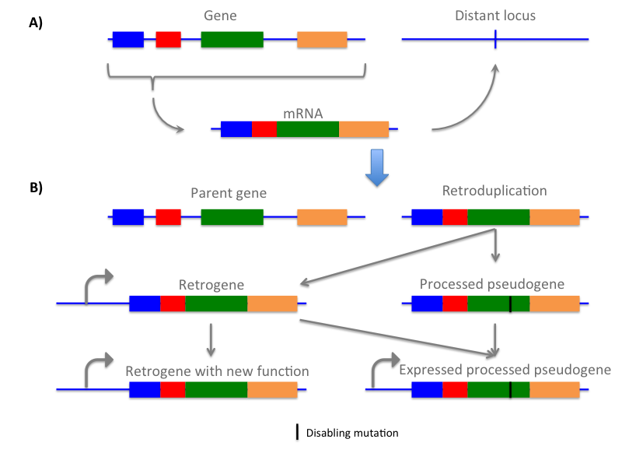
Figure S1. A) Reverse transcription of mRNA to genomic DNA creates retroduplication. B) Some retroduplications can acquire new promoters to become retrogenes and evolve to have new functions. Others can acquire disabling mutation(s) in coding sequence and turn into ‘processed pseudogenes’, which, if expressed, can regulate mRNA abundance of the parents.

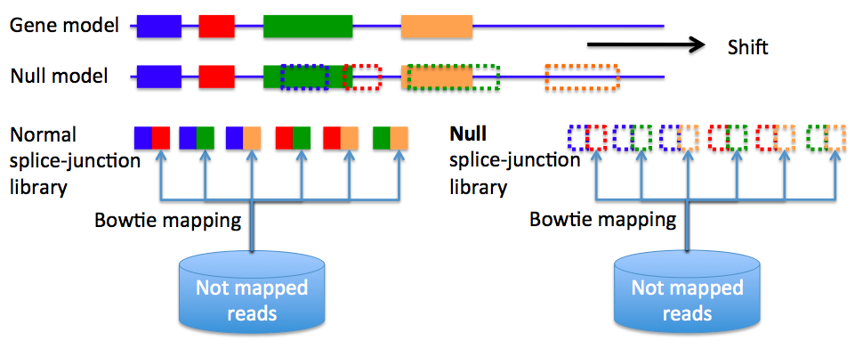

Figure S2. Constructing null model. Splice-junction library used to discover retroduplications was constructed using GENCODE annotation. Null spliced-junction library used for background estimation was constructed using shifted GENCODE annotation.

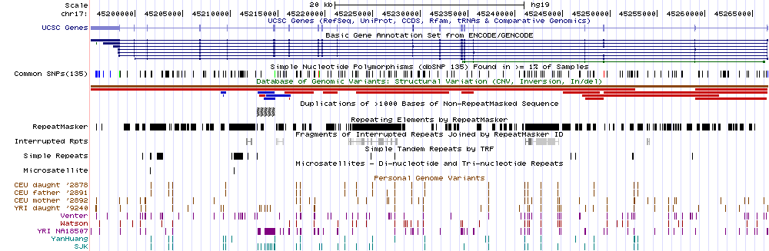
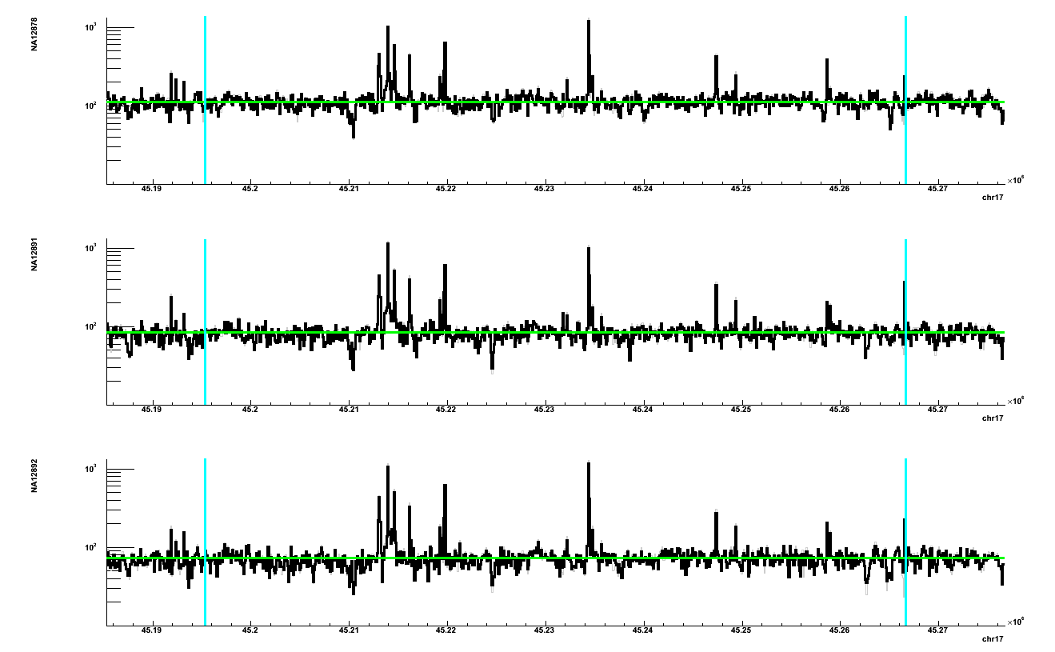

Figure S3. Read depth evidence in CEU trio for retroduplication(s) descended from CDC27 gene. Black line is read depth signal; green line is average RD per genome; cyan lines define the bounds of the gene. Majority of regions with elevated (compared to average) read depth match annotated exons.

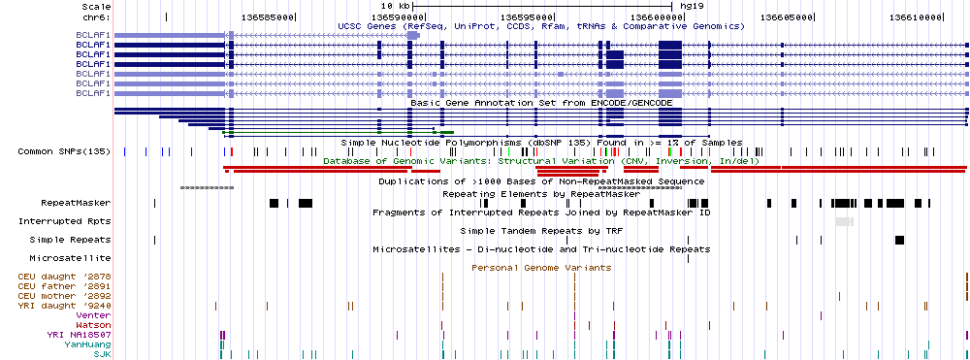
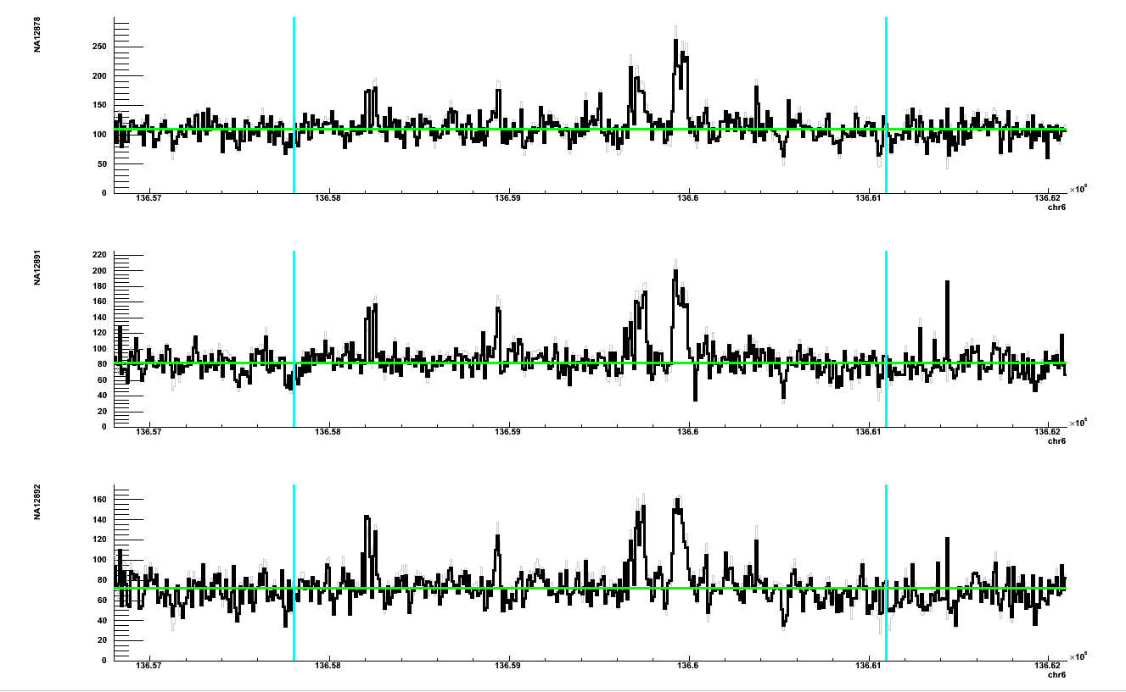

Figure S4. Read depth evidence in CEU trio for retroduplication(s) descended from BCLAF1 gene. Black line is read depth signal; green line is average RD per genome; cyan lines define the bounds of the gene. Majority of regions with elevated (compared to average) read depth match annotated exons.

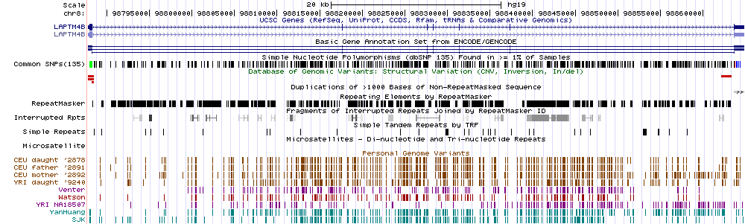
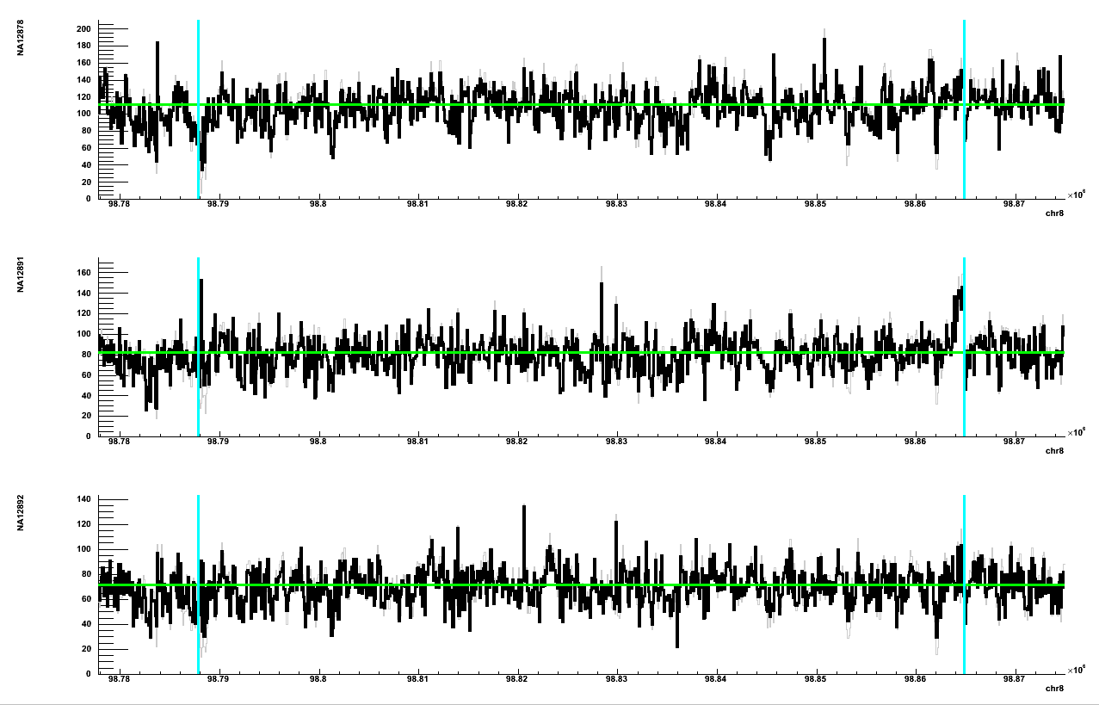
Figure S5. Read depth evidence in CEU trio for retroduplication(s) descended from LAPTM4B gene. Black line is read depth signal; green line is average RD per genome; cyan lines define the bounds of the gene. Elevated (compared to average) read depth in NA12891 matches annotated 3’-end, 5’-end and few other exons.

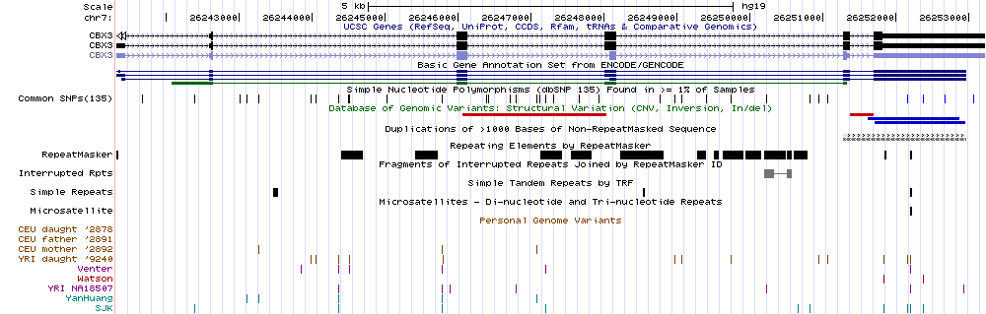
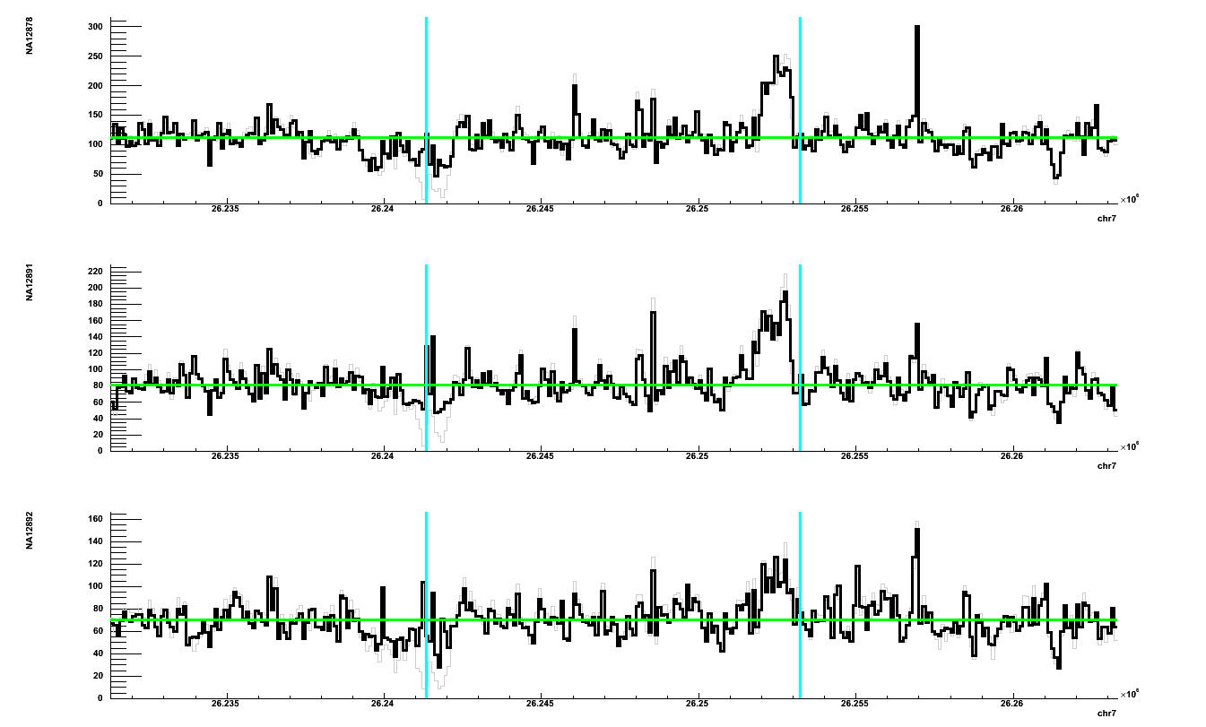
Figure S6. Read depth evidence in CEU trio for retroduplication(s) descended from CBX3 gene. Black line is read depth signal; green line is average RD per genome; cyan lines define the bounds of the gene. Majority of regions with elevated (compared to average) read depth match annotated exons.

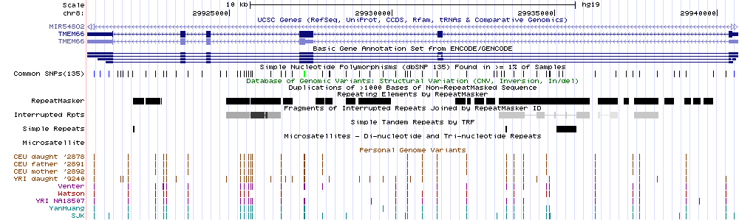
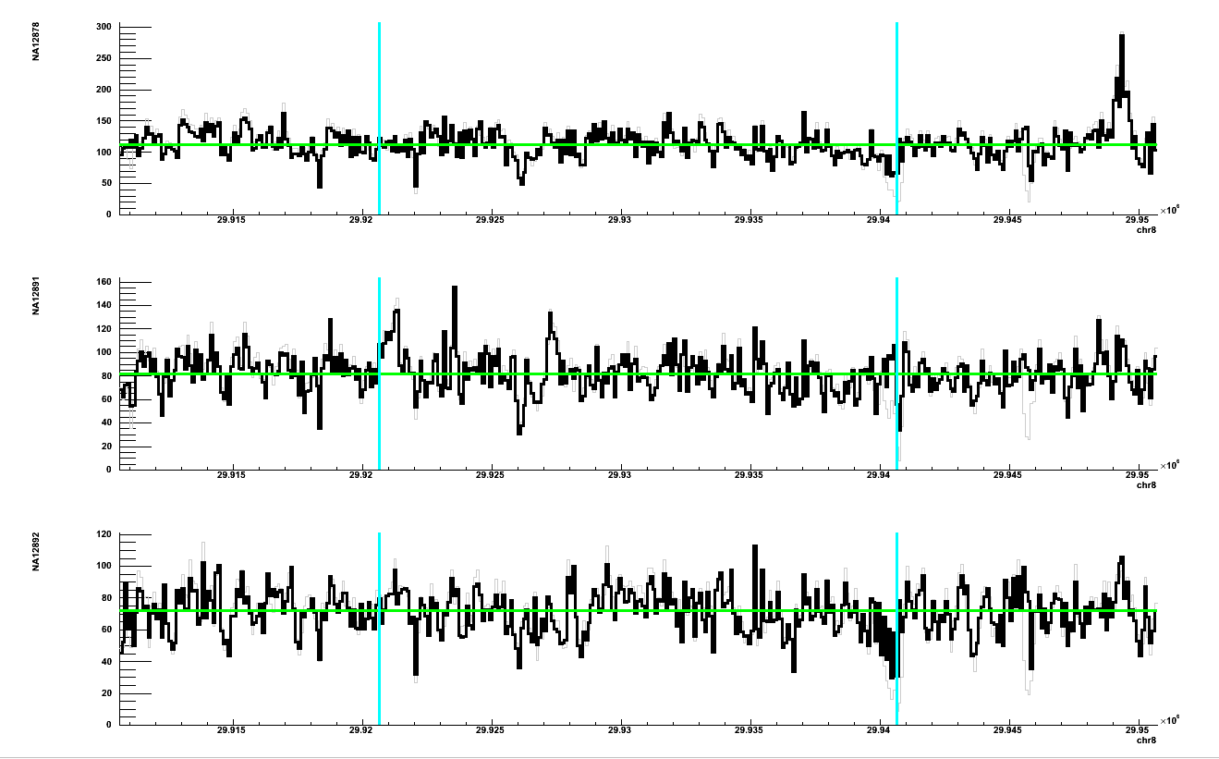
Figure S7. Read depth evidence in CEU trio for retroduplication(s) descended from TMEM66 gene. Black line is read depth signal; green line is average RD per genome; cyan lines define the bounds of the gene. Majority of regions with elevated (compared to average) read depth in NA12891 match annotated exons.

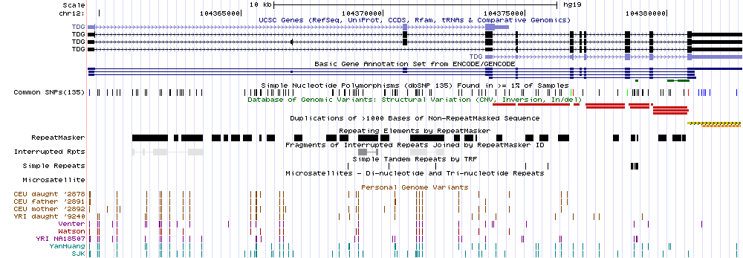
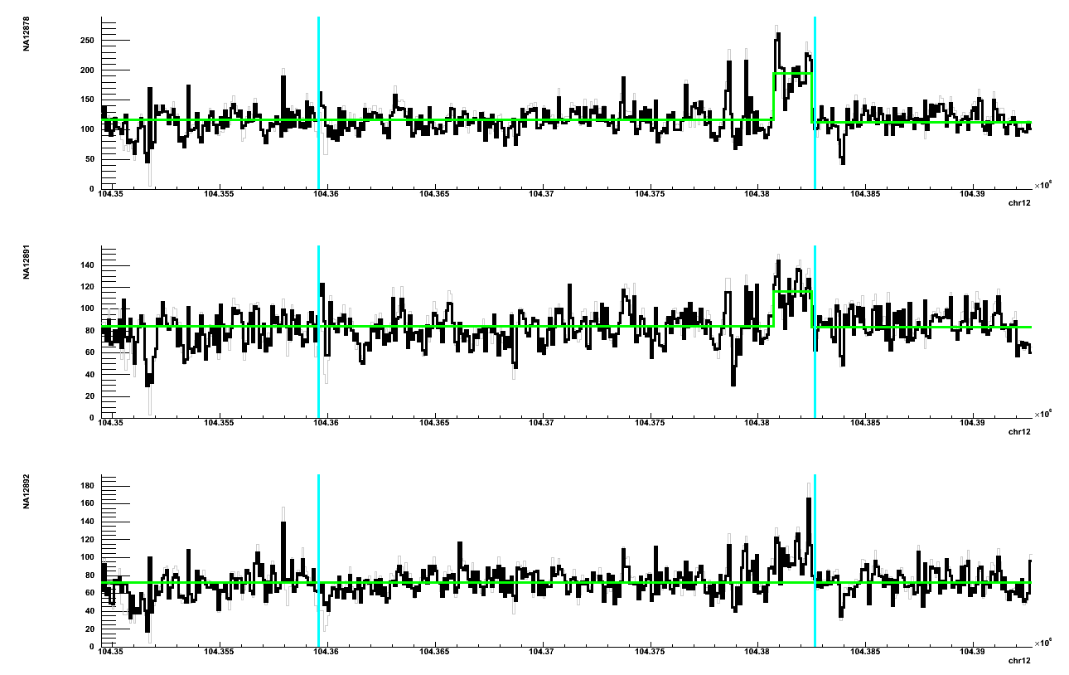
Figure S8. Read depth evidence in CEU trio for retroduplication(s) descended from TDG gene. Black line is read depth signal; green line is average RD per genome except for 3’-end where duplication is detected; cyan lines define the bounds of the gene. Majority of regions with elevated (compared to average) read depth match annotated exons.

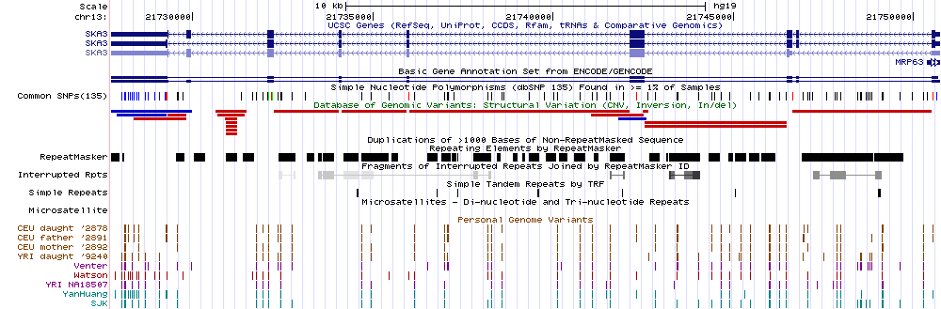
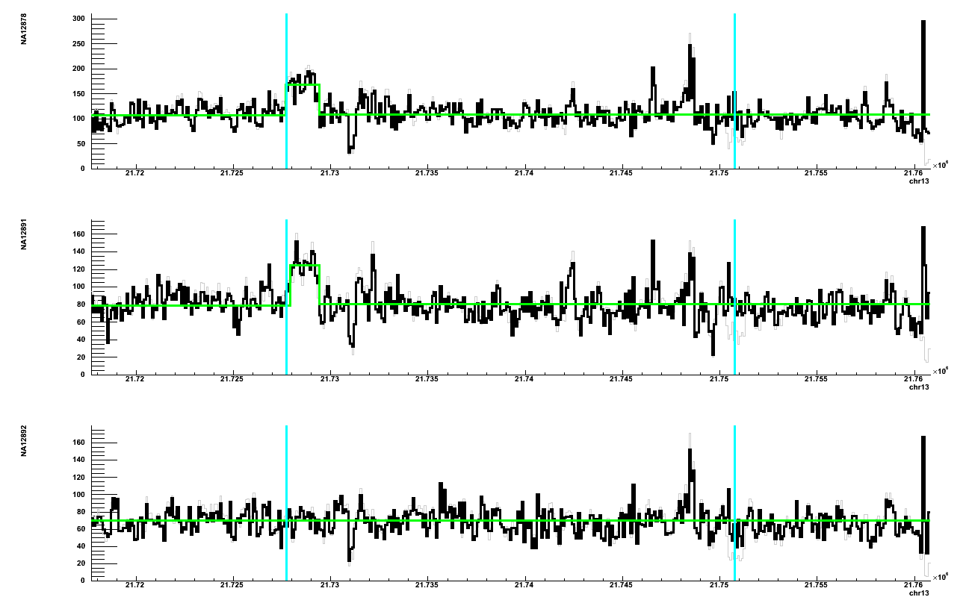
Figure S9. Read depth evidence in CEU trio for retroduplication(s) descended from SKA3 gene. Black line is read depth signal; green line is average RD per genome except for 3’-end where duplication is detected; cyan lines define the bounds of the gene. Majority of regions with elevated (compared to average) read depth match annotated exons.

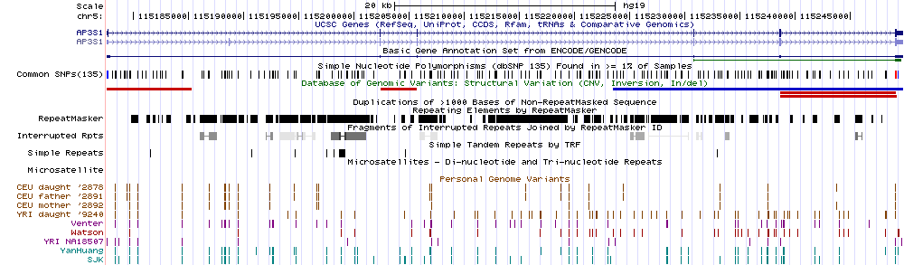
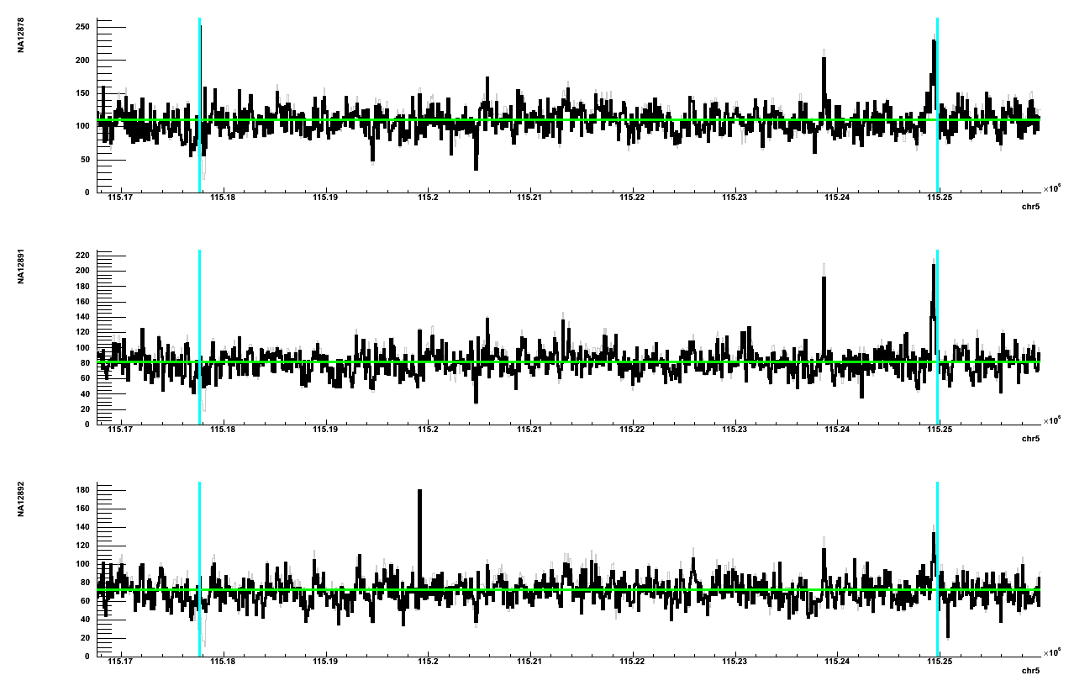
Figure S10. Read depth evidence in CEU trio for retroduplication(s) descended from AP3S1 gene. Black line is read depth signal; green line is average RD per genome; cyan lines define the bounds of the gene. Majority of regions with elevated (compared to average) read depth match annotated exons.

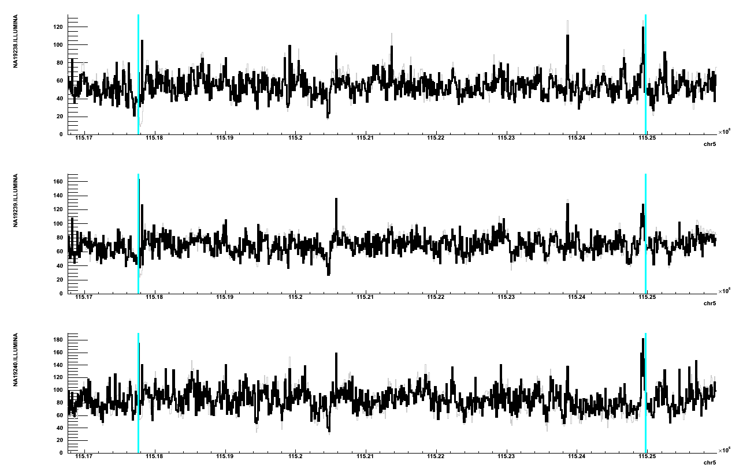
Figure S11. Read depth evidence in YRI trio for retroduplication(s) descended from AP3S1 gene. Black line is read depth signal; gray line is average read depth signal before GC bias correction; cyan lines define the bounds of the gene. Majority of regions with elevated (compared to average) read depth match annotated exons.

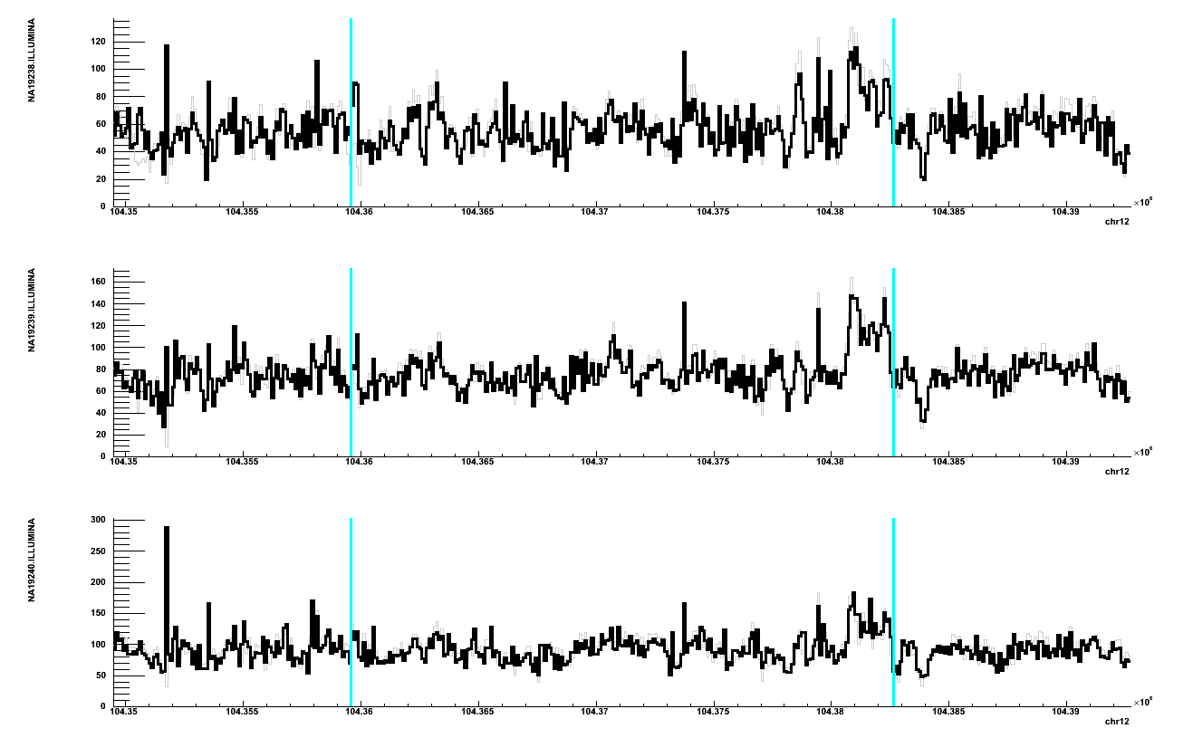
Figure S12. Read depth evidence in YRI trio for retroduplication(s) descended from TDG gene. Black line is read depth signal; gray line is average read depth signal before GC bias correction; cyan lines define the bounds of the gene. Majority of regions with elevated (compared to average) read depth match annotated exons.

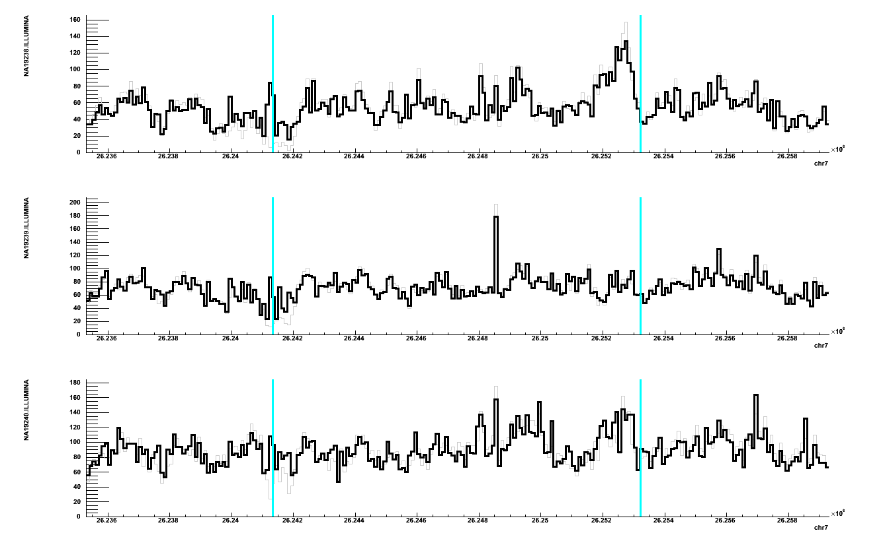
Figure S13. Read depth evidence in YRI trio for retroduplication(s) descended from CBX3 gene. Black line is read depth signal; gray line is average read depth signal before GC bias correction; cyan lines define the bounds of the gene. Majority of regions with elevated (compared to average) read depth match annotated exons.

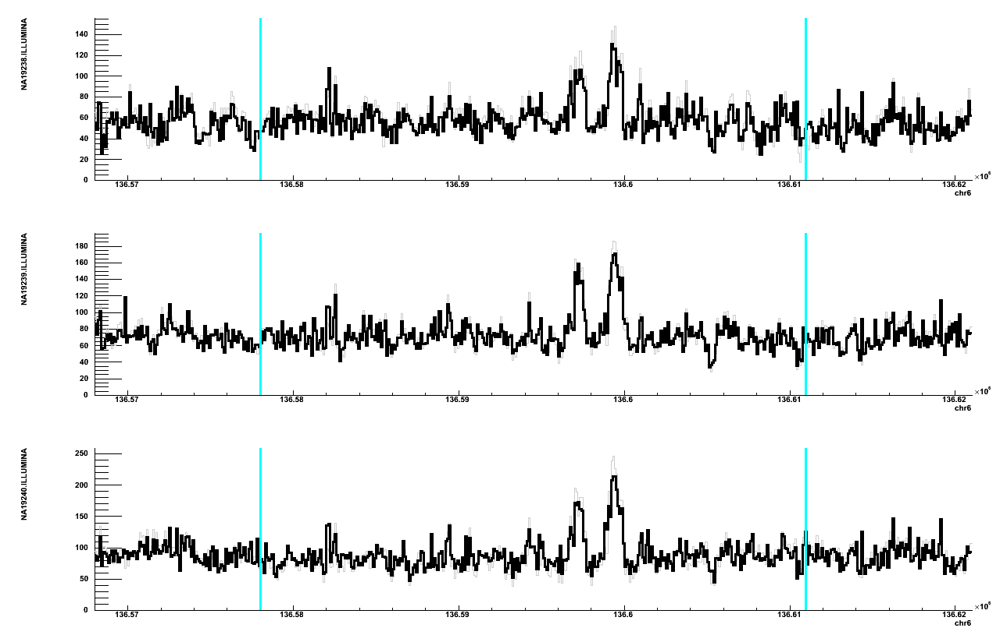
Figure S14. Read depth evidence in YRI trio for retroduplication(s) descended from BCLAF1 gene. Black line is read depth signal; gray line is average read depth signal before GC bias correction; cyan lines define the bounds of the gene. Majority of regions with elevated (compared to average) read depth match annotated exons.

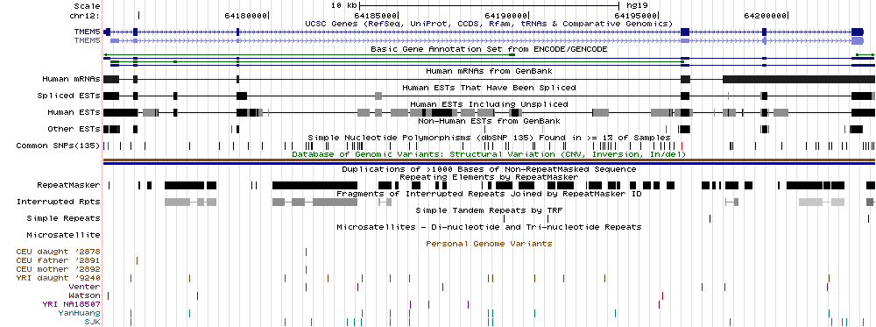
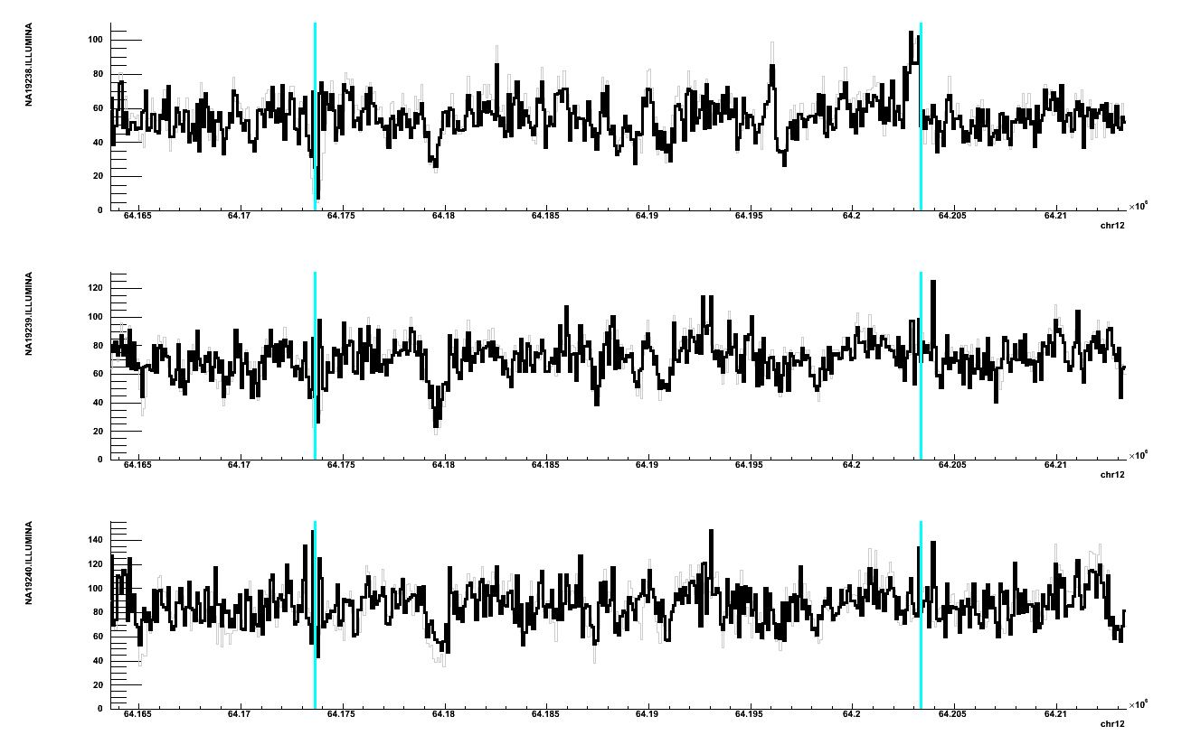
Figure S15. Read depth evidence in YRI trio for retroduplication(s) descended from TMEM5 gene. Black line is read depth signal; gray line is average read depth signal before GC bias correction; cyan lines define the bounds of the gene. Regions with elevated (compared to average) read depth in NA19238 match 3’-end and preceding exon.

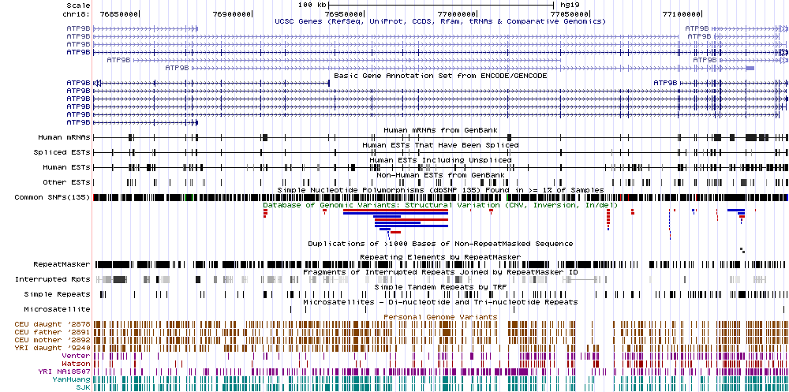
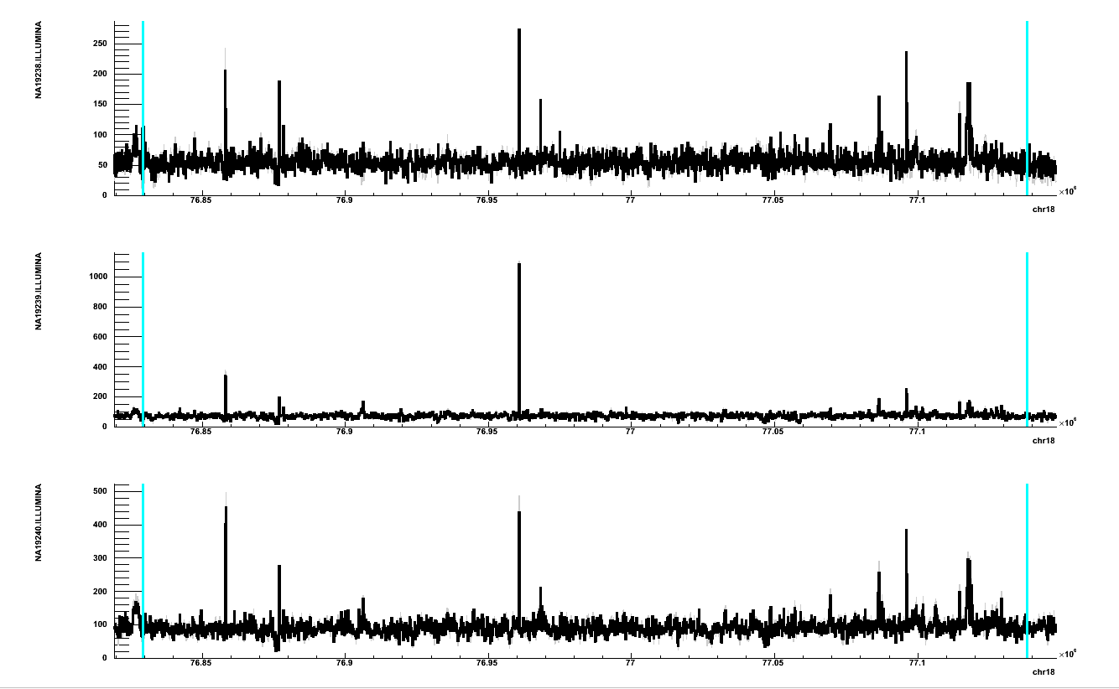
Figure S16. Read depth evidence in YRI trio for retroduplication(s) descended from ATP9B gene. Black line is read depth signal; gray line is average read depth signal before GC bias correction; cyan lines define the bounds of the gene. Majority of regions with elevated (compared to average) read depth in NA19238 match annotated exons.

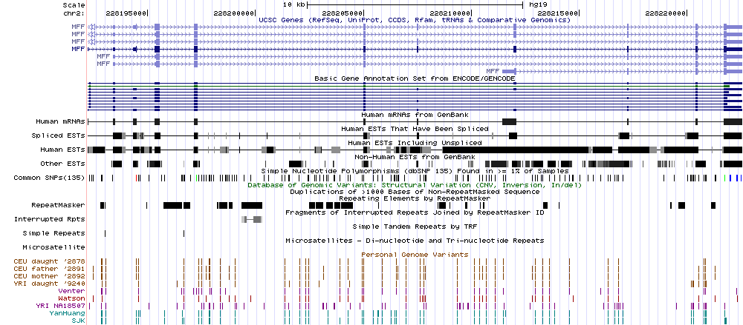
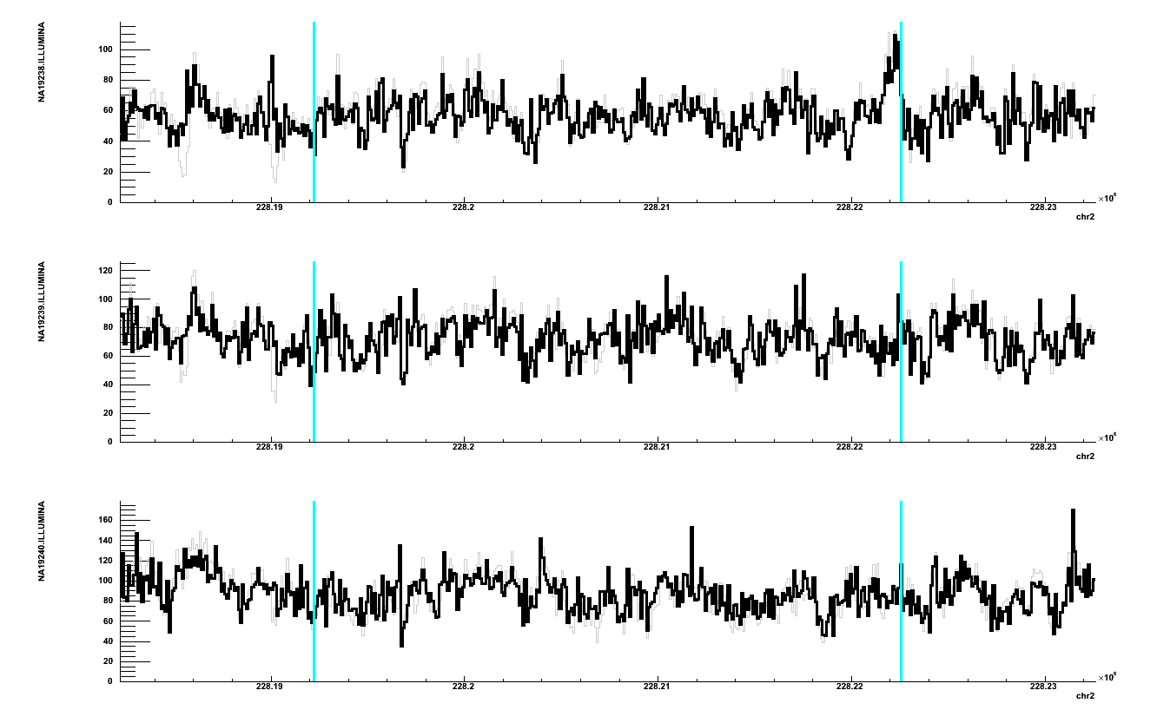
Figure S17. Read depth evidence in YRI trio for retroduplication(s) descended from MFF gene. Black line is read depth signal; gray line is average read depth signal before GC bias correction; cyan lines define the bounds of the gene. Region with elevated (compared to average) read depth in NA19238 match annotated 3’-end.

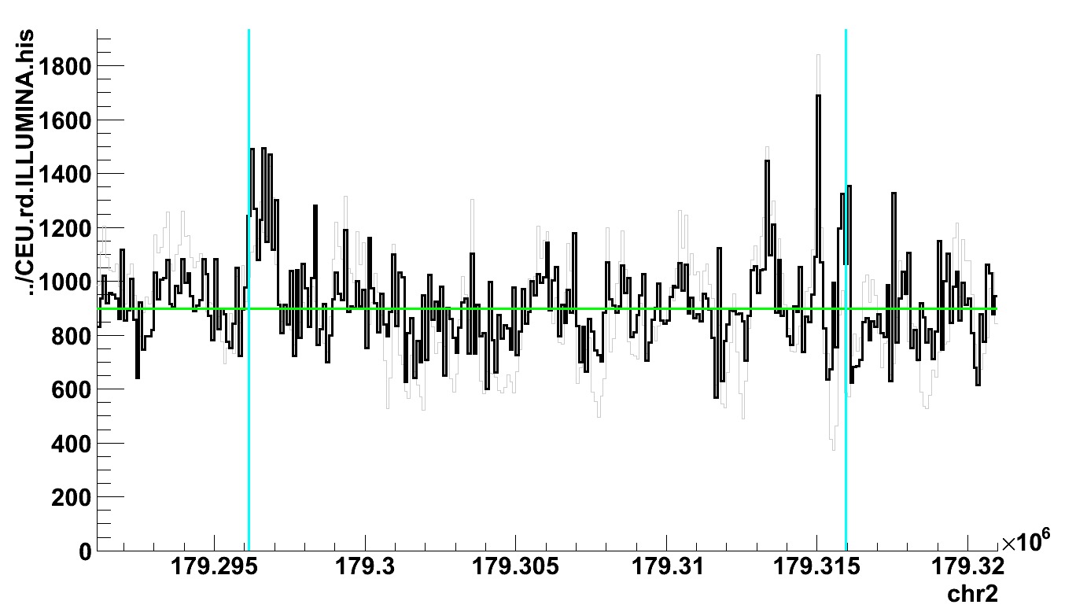
Figure S18. Read depth evidence in CEU population for RE(s) descended from PRKRA gene. Black line is read depth signal; gray line is average read depth signal before GC bias correction; cyan lines define the bounds of the gene. Region with elevated (compared to average) read depth in CEU population match annotated 3’-end and some exons.

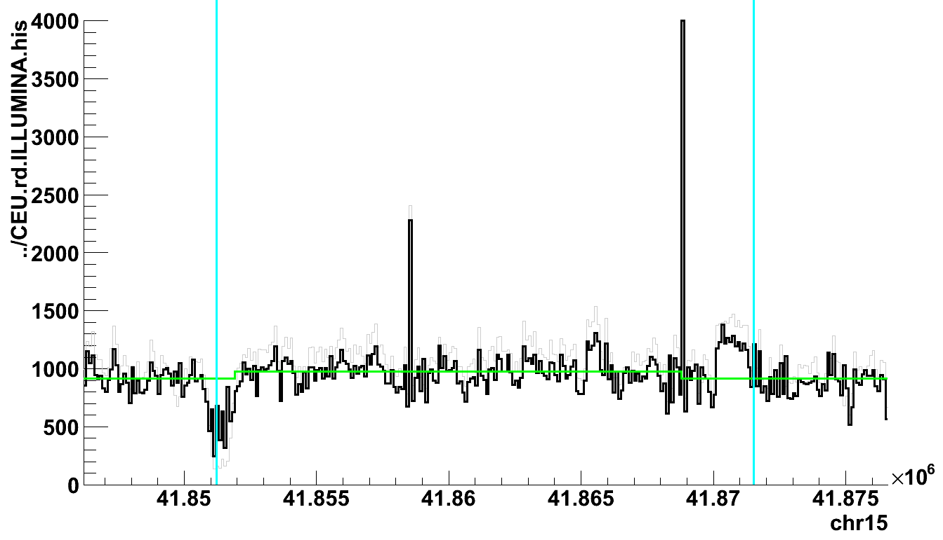
Figure S19. Read depth evidence in CEU population for RE(s) descended from TYRO3 gene. Black line is read depth signal; gray line is average read depth signal before GC bias correction; cyan lines define the bounds of the gene. Region with elevated (compared to average) read depth in CEU population match annotated 3’-end.

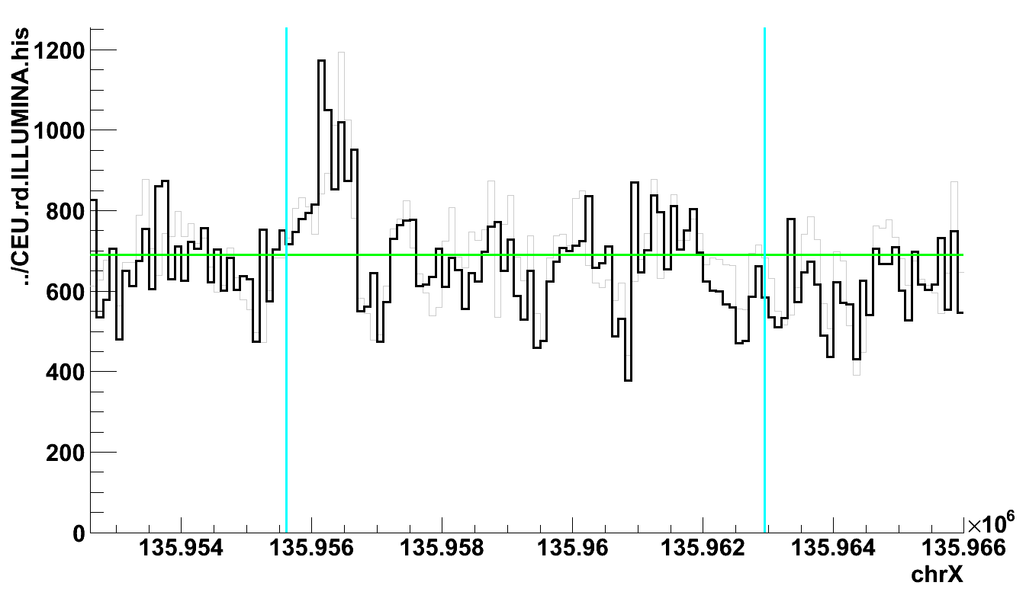
Figure S20. Read depth evidence in CEU population for RE(s) descended from RBMX gene. Black line is read depth signal; gray line is average read depth signal before GC bias correction; cyan lines define the bounds of the gene. Region with elevated (compared to average) read depth in CEU population match annotated 3’-end.

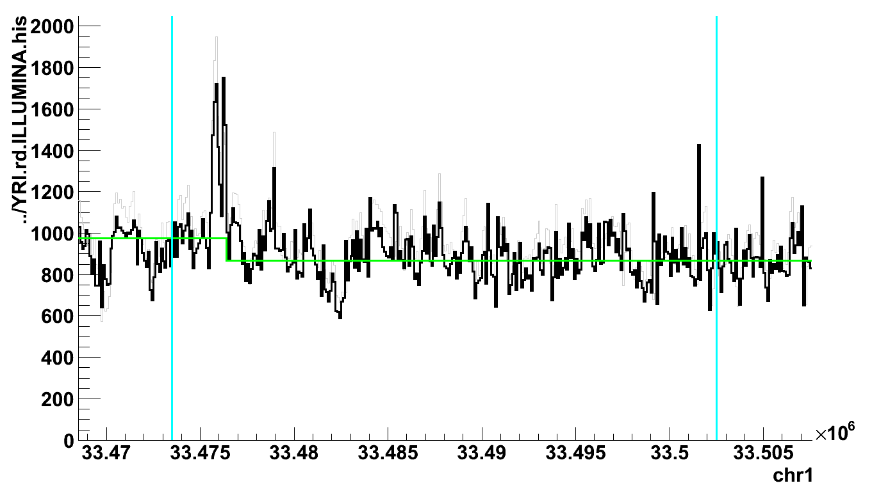

Figure S21. Read depth evidence in YRI population for RE(s) descended from AK2 gene. Black line is read depth signal; gray line is average read depth signal before GC bias correction; cyan lines define the bounds of the gene. Region with elevated (compared to average) read depth in YRI population match annotated 3’-end and other exons.

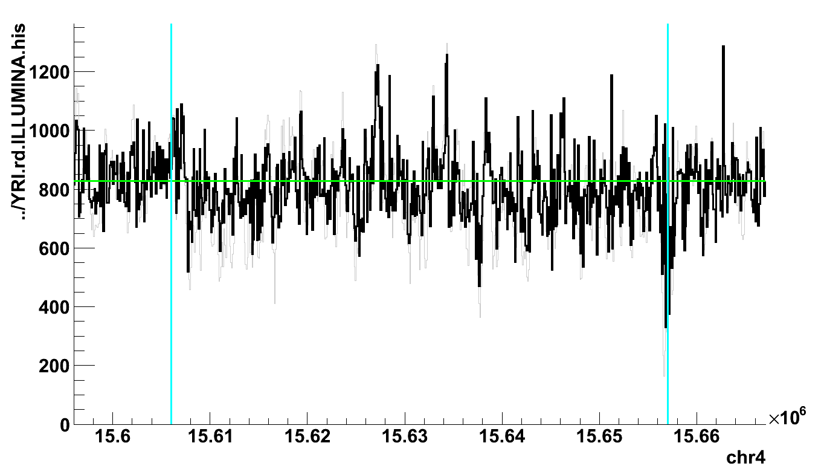

Figure S22. Read depth evidence in YRI population for RE(s) descended from FBXL5 gene. Black line is read depth signal; gray line is average read depth signal before GC bias correction; cyan lines define the bounds of the gene. Region with elevated (compared to average) read depth in YRI population match annotated 3’-end and other exons.

Figure S23. Discovery and genotyping of retroduplications in 14 populations.

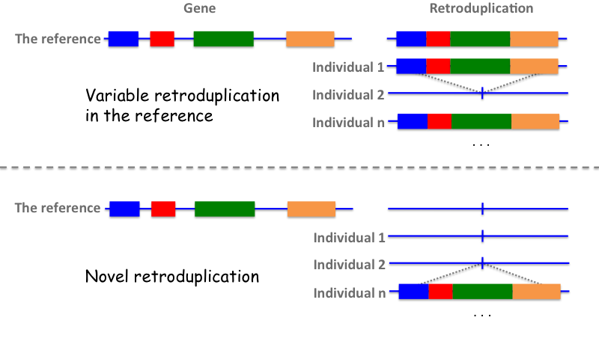

Figure S24. Retroduplication variant (RDV) can be present in the reference genome (upper panel) or absent from it (lower panel). In our analysis we utilized retroduplications of both types.

A
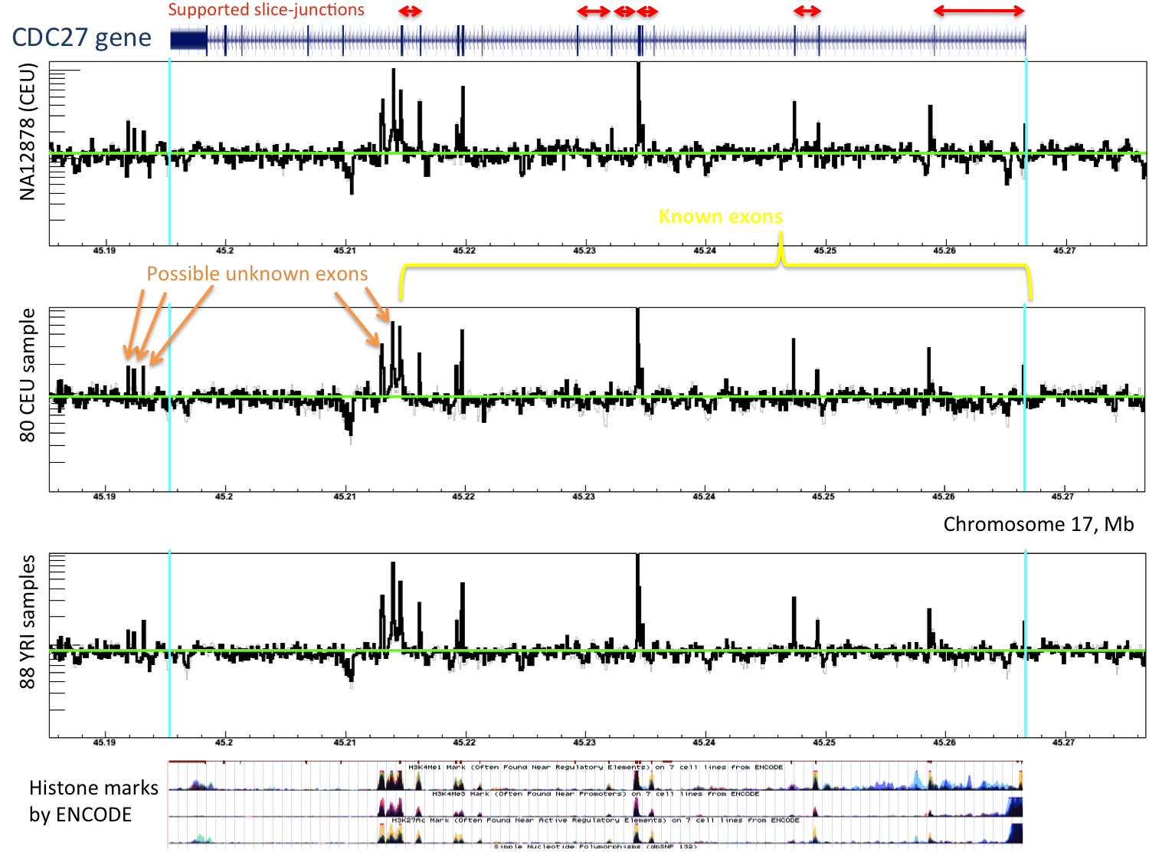
B
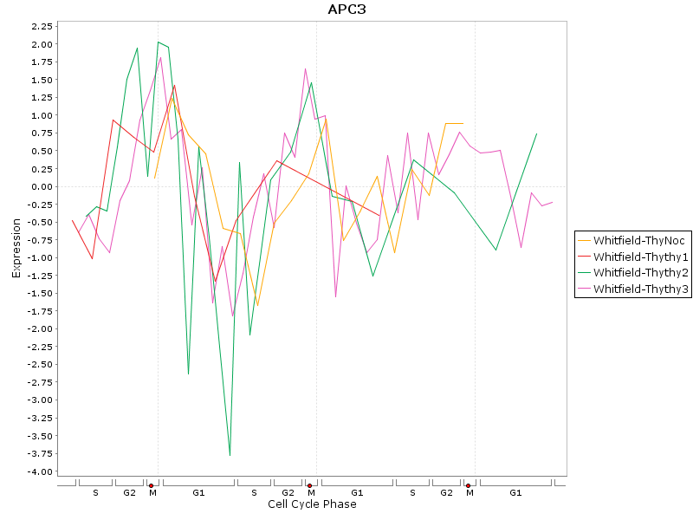
Figure S25. Evidence for more than a dozen of novel retroduplications for CDC27 gene (read-depth analysis of whole-genome DNA sequencing data). A) Six splice-junctions (red) are confirmed by uniquely mapped reads. Increased (relative to average level, green line) genome sequence read depth signal for several exons (yellow bracket) indicates existence of novel retroduplication in multiple copies. Note, log scale in y-axis. The same signal suggests that retroduplication(s) may have had a different 3'-end, leading to additional, novel exons (orange arrows) in the retroduplications. Histone-modification marks generated by ChIP-Seq by the ENCODE project (ENCODE Project Consortium et al. 2012) within genomic coordinates of CDC27 show a strong correlation with elevation in read depth signal, strongly suggesting that the histone signal may have originated from unknown (i.e., not existing in the reference) retroduplications. H3K4me3, H3K4me1 and H3K27ac and are histones marks for actively transcribed regions, implying that unknown retroduplication copies of CDC27 are expressed. We take this as further sign of the potentially significant functional relevance of the CDC27 retroduplications. B) Periodic expression of CDC27 gene.

AMD1 (M phase), 19.9 FPKM | MCM2 (G1/S phase), 136.6 FPKM
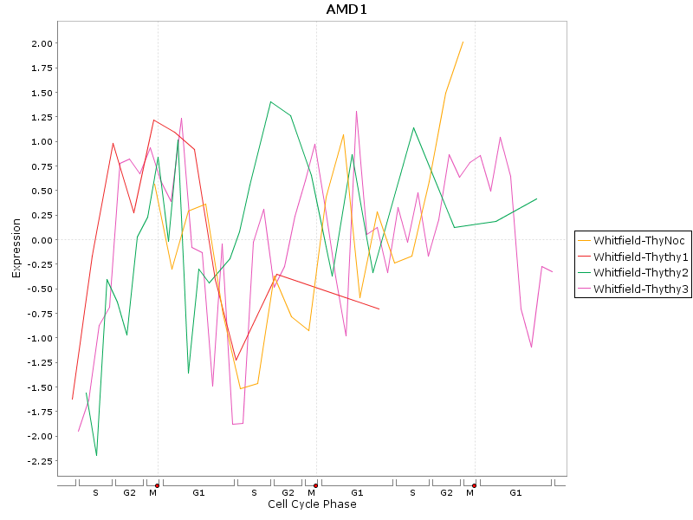 | 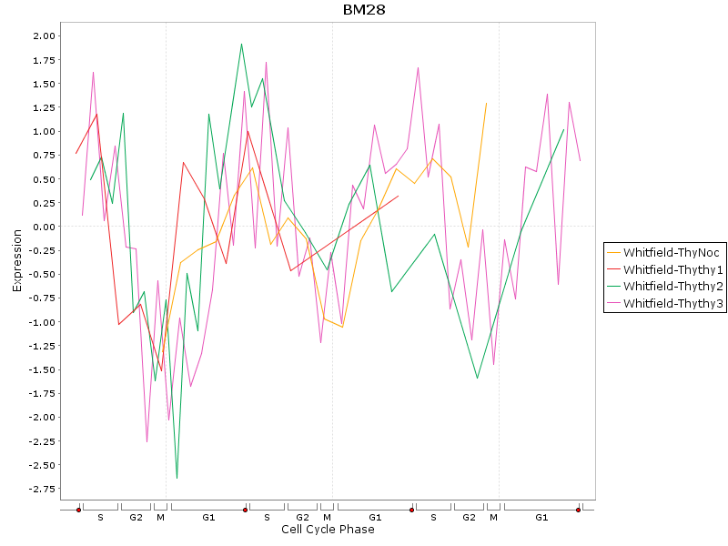
Figure S26. Two genes, AMD1 (ENSG00000123505) and MCM2 (ENSG00000073111), are expressed at M and G1/S phases respectively. Despite having almost 7 fold larger expression (as could be determined from ENCODE RNAseq data) MCM2 has no known retroduplications while AMD1 has six. FPKM (fragments per kilobase of exon per million fragments mapped) is the measure of absolute gene expression. The difference in the number of retroduplications can, perhaps, be attributed to time for gene expression. Namely, expression of AMD1 during mitosis lead to its mRNA being retrotransposed more frequently the mRNA of MCM2.

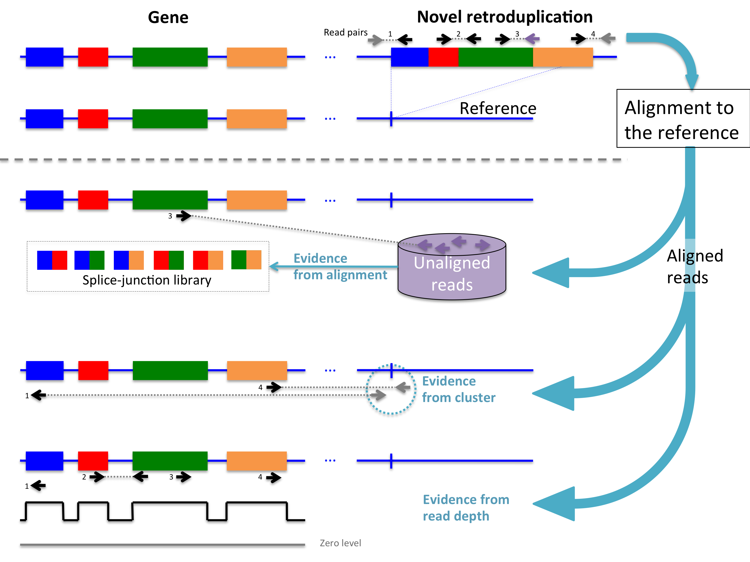
Figure S27. Conceptual approaches to discover novel retroduplications.
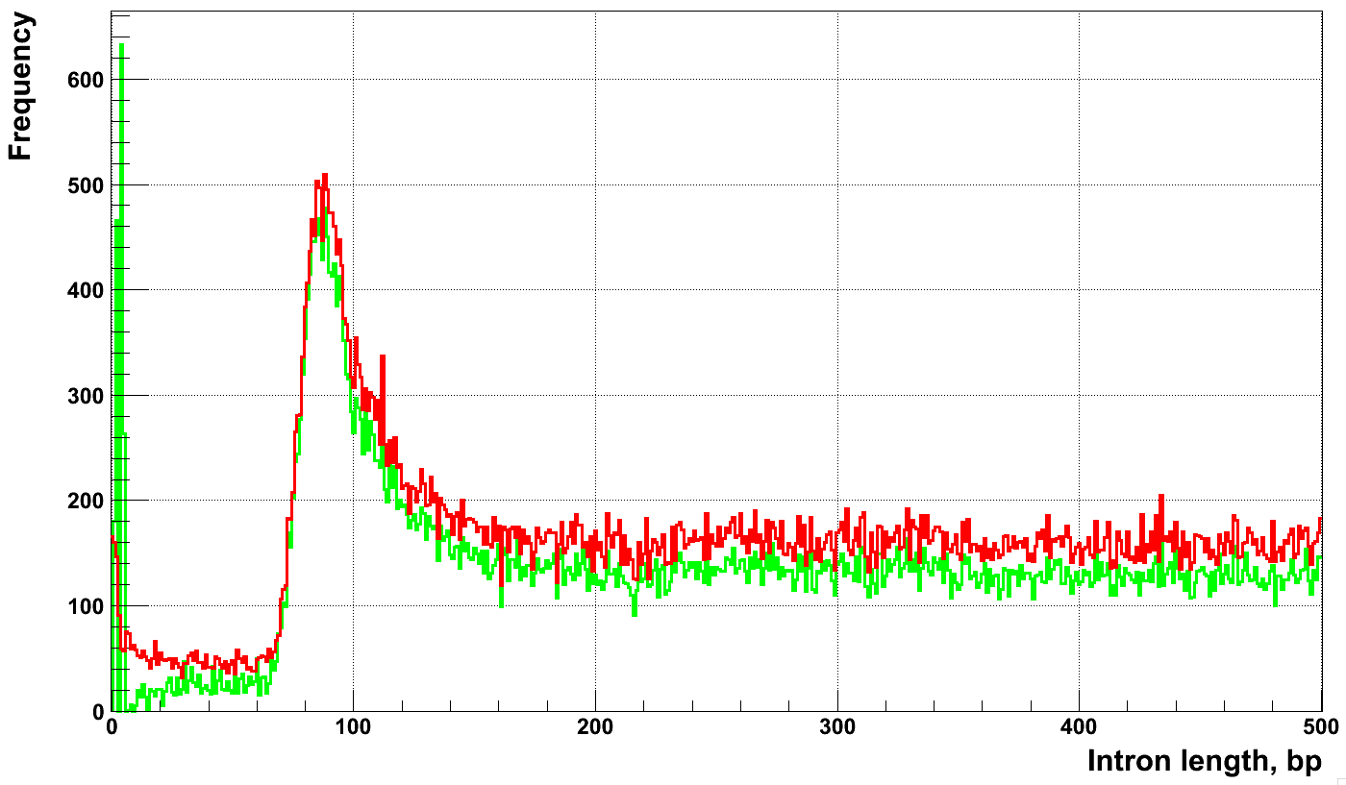
Figure S28. Distribution of intron length. Here by intron length we mean the distance between 3’-end of upstream and 5’-end of downstream exons within the same gene. We use such definition to account for possible alternative splicing. There is clear lower bound of intron length of ~70-100 bps. Smaller introns can be the result of mis-annotation and we exclude them from our analysis.

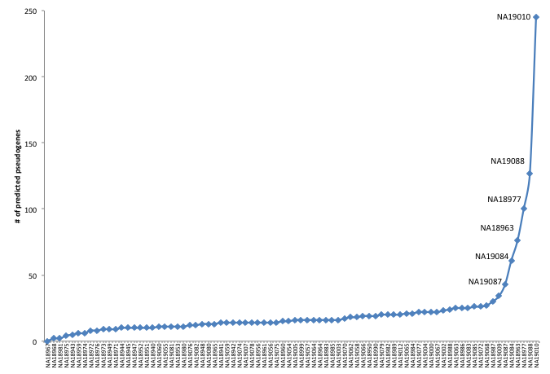

Figure S29. Discovery of retroduplications in Japanese population as progression with the number of utilized individuals. Individuals were sorted in order that allows discovering least to most retroduplications. 6 individuals (named next to the curve) account for majority of retroduplications discovered. We term them abnormal and separate from the main analysis.

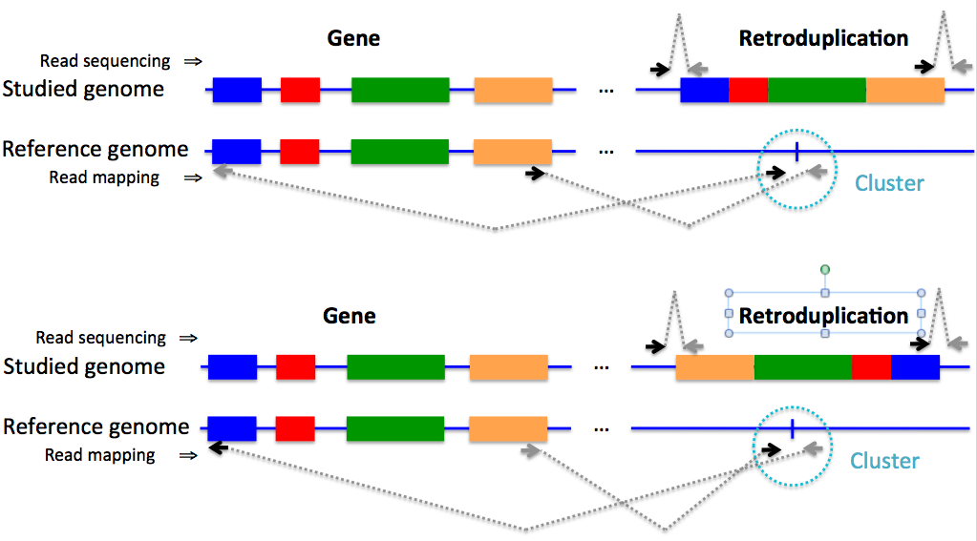
Figure S30. Pairs of read indicative of retroduplication insertion must have particular orientation and placement as displayed in the figure.

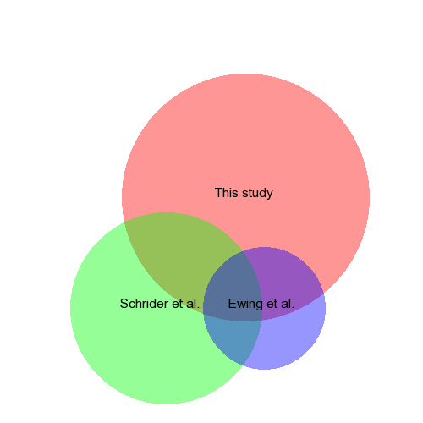
Figure 31. Comparison predictions of parents with novel retroduplications with other studies (Ewing et al. 2013; Schrider et al. 2013).

Figure S32. Enrichment of parent genes for expression at different cell cycles using the dataset from Bar-Joseph et al. Average number of retroduplications in the references genome per gene (y-axis) is depicted for periodic genes with maximum expression at particular cell cycle phase (x-axis). Genes expressed in G2/M phases generate significantly more retroduplications than genes expressed during other phases, suggesting that they have a higher chance of being retroduplicated.

References
Bar-Joseph Z, Siegfried Z, Brandeis M, Brors B, Lu Y, Eils R, Dynlacht BD, Simon I. 2008. Genome-wide transcriptional analysis of the human cell cycle identifies genes differentially regulated in normal and cancer cells. Proc Natl Acad Sci USA 105: 955–960.
Djebali S, Davis CA, Merkel A, Dobin A, Lassmann T, Mortazavi A, Tanzer A, Lagarde J, Lin W, Schlesinger F, et al. 2012. Landscape of transcription in human cells. Nature 489: 101–108.
ENCODE Project Consortium, Bernstein BE, Birney E, Dunham I, Green ED, Gunter C, Snyder M. 2012. An integrated encyclopedia of DNA elements in the human genome. Nature 489: 57–74.
Ewing AD, Ballinger TJ, Earl D, Program BIGSAA, Harris CC, Ding L, Wilson RK, Haussler D. 2013. Retrotransposition of gene transcripts leads to structural variation in mammalian genomes. Genome Biol 14: R22.
Gauthier NP, Jensen LJ, Wernersson R, Brunak S, Jensen TS. 2010. Cyclebase.org: version 2.0, an updated comprehensive, multi-species repository of cell cycle experiments and derived analysis results. Nucleic Acids Res 38: D699–702.
Iskow RC, Gokcumen O, Abyzov A, Malukiewicz J, Zhu Q, Sukumar AT, Pai AA, Mills RE, Habegger L, Cusanovich DA, et al. 2012. Regulatory element copy number differences shape primate expression profiles. Proc Natl Acad Sci USA 109: 12656–12661.
Lewis BP, Shih I-H, Jones-Rhoades MW, Bartel DP, Burge CB. 2003. Prediction of mammalian microRNA targets. Cell 115: 787–798.
Poliseno L, Salmena L, Zhang J, Carver B, Haveman WJ, Pandolfi PP. 2010. A coding-independent function of gene and pseudogene mRNAs regulates tumour biology. Nature 465: 1033–1038.
Salmena L, Poliseno L, Tay Y, Kats L, Pandolfi PP. 2011. A ceRNA hypothesis: the Rosetta Stone of a hidden RNA language? Cell 146: 353–358.
Sasidharan R, Gerstein M. 2008. Genomics: protein fossils live on as RNA. Nature 453: 729–731.
Schrider DR, Navarro FCP, Galante PAF, Parmigiani RB, Camargo AA, Hahn MW, de Souza SJ. 2013. Gene copy-number polymorphism caused by retrotransposition in humans. PLoS Genet 9: e1003242.
Whitfield ML, Sherlock G, Saldanha AJ, Murray JI, Ball CA, Alexander KE, Matese JC, Perou CM, Hurt MM, Brown PO, et al. 2002. Identification of genes periodically expressed in the human cell cycle and their expression in tumors. Mol Biol Cell 13: 1977–2000.

