Massively parallel synthetic promoter assays reveal the in vivo effects of binding site variants – Supplementary Information

Ilaria Mogno^{1, 2}, Jamie C. Kwasnieski^{1, 2}, and Barak A. Cohen^{1, 3}

- Center for Genome Sciences and Systems Biology, Department of Genetics, Washington University School of Medicine in St. Louis, MO, 63108
- These authors contributed equally to this work
- To whom correspondence may be addressed. Email: cohen@genetics.wustl.edu

Table S1
TableS2
Figure S1
Figure S2
Figure S3
Figure S4

Parameter | Values ±95% CI
ΔGMig1-RNAP | 3.76±1.95
ΔGMig1^{(R)}-RNAP | 3.95±2.68
ΔGReb1-RNAP | -0.14±0.08
ΔGReb1^{(R)}-RNAP | -0.05±0.11
ΔGRap1-RNAP | -0.35±0.11
ΔGRap1^{(R)}-RNAP | -0.21±0.11
ΔGGcr1-RNAP | -0.27±0.10
ΔGGcr1^{(R)}-RNAP | -0.37±0.08
ΔGX-RNAP | -0.24±0.08
ΔGX^{(R)}-RNAP | -0.13±0.07
ΔGY-RNAP | -0.18±0.06
ΔGY^{(R)}-RNAP | -0.20±0.06
ΔGMig1-Mig1 | -0.68±0.33
ΔGGcr1-Gcr1 | -0.15±0.12
ΔGMig1₂-DNA - ΔGMig1₁-DNA | 1.10 ± 0.12
ΔGMig1₃-DNA - ΔGMig1₁-DNA | 4.40 ± 1.88
ΔGRap1₃-DNA - ΔGRap1₁-DNA | -1.52 ± 0.51
ΔGReb1₂-DNA - ΔGReb1₁-DNA | -0.14 ± 0.11
ΔGGcr1₂-DNA - ΔGGcr1₁-DNA | -0.86 ± 0.24
ΔGGcr1₃-DNA - ΔGGcr1₁-DNA | -0.37 ± 0.30
R² | 0.57
Table S1: This table reports the estimated parameters of our thermodynamic model as proportional to ΔG or the difference of ΔGs (ΔΔG). X and Y denote the unknown TFs predicted to bind at site Reb1₃ and Rap1₂ respectively. (R) denotes the TFBS in the reverse orientation. A negative value for G between TF and RNAP or TF-TF indicates a favorable interaction, while a positive value indicates an unfavorable interaction. A negative value for the difference of Gs between TF and DNA indicates a stronger site (higher affinity), while a positive value indicates a weaker site (lower affinity). For each model we performed 100 independent fits to the data. In general the fits converged ~40% of the time. In all cases where the fits did converge, we recovered parameters that were within the 95% confidence interval.

Primer name | Sequence
prIM01 | GGCCGAANNNNWNNNNWNNNNNAGCTCGT
prIM02 | CTAGACGAGCTNNNNNWNNNNWNNNNTTC
prIM03 | TATAGGTACCGGCTCGGGTTGGCAAA
prIM04 | GTTCCGGCCGTTATTTGTACAATTCATCCATACCATGGGT
prIM05 | TGAATTGTACAAATAAGCGGCCGAA
prIM06 | TTAACTCGAGAAGTAGATAAAGTCAGTGCTTAAACAC
prIM07 | ATATCTCGAGCCTGCGATGTATATTTTCCTGTAC
prIM08 | CAAGCAGAAGACGGCATACGAGCTCTTCCGATCT
prIM09 | AATGATACGGCGACCACCGAGATCTACACTCTTTCCCTACACGACGCTCTTCCGATCT
Table S2: Primer sequences

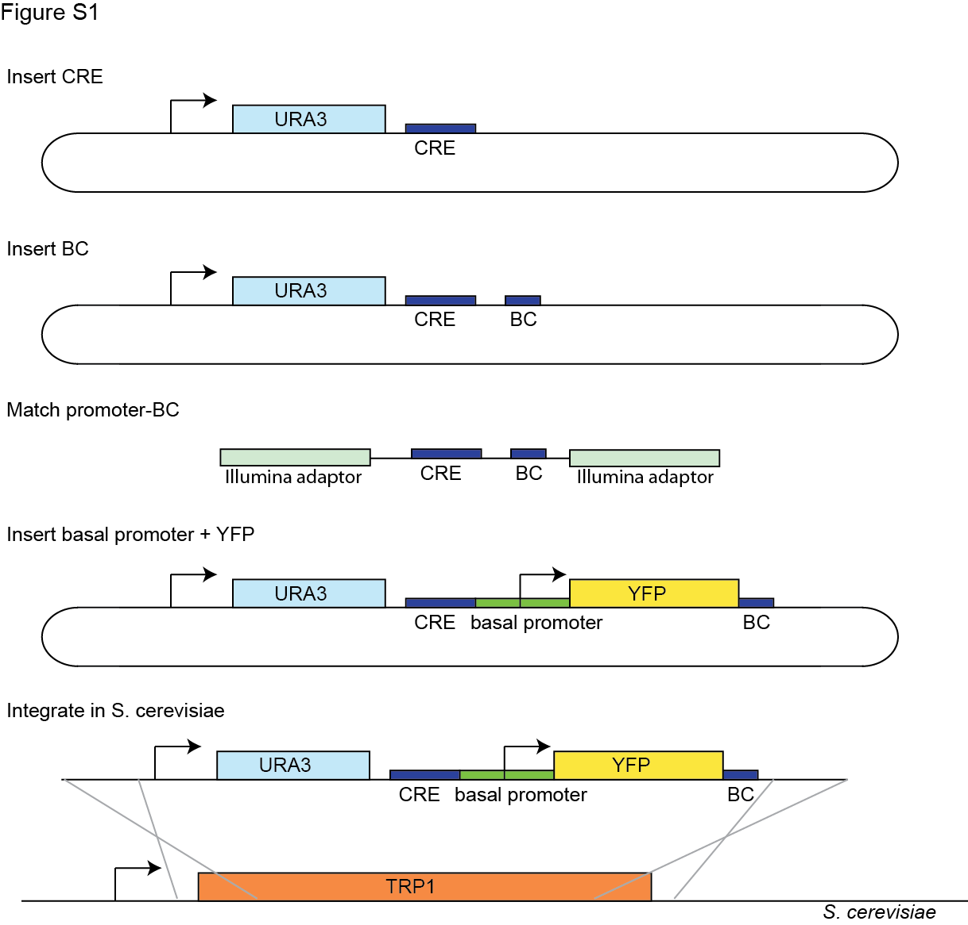
Figure S1: The complete CRE-seq cloning strategy with chromosomal integration. First, we cloned the CREs into a plasmid creating a library of CRE sequences. Into this library we then cloned a library of BCs downstream of the CREs. To match CREs to BCs we digested away the plasmid backbone, ligated Illumina adapters, and sequenced the DNA with a paired end run. We then inserted the basal promoter and YFP gene between the CREs and the BCs. Finally, we integrated the library cassette into S. cerevisiae at the TRP1 locus, and pooled colonies for use in the CRE-seq assay.

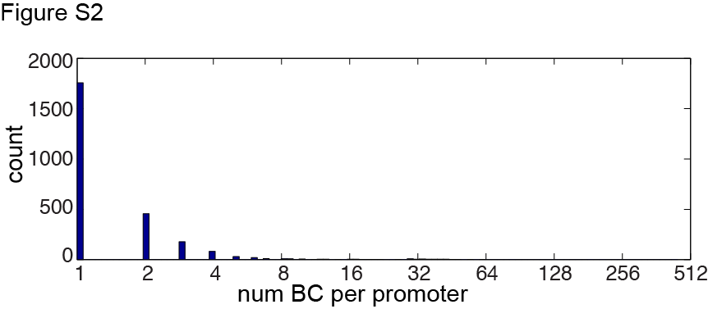
Figure S2: Distribution of BC number per CRE. 66.7% of the CREs are represented by 1 BC only, and 16.1% of the CREs are represented by 3 or more BCs.

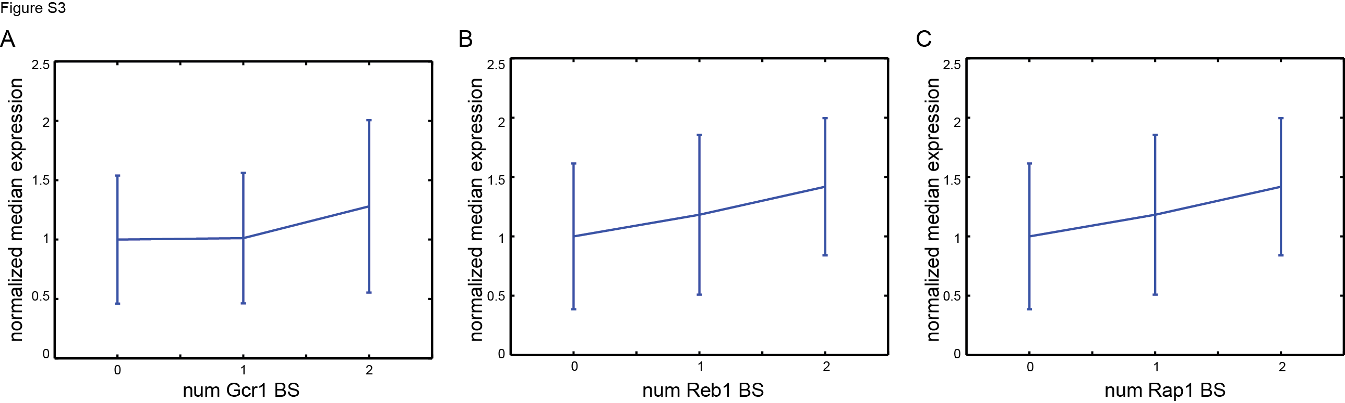
Figure S3: The effect of 0, 1 and 2 Gcr1, Reb1 and Rap1 sites on gene expression. While expression (y-axis) grows linearly with the number of Reb1 and Rap1 sites (x-axis, panels B and C), Gcr1 shows a different behavior (panel A). We observe no increase over basal expression until two Gcr1 sites are present. This plot includes all promoters containing 0, 1, or 2 sites of interest, among other sites.

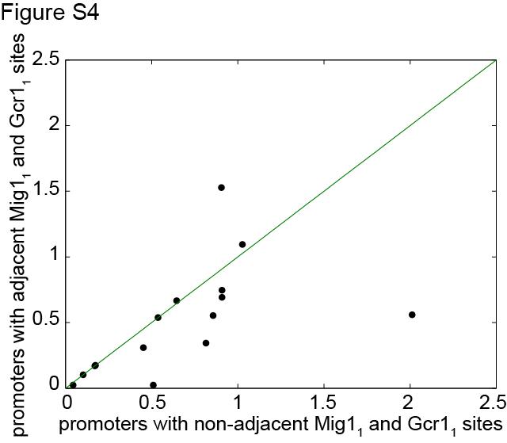
Figure S4: Expression of promoters composed of the same TFBSs. The expression driven by CREs containing adjacent Gcr1₁ and Mig1₁ sites (y-axis), is, in general, lower than the expression driven by CREs with the same TFBS content but non-adjacent Gcr1₁ and Mig1₁ TFBSs (x-axis).

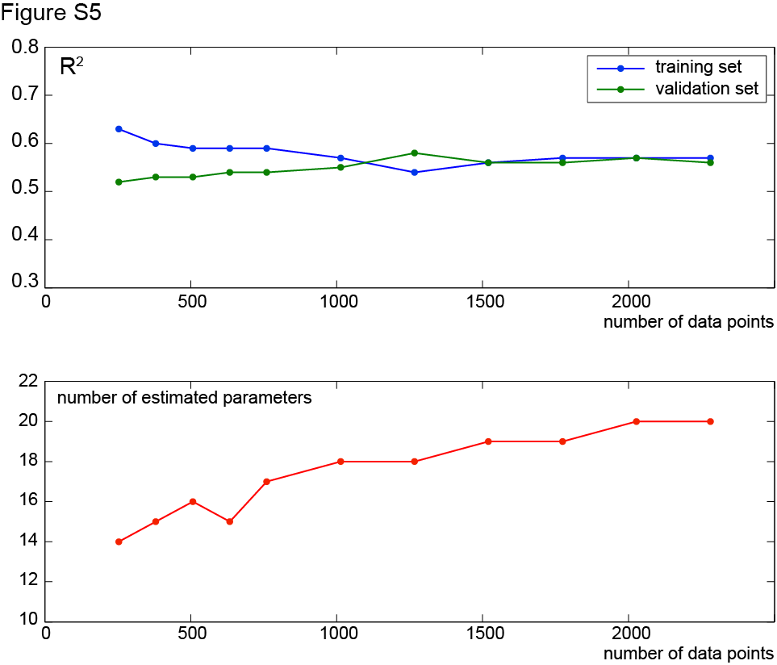
Figure S5: Repeated random sub-sampling validation results. The 2534 data points were split in two sets, a training set and a validation set. The size of the training set varied; sets were defined by randomly picking 10%, 15%, 20%, 25%, 30%, 40%, 50%, 60%, 70%, 80% or 90% of the total number of data points. The model was fit on the training set and then applied to the validation sets. R² values were estimated for the two sets. The R² values reported in the first panel of the figure are averaged across the 20 trials of this procedure. The figure shows that with 1000 unique data points (CREs), we have similar performances in the training set as in the validation set. With fewer data points the model is over-fit and predicts the validation set less well. The second panel shows that the number of significant parameters increases with the number of data points. When we include fewer than 2000 promoters we lose significant parameters, while the values of the others do not change significantly. This suggests that in order to recover weak behaviors we need to have a large number of unique promoters.

