SUPPLEMENTAL MATERIAL
PeptideAtlas of M. maripaludis S2: Generating a comprehensive parts list
A peptide atlas (PA) is a repository of peptide and proteins mapped to the genome by uniformly processed tandem mass spectrometry data (Deutsch 2010). We constructed a PA covering 77.1% (or 1367) of the predicted proteome of M. maripaludis by compiling 7,906,260 LC-MS/MS spectra from our proteomic studies on nutrient limitation (Xia et al. 2006; Xia et al. 2009) (Supplemental Table S1). The raw MS spectra were processed through the X!Tandem (Craig and Beavis 2004) and Trans-Proteomic Pipeline (TPP) (Keller et al. 2005). The PA was constructed to allow a search for protein products of unannotated transcripts that were discovered from transcriptome architecture analysis (Yoon et al. 2011). Of 91 novel transcripts discovered in that study, one matched to peptide mass spectra in the PA (a homolog of a hypothetical protein YP_004742139 from M. maripaludis X1 (BLASTX E-value = 2×10⁻³¹)) (Supplemental Table S2). No peptides matched to the non-coding RNAs discovered from the transcriptome architecture analysis (Yoon et al. 2011), which means these transcripts are likely to be non-coding. However, since the PA was constructed from a small dataset that was generated using total protein preparations from a limited set of environmental conditions (Xia et al. 2006; Xia et al. 2009), it is entirely possible that there might be additional protein-coding transcripts that remain to be discovered as and when relevant data become available. Thus, analysis of experimentally discovered unannotated transcripts (Yoon et al. 2011) in context of experimentally observed peptides in the PA has helped to generate a comprehensive list of protein coding and non-coding RNAs for systems biology of M. maripaludis.
SUPPLEMENTAL FIGURES
Figure S1. Summary view for all the biclusters in Methanococcus network model. The cMonkey biclustering algorithm identified 166 subsets of genes that were co-regulated in certain environments (biclusters). Upper panel: expression ratios of the bicluster's genes, over all experimental conditions (conditions included within the bicluster are to the left of the red dotted line). Left middle: motif logos and E-values for motifs that were detected in the bicluster. Left bottom: network of associations between the bicluster's genes in the various association networks used by cMonkey, including operons and functional association from STRING database. Right bottom: diagram of the upstream positions of the motifs, colored red and green for motifs #1, 2, respectively. The gene name and its associated line are in the same color corresponding to that in the expression ratio plots.
Figure S2. Transcriptional changes of member genes of biclusters enriched for methane metabolism in KEGG pathways (P < 0.01). The mRNA log₁₀ ratios of time series data were normalized to the first condition – a sample from OD₆₆₀= 0.2 for a growth curve experiment (Yoon et al. 2011) and a sample from pre-perturbation for H₂ perturbation experiments. Normalized mRNA levels were plotted as heatmap with bicluster member genes as rows and conditions as columns. Above the heat map, different culture conditions before and after perturbation are shown for excess (red triangle) and limiting (inverted green triangle) of a nutrient. Below the heat map, two distinct cis-regulatory motifs are depicted. Legend for the conditions is given at the lower right.

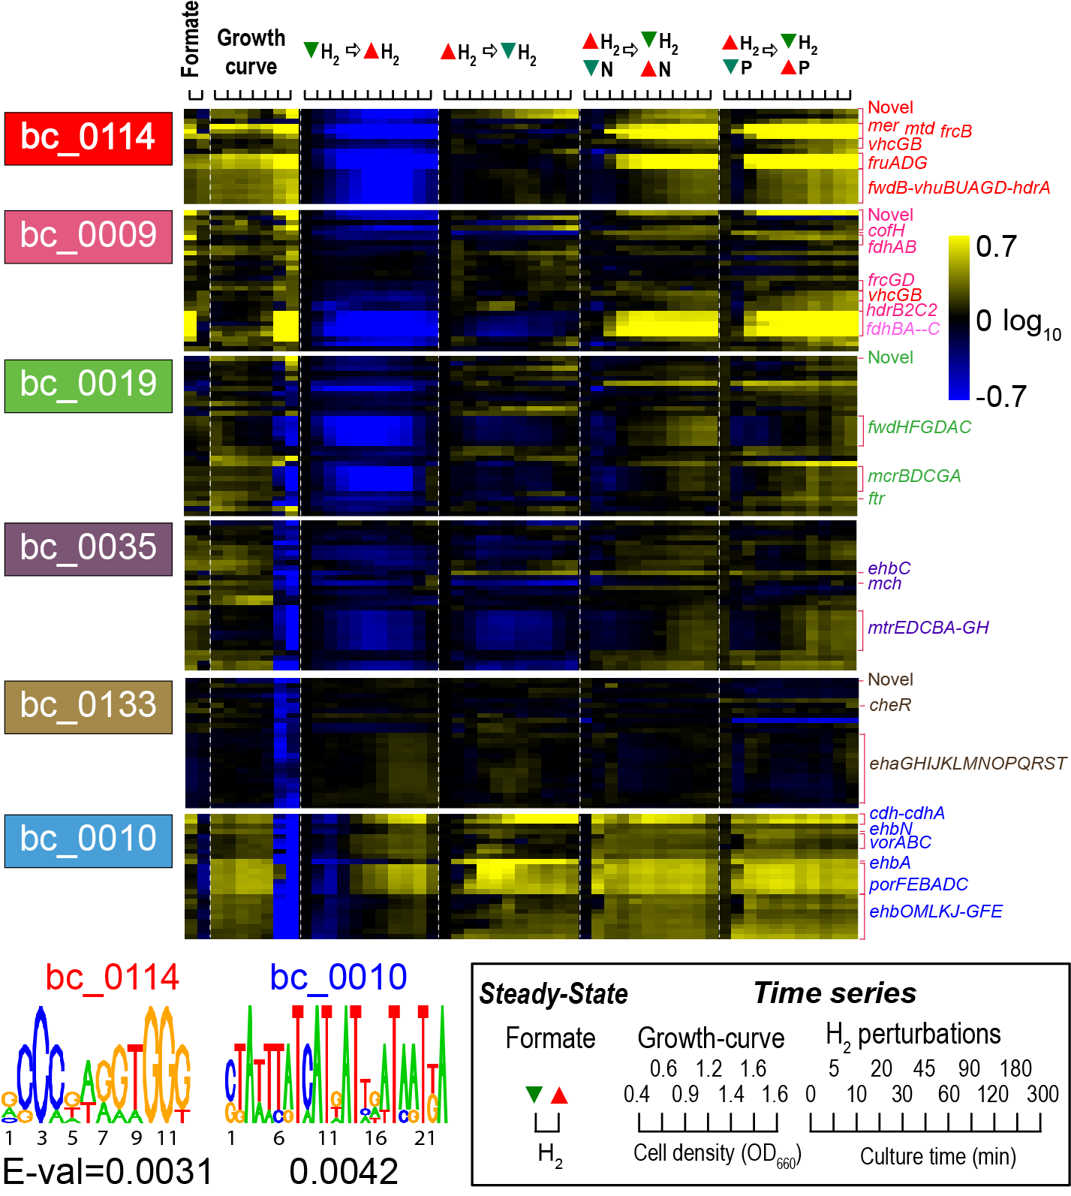
Figure S3. Transcription factor MMP1100 as a regulator for methanogenesis genes. Time profile of expression ratios of MMP1100 and genes in the methanogenesis pathway (colored according to Fig. 2). Y-axis denotes log₁₀ mRNA abundance ratios normalized to the first condition in each time series (see the legend of Supplemental Fig. S2 for the details)

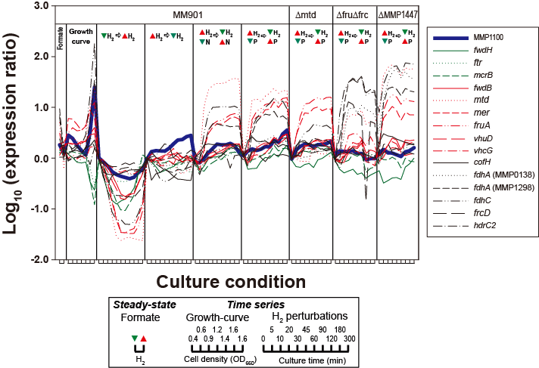
Table S1. Summary of M. maripaludis S2 PeptideAtlas

 | Count
Experiments | 19
LC-MS/MS runs | 896
LC-MS/MS spectra searched | 7,906,260
LC-MS/MS spectra identifiedª | 1,655,021
Distinct peptidesª | 13,779
Annotated ORFs detected | 1,367 (77.1%)
Unannotated transcripts detected | 1
ªPeptide-spectrum match (PSM) FDR = 0.0014

Table S2. Putative novel genes involved in methanogenesis or matched to peptide mass spectra
bicluster | Function of the bicluster (P-valueª) | ID^{b} | Genomic location  (strand, position, size) | Size (a.a)^{c} | Homolog^{d}
114 | Methane metabolism (4.1E-06) | Unanno_20 | reverse, 454854~454986 (133 bp) | 44 | ND
114 | Methane metabolism (4.1E-06) | Unanno_25 | forward, 473456~473597 (142 bp) | 39 | ND
114 | Methane metabolism (4.1E-06) | Unanno_63 | reverse, 1651050~1651258 (209 bp) | 62 | ND
19 | Methane metabolism (7.5E-03) | Antisense_27 | reverse, 1577461~1578871 (1411 bp) | 96 | Formate hydrogenlyase subunit 7 gene (fhl7)  [AF034788, M. maripaludis JJ]  (BLASTN, Query coverage: 27%, E-value: 6E-163)
33 | ND | Unanno_39e | reverse, 728806~729014 (209 bp) | 57 | Hypothetical protein  [YP_004742139, M. maripaludis X1]  (BLASTX, Query coverage: 80%, E-value: 2E-31)
ªSignificance of overrepresentation of a KEGG pathway.
^{b}Transcripts from our previous study (Genome Research, 2011, 21:1892-1904) which did not match to any protein sequence in the nr database or is antisense to annotated genes
^{c}Longest amino acid sequence found in the genomic region
^{d}Sequence producing the most significant alignment using BLASTN or BLASTX
^{e}Unannotated transcript which matched to peptide mass spectra in the PeptideAtlas constructed in this study
ND: not detected
Table S3. Composition of input gas and culture media

Culture condition | ªGas composition (mL/min) |  | ^{b}Medium composition (mM) |  |  | Number of samples  (Culture no. from Supplementary Table S4)
Culture condition | H₂ | Ar | NH₄Cl | K₂HPO₄ | Formate | Number of samples  (Culture no. from Supplementary Table S4)
H₂ excess & P excess & N excess | 110 | 35 | 10 | 0.8 | 0 | 8ea(2), 11ea(3), 1ea(4)
H₂ limiting & P excess & N excess | 21 | 125 | 10 | 0.8 | 0 | 1ea(3) , 11ea(4), 11ea(5), 11ea(6), 10ea(7), 10ea(8), 9ea(9), 9ea(10), 9ea(11)
H₂ excess & N limiting | 110 | 35 | 2.8 | 0.8 | 0 | 1ea(5)
H₂ excess & P limiting | 110 | 35 | 10 | 0.12 or 0.18 | 0 | 1ea(6), 1ea(7), 1ea(8), 1ea(9), 1ea(10), 1ea(11)
Formate excess & H₂ limiting | 21 | 125 | 10 | 0.8 | 380 | 1ea(1)
Formate excess & H₂ excess | 110 | 35 | 10 | 0.8 | 380 | 1ea(1)
^{b}Formate limiting | 0 | 0 | 10 | 0.8 | 200 | 1ea(12)
^{b}Formate excess & P limiting | 0 | 0 | 10 | 0.08 | 380 | 1ea(12)
^{b}Formate excess & N limiting | 0 | 0 | 2 | 0.8 | 380 | 1ea(12)
^{b}Formate excess & P excess & N excess | 0 | 0 | 10 | 0.8 | 380 | 1ea(12)
Compositions modified from the standard medium are in bold
ªContains 40 mL/min of CO₂ and 15mL/min of H₂S/Ar (1:99) mixture
^{b}For complete medium contents, see (Costa et al. 2013)
SUPPLEMENTAL METHODS
Construction of PeptideAtlas
We assembled 19 deeply sampled LC-MS/MS (liquid chromatography, tandem mass spectrometry) experiments from our proteomic studies (Xia et al. 2006; Xia et al. 2009). We searched MS spectra against the complete set of M. maripaludis S2 protein sequences and three-frame translations of all newly discovered transcripts from our transcriptome architecture TS analysis (Yoon et al. 2011). The raw MS data files were converted to mzXML format (Pedrioli et al. 2004) and were searched using X!Tandem (Craig and Beavis 2004) with the k-score plugin (MacLean et al. 2006). The MS spectra were processed through the Trans-Proteomic Pipeline (TPP) (Keller et al. 2005), a collection of software for assignment and validation of peptide (by PeptideProphet (Keller et al. 2002) and iProphet (Shteynberg et al. 2011) and protein (ProteinProphet (Nesvizhskii et al. 2003)). All identifications where filtered at a petide-spectrum-match (PSM) FDR threshold of 0.0014 which yielded a protein-level FDR of 0.01 as estimated using the decoy identifications. These filtered results were aligned to the genome and loaded into the database (http://www.peptideatlas.org/) and are available to the community.

SUPPLEMENTAL REFERENCES

Costa KC, Yoon SH, Pan M, Burn JA, Baliga NS, Leigh JA. 2013. Effects of H₂ and formate on growth yield and regulation of methanogenesis in Methanococcus maripaludis. J Bacteriol 195(7): 1456-1462.
Craig R, Beavis RC. 2004. TANDEM: matching proteins with tandem mass spectra. Bioinformatics 20(9): 1466-1467.
Deutsch EW. 2010. The PeptideAtlas Project. Methods Mol Biol 604: 285-296.
Keller A, Eng J, Zhang N, Li XJ, Aebersold R. 2005. A uniform proteomics MS/MS analysis platform utilizing open XML file formats. Mol Syst Biol 1: 2005 0017.
Keller A, Nesvizhskii AI, Kolker E, Aebersold R. 2002. Empirical statistical model to estimate the accuracy of peptide identifications made by MS/MS and database search. Anal Chem 74(20): 5383-5392.
MacLean B, Eng JK, Beavis RC, McIntosh M. 2006. General framework for developing and evaluating database scoring algorithms using the TANDEM search engine. Bioinformatics 22(22): 2830-2832.
Nesvizhskii AI, Keller A, Kolker E, Aebersold R. 2003. A statistical model for identifying proteins by tandem mass spectrometry. Anal Chem 75(17): 4646-4658.
Pedrioli PG, Eng JK, Hubley R, Vogelzang M, Deutsch EW, Raught B, Pratt B, Nilsson E, Angeletti RH, Apweiler R et al. 2004. A common open representation of mass spectrometry data and its application to proteomics research. Nat Biotechnol 22(11): 1459-1466.
Shteynberg D, Deutsch EW, Lam H, Eng JK, Sun Z, Tasman N, Mendoza L, Moritz RL, Aebersold R, Nesvizhskii AI. 2011. iProphet: multi-level integrative analysis of shotgun proteomic data improves peptide and protein identification rates and error estimates. Mol Cell Proteomics 10(12): M111 007690.
Xia Q, Hendrickson EL, Zhang Y, Wang T, Taub F, Moore BC, Porat I, Whitman WB, Hackett M, Leigh JA. 2006. Quantitative proteomics of the archaeon Methanococcus maripaludis validated by microarray analysis and real time PCR. Mol Cell Proteomics 5(5): 868-881.
Xia Q, Wang T, Hendrickson EL, Lie TJ, Hackett M, Leigh JA. 2009. Quantitative proteomics of nutrient limitation in the hydrogenotrophic methanogen Methanococcus maripaludis. BMC Microbiol 9: 149.
Yoon SH, Reiss DJ, Bare JC, Tenenbaum D, Pan M, Slagel J, Moritz RL, Lim S, Hackett M, Menon AL et al. 2011. Parallel evolution of transcriptome architecture during genome reorganization. Genome Res 21(11): 1892-1904.

