Supplemental Tables
Supplemental Table 1: Reduced set of Biological Process Gene Ontology terms over and under-represented in genes with 4NQO-induced suppression of transcripts that lack a complete CDS.
Overrepresented Terms | p | n | N
establishment of localization | 2.04E-05 | 186 | 1001
transport | 2.04E-05 | 182 | 979
transcription from RNA polymerase II promoter | 3.40E-05 | 78 | 346
localization | 6.82E-05 | 190 | 1048
post-translational protein modification | 8.47E-05 | 84 | 388
signal transduction | 4.82E-04 | 21 | 213
cell communication | 0.00206 | 52 | 228
biological regulation | 0.00488 | 166 | 955
intracellular signaling cascade | 0.00683 | 35 | 143
response to stimulus | 0.0143 | 137 | 777
Underrepresented Terms | p | n | N
rRNA metabolic process | 0.00683 | 13 | 255
gene expression | 2.04E-05 | 160 | 1680
macromolecule biosynthetic process | 7.66E-07 | 62 | 889
biosynthetic process | 1.53E-08 | 95 | 1251
translation | 7.89E-12 | 26 | 687
cellular biosynthetic process | 7.89E-12 | 57 | 1009
Terms: p= p-value under null hypothesis; n= number of genes matching term in the set of genes with internal poly(A) sites; N= number of genes matching term in the yeast genome.

Supplemental Table 2: GOstat results for genes with suppression of transcripts that terminate in the CDS. See attached file: SuppTable2.txt

Supplemental Table 3: 4NQO-induced changes in transcripts that encode poly(A) factors
 |  | Log2ratio, Normalized to 3rd Quantile |  |  | Normalized to Actin
gene | symbol | Total | Full-length | Optimal | Total | Full-length | Optimal
YAL043C | PTA1 | 0.398 | 0.435 | 0.435 | 0.977 | 1.002 | 1.327
YDL140C | RPO21 (RPB1) | 0.173 | 0.793 | 0.806 | 0.753 | 1.359 | 1.699
YDR195W | REF2 | 1.353 | 1.431 | 1.426 | 1.933 | 1.998 | 2.318
YDR228C | PCF11 | 0.796 | 1.402 | 1.593 | 1.375 | 1.968 | 2.486
YDR301W | CFT1 | 0.151 | 1.217 | 1.217 | 0.730 | 1.784 | 2.110
YDR432W | NPL3 | -1.167 | -1.145 | -1.508 | -0.588 | -0.579 | -0.616
YER032W | FIR1 | -0.105 | -0.005 | 0.295 | 0.475 | 0.562 | 1.187
YGL044C | RNA15 | 1.115 | 1.326 | 1.456 | 1.694 | 1.893 | 2.349
YGL122C | NAB2 | -0.490 | -0.370 | -0.380 | 0.089 | 0.197 | 0.513
YGR156W | PTI1 | 0.217 | -0.077 | 1.349 | 0.797 | 0.489 | 2.241
YGR178C | PBP1 | -0.201 | -0.148 | -0.176 | 0.378 | 0.419 | 0.717
YJR093C | FIP1 | 0.375 | 0.687 | 0.575 | 0.954 | 1.254 | 1.468
YKL059C | MPE1 | 0.364 | 0.397 | 0.450 | 0.944 | 0.963 | 1.343
YKR002W | PAP1 | 0.367 | 0.718 | 0.718 | 0.947 | 1.285 | 1.611
YLR115W | CFT2 | 0.539 | 0.726 | 0.726 | 1.119 | 1.292 | 1.618
YLR277C | YSH1 | 1.328 | 1.802 | 1.802 | 1.907 | 2.369 | 2.695
YMR061W | RNA14 | 0.550 | 1.695 | 1.692 | 1.130 | 2.262 | 2.584
YMR125W | STO1 (CBP80) | 0.778 | 1.217 | 1.215 | 1.357 | 1.784 | 2.107
YNL222W | SSU72 | 1.637 | 2.021 | 1.845 | 2.216 | 2.588 | 2.737
YNL317W | PFS2 | -0.389 | -0.341 | -0.396 | 0.190 | 0.226 | 0.497
YOL123W | HRP1 | -0.797 | 0.509 | 0.682 | -0.217 | 1.076 | 1.575
YOR179C | SYC1 | -0.794 | -0.765 | -0.927 | -0.215 | -0.198 | -0.034
YOR250C | CLP1 | 0.401 | 0.410 | 0.410 | 0.980 | 0.977 | 1.303
YPR107C | YTH1 | 1.069 | 1.195 | 1.181 | 1.649 | 1.761 | 2.074
YFL039C | ACT1 | -0.579 | -0.567 | -0.893 | 0.000 | 0.000 | 0.000

Supplemental Tables 4-10: DPWC results for sequence analysis of putative poly(A) site signals. See separate files. Format Notes for DPWC files: These files are tab-delimited text files, describing the differential sequence content on two underlying bases: columns 3-9 reflect fractions and probabilities based on a normalization to all pentamers counted in the specific position window in each sequence set; columns 10-15 reflect fractions and probabilities based on the normalization to the total number of sequences in each set, such that the fractions can be read as the fraction of sequences in the set that have at least one copy of the pentamer in question.

Columns:
1: wStart: window start position, relative to poly(A) site
2: sWord pentamer under analysis
3: fw1 fraction of all pentamers in this window for sequence set 1
4: fw2 fraction of all pentamers in this window for sequence set 2
5: Zw Z-score comparing column 3 and column 4
6: pw(All) empirical probability of getting |Z| >= |Zw| based on permutations and based on measurement of all pentamers in all windows
7: pw(Win) empirical probability of getting |Z| >= |Zw| based on permutations and based on measurement of all pentamers in this particular window
8: pw(Word) empirical probability of getting |Z| >= |Zw| based on permutations and based on measurement of this pentamer in this all windows
9: pw(Spec) empirical probability of getting |Z| >= |Zw| based on permutations and based on measurement of this pentamer in this particular window
10-15: fs1, fs2, Zs, ps(All), ps(Win), ps(Word), ps(Spec) are identical to columns 3-9, but with sequence based probabilities as described above.

Supplemental Table 4: eA_sA.tfwc.txt Putatively suppressed vs. enhanced poly(A) sites, all genomic regions.
Supplemental Table 5: e5C_cA.tfwc.txt Putatively enhanced sites located in 5’-UTR or CDS vs. constitutive poly(A) sites.
Supplemental Table 6: e3_cA.tfwc.txt Putatively enhanced sites located in 3’-UTR vs. constitutive poly(A) sites.
Supplemental Table 7: eA_cA.tfwc.txt All putatively enhanced sites vs. constitutive poly(A) sites.
Supplemental Table 8: s5C_cA.tfwc.txt Putatively suppressed sites located in 5’-UTR or CDS vs. constitutive poly(A) sites.
Supplemental Table 9: s3_cA.tfwc.txt Putatively suppressed sites located in 3’-UTR vs. constitutive poly(A) sites.
Supplemental Table 10: sA_cA.tfwc.txt All putatively suppressed sites vs. constitutive poly(A) sites.

Supplemental Table 11: Genes with poly(A) sites upstream of the stop codon that are unaffected or increased in expression with 4NQO exposure.
YAL015C | YDR127W | YGR140W | YJR021C | YLR346C | YOR038C
YBL002W | YDR160W | YGR156W | YJR055W | YLR409C | YOR080W
YBL008W | YDR206W | YGR158C | YJR079W | YLR451W | YOR116C
YBL043W | YDR213W | YGR240C-A | YJR132W | YLR452C | YOR129C
YBL106C | YDR242W | YGR245C | YKL014C | YML014W | YOR178C
YBR017C | YDR256C | YGR252W | YKL022C | YML096W | YOR222W
YBR021W | YDR273W | YGR283C | YKL029C | YML111W | YOR265W
YBR119W | YDR306C | YHR015W | YKL187C | YMR023C | YOR328W
YBR141C | YDR398W | YHR023W | YKR027W | YMR100W | YOR341W
YBR219C | YDR428C | YHR048W | YKR054C | YMR163C | YOR368W
YBR242W | YDR449C | YHR067W | YKR063C | YMR187C | YPL067C
YBR257W | YEL022W | YHR078W | YLL006W | YMR206W | YPL070W
YBR284W | YEL055C | YHR100C | YLL025W | YMR230W-A | YPL076W
YBR293W | YER060W | YHR140W | YLL051C | YMR253C | YPL109C
YBR295W | YER077C | YHR154W | YLR002C | YMR259C | YPL110C
YCL014W | YER175C | YHR155W | YLR106C | YNL058C | YPL183C
YCR073C | YFL007W | YHR164C | YLR107W | YNL102W | YPL191C
YDL033C | YFL050C | YHR204W | YLR121C | YNL112W | YPL241C
YDL079C | YFL055W | YIL057C | YLR133W | YNL119W | YPL263C
YDL112W | YFR043C | YIL064W | YLR165C | YNL142W | YPR112C
YDL167C | YGL021W | YIL083C | YLR170C | YNL146C-A | YPR135W
YDL222C | YGL047W | YIL096C | YLR195C | YNL194C | YPR145C-A
YDR018C | YGL050W | YJL033W | YLR242C | YNL211C | YPR151C
YDR022C | YGL065C | YJL046W | YLR272C | YNL270C
YDR030C | YGL066W | YJL047C | YLR278C | YNL273W
YDR040C | YGL067W | YJL068C | YLR286C | YNR016C
YDR043C | YGL168W | YJL109C | YLR287C | YOL084W
YDR060W | YGR032W | YJL116C | YLR305C | YOL090W
YDR091C | YGR043C | YJL130C | YLR342W | YOL092W
YDR107C | YGR096W | YJL137C | YLR342W-A | YOR034C
Determined as genes with at least 200 DRS tags total, for which the CPD fraction within the coding sequence > 0.15 for both with and without 4NQO exposure, and for which the fraction within the coding sequence either was unchanged (within 0.05) or increased with exposure to 4NQO.

Supplemental Table 12. Primers used for RNA analysis. The primer positions are given relative to the start codon.
Primer name | Primer sequence
3’ RACE
Anchor oligo(dT) adaptor | 5’- GCG TCG ACT CTA GAG AAT TCT TTT TTT TTT TTT TTT TTV N -3’; V=A,C,G; N=A,C,G,T
Anchor PCR primer | 5’- GCG TCG ACT CTA GAG AAT TC -3’
ACT1 (1231-1248) | 5’- GGT ATT GCC GAA AGA ATG -3’
DEF1 (-77 to -62) | 5’- CAC CAT CAT AAA GTA C -3’
DEF1 (1856-1873 nt) | 5’- GTG TAG CTG GTC AAT ATC -3’
NHX1 (807-824 nt) | 5’- GAT AGG CGT TCT TAT AGG -3’
RAD53 pA1 (2319-2333 nt) | 5’- GTC ACC GAT TAA TGC -3’
RAD53 pA2 (2712-2730 nt) | 5’- CTT GAT GTG GTA CAA CAA G -3’
RNA14 (715-734 nt) | 5’- CAG GAA TGG TTG AAC GTT AC -3’
In vitro transcription templates
RNA14 pA1 forward (T3 promoter + 704-717 nt) | 5' - AAT TAA CCC TCA CTA AAG Ggt tcc tta tac cag-3'
RNA14 pA1 reverse (1206-1226 nt) | 5' - CTG TGT TTG TAT AGC AGC TC-3'
RNA14 pA3 forward (T3 promoter + 1824-1837 nt) | 5' -T3 AAT TAA CCC TCA CTA AAG Gga gac taa t gg agg-3'
RNA14 pA3 reverse (2303-2317 nt) | 5' - cgg tga tta ccg ttc-3'

Supplemental Figures

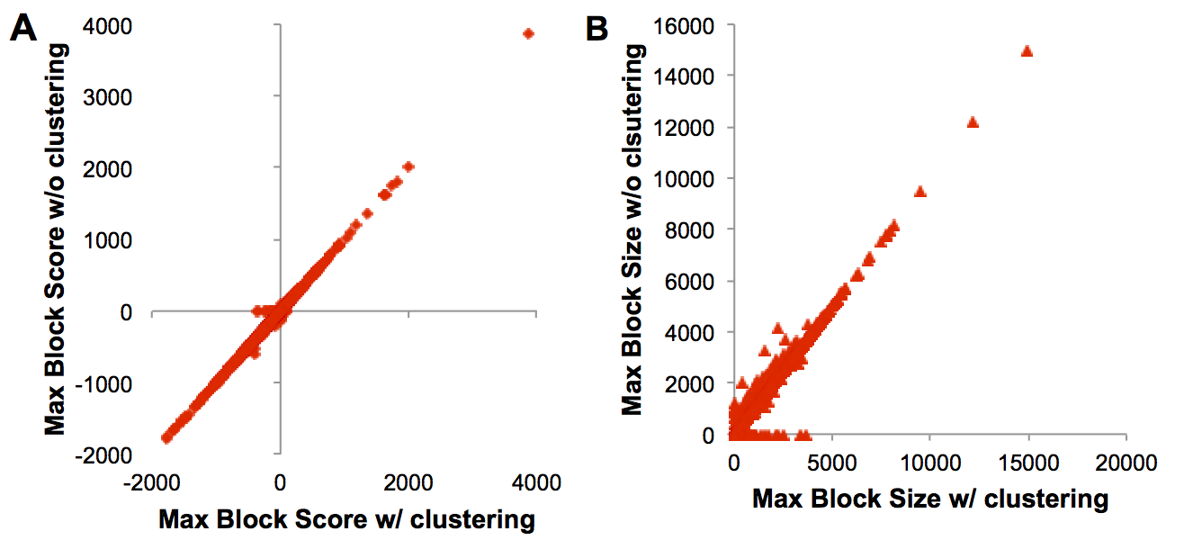Supplemental Figure 1. A comparison of the CPD maximum difference block with and without local clustering and condensation of poly(A) sites. Maximum difference block (defined in the main text) score and size were collected with the sites as is, and also with clustering, such that any sites closer than 12 nt were condensed and placed at the site of the site with higher tag count. Each point represents one of the ~5800 genes under study. Variation in blocks was seen primarily for small or low scoring blocks.

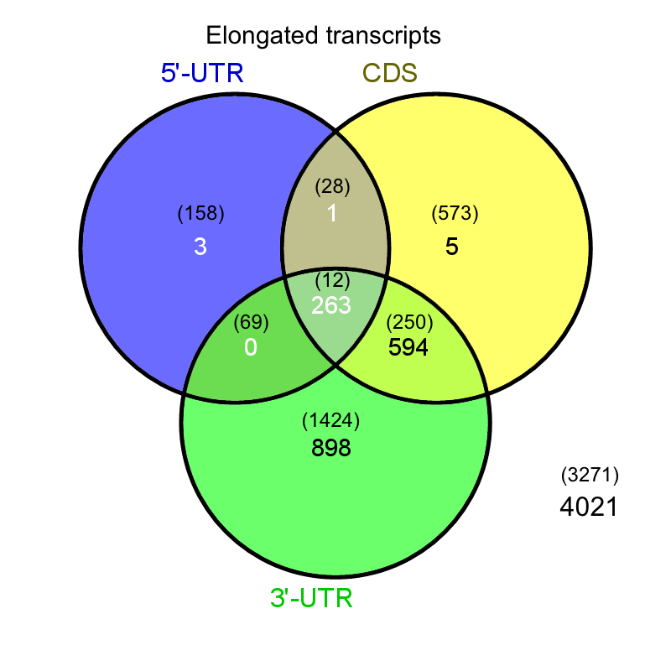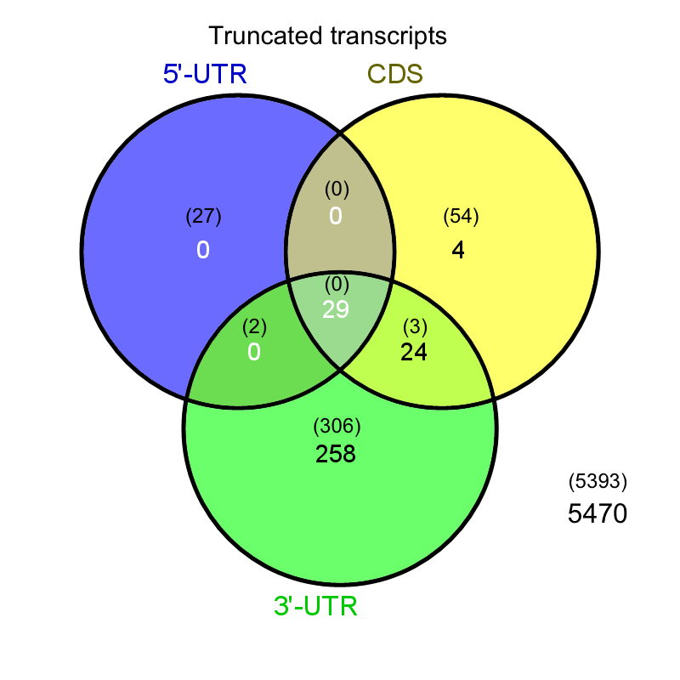
Supplemental Figure 2. The distribution of gene region overlap of significant variation for transcripts with 4NQO-induced elongation (on the left) and truncation (on the right). Expected distribution based on the assumption of independent populations are shown in parentheses

- + 4-NQO

Supplemental Figure 3. 3' rapid amplification of cDNA ends (RACE) of representative transcripts. Total RNA, isolated from either untreated or 4NQO-treated yeast cells, was reverse-transcribed into cDNA. The cDNA was then used for PCR using an anchor primer and gene-specific primers. All primer sequences are listed in the Supplemental Table 6. The 3’RACE products are indicated by the numbering of poly(A) sites in their order from the transcription start site. First lanes, a 100 bp DNA ladder with the 500-base pair band indicated. The ratios indicate the fold change of each poly(A)-site usage in 4NQO-treated cells compared to that in untreated cells. For analysis of the RAD53 first poly(A) site (pA1), PCR was performed at 35 cycles (lanes 2 and 6), or 30 cycles (lanes 3 and 7).
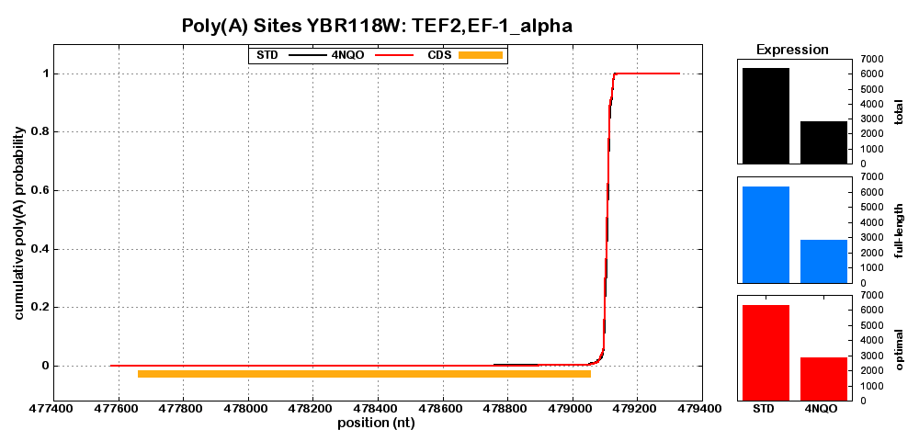
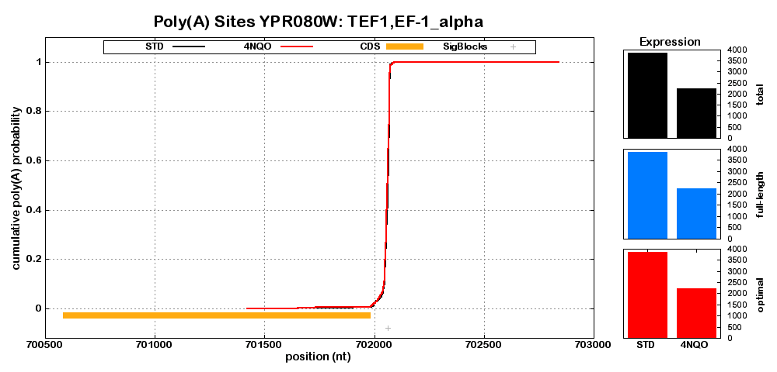
Supplemental Figure 4. CPD plots for other gene examples, comparing with and without exposure to 4NQO. Black and red line-plots represent the CPD without and with exposure to 4NQO, respectively. Orange bars show CDS positions, with all plots oriented such that the 5’-3’ direction of transcription is left to right. Light blue bars identify the largest block of difference between 4NQO and STD samples, and are displayed if the block was measured as significant. Grey bars show all significantly differing regions in the CPD after 4NQO exposure. Normalized expression levels were calculated for total (black column plot), full-length (blue column plot), and optimal transcripts (red column plot). In presentation order, plots include genes with constitutive poly(A) sites (TEF1, TEF2), genes with for which truncated transcripts are suppressed with exposure to 4NQO (ACT1, SUA7, NHX1), genes encoding 3’-end processing factors (CFT1, CFT2, CLP1, FIP1, HRP1, MPE1, NPL3, PAP1, PCF11, PFS2, PTA1, PTI1, RNA15, SSU72, CBP80, REF2, SYC1, YSH1, YTH1), a gene previously studied for isoform variation with stress (RPB2), and genes with no change in or increased relative expression of truncated isoforms (GAC1, MAK21, REC107).

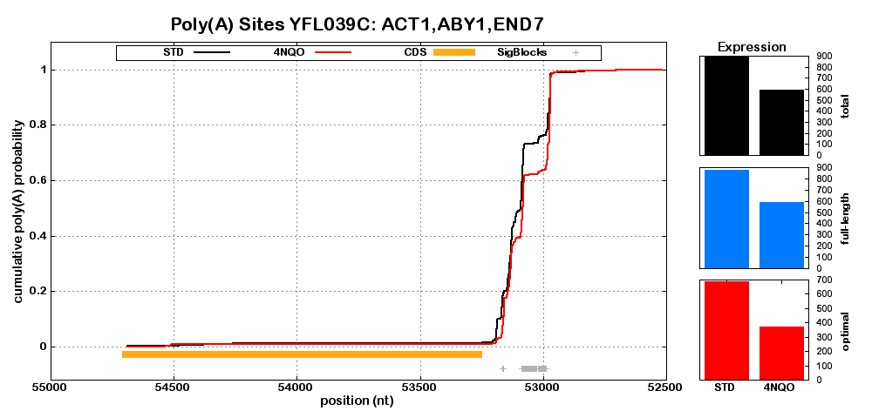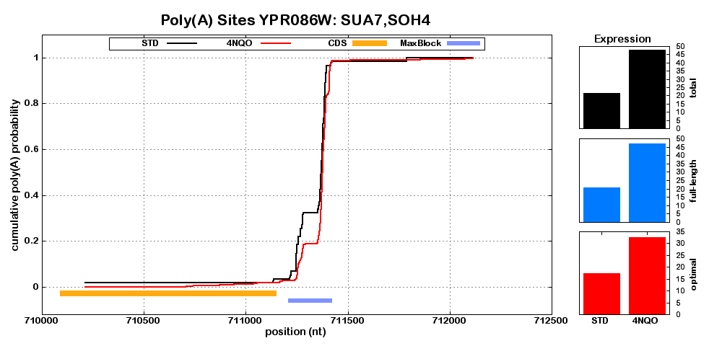
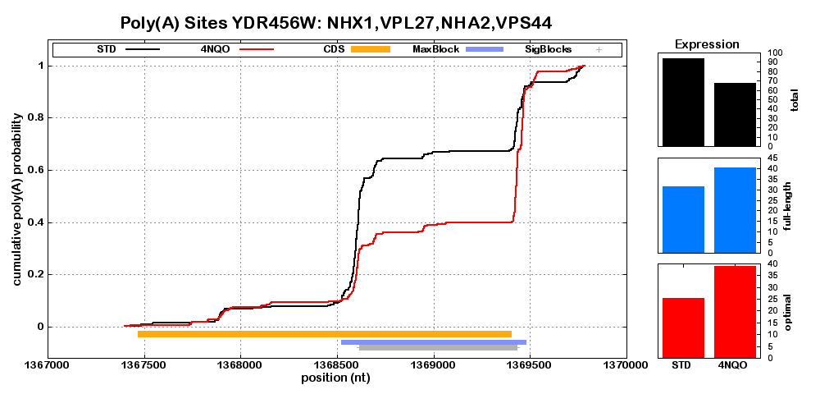
Supplemental Figure 4. (continued)

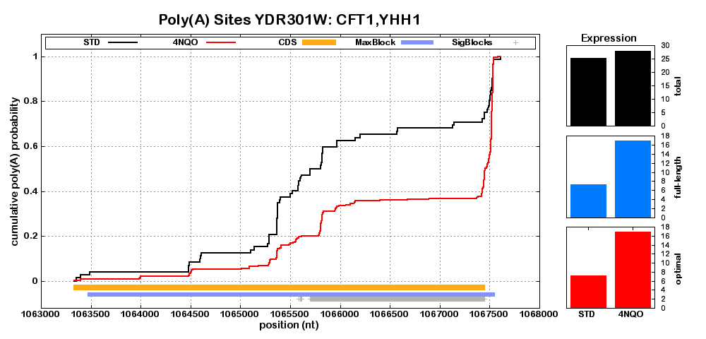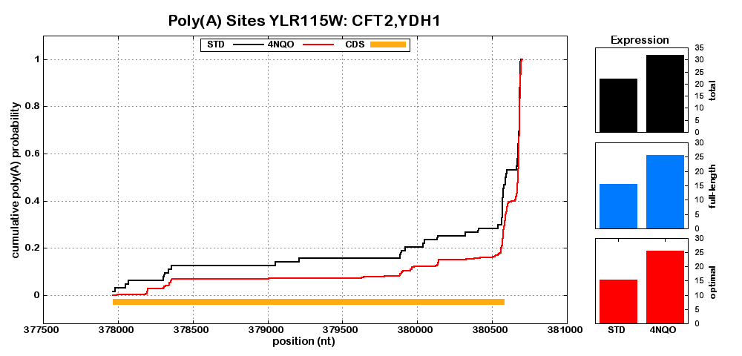
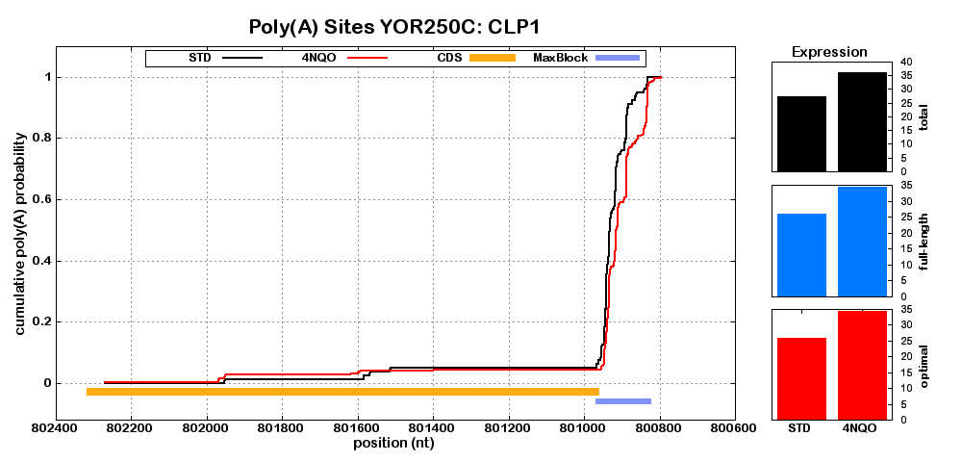
Supplemental Figure 4. (continued)

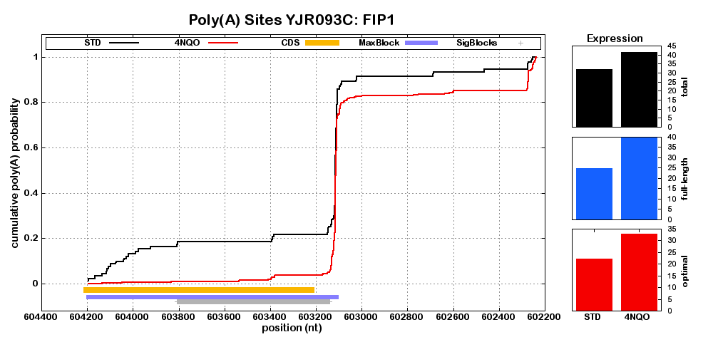
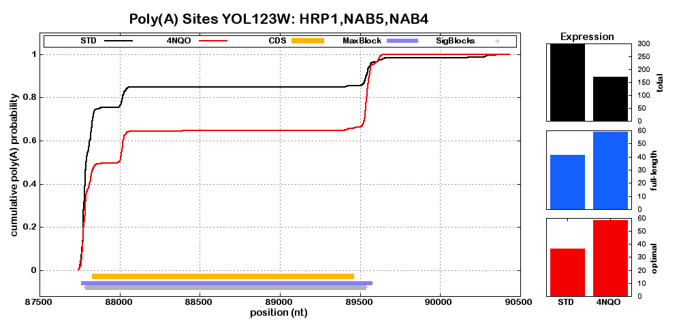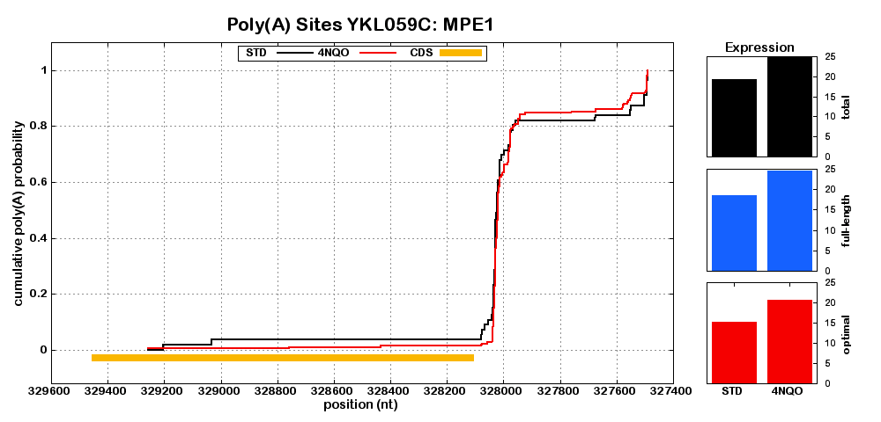
Supplemental Figure 4. (continued)
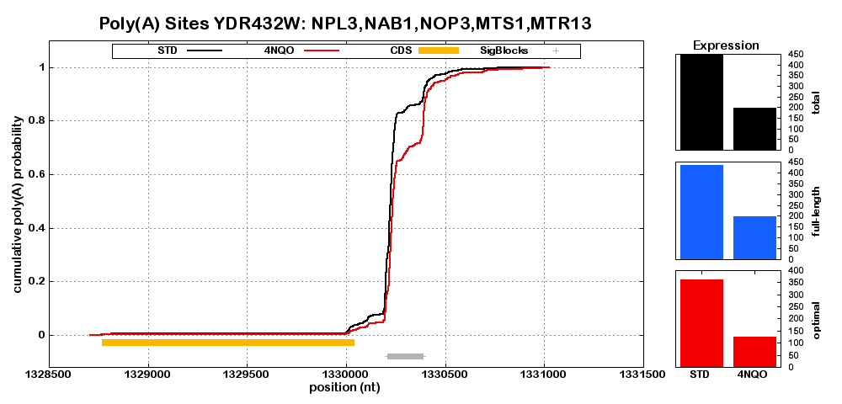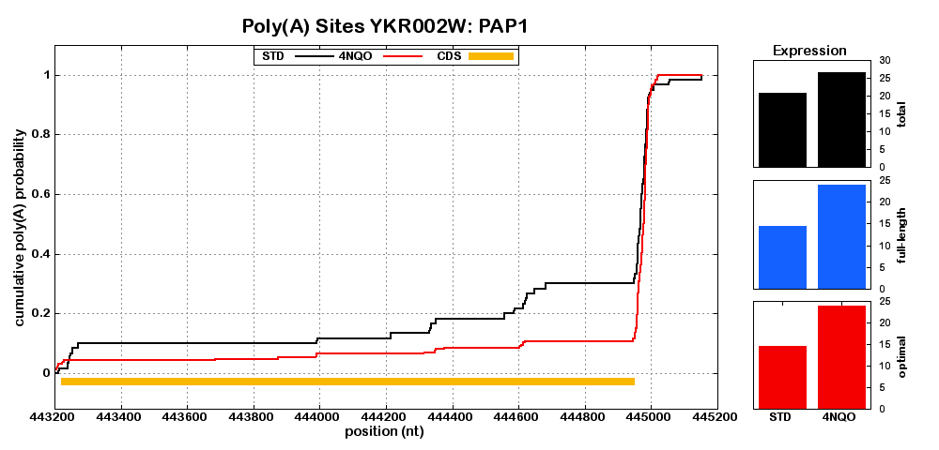
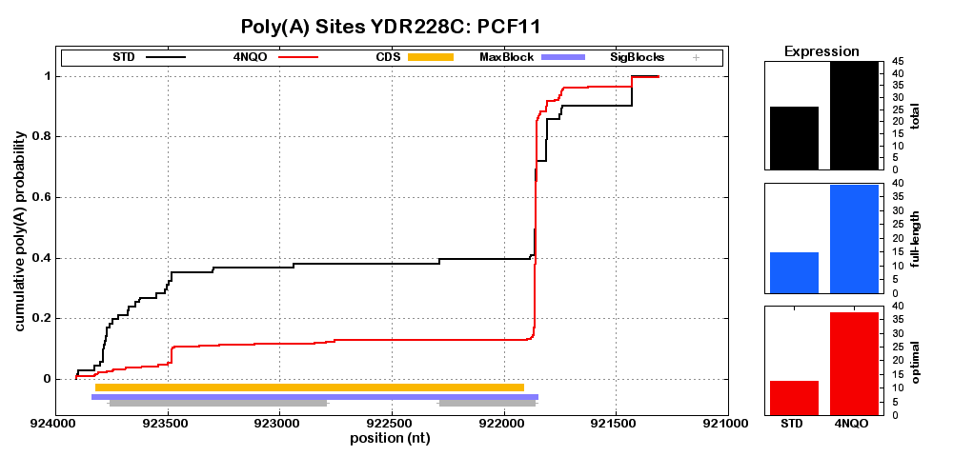
Supplemental Figure 4. (continued)

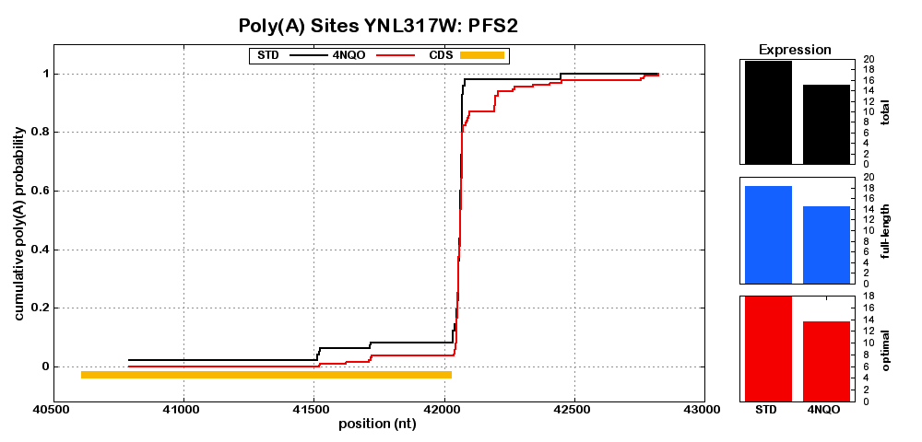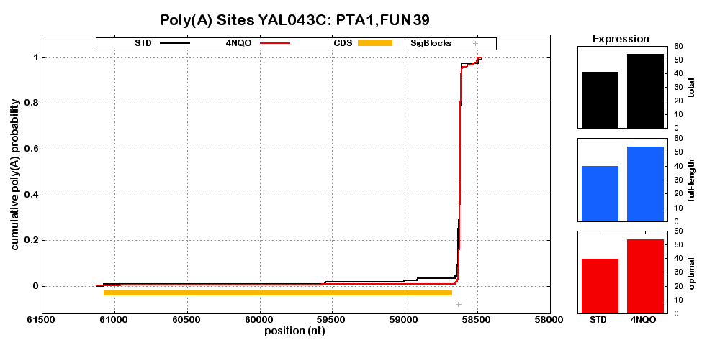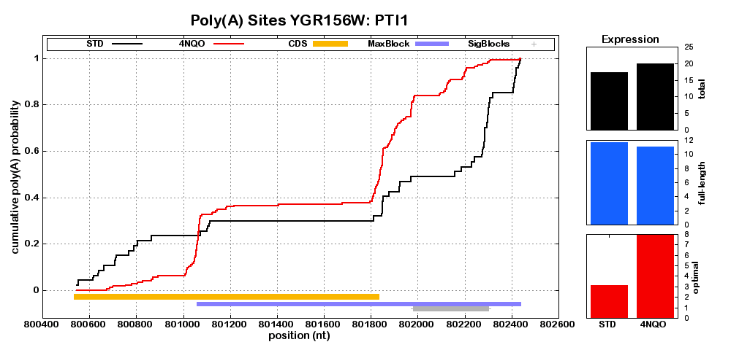
Supplemental Figure 4. (continued)

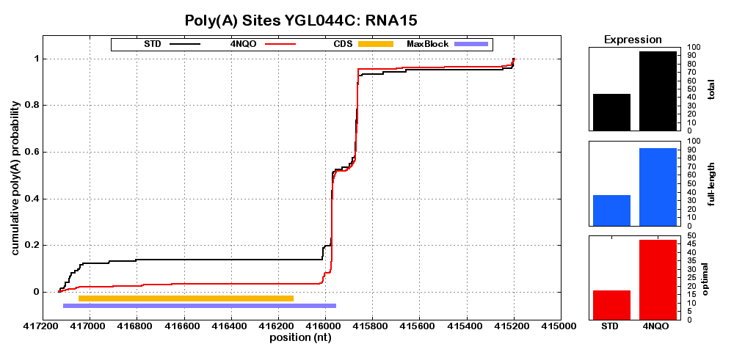

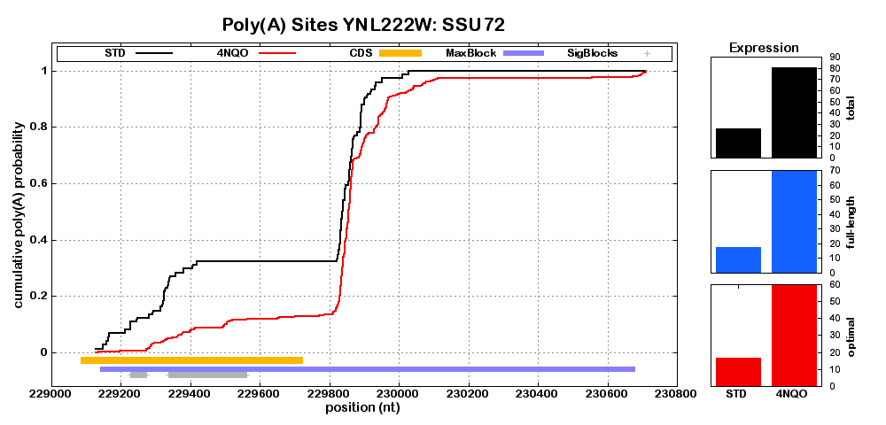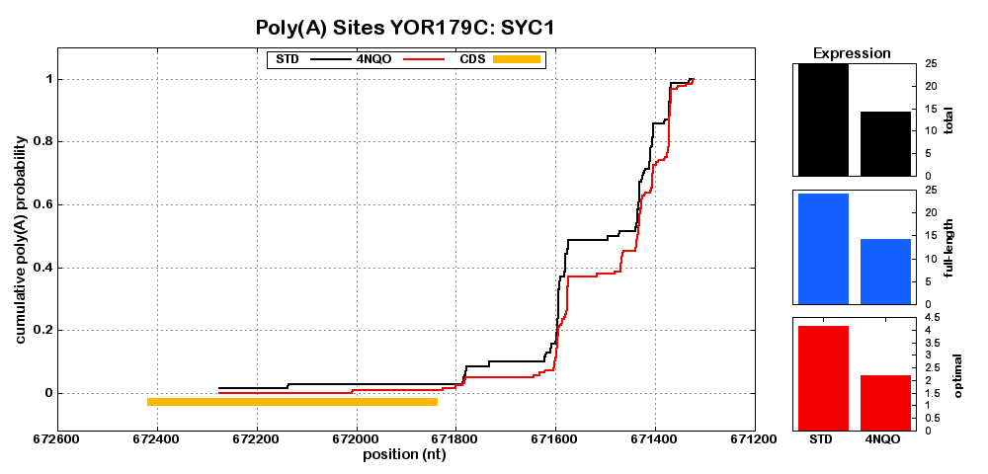
Supplemental Figure 4. (continued)
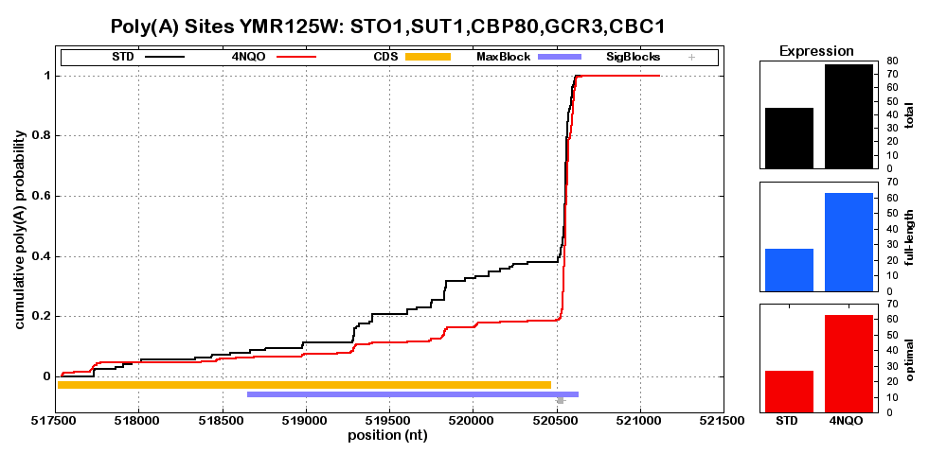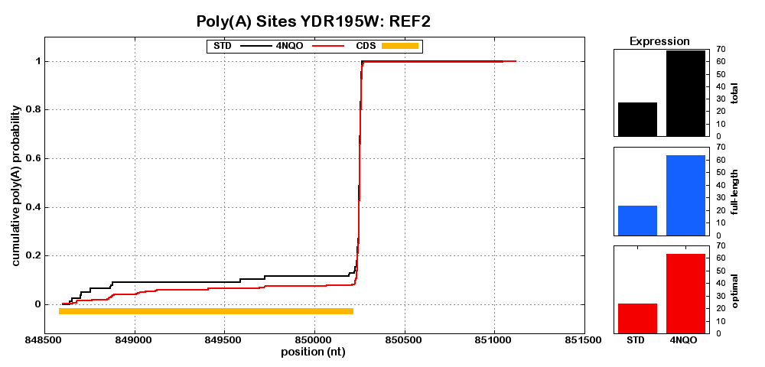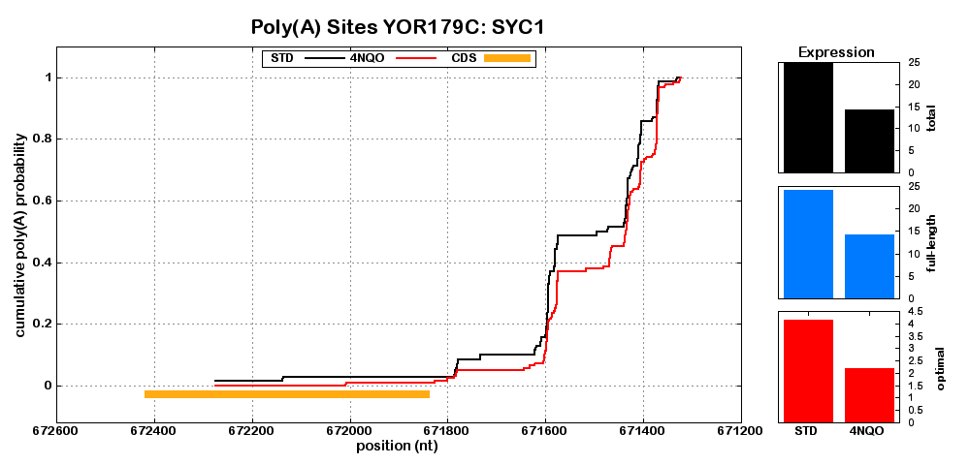
Supplemental Figure 4. (continued)

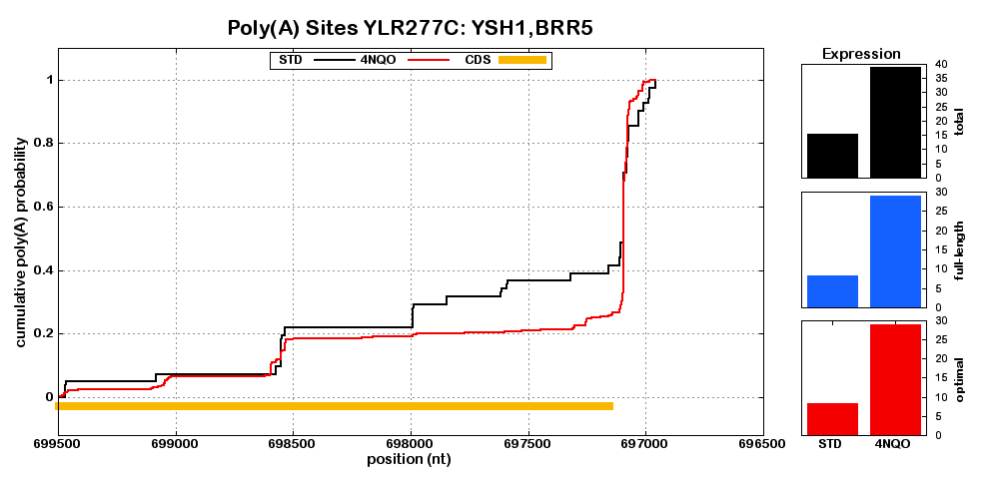
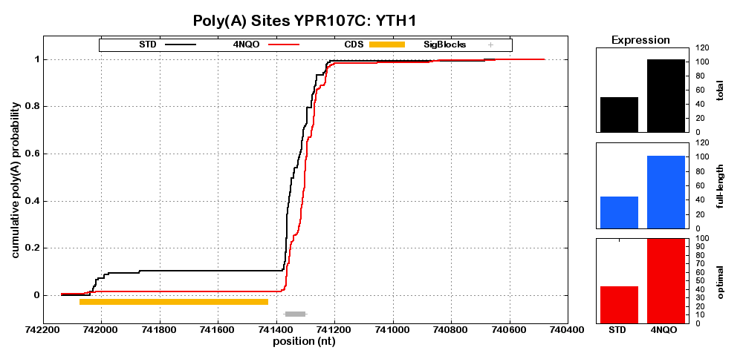
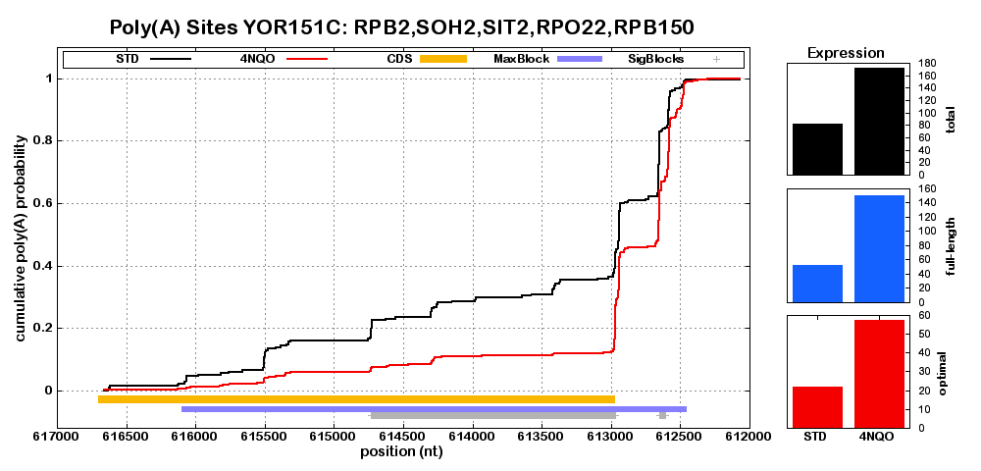
Supplemental Figure 4. (continued)

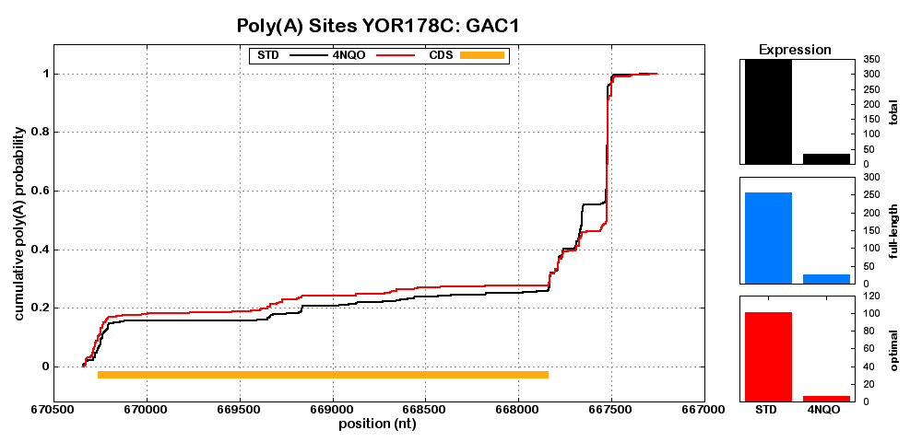

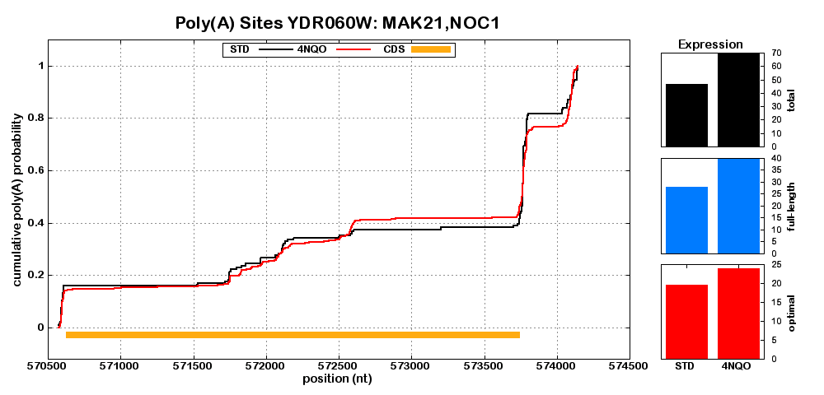
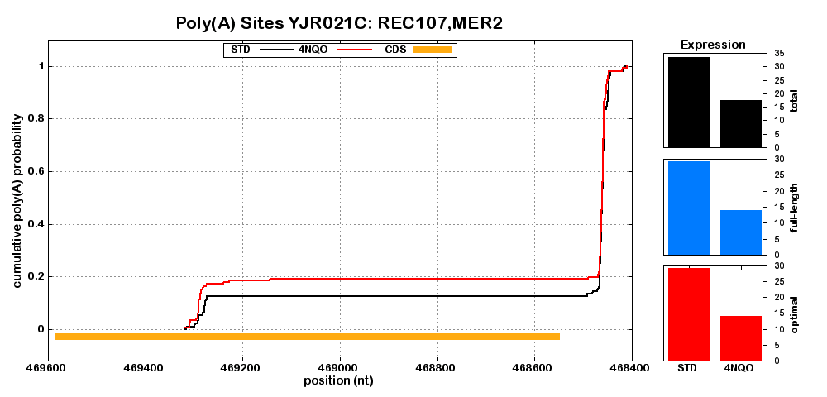
Supplemental Figure 4. (continued)

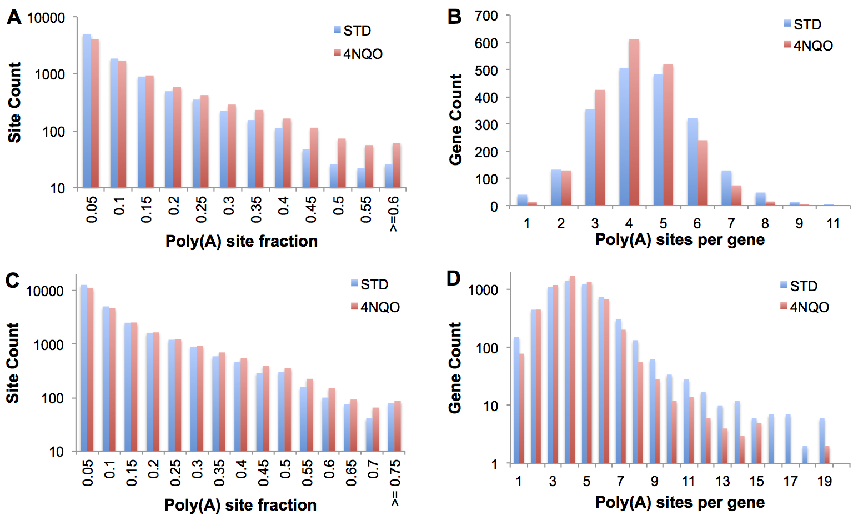
Supplemental Figure 5. Exposure to 4NQO results in a focusing of transcripts to a smaller number of higher fraction poly(A) sites. Poly(A) sites were identified by applying the edge-finding algorithm in Supplemental Figure 15 to the CPD plots, and restricting to sites that represented at least 5% of the transcripts measured for that gene in the sample. Analysis of parts (A) and (B) were restricted to the genes deemed significant at FDR < 0.1 and for which at least 30 tags were available in all samples. This restriction was relaxed for (C) and (D). (A) and (C) show the distribution of poly(A) site fractions, and demonstrate that exposure to 4NQO results in an increase in poly(A) sites represented in 0.35 or more of the transcripts. (C) and (D) show the count of distinct poly(A) sites for each gene and show a loss of high poly(A) count genes with exposure to 4NQO. We also note a loss of very low count, and attribute that to genes whose control CPDs were characterized by ramp-like appearance with many diffuse poly(A) sites that focus to a discrete number with exposure to 4NQO. The pairs of plots in all four panels pass a Chi-squared test for different distributions at p < 1e-6.

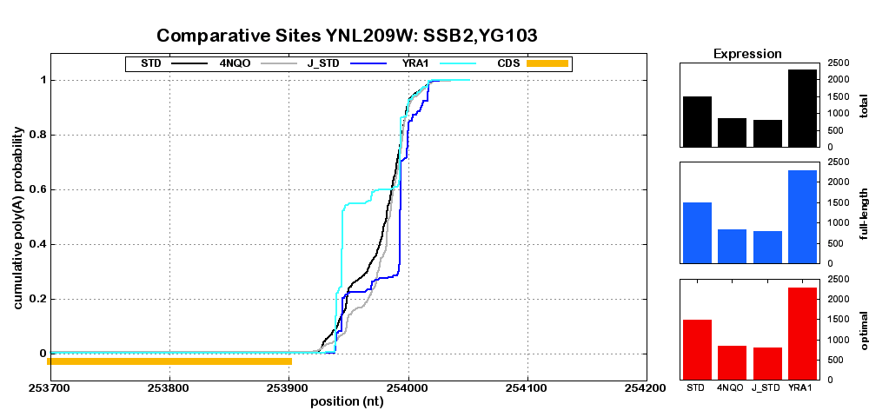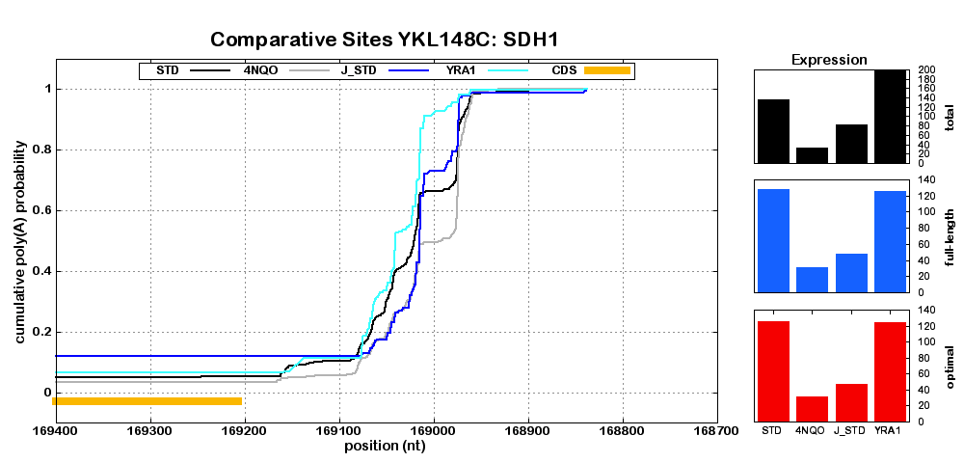 Supplemental Figure 6: CPD plots for comparison with the previous Yra1-depletion analysis (Johnson et al. 2011). Our independent comparative analysis of the Yra1-depletion experiment largely reproduces the prior analysis. Shorter isoforms are produced for SSB2 (A) and SDH1 (B) upon Yra1 depletion to give a poly(A) site use profile similar to that of Figure 5a of the previous study. Standard and Yra1-depleted conditions are shown as blue and cyan lines, respectively. For comparison, the current standard (black) and 4NQO (gray) samples are also shown, as well as the changes in abundance, by the three measures defined in the main text.
A
B
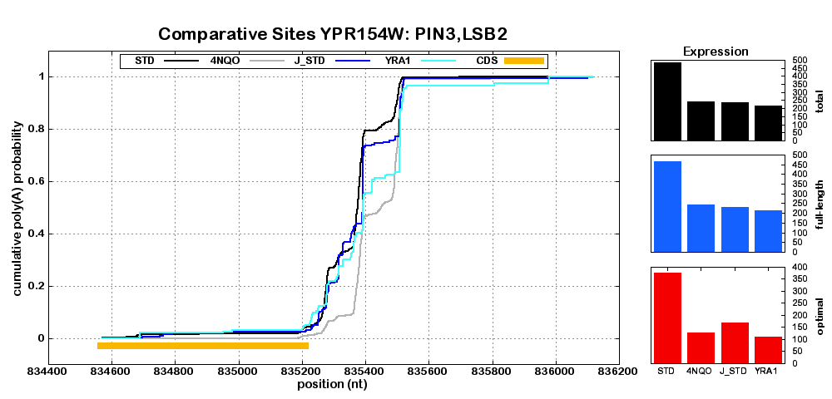
C
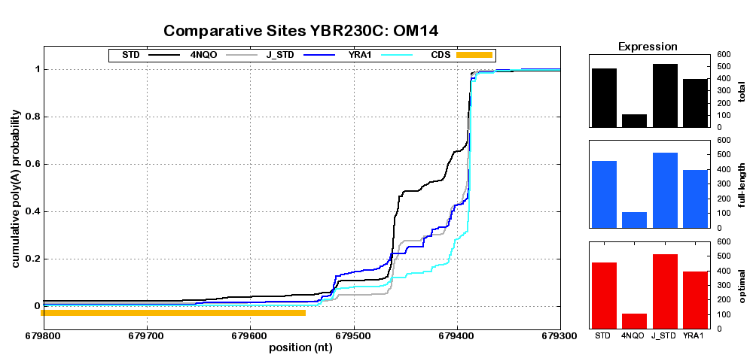
D
Supplemental Figure 6 (continued). (C) PIN3 and (D) OM14 are relatively elongated with Yra-1 depletion and can be compared with Figure 5b of the previous study

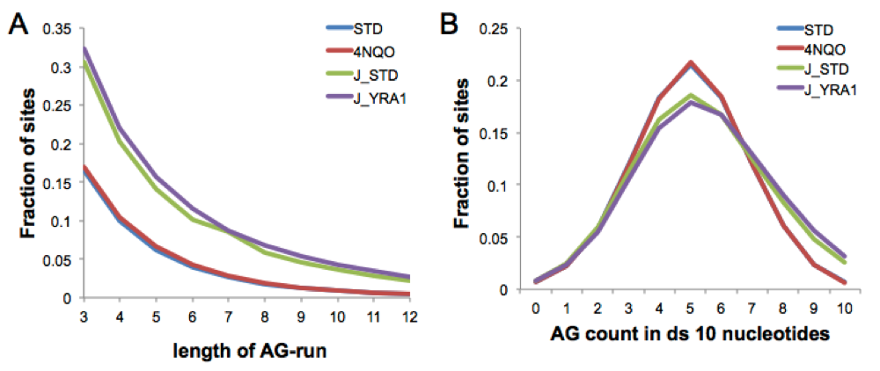
Supplemental Figure 7: Analysis of A- and AG-rich runs downstream of aligned tags suggests that oligo-dT-VN primed data is significantly more subject to internal priming than DRS. Sequence tags were aligned to the genome without prior filtering. 10-nt sequence fragments were extracted from the genome immediately adjacent and downstream of the aligned tag. (A) Runs of purines (A or G) were significantly more abundant in the oligo-dT data than in DRS. Normalization is to the number of uniquely identified sites. An analysis with normalization to the total number sequence tags produced highly similar analysis (data not shown). (B) The count of A or G residues in the next ten bases is skewed and biased toward higher content in oligo-dT-VN primed data. The symmetry of the DRS curves suggests no significant enrichment in DRS data. Based on these plots, DRS data was filtered for sequences that align next to an AG-run of 6 or more nt. Oligo-dT-VN data was filtered for AG-runs of 6 or more nt, and also for 8 or more As or Gs in the downstream 10 nt.

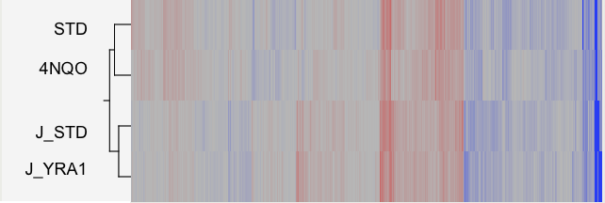
Supplemental Figure 8: Within experiment, differentially treated, samples are more similar in expression abundance than controls in different experiments. Hierarchical clustering, based on log-transformed total expression counts for each gene (as defined in the main text), was performed with JMP statistical software (http://www.jmp.com/) with Ward distance metric preceded by standardization of each expression vector. Abbreviations: 4NQO, STD data from the current study. J_STD, J_YRA1= control and YRA1-depleted samples from (Johnson et al. 2011).

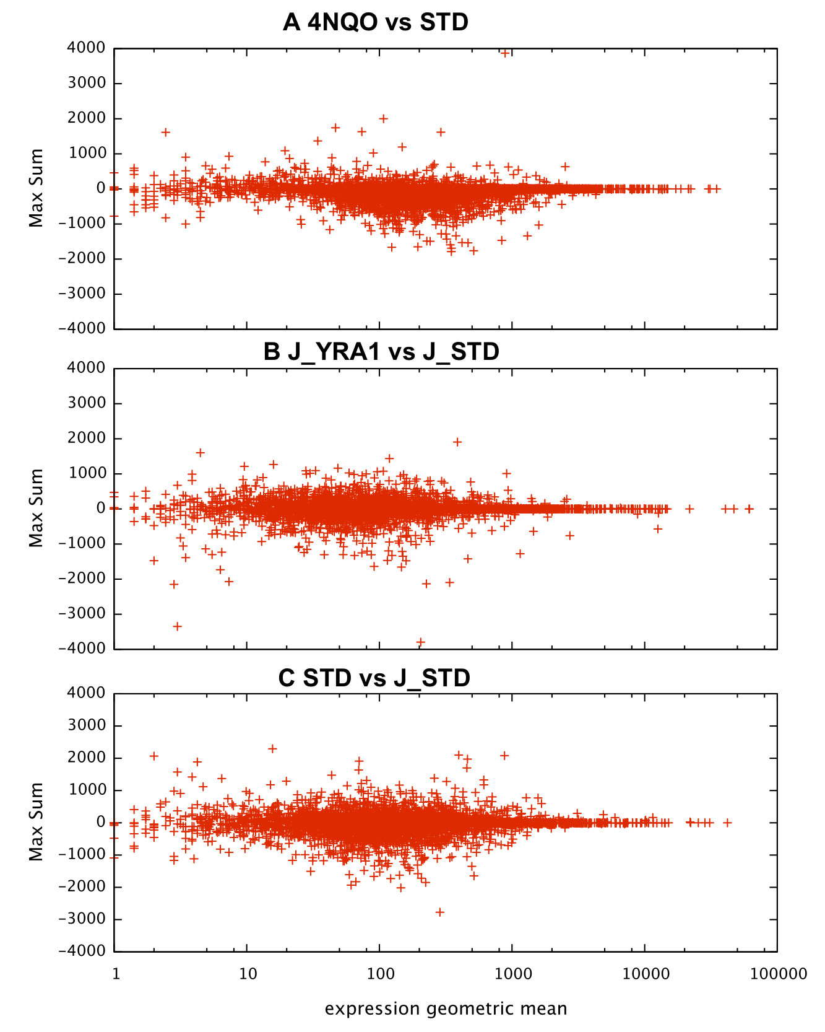
Supplemental Figure 9: Highly expressed genes are largely invariant in isoforms that use different poly(A) sites. We calculated the maximum CPD block difference score (as described in Methods) for each gene. Positive (negative) block difference signifies a relative truncation (elongation) in the first listed sample with respect to the second. The x-axis is plotted as the geometric mean (square root of the product) of the total expression (as defined in the text) for the gene in the two samples. Each point represents one gene’s largest identified block. Abbreviations: 4NQO, STD data from the current study. J_STD, J_YRA1= control and YRA1-depleted samples from (Johnson et al. 2011).

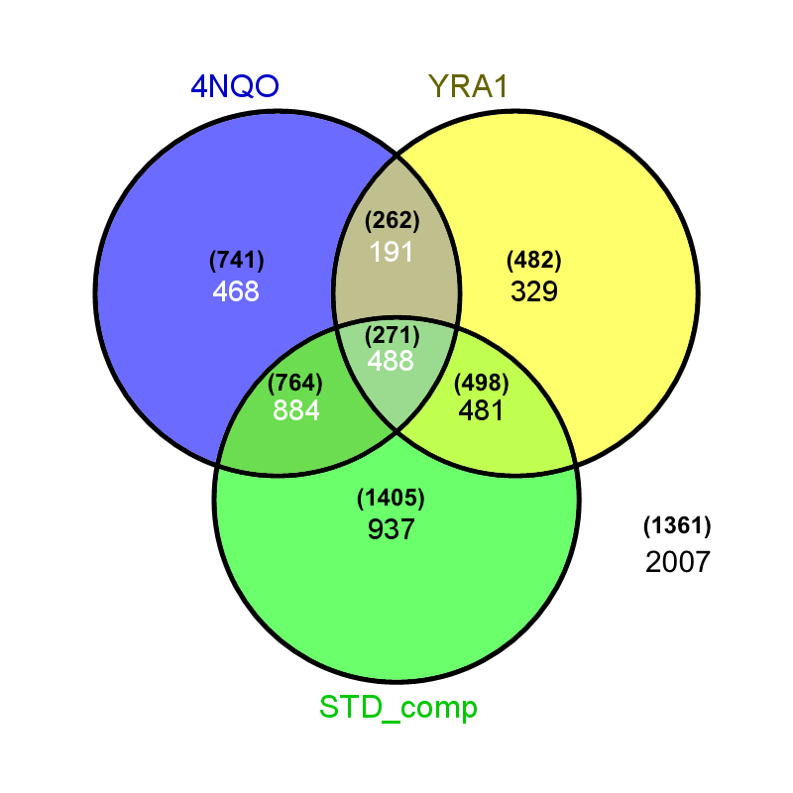
Supplemental Figure 10: Overlap analysis of the genes identified as significant in the difference comparisons. 4NQO: differences between 4NQO and STD in the current study. YRA1: differences between YRA1-depleted and control (Johnson et al. 2011). STD_comp: comparison between the two control experiments. The expected distribution based on the assumption of independent populations are shown in parentheses.
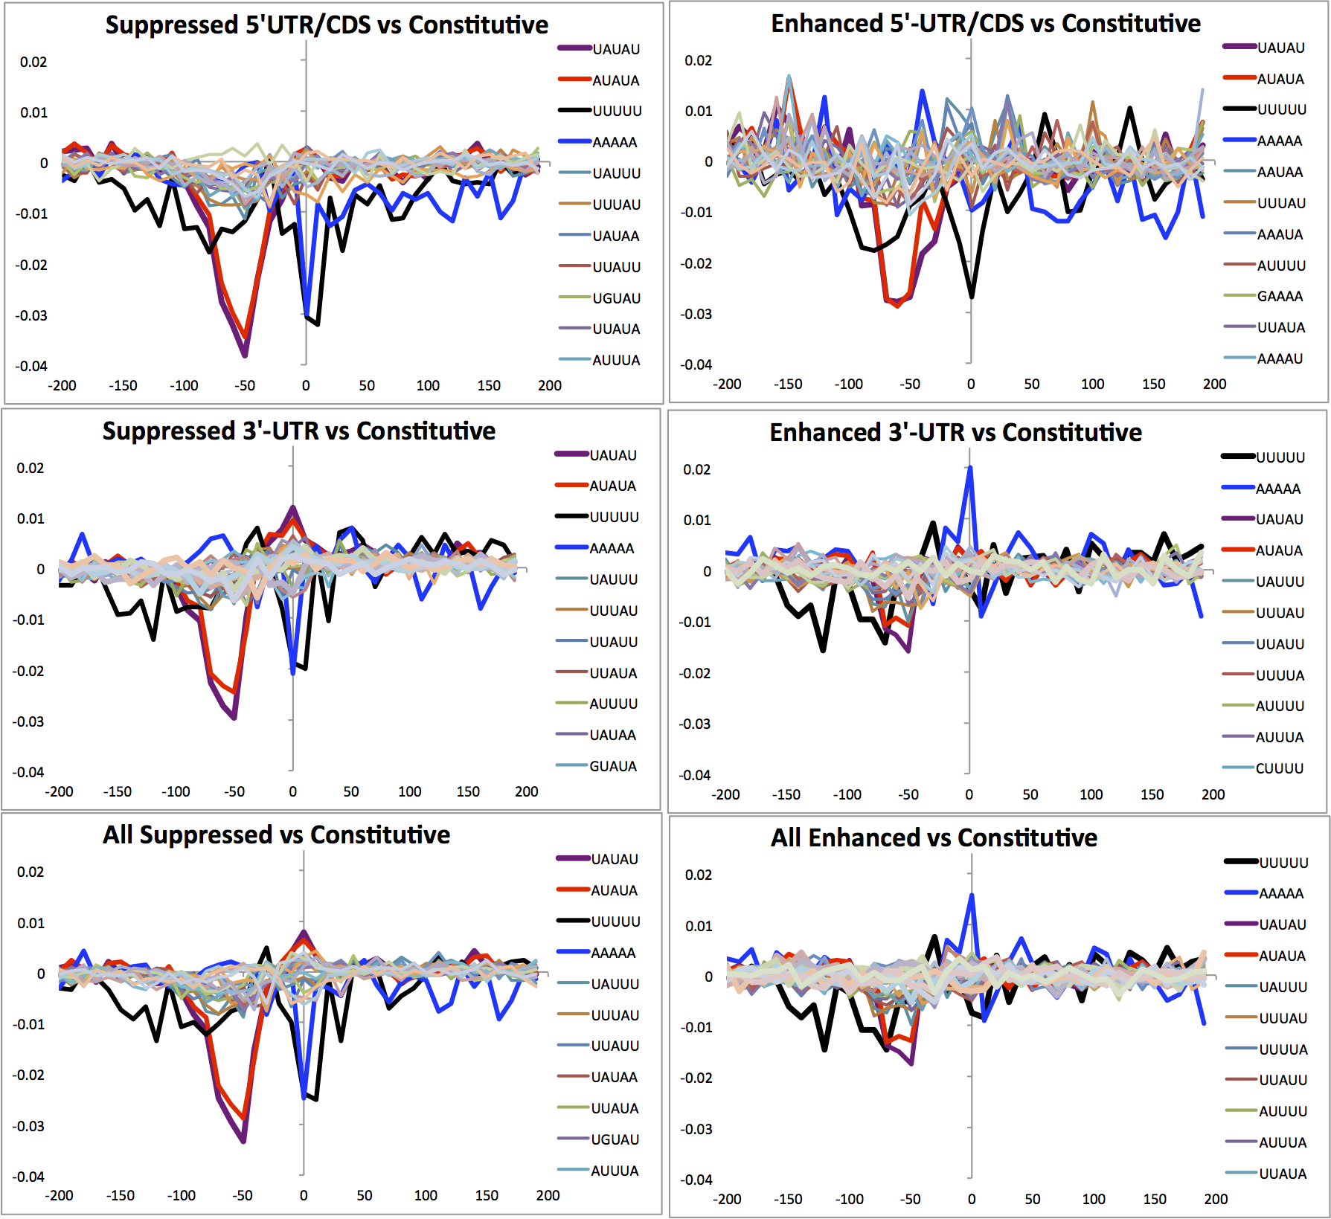
Supplemental Figure 11. Putatively variable poly(A) sites are distinguished by sequence content. Line plots of the differences in sequence content flanking putatively suppressed and constitutive poly(A) or putatively enhanced and constitutive poly(A) sites, with sites separated by gene region. Sites occurring in the 5’-UTR and CDS were pooled to increase the number of sequences and therefore statistical power. The representative pentamers AAAAA, UAUAU, AUAUA, and UUUUU are highlighted in all plots. Other pentamers are shown for reference and to distinguish the behavior of the representative pentamers. NOTE: Data in here is plotted as the difference in the fraction of all pentamers counted in each window, where as Figure 6 in the main text shows the difference in the fraction of the sequences that have at least one copy of the pentamer in that window. Complete results of these analyses are available in Supplemental Tables 3-9.

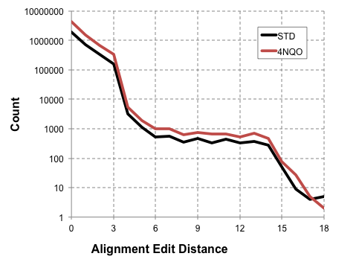
Supplemental Figure 12: Empirical determination of error rate thresholds in alignments. RUM produces a SAM output file, including a term “NM:” signifying the edit distance between the read sequence and the genomic target. We collected and binned all successful alignments based on the edit distance. Based on this plot, we kept alignments with NM:3 or less for subsequent analysis.

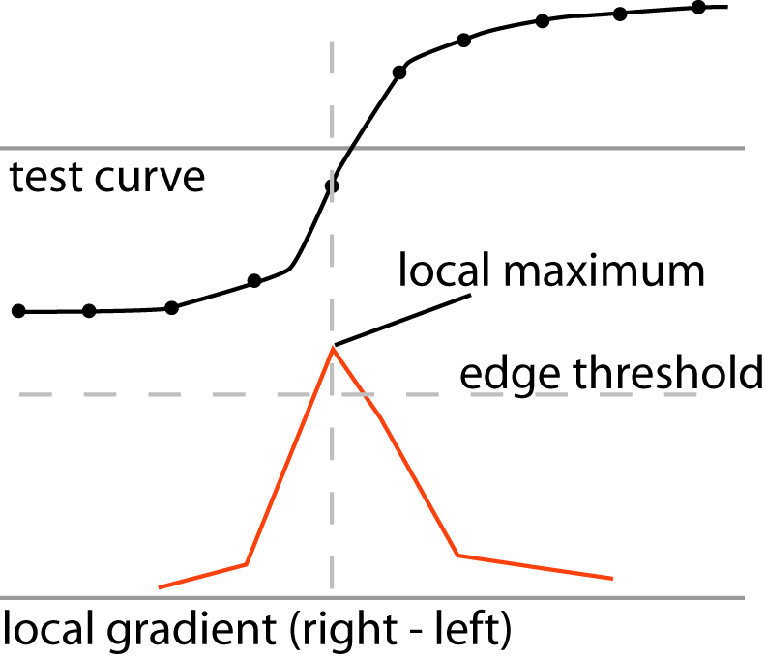

Supplemental Figure 13. Diagram of the edge-finding routine. The local gradient (red plot) is obtained as difference between a common number of data points left and right of each point in the plot. Two points are used in the example shown here. Three points were used in the generation of the figures shown above. Edges are reported when two criteria are met: 1), the position must represent a local maximum in the local gradient plot (defined as being greater than or equal to its flanking points), and 2) the gradient must exceed a user set threshold.

Supplement References

Johnson, S.A., Kim, H., Erickson, B., and Bentley, D.L. 2011. The export factor Yra1 modulates mRNA 3' end processing. Nat Struct Mol Biol 18(10): 1164-1171.

