Supplemental Materials

Next-generation sequencing of paired tyrosine kinase inhibitor-sensitive and -resistant EGFR mutant lung cancer cell lines identifies spectrum of DNA changes associated with drug resistance

Peilin Jia,¹ Hailing Jin,² Catherine B. Meador,² Junfeng Xia,¹ Kadoaki Ohashi,² Lin Liu,^{3,4} Valentina Pirazzoli,^{5,6} Kimberly B. Dahlman,⁷ Katerina Politi,^{5,6,8} Franziska Michor,^{3,4} Zhongming Zhao,^{1,7,9} and William Pao^{2,7,9}

¹Departments of Biomedical Informatics, ²Medicine, Vanderbilt University School of Medicine, Nashville, Tennessee 37232, USA
³Department of Biostatistics and Computational Biology, Dana-Farber Cancer Institute, Boston, Massachusetts 02215, USA
⁴Department of Biostatistics, Harvard School of Public Health, Boston, Massachusetts 02215, USA
⁵Department of Pathology, ⁶Yale Cancer Center, Yale University School of Medicine, New Haven, Connecticut 06510, USA
⁷Department of Cancer Biology, Vanderbilt University School of Medicine, Nashville, Tennessee 37232, USA
⁸Department of Medicine, Yale University School of Medicine, New Haven, Connecticut 06510, USA

⁹To whom correspondence should be addressed:
William Pao, MD, PhD
2220 Pierce Ave 777 PRB
Nashville, TN 37232
william.pao@vanderbilt.edu
or
Zhongming Zhao, PhD
2525 West End Avenue, Suite 600
Nashville, TN 37203
zhongming.zhao@vanderbilt.edu

Contents
Supplemental Tables
Supplemental Table S1 --------------------------------------------------------------------------- 3
Supplemental Table S2 --------------------------------------------------------------------------- 4
Supplemental Table S3 --------------------------------------------------------------------------- 5
Supplemental Table S4 --------------------------------------------------------------------------- 6
Supplemental Table S5 --------------------------------------------------------------------------- 7
Supplemental Table S6 --------------------------------------------------------------------------- 8
Supplemental Table S7 --------------------------------------------------------------------------- 9
Supplemental Table S8 --------------------------------------------------------------------------- 10
Supplemental Table S9 --------------------------------------------------------------------------- 11
Supplemental Table S10 ------------------------------------------------------------------------- 12
Supplemental Table S11 ------------------------------------------------------------------------- 13
Supplemental Table S12 ------------------------------------------------------------------------- 14

Supplemental Figures
Supplemental Figure S1 -------------------------------------------------------------------------- 15
Supplemental Figure S2 -------------------------------------------------------------------------- 16
Supplemental Figure S3 -------------------------------------------------------------------------- 17
Supplemental Figure S4 -------------------------------------------------------------------------- 18
Supplemental Figure S5 -------------------------------------------------------------------------- 19
Supplemental Figure S6 -------------------------------------------------------------------------- 20
Supplemental Figure S7 -------------------------------------------------------------------------- 21
Supplemental Figure S8 -------------------------------------------------------------------------- 22
Supplemental Figure S9 -------------------------------------------------------------------------- 23
Supplemental Figure S10 ------------------------------------------------------------------------- 24
Table S1. List of validated SNVs and indels in PC-9/ER cells (Each row is for one transcript and multiple transcripts of each gene are listed.)
Gene | Chr.* | Position (bp) | RefSeq | Nucleotide change | Amino acid change | Tumor var freq**
SNVs
KIF17 | 1 | 20998644 | NM_020816 | c.C2509T | p.Q837X | 41.38%
 |  |  | NM_001122819 | c.C2509T | p.Q837X
GPR61 | 1 | 110085927 | NM_031936 | c.C283T | p.P95S | 43.75%
PKP4 | 2 | 159477811 | NM_001005476 | c.G481C | p.G161R | 50%
 |  |  | NM_003628 | c.G481C | p.G161R
SRGAP3 | 3 | 9032400 | NM_001033117 | c.C2610A | p.S870R | 58.82%
 |  |  | NM_014850 | c.C2682A | p.S894R
ZNF445 | 3 | 44489533 | NM_181489 | c.G1630A | p.D544N | 42.42%
ATP8A1 | 4 | 42551076 | NM_006095 | c.G1606C | p.G536R | 20.83%
 |  |  | NM_001105529 | c.G1561C | p.G521R
AFAP1L1 | 5 | 148702274 | NM_152406 | c.G1804A | p.A602T | 27.27%
 |  |  | NM_001146337 | c.G1804A | p.A602T
EGFR | 7 | 55249071 | NM_005228 | c.C2369T | p.T790M | 21.92%
LIN7C | 11 | 27528284 | NM_018362 | c.G16T | p.E6X | 26.67%
SF1 | 11 | 64535163 | NM_201997 | c.C1222T | p.H408Y | 21.62%
 |  |  | NM_201998 | c.C1222T | p.H408Y
 |  |  | NM_201995 | c.C1222T | p.H408Y
 |  |  | NM_001178030 | c.C1597T | p.H533Y
 |  |  | NM_001178031 | c.C1144T | p.H382Y
 |  |  | NM_004630 | c.C1222T | p.H408Y
BIRC3 | 11 | 102195950 | NM_182962 | c.A710T | p.N237I | 25.84%
 |  |  | NM_001165 | c.A710T | p.N237I
CPNE8 | 12 | 39161493 | NM_153634 | c.C519A | p.D173E | 42.11%
GNPTG | 16 | 1412518 | NM_032520 | c.G592T | p.E198X | 36.67%
PDILT | 16 | 20387492 | NM_174924 | c.G441C | p.W147C | 34.04%
AOC2 | 17 | 40997679 | NM_009590 | c.G1036C | p.V346L | 25%
 |  |  | NM_001158 | c.G1036C | p.V346L
TSGA10# | 2 | 99720494 | NM_182911 | c.G547A | p.A183T | 27.78%
 |  |  | NM_025244 | c.G547A | p.A183T
FRAS1# | 4 | 79238630 | NM_001166133 | c.A1928T | p.E643V | 59.09%
 |  |  | NM_025074 | c.A1928T | p.E643V
SEC24D# | 4 | 119738478 | NM_014822 | c.C338G | p.S113C | 41.46%
ATP2A1# | 16 | 28914722 | NM_004320 | c.G2941A | p.D981N | 46.15%
 |  |  | NM_173201 | c.G2941A | p.D981N
GRIN3B# | 19 | 1003585 | NM_138690 | c.G883T | p.D295Y | 55.56%
Indels
ZNF385B | 2 | 180383295-180383297 | NM_001113398 | c.159_161del | p.53_54del | 20.75%
 |  |  | NM_152520 | c.465_467del | p.155_156del
 |  |  | NM_001113397 | c.237_239del | p.79_80del
ACACA | 17 | 35601597-35601602 | NM_198834 | c.2644_2649del | p.882_883del | 34.55%
 |  |  | NM_198838 | c.2299_2304del | p.767_768del
 |  |  | NM_198837 | c.2359_2364del | p.787_788del
 |  |  | NM_198839 | c.2533_2538del | p.845_846del
 |  |  | NM_198836 | c.2533_2538del | p.845_846del
FAM122C | X | 133941611-133941611 | NM_001170780 | c.91delT | p.L31fs | 38.60%
LRCH2 | X | 114391202-114391204 | NM_020871 | c.1490_1492del | p.497_498del | 33.33%
TBC1D8B | X | 106069294-106069314 | NM_017752 | c.862_882del | p.288_294del | 52.63%
 |  |  | NM_198881 | c.862_882del | p.288_294del
ZNF793 | 19 | 38028414- 38028414 | NM_001013659 | c.854_855insT | p.C285fs | 20.75%
*Chr.: chromosomes. **Var freq: variant frequency. # These genes are missed by our stringent filtering criteria but were confirmed by Sanger resequencing.
Table S2. CNV regions in PC-9/ER
Cytoband | Start (Mb) | End (Mb) | Copy  number | Size (Mb) | CGC* genes
Amplification
2p25.3 | 0 | 0.79 | 3-4 | 0.79
5p15.1-p15.2 | 11.53 | 15.28 | 3 | 3.74
7p11.2-p13 | 43.36 | 55.33 | 3 | 11.97 | EGFR, IKZF1
7q32.3 | 130.50 | 130.63 | 3 | 0.13
22q12.3-q13.1 | 35.99 | 39.24 | 3 | 3.25 | MYH9
Deletion
2q22.1 | 141.73 | 142.17 | 1 | 0.44
2q32 | 189.12 | 197.88 | 1 | 8.76 | PMS1
2q34 | 202.75 | 214.48 | 1 | 11.73 | CREB1, IDH1
7q31.1-q32.3 | 112.95 | 130.5 | 1 | 17.55 | MET
7q32.3-q33 | 130.63 | 133.53 | 1 | 2.9
7q33-q35 | 134.71 | 146.79 | 1 | 12.07 | BRAF, CREB3L2, KIAA1549
9q13 | 66.93 | 67.04 | 1 | 0.11
10p14-p15.3 | 0.00 | 11.77 | 1 | 11.77
10p11.21-p12.32 | 11.77 | 35.58 | 1 | 23.81 | ABI1, MLLT10, KIF5B
15q25.2 | 82.89 | 83.02 | 1 | 0.13
22q11.21 | 20.34 | 20.49 | 1 | 0.15
Xp11.4-p21.1 | 35.38 | 38.4 | 1 | 3.02
* CGC: Cancer Gene Census.

Table S3. List of validated SNVs in cell line PC-9/BRc1
Gene | Chr. * | Position (bp) | RefSeq | Nucleotide change | Amino acid change | Tumor var freq**
LRP1B | 2 | 141214142 | NM_018557 | c.G9845T | p.G3282V, | 37.77%
LRP1B | 2 | 141459727 | NM_018557 | c.C6285A | p.Y2095X, | 28.71%
LRP1B | 2 | 141660570 | NM_018557 | c.G3685T | p.E1229X, | 40.13%
RFX6 | 6 | 117240392 | NM_173560 | c.A1115T | p.K372I, | 26.43%
AHI1 | 6 | 135644437 | NM_001134831 | c.C3191T | p.A1064V,AHI1 | 59.26%
 |  |  | NM_001134830 | c.C3191T | p.A1064V,AHI1
 |  |  | NM_017651 | c.C3191T | p.A1064V,
EGFR | 7 | 55249071 | NM_005228 | c.C2369T | p.T790M, | 33.24%
MLL2 | 12 | 49434397 | NM_003482 | c.C7156T | p.R2386W, | 37.74%
PCDH9 | 13 | 67800964 | NM_203487 | c.C1609T | p.R537X,PCDH9 | 20%
 |  |  | NM_020403 | c.C1609T | p.R537X,
CDH24 | 14 | 23524547 | NM_144985 | c.G217A | p.D73N,CDH24 | 35.34%
 |  |  | NM_022478 | c.G217A | p.D73N,
HIRA | 22 | 19343811 | NM_003325 | c.G2397T | p.W799C, | 60.66%
ATRX | X | 76875965 | NM_000489 | c.C5170A | p.L1724I,ATRX | 41.67%
 |  |  | NM_138270 | c.C5056A | p.L1686I,
*Chr.: chromosomes. **Var freq: variant frequency.

Table S4. CNV regions in PC-9/BRc1
Cytoband | Start (Mb) | End (Mb) | Copy number | Size (Mb) | CGC* genes
Amplification
1p36.21-p36.33 | 0.75 | 13.93 | 4.78 | 13.19 | CAMTA1, PRDM16, RPL22, TNFRSF14
3q13.13-q27.3 | 111.26 | 187.45 | 3.00 | 76.19 | BCL6, EIF4A2, ETV5, FOXL2, GATA2, GMPS, MECOM, MLF1, PIK3CA, RPN1, SOX2, WWTR1
4q33-q35.2 | 172.74 | 190.86 | 3.33 | 18.13
7q11.21-q11.22 | 64.25 | 71.28 |  | 7.02 | SBDS
10q26.11-q26.3 | 121.54 | 134.92 | 3.89 | 13.38 | FGFR2
13q32.1-q34 | 96.41 | 99.08 | 3 | 2.67
14q21.2-q24.3 | 42.37 | 75.47 | 3.68 | 33.10
15q26.2-q26.3 | 96.87 | 101.87 | 3.00 | 5.00
16q23.3-q24.3 | 83.38 | 90.03 | 3.92 | 6.65 | CBFA2T3, FANCA
19q13.32-q13.41 | 47.71 | 52.73 | 3.00 | 5.02 | KLK2, PPP2R1A
21p11.1-q22.3 | 9.91 | 48.08 | 3.33 | 38.18 | ERG, OLIG2, RUNX1, TMPRSS2, U2AF1
22q13.2-q13.33 | 43.09 | 51.19 | 4.40 | 8.10
Xp21.1 | 35.82 | 37.67 | 4.50 | 1.85
Deletion
2q22.2-q31.1 | 142.57 | 171.40 | 1.00 | 28.83
2q33.1 | 197.89 | 202.74 | 1.00 | 4.85 | SF3B1
2q34-q35 | 214.73 | 217.06 | 1.00 | 2.33 | ATIC
2q36.3-q37.1 | 227.66 | 233.43 | 1.00 | 5.77
2q37.2 | 236.79 | 237.03 | 1.00 | 0.24
3q11.2 | 96.53 | 96.96 | 1.00 | 0.43
4q12 | 53.46 | 54.55 | 1.00 | 1.08 | FIP1L1
5p14.3-p15.33 | 0.14 | 20.31 | 1.00 | 20.16
5p12-p14.3 | 21.98 | 45.65 | 1.00 | 23.67 | IL7R, LIFR
6p25.3 | 0.11 | 0.29 | 1.00 | 0.19
6q12 | 64.29 | 66.21 | 1.00 | 1.92
6q12-q27 | 69.35 | 170.89 | 1.00 | 101.54 | ECT2L, EZR, FGFR1OP, FOXO3, GOPC, MLLT4, MYB, PRDM1, ROS1, TNFAIP3
7q35-q36.3 | 147.08 | 158.94 | 1.00 | 11.86 | EZH2, MLL3, MNX1
8q21.13-q21.2 | 85.44 | 86.09 | 1.00 | 0.65
9p11.1-q34.3 | 40.70 | 141.11 | 1.00 | 100.42 | ABL1, BRD3, FANCC, GNAQ, NUP214, OMD, PTCH1, RALGDS, SYK, TSC1, XPA
10p11.1-p15.3 | 0.09 | 38.69 | 1.00 | 38.59 | ABI1, GATA3, KIF5B, KLF6, MLLT10
11p11.2-p12 | 36.68 | 45.31 | 1.00 | 8.63 | EXT2
11q13.4 | 74.55 | 74.65 | 1.00 | 0.11
12p13.33 | 0.18 | 1.92 | 1.00 | 1.74 | ERC1, KDM5A
14q24.3-q32.33 | 76.09 | 107.28 | 1.00 | 31.19 | BCL11B, DICER1, GOLGA5, TCL1A, TRIP11, TSHR, AKT1
17q25.1-q25.3 | 73.66 | 81.05 | 1.00 | 7.39 | ASPSCR1, CANT1, RNF213, SEPT9, SRSF2
18p11.32 | 0.16 | 0.63 | 1.00 | 0.46
19p13.3 | 0.07 | 1.13 | 1.00 | 1.06
20p13 | 0.07 | 0.37 | 1.00 | 0.30
20p11.1- q13.12 | 17.92 | 45.36 | 1.00 | 27.44 | ASXL1, MAFB, TOP1, SDC4
22q12.3-q13.1 | 36.00 | 40.07 | 1.00 | 4.06 | MYH9, PDGFB
* CGC: Cancer Gene Census.

Table S5. List of validated SNVs in cell line HCC827/R1
Gene | Chr. * | Position (bp) | RefSeq | Nucleotide change | Amino acid change | Tumor var freq**
C1orf87 | 1 | 60476121 | NM_152377 | c.A1135T | p.N379Y | 23.59%
TTC13 | 1 | 231067615 | NM_024525 | c.G992A | p.G331D | 20.75%
 |  |  | NM_001122835 | c.G833A | p.G278D
LRP1B | 2 | 141093341 | NM_018557 | c.G11959A | p.D3987N | 25.88%
ADCY5 | 3 | 123044280 | NM_183357 | c.G1977A | p.M659I | 20%
 |  |  | NM_001199642 | c.G927A | p.M309I
CPEB2 | 4 | 15009978 | NM_182485 | c.A1961G | p.Q654R | 25%
 |  |  | NM_001177382 | c.A1961G | p.Q654R
TLR2 | 4 | 154625931 | NM_003264 | c.G1872A | p.W624X | 30.19%
NOS3 | 7 | 150693625 | NM_001160110 | c.A404G | p.Y135C | 38.46%
 |  |  | NM_000603 | c.A404G | p.Y135C
 |  |  | NM_001160109 | c.A404G | p.Y135C
 |  |  | NM_001160111 | c.A404G | p.Y135C
MYH1 | 17 | 10411873 | NM_005963 | c.G1704T | p.K568N | 20.30%
SFRP1# | 8 | 41122998 | NM_003012 | c.G633A | p.M211I | 29.03%
*Chr.: chromosomes.
**Var freq: variant frequency.
# These genes were missed by our stringent filtering criteria but were confirmed by Sanger resequencing.

Table S6. CNV regions in HCC827/R1
Cytoband | Start (Mb) | End (Mb) | Copy  number | Size (Mb) | CGC* genes
Amplification
7p12.1-p22.3 | 0.54 | 51.26 | 3 | 50.72 | CARD11, ETV1, HNRNPA2B1, HOXA11, HOXA13, HOXA9, IKZF1, PMS2
7q11.21 | 62.91 | 158.94 | 3.80 | 82.11 | SBDS, AKAP9, CDK6, MET, SMO, CREB3L2, KIAA1549, BRAF, EZH2, MLL3, MNX1
12q13.13 | 54.74 | 54.89 | 3 | 0.16
17q12 | 35.31 | 37.12 | 3.88 | 1.14 | LASP1, MLLT6
18p11.22 | 8.83 | 9.20 | 4 | 0.37
18q11.2-q23 | 22.80 | 78.01 | 4.076 | 55.20 | SS18, ZNF521, MALT1, SMAD4, BCL2, KDSR
21p11.1-q22.3 | 9.59 | 45.92 | 3.5 | 36.33 | ERG, OLIG2, RUNX1, TMPRSS2, U2AF1
Deletion
11q12.1 | 57.19 | 57.32 | 1 | 0.13
12p12.2-p13.33 | 0.07 | 20.83 | 1 | 20.76 | CCND2, ERC1, ETV6, KDM5A, ZNF384
17q21.2 | 39.15 | 39.43 | 1 | 0.28
18q11.2 | 21.10 | 22.06 | 1 | 0.96
2q11.2 | 97.51 | 97.69 | 1 | 0.18
5p11-q35.3 | 0.14 | 180.69 | 1 | 180.55 | ACSL6, AFF4, APC, ARHGAP26, CD74, EBF1, IL6ST, IL7R, ITK, LIFR, NPM1, NSD1, PDGFRB, PIK3R1, RANBP17, TLX3
7p11.2-p12.1 | 51.29 | 57.52 | 1 | 6.24 | EGFR
8p11.21-p11.22 | 38.95 | 40.53 | 4 | 1.58
* CGC: Cancer Gene Census.
Table S7. List of validated SNVs in cell line HCC827/R2
Gene | Chr.* | Position (bp) | RefSeq | Nucleotide change | Amino acid change | Tumor var freq**
PPM1B | 2 | 44428427 | NM_001033557 | c.A89C | p.Q30P | 26.27%
 |  |  | NM_002706 | c.A89C | p.Q30P
 |  |  | NM_001033556 | c.A89C | p.Q30P
 |  |  | NM_177968 | c.A89C | p.Q30P
PIKFYVE | 2 | 209218871 | NM_015040 | c.G6094T | p.V2032F | 26.42%
COL4A3 | 2 | 228172569 | NM_000091 | c.C4396G | p.P1466A | 25.22%
PRUNE2 | 9 | 79469101 | NM_015225 | c.G60T | p.K20N | 30%
IPPK | 9 | 95397576 | NM_022755 | c.G931C | p.E311Q | 24.44%
HIPK3 | 11 | 33360958 | NM_005734 | c.A1491T | p.E497D | 45.97%
 |  |  | NM_001048200 | c.A1491T | p.E497D
DNAH9 | 17 | 11872719 | NM_004662 | c.T2272A | p.Y758N | 20.35%
 |  |  | NM_001372 | c.T13336A | p.Y4446N
MYO15A | 17 | 18058678 | NM_016239 | c.C8391G | p.I2797M | 28.21%
ITGA3 | 17 | 48151895 | NM_002204 | c.C1466T | p.S489F | 21.98%
 |  |  | NM_005501 | c.C1466T | p.S489F
C19orf57 | 19 | 14000422 | NM_024323 | c.C1247T | p.T416I | 22.73%
ZNF573 | 19 | 38230827 | NM_152360 | c.A390T | p.K130N | 48.09%
 |  |  | NM_001172692 | c.A300T | p.K100N
 |  |  | NM_001172689 | c.A300T | p.K100N
 |  |  | NM_001172691 | c.A558T | p.K186N
 |  |  | NM_001172690 | c.A564T | p.K188N
AIFM3 | 22 | 21331162 | NM_001018060 | c.G1153C | p.E385Q | 51.56%
 |  |  | NM_001146288 | c.G1171C | p.E391Q
 |  |  | NM_144704 | c.G1153C | p.E385Q
DDX3X | X | 41205842 | NM_001356 | c.C1582T | p.R528C | 43.03%
 |  |  | NM_001193417 | c.C1534T | p.R512C
 |  |  | NM_001193416 | c.C1582T | p.R528C
IL1RAPL2 | X | 105011627 | NM_017416 | c.G2034T | p.E678D | 30.29%
F9 | X | 138642963 | NM_000133 | c.G787C | p.V263L | 30.27%
SLC36A2# | 5 | 150718671 | NM_181776 | c.C475G | p.L159V | 18.06%
*Chr.: chromosomes.
**Var freq: variant frequency.
# These genes were missed by our stringent filtering criteria but were confirmed by Sanger resequencing.

Table S8. CNV regions (>100kb) in HCC827/R2
Cytoband | Start (Mb) |  |  | End (Mb) | Copy  number | Size (Mb) | CGC* genes
Amplification
5p15.2-p15.33 | 0.14 |  | 11.73 |  | 3 | 11.59
7q21.3-q31.1 | 97.49 |  | 108.16 |  | 4.45 | 10.67
7q31.1-q31.31 | 111.85 |  | 117.88 |  | 5 | 6.03 | MET
18q11.2 | 21.21 |  | 21.78 |  | 3.83 | 0.56
Deletion
1p22.1 | 93.65 |  | 93.83 |  | 1 | 0.17
1p13.2 | 115.40 |  | 115.54 |  | 1 | 0.14
1q32.3 | 213.25 |  | 213.44 |  | 1 | 0.19
7p14.3 | 32.11 |  | 32.86 |  | 1 | 0.75
7q31.31-q36.3 | 119.91 |  | 158.94 |  | 1 | 39.02 | BRAF,CREB3L2,EZH2,KIAA1549,MLL3,MNX1,SMO
9p22.3 | 15.27 |  | 15.68 |  | 1 | 0.41 | PSIP1
9p22.2 | 17.23 |  | 17.76 |  | 1 | 0.54
18q11.2-q23 | 21.86 |  | 77.96 |  | 1 | 56.10 | BCL2,KDSR,MALT1,SMAD4,SS18,ZNF521
20q11.21-q11.22 | 29.62 |  | 32.44 |  | 1 | 2.82 | ASXL1
20q11.22-q11.23 | 34.00 |  | 35.18 |  | 1 | 1.18
* CGC: Cancer Gene Census.

Table S9. List of validated SNVs in cell line HCC4006/ER
Gene | Chr.* | Position (bp) | RefSeq | Nucleotide change | Amino acid change | Tumor var freq**
APOB | 2 | 21233340 | NM_000384 | c.C6400A | p.Q2134K | 32.81%
GABRB2 | 5 | 160837999 | NM_000813 | c.A523C | p.T175P | 20.22%
 |  |  | NM_021911 | c.A523C | p.T175P
MDN1 | 6 | 90428335 | NM_014611 | c.A6333G | p.I2111M | 31.12%
RUNDC3B | 7 | 87445550 | NM_138290 | c.C1249A | p.Q417K | 25.40%
 |  |  | NM_001134406 | c.C1051A | p.Q351K
 |  |  | NM_001134405 | c.C1198A | p.Q400K
OPRK1 | 8 | 54147411 | NM_000912 | c.T518G | p.L173W | 31.51%
DNAJB5 | 9 | 34996685 | NM_012266 | c.A635G | p.H212R | 21.57%
 |  |  | NM_001135004 | c.A737G | p.H246R
 |  |  | NM_001135005 | c.A851G | p.H284R,
MON2 | 12 | 62926233 | NM_015026 | c.C1416A | p.D472E | 30.95%
CCDC33 | 15 | 74627461 | NM_182791 | c.G1052C | p.G351A | 24.32%
ITSN1 | 21 | 35258716 | NM_003024 | c.G4969A | p.E1657K | 60%
*Chr.: chromosomes.
**Var freq: variant frequency.

Table S10. Distribution of SNVs in 5’ versus 3’ UTRs and within the gene body across the different cell lines.
 | 5’-UTR | 3’-UTR | Gene body*
PC-9/S1 | 3 | 2 | 4
PC-9/ER | 8 | 2 | 23
PC-9/S2 | 6 | 3 | 18
PC-9/BRc1 | 10 | 3 | 76
HCC827 vs. HCC827/R1 | 2 | 0 | 6
HCC827/R1 | 1 | 1 | 10
HCC827/R2 | 4 | 1 | 21
HCC4006 | 3 | 0 | 9
HCC4006/ER | 1 | 3 | 16
*We excluded those SNVs that failed in experimental validation. Therefore the numbers here may not match exactly to those listed in Table 2. Gene body indicates all the regions in a gene excluding the 5’- and 3’-UTRs.

Table S11. Summary of kinase genes harboring non-silent SNVs/indels in each cell line.
 | PC-9  /S1 | PC-9  /ER | PC-9  /S2 | PC-9  /BRc1 | HCC827 |  | HCC827  /R1 | HCC827  /R2 | HCC4006 | HCC4006  /ER
 |  |  |  |  | vs. R1 | vs. R2
By SNV | 0 | EGFR* | MAP3K3 | EGFR* | 0 | 0 | 0 | HIPK3 | TESK2 | 0
By indel | 0 | MAP3K4 | 0 | 0 | 0 | 0 | TBCK | 0 | 0 | 0
*Mutations involved in phosphorylation sites.
Table S12. Lists of exonic variants in all cell lines (please refer to the separate Excel file, Supplemental Table 12.xlsx).

Figure S1. Effect of erlotinib and WZ4002 (T790M-specific small molecule) on the growth of PC-9 (A) and PC-9/ER cells (B). The data suggest that PC-9/ER still depend upon EGFR signaling for survival.

Figure S2. Analysis pipeline. The process to call SNVs and small insertions and deletions (indels) was the same for whole genome sequencing (WGS) and whole exome sequencing (WES) data but was different for calling copy number variations. HC: high confidence.

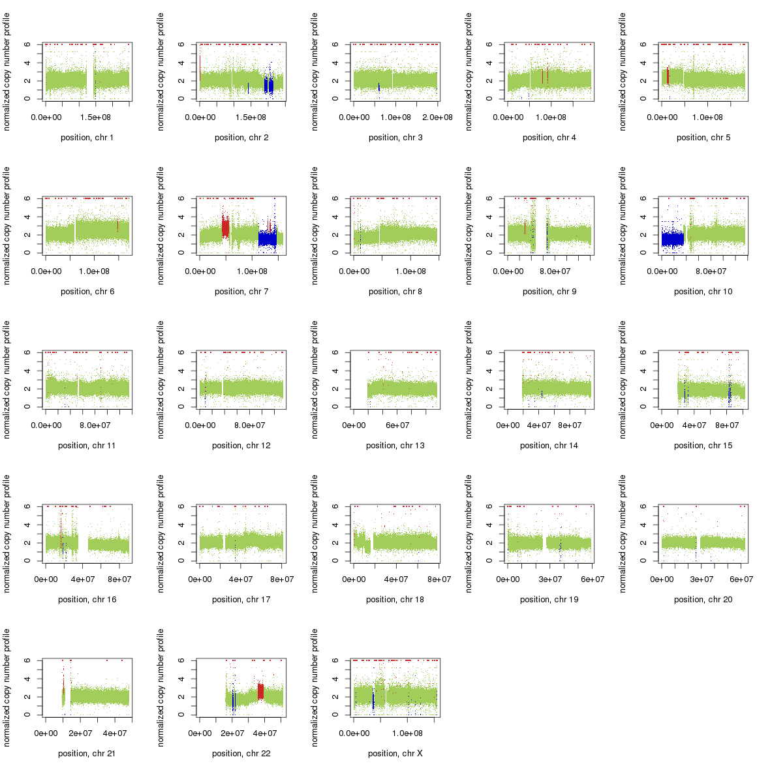
Figure S3. Copy number variation (CNV) changes in PC-9/ER compared to PC-9/S1 by Control-FREEC. Red: CNV gain; blue: CNV loss; green: no change.

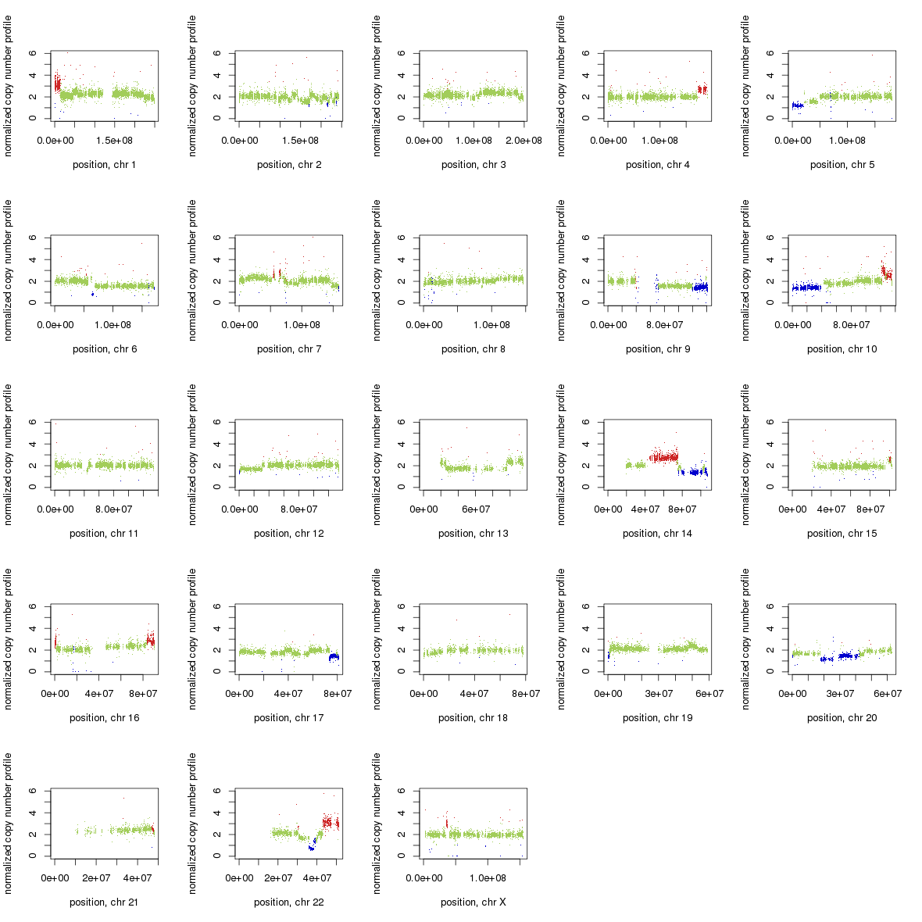
Figure S4. Copy number variation (CNV) changes in PC-9/BRc1 compared to PC-9/S2. Red: CNV gain; blue: CNV loss; green: no change.

Figure S5. Effect of erlotinib and WZ4002 (T790M-specific small molecule) on the growth of HCC827 (A), HCC827/R1 (B), and HCC827/R2 (C) cells. The data suggest that HCC827/R1 but not HCC827/R2 cells still depend upon EGFR signaling for survival.

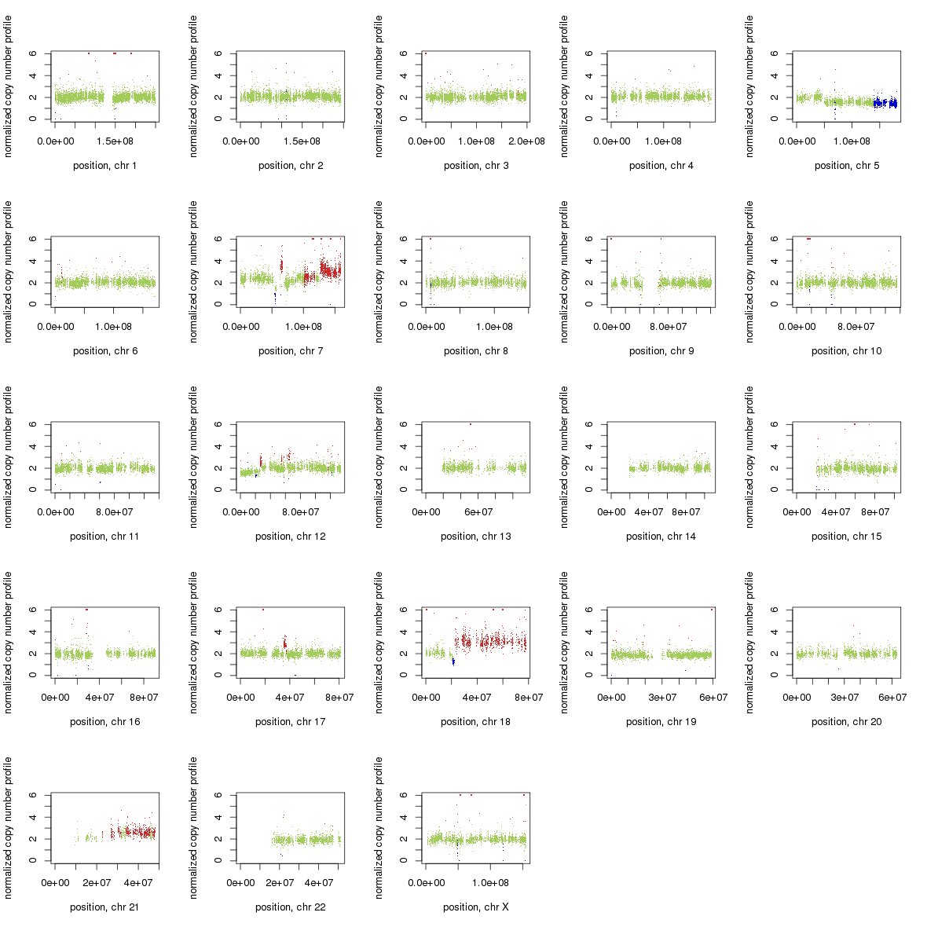
Figure S6. Copy number variation (CNV) changes in HCC827/R1 compared to HCC827. Red: CNV gain; blue: CNV loss; green: no change.

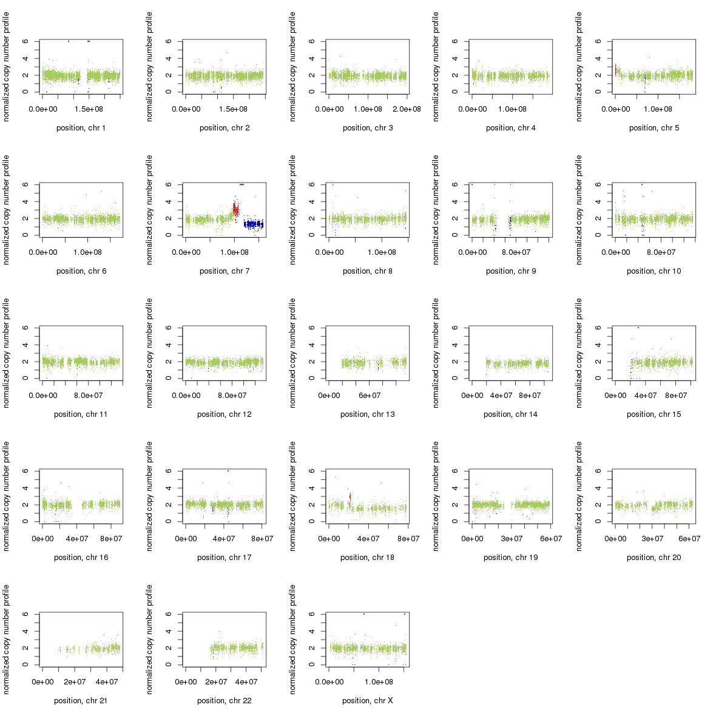
Figure S7. Copy number variation (CNV) changes in HCC827/R2 compared to HCC827. Red: CNV gain; blue: CNV loss; green: no change.

Figure S8. Effect of erlotinib and WZ4002 (T790M-specific small molecule) on the growth of HCC4006 (A) and HCC4006/ER (B) cells.

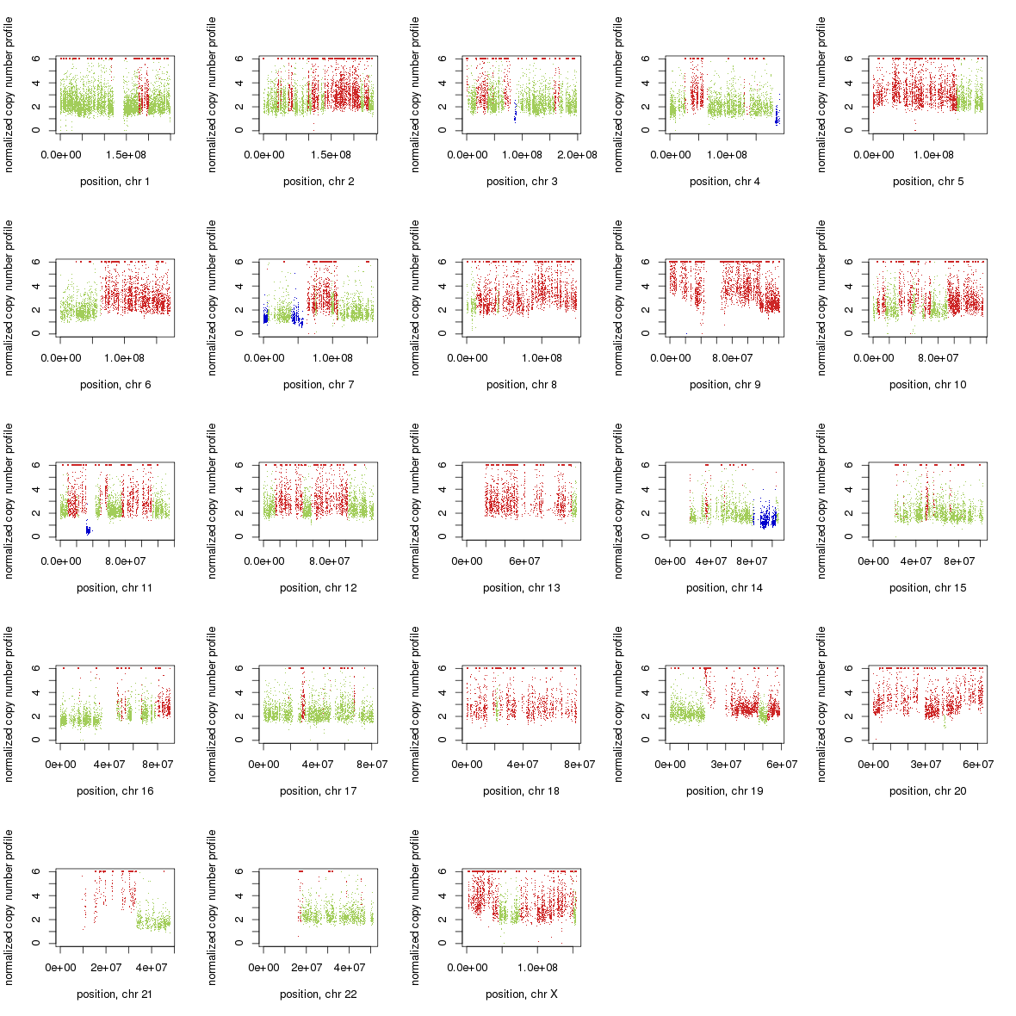
Figure S9. Copy number variation (CNV) changes in HCC4006/ER compared to HCC4006. Red: CNV gain; blue: CNV loss; green: no change.

(A). EGFR (NM_005228) in PC-9/ER, PC-9/BRc1 and HCC827/R1(validated) | (B). HIPK3 (NM_005734) in HCC827/R2  (validated)
(C). MAP3K3 (NM_203351) in PC-9/S2 | (D). MAP3K4 (NM_005922) in PC-9/ER
(E). TBCK (NM_033115) in HCC827/R1 | (F). TESK2 (NM_007170) in HCC4006 (validated)

Figure S10. Illustration of location of mutations in kinase genes detected in the cell lines.

