Supplement to: Integrative phenomics reveals insight into the structure of phenotypic diversity in budding yeast

Daniel A. Skelly¹, Gennifer E. Merrihew¹, Michael Riffle², Caitlin F. Connelly¹, Emily O. Kerr¹, Marnie Johansson¹, Daniel Jaschob², Beth Graczyk², Nicholas J. Shulman², Jon Wakefield^{3,4}, Sara J. Cooper^{1,†}, Stanley Fields^{1,5}, William S. Noble^{1,6}, Eric G. D. Muller², Trisha N. Davis², Maitreya J. Dunham^{1*}, Michael J. MacCoss^{1*}, and Joshua M. Akey^{1*}
¹Department of Genome Sciences, University of Washington, Seattle, WA, 98195, USA.
²Department of Biochemistry, University of Washington, Seattle, WA, 98195, USA.
³Department of Biostatistics, University of Washington, Seattle, WA, 98195, USA.
⁴Department of Statistics, University of Washington, Seattle, WA, 98195, USA.
⁵Howard Hughes Medical Institute, University of Washington, Seattle, WA, 98195, USA.
⁶Department of Computer Science and Engineering, University of Washington, Seattle, WA, 98195, USA.
*Correspondence to: akeyj@uw.edu (J.M.A.); maitreya@uw.edu (M.J.D.); maccoss@uw.edu (M.J.M)
†Present address: HudsonAlpha Institute for Biotechnology, 601 Genome Way, Huntsville, AL, 35806 USA.

Supplementary Figures 1-6

Supplementary Tables 1-8

Supplementary Note

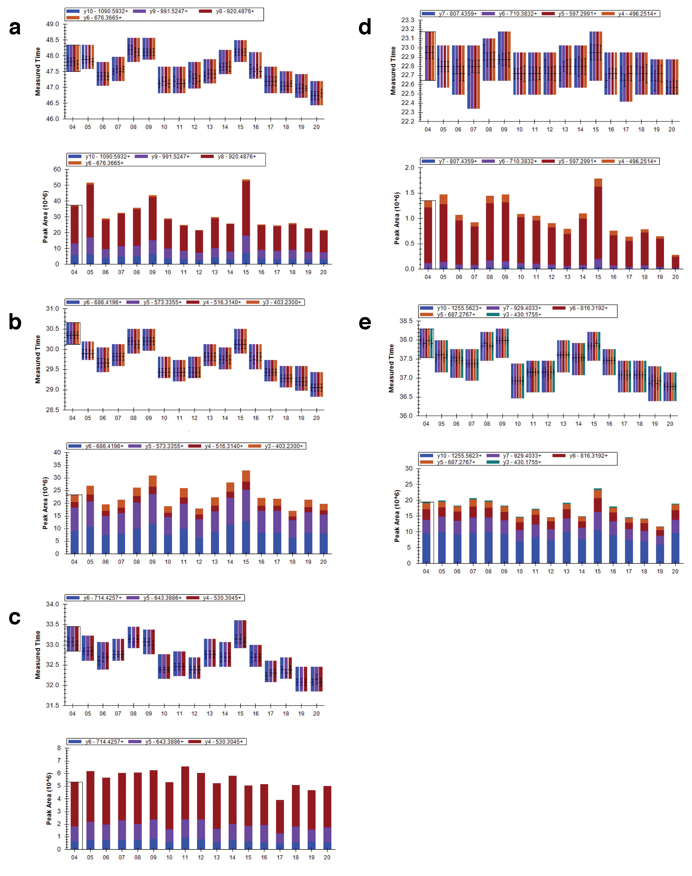

Supplementary Figure 1: Comparison of retention time and peak area for quality control peptides. Plots were generated using Skyline software (MacLean et al. 2010). For all panels, replicates are plotted across the x-axis. For each subpanel, top panel shows the retention time in minutes of the peptide’s fragment ions over the 17 replicates and bottom panel shows the peak area of the peptide’s fragment ions over the 17 replicates. (a) bovine alpha casein peptide R.FFVAPFPEVFGK.E for quality control mass spectrometry replicates 4-20. (b) bovine glutamate dehydrogenase peptide K.YNLGLDLR.T for quality control mass spectrometry replicates 4-20. (c) bovine lactoperoxidase peptide K.IHGFDLAAINLQR.C for quality control mass spectrometry replicates 4-20. (d) bovine carbonic anhydrase peptide K.DGPLTGTYR.L for quality control mass spectrometry replicates 4-20. (e) bovine beta lactoglobulin peptide R.LSFNPTQLEEQCHI.- for quality control mass spectrometry replicates 4-20.

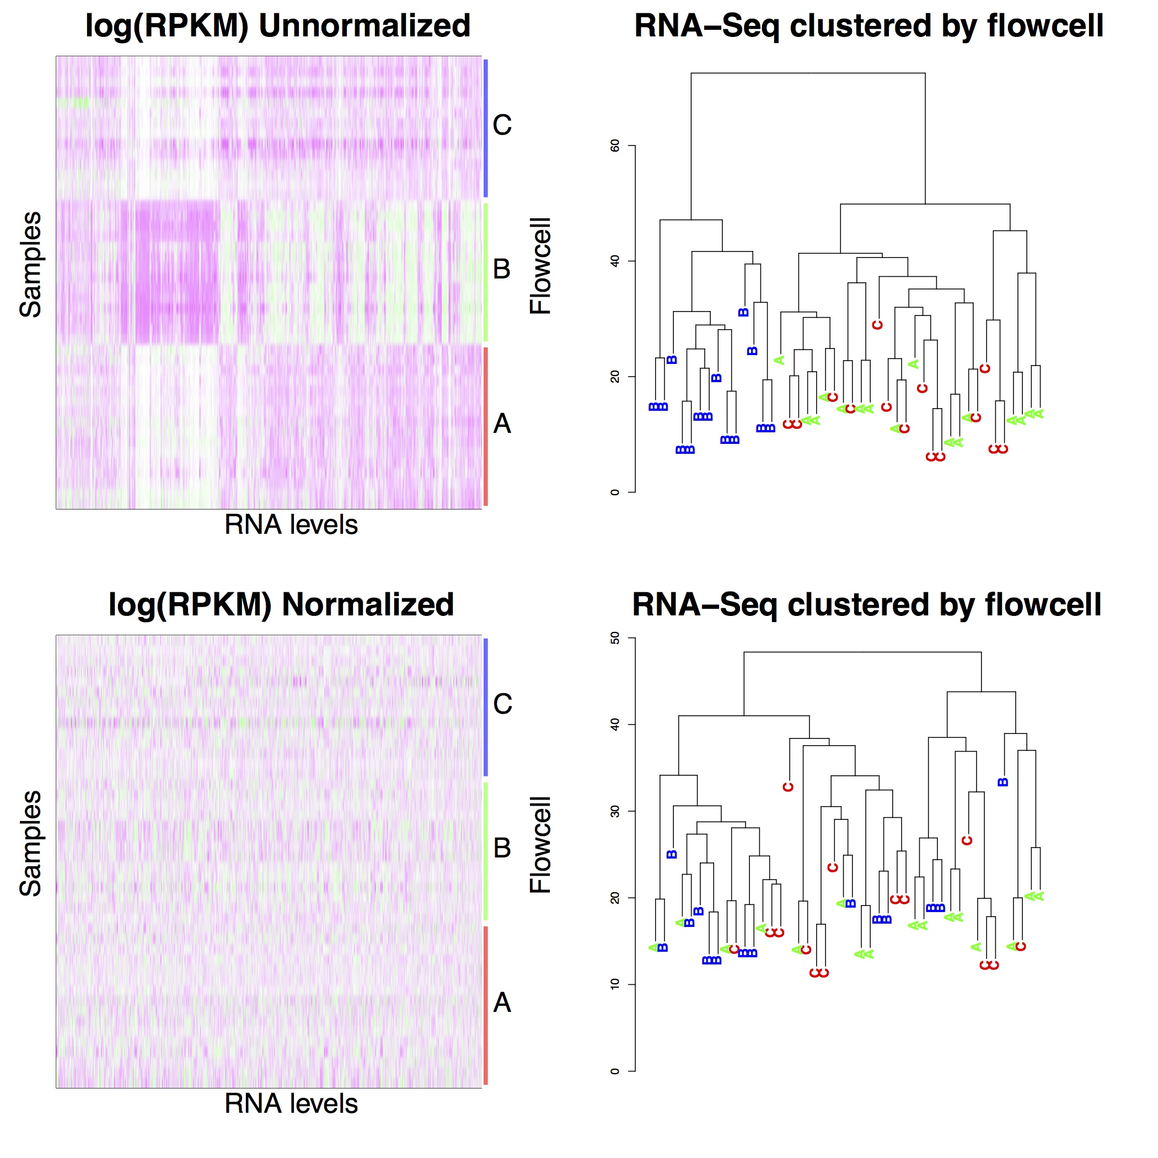

Supplementary Figure 2: Flowcell batch effect in RNA-Seq data. Heatmaps on left show gene expression levels for all genes, grouped by RNA-Seq flowcell. Magenta indicates lower expression, green higher expression, and white intermediate expression. Dendrograms on right show samples clustered using a simple distance metric, and labeled by their flowcell of origin. Top two panels show unnormalized RNA-Seq data. A prominent flowcell effect is visible, where samples from flowcell B have distinct patterns of expression and cluster separately from samples originating from flowcells A or C. Bottom two panels show normalized RNA-Seq data. Samples from flowcell B no longer have distinct expression patterns, and are interspersed with other samples in the dendrogram at the lower right.

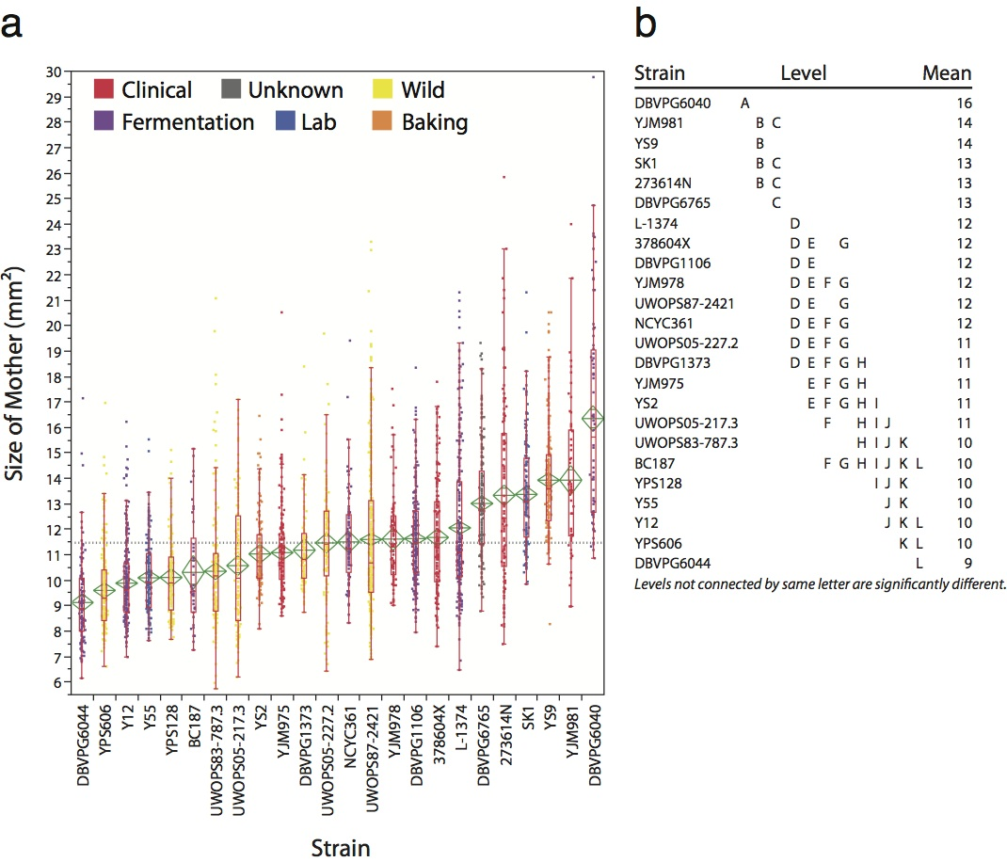

Supplementary Figure 3: Size Distribution of Saccharomyces cerevisiae. (a) Each dot represents the measurement of a unique cell using Calmorph software (Ohya et al. 2005). Only the size of the mother cell of small and medium budded cells is reported. This assures that all strains are in the same (S/G2) stage of the cell cycle at a time when most cell growth is directed to the emerging bud. Colors reflect the source of the strain. The centers of the green diamonds show the mean, while the upper and lower vertices represent the 95% confidence interval. The red outlier box plot shows the median as a red line within the box and the ends of the box represent the 25-75% quartiles. The whiskers are 1.5 × quartiles. (b) A Tukey-Kramer HSD comparison test was performed with a 95% alpha-level for all pair-wise differences among the means As indicated, levels not connected by the same letter are significantly different. A separate nonparametric analysis of the means with transformed ranks showed that all strains in the group designated “E” are not significantly different (95% confidence) from the grand mean, while those with letters either before or after “E” are significantly larger or smaller, respectively, than the grand mean. For this figure all statistical analysis was performed using JMP® software.

Supplementary Figure 4: Plot shows type I error rate for detecting true cis-associations in simulated data. The mean observed type I error rate from 1,000 simulations is plotted versus the expected type I error rate for association tests done using a simple t-test (blue) and EMMA (Kang et al. 2008) (red). The theoretical expectation in the absence of population structure is shown as a dashed line. Inset shows detail of the observed vs. expected type I error rates at low expected error rates.

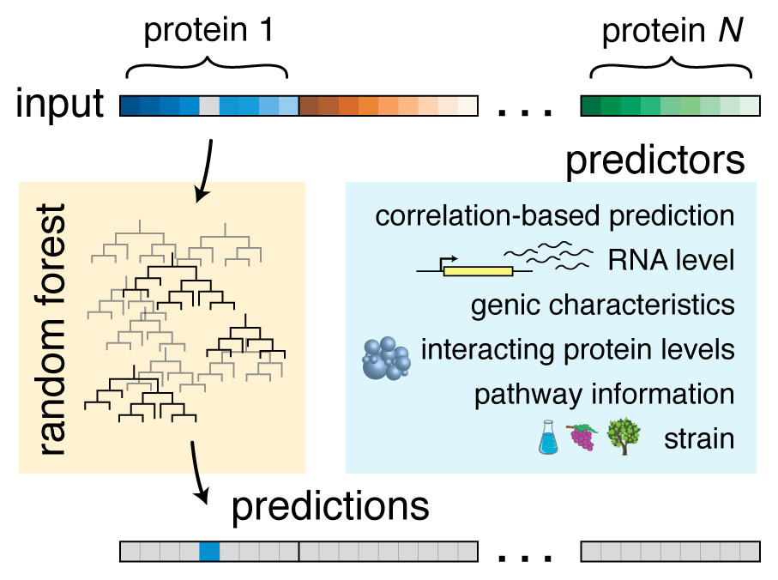

Supplementary Figure 5: Schematic outlining our approach to predicting abundance of one protein in one strain. Across top, a vector of phenotype × strain measurements is used to train the random forest model. On right, predictor variables included in the model. Along bottom, a prediction for the missing square at top (gray) is shown in blue.

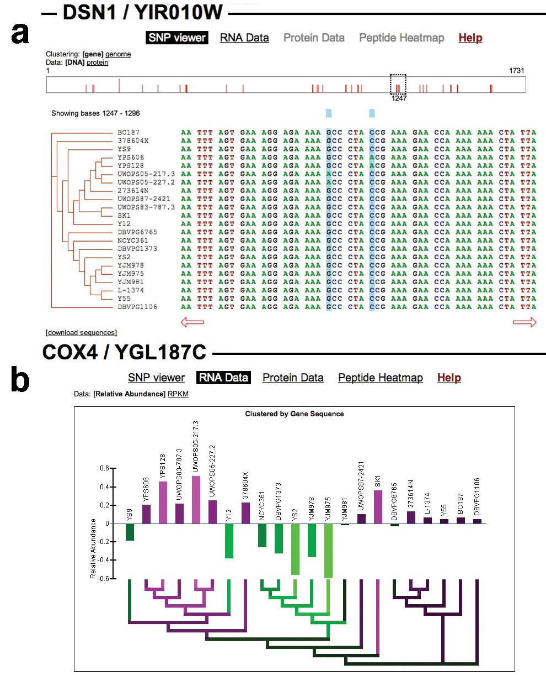

Supplementary Figure 6: Sample screenshots from data accessibility web application. (a) A screen shot of the SNP viewer we developed, here depicting the gene DSN1. SNP viewer can display either DNA or protein sequences. Phylogeny at left shows approximate genealogical relationships between strains. At the top left, this clustering can be toggled between gene and genome sequence, indicating a phylogeny built using only the sequence of the gene in question and 500 bp upstream and downstream (“gene”) versus the complete genome sequences of the strains (“genome”). The rectangle area below these links represents the sequence, and red bars in this area represent locations of SNPs or amino acid polymorphisms, depending on whether DNA or protein sequences are displayed. In the case of DNA, dark red lines represent non-silent mutations and light red lines represent silent mutations. In the case of protein sequence, the lines are colored such that darker red indicates more significant variation as determined by a comparison among all strains using the BLOSUM80 scoring matrix at that position. Users may click anywhere in this rectangle to shift the viewing window to that location in the sequence. The dashed rectangle on this bar indicates the location of the current viewing window and may, itself, be clicked on and dragged to any location in the sequence. (b) A screen shot visualizing the relative abundance of RNA levels of the gene COX4 across strains. Phylogeny below shows approximate genealogical relationships between strains. At the top left, this clustering can be toggled between gene and genome sequence, as in (a). Users may choose to view the data as “relative abundance” (derived from the statistical model described in the “Methods” section) or as absolute abundance as measured by RPKM. The bars are colored such that bright magenta represents values above the mean and bright green represents values below the mean. These colors extend into the dendrogram so that patterns may be observed more easily in a phylogenetic context.

Supplementary Table 1: Brief information about strains used in this study. For more detailed information on these strains, see Liti et al. (2009). Checkmarks indicate that data of the specified type was collected for the strain in question in this study.
Strain name | Location isolated | Source | Strain type | DNA | RNA | protein | metabolite | morphology
273614N | Newcastle, UK | fecal | clinical | ✓ | ✓ | ✓ | ✓ | ✓
378604X | Newcastle, UK | sputum | clinical | ✓ | ✓ | ✓ |  | ✓
BC187 | Napa Valley, CA | barrel | fermentation | ✓ | ✓ | ✓ | ✓ | ✓
DBVPG1106 | Australia | grapes | fermentation | ✓ | ✓ | ✓ | ✓ | ✓
DBVPG1373 | Netherlands | soil | wild | ✓ | ✓ | ✓ | ✓ | ✓
DBVPG6040¹ | Netherlands | juice | fermentation |  |  | ✓ |  | ✓
DBVPG6044¹ | West Africa | bili wine | fermentation |  |  | ✓ | ✓ | ✓
DBVPG6765 | unknown | - | - | ✓ | ✓ | ✓ | ✓ | ✓
K11² | Japan | sake | fermentation | ✓ | ✓ | ✓ | ✓ | ✓
L-1374 | Chile | must | fermentation | ✓ | ✓ | ✓ | ✓ | ✓
NCYC361 | Ireland | wort | fermentation | ✓ | ✓ | ✓ | ✓ | ✓
SK1 | USA | soil | lab | ✓ | ✓ | ✓ | ✓ | ✓
UWOPS05-217.3 | Malaysia | plant | wild | ✓ | ✓ | ✓ | ✓ | ✓
UWOPS05-227.2 | Malaysia | bee | wild | ✓ | ✓ | ✓ | ✓ | ✓
UWOPS83-787.3 | Bahamas | fruit | wild | ✓ | ✓ | ✓ | ✓ | ✓
UWOPS87-2421 | Hawaii | plant | wild | ✓ | ✓ | ✓ | ✓ | ✓
Y12 | Africa | palm wine | fermentation | ✓ | ✓ | ✓ | ✓ | ✓
Y55 | France | grape | lab | ✓ | ✓ | ✓ | ✓ | ✓
YJM975 | Bergamo, Italy | vaginal | clinical | ✓ | ✓ | ✓ | ✓ | ✓
YJM978 | Bergamo, Italy | vaginal | clinical | ✓ | ✓ | ✓ | ✓ | ✓
YJM981 | Bergamo, Italy | vaginal | clinical | ✓ | ✓ | ✓ | ✓ | ✓
YPS128 | Pennsylvania | oak tree | wild | ✓ | ✓ | ✓ | ✓ | ✓
YPS606 | Pennsylvania | oak tree | wild | ✓ | ✓ | ✓ | ✓ | ✓
YS2 | Australia | - | baking | ✓ | ✓ | ✓ | ✓ | ✓
YS9 | Singapore | - | baking | ✓ | ✓ | ✓ | ✓ | ✓

¹ We obtained partial data for strains DBVPG6040 and DBVPG6044. Due to difficulties with chemostat growth, we obtained only one sample of each strain.
² Strain K11 was determined not to be phosphate limited (Supplementary Note) and was not included in phenomics analyses, with the exception of analyses searching for novel and unconfirmed biomolecules.

Supplementary Table 2: Table of five bovine peptides used for quality control of chromatography during mass spectrometry analysis.

Protein | Peptide | Precursor  Ion Mass | Fragment Ion | Fragment  Ion Mass
alpha casein | R.FFVAPFPEVFGK.E | 692.8686 (++) | y10  y9  y8  y6 | 1090.5932 (+)  991.5247 (+)  920.4876 (+)  676.3665 (+)
glutamate dehydrogenase | K.YNLGLDLR.T | 482.2665 (++) | y6  y5  y4  y3 | 686.4196 (+)  573.3355 (+)  516.3140 (+)  403.2300 (+)
lactoperoxidase | K.IHGFDLAAINLQR.C | 489.9404 (++) | y6  y5  y4 | 714.4257 (+)  643.3886 (+)  530.3045 (+)
carbonic anhydrase | K.DGPLTGTYR.L | 490.2458 (++) | y7  y6  y5  y4 | 807.4359 (+)  710.3832 (+)  597.2991 (+)  496.2514 (+)
beta lactoglobulin | R.LSFNPTQLEEQCHI.- | 858.8985 (++) | y10  y7  y6  y5  y3 | 1255.5623 (+)  929.4033 (+)  816.3192 (+)  687.2767 (+)  430.1755 (+)

Supplementary Table 3: List of metabolites measured in the study that passed filtering criteria detailed in Supplementary Note. Blank fields indicate unknown or uncertain values.

See additional file SupplementaryTable3.xlsx.

Supplementary Table 4: List of terms showing significant Gene Ontology enrichment for genes with most variable RNA and protein levels. Terms tested were gathered from Gene Ontology annotations, GO-Slim annotations, and protein complex annotations (Cherry et al. 2012).

Data type | term | p-value  (Bonferroni  corrected)
RNA | mitochondrial envelope | 2.81e-09
RNA | cellular respiration | 2.44e-07
RNA | mitochondrial translation | 4.68e-07
RNA | mitochondrial translation | 1.65e-06
RNA | mitochondrial respiratory chain complex III | 2.72e-06
RNA | mitochondrial respiratory chain complex III | 2.72e-06
RNA | ATP synthesis coupled proton transport | 1.45e-05
RNA | mitochondrial proton-transporting ATP synthase complex | 2.54e-05
RNA | ubiquinol-cytochrome-c reductase activity | 6.1e-05
RNA | generation of precursor metabolites and energy | 0.00013
RNA | respiratory chain | 0.00022
RNA | mitochondrial electron transport, ubiquinol to cytochrome c | 0.000318
RNA | mitochondrial proton-transporting ATP synthase complex, coupling factor F(o) | 0.000619
RNA | aerobic respiration | 0.00135
RNA | mitochondrial ribosome | 0.00173
protein | generation of precursor metabolites and energy | 0.00177
RNA | proton-transporting ATPase activity, rotational mechanism | 0.00184
protein | mitochondrial envelope | 0.0037
RNA | ATP biosynthetic process | 0.00534
RNA | Group I intron splicing | 0.00553
RNA | hydrogen ion transporting ATP synthase activity, rotational mechanism | 0.00724
protein | oligosaccharide metabolic process | 0.00881
RNA | mitochondrial proton-transporting ATP synthase complex, coupling factor F(o) | 0.00988
RNA | proton-transporting ATP synthase complex, coupling factor F(o) | 0.00988
protein | trehalose biosynthetic process | 0.0162
RNA | electron transport chain | 0.0189
RNA | mitochondrial proton-transporting ATP synthase, stator stalk | 0.025
RNA | mitochondrial proton-transporting ATP synthase, stator stalk | 0.025
protein | cytochrome-c oxidase activity | 0.0264
protein | mitochondrial respiratory chain complex IV | 0.0264
protein | mitochondrial respiratory chain complex IV | 0.0264
RNA | proton transport | 0.0352

Supplementary Table 5: Power to detect associations of a variety of effect sizes. α levels shown are not corrected for multiple testing. For the peptide association tests we performed, an α level of 0.001 corresponds to approximately a 5% FDR. For the RNA association tests we performed, an α level of 0.005 corresponds to approximately a 5% FDR.

Effect size  (% variance explained) | α Level | Power
0.25 | 0.05 | 0.788
0.25 | 0.005 | 0.467
0.25 | 0.001 | 0.274
0.25 | 1 × 10⁻⁵ | 0.022
0.5 | 0.05 | 0.986
0.5 | 0.005 | 0.908
0.5 | 0.001 | 0.817
0.5 | 1 × 10⁻⁵ | 0.389
0.75 | 0.05 | 1.000
0.75 | 0.005 | 0.998
0.75 | 0.001 | 0.995
0.75 | 1 × 10⁻⁵ | 0.925

Supplementary Table 6: List of terms showing significant Gene Ontology enrichment for genes with RNA or protein levels among the top 50 most highly correlated. Top 50 most highly correlated genes were defined by ranking genes by the number of significant correlations to other phenotypes. Terms tested were gathered from Gene Ontology annotations, GO-Slim annotations, and protein complex annotations (Cherry et al. 2012).

Data type | Term | p-value  (Bonferroni  corrected)
Protein | mitochondrial envelope | 2.05e-18
Protein | generation of precursor metabolites and energy | 8.29e-09
Protein | respiratory chain | 1.62e-08
RNA | generation of precursor metabolites and energy | 1.09e-07
Protein | cellular respiration | 5.58e-07
Protein | mitochondrial respiratory chain complex III | 2.58e-06
Protein | aerobic respiration | 4.05e-06
Protein | ATP synthesis coupled proton transport | 6.24e-05
Protein | mitochondrial proton-transporting ATP synthase complex | 6.24e-05
Protein | mitochondrial electron transport, ubiquinol to cytochrome c | 6.75e-05
Protein | ubiquinol-cytochrome-c reductase activity | 6.75e-05
Protein | cytochrome-c oxidase activity | 7.11e-05
Protein | mitochondrial respiratory chain complex IV | 7.11e-05
Protein | electron transport chain | 0.000179
RNA | cellular respiration | 0.000185
Protein | glycogen biosynthetic process | 0.00023
Protein | mitochondrial electron transport, cytochrome c to oxygen | 0.00023
Protein | hydrogen ion transporting ATP synthase activity, rotational mechanism | 0.00091
Protein | mitochondrial proton-transporting ATP synthase complex, coupling factor F(o) | 0.00254
RNA | respiratory chain | 0.00264
Protein | ATP biosynthetic process | 0.00503
Protein | mitochondrial proton-transporting ATP synthase, stator stalk | 0.0101
Protein | proton transport | 0.013
Protein | proton-transporting ATPase activity, rotational mechanism | 0.0238
RNA | mitochondrial respiratory chain complex III | 0.0268
RNA | mitochondrial electron transport, ubiquinol to cytochrome c | 0.0268
Protein | transmembrane transport | 0.0344
Protein | proton-transporting ATP synthase complex, coupling factor F(o) | 0.0381

Supplementary Table 7: List of terms showing significant Gene Ontology enrichment for genes with RNA and protein levels that were well predicted in our correlation-based predictions. For these well-predicted genes, our predictions explained at least 50% of interstrain variation. Terms tested were gathered from Gene Ontology annotations, GO-Slim annotations, and protein complex annotations (Cherry et al. 2012).

Prediction type | Term | p-value  (Bonferroni  corrected)
All traits | mitochondrial translation | 2.63e-24
All traits | mitochondrial ribosome | 9.86e-23
Tag traits | mitochondrial translation | 1.2e-19
All traits | translation | 3.06e-17
Tag traits | mitochondrial envelope | 2.33e-15
Tag traits | ribosome biogenesis | 5.25e-15
All traits | ribosome biogenesis | 4.68e-14
All traits | structural constituent of ribosome | 1.81e-13
Tag traits | mitochondrial ribosome | 5.01e-13
Tag traits | translation | 9.69e-13
All traits | mitochondrial envelope | 2.49e-12
All traits | preribosome | 8.72e-12
All traits | mitochondrial large ribosomal subunit | 2.71e-11
Tag traits | mitochondrial small ribosomal subunit | 3.73e-10
Tag traits | preribosome | 6.43e-10
Tag traits | tRNA aminoacylation for protein translation | 1.03e-09
Tag traits | cellular respiration | 2.32e-09
All traits | mitochondrial small ribosomal subunit | 2.74e-09
Tag traits | aminoacyl-tRNA ligase activity | 6.53e-09
All traits | tRNA aminoacylation for protein translation | 1.06e-08
Tag traits | generation of precursor metabolites and energy | 1.06e-08
All traits | aminoacyl-tRNA ligase activity | 1.11e-08
Tag traits | ATP synthesis coupled proton transport | 5.08e-08
All traits | large ribosomal subunit | 6.74e-08
Tag traits | structural constituent of ribosome | 1.46e-07
All traits | cellular amino acid metabolic process | 1.85e-07
Tag traits | mitochondrial proton-transporting ATP synthase complex | 2.64e-07
All traits | mitochondrial matrix | 9.08e-07
All traits | generation of precursor metabolites and energy | 1.52e-06
All traits | cellular respiration | 3.99e-06
All traits | 90S preribosome | 1.27e-05
Tag traits | mitochondrial matrix | 1.58e-05
Tag traits | 90S preribosome | 2.74e-05
All traits | mitochondrial proton-transporting ATP synthase complex | 2.76e-05
All traits | ribosomal large subunit biogenesis | 3.45e-05
All traits | ATP synthesis coupled proton transport | 0.000103
All traits | cytochrome-c oxidase activity | 0.000136
Tag traits | respiratory chain | 0.000173
Tag traits | ATP biosynthetic process | 0.000178
All traits | nucleobase-containing small molecule metabolic process | 0.000272
Tag traits | mitochondrial respiratory chain complex IV | 0.000278
Tag traits | mitochondrial proton-transporting ATP synthase complex, coupling factor F(o) | 0.000404
All traits | endonucleolytic cleavage in ITS1 to separate SSU-rRNA from 5.8S rRNA and LSU-rRNA from tricistronic rRNA transcript (SSU-rRNA, 5.8S rRNA, LSU-rRNA) | 0.000459
Tag traits | mitochondrial respiratory chain complex III | 0.000489
Tag traits | hydrogen ion transporting ATP synthase activity, rotational mechanism | 0.000511
Tag traits | preribosome, large subunit precursor | 0.000586
Tag traits | ribosomal large subunit biogenesis | 0.000787
Tag traits | ribosomal small subunit biogenesis | 0.000827
Tag traits | mitochondrial large ribosomal subunit | 0.0016
All traits | preribosome, large subunit precursor | 0.00165
All traits | small-subunit processome | 0.00226
Tag traits | proton-transporting ATP synthase complex, coupling factor F(o) | 0.00234
Tag traits | mitochondrial electron transport, ubiquinol to cytochrome c | 0.00234
Tag traits | ubiquinol-cytochrome-c reductase activity | 0.00305
Tag traits | cellular amino acid metabolic process | 0.00767
Tag traits | mitochondrial electron transport, cytochrome c to oxygen | 0.00815
All traits | ribosomal small subunit biogenesis | 0.0134
All traits | hydrogen ion transporting ATP synthase activity, rotational mechanism | 0.0194
All traits | endonucleolytic cleavage to generate mature 5'-end of SSU-rRNA from (SSU-rRNA, 5.8S rRNA, LSU-rRNA) | 0.0267
Tag traits | cytochrome-c oxidase activity | 0.0286
Tag traits | proton-transporting ATPase activity, rotational mechanism | 0.0314
All traits | endonucleolytic cleavage in 5'-ETS of tricistronic rRNA transcript (SSU-rRNA, 5.8S rRNA, LSU-rRNA) | 0.0358
All traits | ligase activity | 0.0376
All traits | aerobic respiration | 0.038
All traits | cofactor metabolic process | 0.0488

Supplementary Table 8: Most informative predictors for expanded model of RNA and protein levels. “Globally” and “Locally” related strains are as described in the Supplementary Note.

Prediction  type | Predictor | % Increase in MSE  upon withholding  predictor from model
RNA | Correlation-based predictions | 261.4
RNA | Protein level for gene | 159
RNA | Strain | 128.8
RNA | RNA level of globally-related strain | 82.3
RNA | RNA level of locally-related strain | 64
RNA | Protein level of globally-related strain | 32.5
RNA | Protein level of locally-related strain | 29.9
RNA | RNA levels for genes in same pathways | 27.6
RNA | GC content of gene | 22.1
RNA | Protein levels for genes in same pathways | 21.1
Protein | RNA level for gene | 172.7
Protein | Strain | 105.5
Protein | Protein level of globally-related strain | 100.2
Protein | Protein level of locally-related strain | 52.3
Protein | Correlation-based predictions | 45.5
Protein | RNA level of globally-related strain | 37.1
Protein | Protein level of predicted interacting proteins | 25.7
Protein | RNA level of locally-related strain | 24.6
Protein | Protein levels for genes in same pathways | 19
Protein | Codon bias | 18.8

Supplementary Note
1. Experimental details 19
1.1. Yeast strains 19
1.2. Chemostat growth 19
1.3. Phosphate limitation of K11 20
1.4. Sanger sequencing for validation of SNP calls 21
1.5. Quantitative proteomics 21
1.6. Metabolite profiling 22
1.7. Cell fixation and staining for morphology measurements 23
2. Algorithmic details 23
2.1. Genotyping and Comparison to Imputation of Liti et al. (2009) 23
2.2. Preparing strain-specific reference genomes and peptide databases 24
2.3. Phylogeny construction 24
2.4. Estimating genomic DNA contamination in RNA-Seq data 25
2.5. Obtaining quantitative measures of peptide abundance 25
2.6. Obtaining quantitative measures of metabolite abundance 26
2.7. Image processing for morphology measurements 27
2.8. Normalization and data analysis 27
2.9. Potential aneuploidies 30
2.10. Simulations to assess power and false positive rate for association tests 30
2.11. Details of tests for cis-association 30
2.12. Predicting phenotypic variation 31
3. Details of Figure 2c 33
4. Data dissemination 33
5. References 34

Experimental details

Yeast strains
We purchased strains used in Liti et al. (2009) from the National Collection of Yeast Cultures (http://www.ncyc.co.uk/sgrp.html). We confirmed strains as haploid through mating tests or made them haploid by integrating a KanMX cassette at the HO locus, sporulating the transformants, and isolating haploid spores. We confirmed that the cassette had integrated at the HO locus through PCR using one primer flanking the cassette and one inside the cassette. Supplemental Table 1 provides a brief overview of the strains we studied. For more detailed information, see Liti et al. (2009).

Chemostat growth
We streaked strains from −80°C freezer stocks in batches of 6-10 strains at a time onto YPD plates. Strains were randomly allocated into batches allowing for two biological replicates per strain. We put the plates at 30°C for 2 days before picking single colonies to grow overnight in 3 ml YPD. We inoculated chemostats with 1 ml YPD culture, and allowed growth for 24 hours before beginning continuous culture. Chemostat media was phosphate limited, and contained the following per liter: 100 mg calcium chloride, 100 mg sodium chloride, 500 mg magnesium sulfate, 5 g ammonium sulfate, 1 g potassium chloride, 10 mg potassium phosphate, 500 µg boric acid, 40 µg copper sulfate, 100 µg potassium iodide, 200 µg ferric chloride, 400 µg manganese sulfate, 200 µg sodium molybdate, 400 µg zinc sulfate, 2 µg biotin, 400 µg calcium pantothenate, 2 µg folic acid, 2 mg inositol, 400 µg niacin, 200 µg p-aminobenzoic acid, 400 µg pyridoxine, 200 µg riboflavin, 400 µg thiamine, and 5 g glucose.

We maintained a dilution rate of 0.17 +/− .01 volumes per hour for 3-4 days, until cultures were deemed to have reached steady state. We defined steady state as stabilizing to within 10% of the previous day’s density measurements. In order to quantify steady state we used measurements by Klett colorimeter and by OD₆₀₀, using the same instruments each time for consistency. To avoid any perturbation, we took sample culture passively at the effluent port. If the culture density stabilized, we harvested the chemostat and used the samples for RNA, protein, metabolite, and microscopy studies. We repeated the above schedule for all strains, such that replicates were harvested, in most cases, in less than 25 generations. Some strains required increased inoculum (2ml) and a slightly extended timeline (up to 32 generations) to reach steady state. At harvest, we took the following samples (in the order listed):
- 3 ml effluent (passively collected) for microscopy.
- 50 ml culture for RNA-Seq. We immediately (within one minute of initial culture perturbation) filtered the sample, froze cells using liquid nitrogen, and stored at −80°C until processing.
- 50 ml culture for protein analysis. We pelleted at 4°C, washed in cold 50 mM ammonium bicarbonate pH 7.8, re-pelleted, and froze the sample using liquid nitrogen at −80°C until processing.
- 50 ml culture for metabolite analysis, which was processed immediately.

Phosphate limitation of K11
One of the strains we grew in chemostats and for which we obtained phenotypic data was strain K11 (Supplemental Table 1). Upon examining RNA-Seq data, we noted that this strain showed dramatically divergent gene expression from the remaining strains. Specifically, we noted many more differentially expressed genes in pairwise comparisons that included K11. We used k-means clustering on a gene-by-gene basis to search for genes where both replicates of K11 clustered together and separately from all other strains. We found that many of these genes included phosphate transporters (with K11 having lower expression than all other strains), suggesting that strain K11 was not phosphate limited. We grew K11 and S288c (as a control) to steady state in chemostat cultures fed either 10 mg/L or 20 mg/L potassium phosphate monobasic. We measured final culture densities by spectrophotometry at 600 nm, klett colorimeter, and dry weight. For S288c, which has previously been shown to be phosphate limited at this phosphate concentration, the density approximately doubled in proportion to the doubling in phosphate, as expected. K11 showed no increase in density, indicating that an unknown nutrient is limiting. We thus excluded K11 from all further analyses.

Sanger sequencing for validation of SNP calls
We sequenced nine randomly chosen regions across seven chromosomes in two strains (NCYC361 and UWOPS83-787.3) in order to validate our short-read genotype calls in regions of imputed sequence (Liti et al. 2009). These two strains are among the most genetically diverse of all the strains we studied and have among the most imputed sequence of any strain. The regions we chose totaled 5.9 kb in size and overlapped 86 imputed SNPs, where our short-read genotyping calls disagreed with the imputed genotype in 41 cases. We grew strains to mid-log phase (OD₆₆₀ 0.8–1.0) in yeast extract peptone dextrose and extracted DNA using the MasterPure Yeast DNA purification kit (Epicentre). We designed primers using the program Primer3 (Rozen and Skaletsky 2000) and sequenced the regions using Sanger sequencing on an ABI 3130xl machine. The regions from which we obtained high-quality sequence were: chrV:240884-241529, chrIX:399255-400030, chrX:48040-48719, chrX:678485-679128, chrXI:588177-588789, chrXIII:332837-333434, chrXIII:900894-901537, chrXV:642438-643100, and chrXVI:840028-840694. We aligned each Sanger sequence read to strain-specific reference genomes using the program SMALT (http://www.sanger.ac.uk/resources/software/smalt/) and found 100% concordance with genotyping calls made using short-read data. There were small insertions/deletions apparent in the Sanger sequence reads (relative to the strain-specific reference genome), but we did not attempt to call these variants using short-read data.

Quantitative proteomics

Lysis
Beginning with aliquots from samples taken from our chemostats, we lysed in batches of 5-10 samples. We pelleted aliquots of 40 ml of cells for each sample by centrifugation for 3 minutes at 2,000 rpm. We resuspended cells in 0.7 ml of 50 mM ammonium bicarbonate pH 7.8 and lysed with 0.7 ml glass beads by vortexing at speed 8-9 for 20-30 minutes in cold room until complete lysis. We first centrifuged lysate at 5,000 × g for 5 minutes at 4°C to clear debris, and then centrifuged again at 100,000 × g for one hour at 4°C to separate soluble and insoluble fractions.

Digestion
We digested samples in three different randomized batches. We resolubilized the insoluble pellet using 0.1% RapiGest (Waters Corporation) in 50 mM ammonium bicarbonate pH 7.8 and sonicated for 20 seconds at speed #3 followed by 5 minutes of heat at 100 °C. After the samples were cooled, we used a BCA protein assay (Pierce) to measure the protein concentration. We then reduced samples with DTT (dithiothreitol), alkylated with IAA (iodoacetic acid) and digested with sequence modified trypsin (Promega) at a 1:50 trypsin:protein ratio for one hour at 37°C. We added 200 mM HCl to cleave RapiGest and halt digestion, and centrifuged to separate peptides from debris. We cleaned samples with mixed-mode cation exchange columns (MCX) (Waters Corporation).

LC-MS/MS
We used fused silica microcapillary columns of 75 μm inner diameter (Polymicro Technologies, Phoenix, AZ) packed in-house by pressure loading 40 cm of Jupiter 90 Å C12 material (Phenomenex, Torrance, CA). To assess quality of the column before and during analysis, we used an equimolar mix of a six protein bovine digest (Michrom Bioresources, Inc., Auburn, CA). We analyzed three of these quality control runs prior to any sample analysis, and after every six sample runs analyzed another quality control run. We randomized samples and ran them in replicate. We loaded 3 μg of each sample digest and 200 femtomole of the six protein bovine digest onto the column by the NanoACQUITY UPLC (Waters Corporation, Milford, MA) system. For buffer solutions we used: water, 0.1% formic acid (buffer A) and acetonitrile, 0.1% formic acid (buffer B). The 100 minute gradient of the six protein bovine digest quality control consisted of 69 minutes of 93% buffer A and 7% buffer B, 1 minute of 65% buffer A and 35% buffer B, 10 minutes of 20% buffer A and 80% buffer B and 20 minutes of 93% buffer A and 7% buffer B at a flow rate of 0.25 μl/min. The 180 minute gradient for the sample digest consisted of 140 minutes of 91% buffer A and 9% buffer B, 20 minutes of 80% buffer A and 20% buffer B, 6 minutes of 20% buffer A and 80% buffer B and 14 minutes of 91% buffer A and 9% buffer B at a flow rate of 0.25 μl/min. Peptides were eluted from the column and electrosprayed directly into an LTQ-FT mass spectrometer (ThermoFisher, San Jose, CA) with the application of a distal 3 kV spray voltage. For the six protein bovine digest quality control analysis, we performed a cycle of one 25,000 resolution full-scan mass spectrum (400-1400 m/z) followed by five selected reaction monitoring (SRM) spectra analyzing five peptides and 4-5 fragment ions per peptide at 35% normalized collision energy with a 2 m/z isolation window (Supplemental Table 2 and Supplemental Fig. 1). For the sample digests, we used a cycle of one 50,000 resolution full-scan mass spectrum (400-1400 m/z) followed by five data-dependent MS/MS spectra at 35% normalized collision energy with a 2 m/z isolation window. We used the ThermoFisher XCalibur data system to control application of the mass spectrometer and UPLC solvent gradients.

Metabolite profiling
Overall, we took an untargeted metabolomics approach. We used chromatography and mass spectrometry to separate and measure compounds, and performed post hoc matching of mass spectra to those of known chemical species to identify metabolites.

Extraction
Beginning with aliquots from samples taken from the chemostats, for each biological replicate we divided 20 ml of culture into two 10 ml aliquots. Each was prepared separately as a technical replicate, yielding a total of four replicates for each strain. We centrifuged at 4°C for 3 minutes at 3000 × g, washed the pellet with 10 ml water, and spun again. We immediately resuspended the pellet in 500 μl water and added 500 μl cold methanol. After mixing, we incubated the mixture on a dry ice-ethanol bath at −40°C for 30 minutes. Then we thawed the frozen mixture on ice for 10 minutes and spun at 4°C for 5 minutes at 3000 × g. We froze the supernatant at −80°C until the time of analysis.

Derivatization
We performed derivatizations as previously described (Fowler et al. 2011). Briefly, we dried down 100 μL of each sample under vacuum. We added methylene chloride to the dried sample and removed under vacuum to remove residual water. To the dry sample, we added 30 μL of 20 mg/ml methoxyamine in pyridine. We incubated the samples at 30°C for 60 minutes. Then we added 70 μL of MSTFA + 1% TCMS (Thermo Scientific catalog number 48915) and incubated at 60°C for 60 minutes.

Two-dimensional gas chromatography with TOF mass spectrometry
We capped and injected derivatized samples using a CTC Analytics autosampler (Gerstel). The GC columns were as follows: primary column 20 m × 250 μm × 0.4 μm RTX-5MS (Restek); secondary column 2 m × 180 μm id × 0.2 μm RTX-200 (Restek). We injected 1 μL of each sample using a split ratio of 1:5. The initial GC oven temperature was 60°C, the modulator temperature was 30°C above the primary oven temperature and the initial secondary oven temperature was 75°C. The inlet temperature was 280°C and the transfer line was 280°C. The flow rate of the helium was 1 ml/min. The oven temperatures increased at a constant rate of 7°C/min to final oven temperatures of 310°C and 325°C, respectively. Modulation to achieve two-dimensional separation was 5 seconds with a 0.4 s hot pulse and 2.1 s cold pulse. The ion source was 250°C and the data were acquired at a rate of 100 Hz from 70-600 m/z. We ran the majority of samples (78/91) on a Pegasus 4D system located in Seattle, WA and the remainder (13/91) on a second Pegasus 4D system located in Huntsville, AL. All methods were identical. Some data processing was different due to differences in average signal. We used location of sample processing as a covariate in normalizations. Unless stated, the samples were otherwise identical.

Cell fixation and staining for morphology measurements
Immediately following the harvest from chemostats, we fixed 1.2 ml cells in media in 3% formaldehyde, 0.1 M potassium phosphate buffer, pH 6.7. The formaldehyde was deactivated in 10 mM ethanolamine in 0.1 M potassium phosphate buffer, pH 6.7. Following centrifugation, we suspended cells in 0.1 M potassium phosphate, pH 6.7, then put on ice, sonicated with 12 pulses (0.5 sec/pulse), pelleted at 2000 rpm for 7 minutes in a microfuge, and resuspended in 10-20 μl PBS. We simultaneously stained DNA, cell wall, and actin with 1 μg/ml DAPI, 200 μg/ml ConA-Alexa Fluor 488 and 0.33 μM Phalloidin-Alexa Fluor 546 (Invitrogen®) in PBS with 0.1% Triton X-100.

Algorithmic details

Genotyping and Comparison to Imputation of Liti et al. (2009)
We used BWA version 0.5.9 (Li and Durbin 2009) to map DNA sequence reads to the S288c reference genome (release 64/UCSC sacCer3), after substituting non-reference nucleotides at sites of known SNPs for each strain where appropriate. Specifically, to construct strain-specific reference sequences we used data generated by Liti et al. (2009) and only considered sites to be high quality non-reference alleles if the base quality exceeded 30 and the site passed “neighbourhood quality standard” (Liti et al. 2009). After mapping reads, we sorted BAM files and marked duplicate reads using Picard version 1.29 (http://picard.sourceforge.net).

We performed indel realignment and base quality recalibration, followed by SNP calling, using GATK version 1.0.5454 (DePristo et al. 2011). Since this version of GATK’s UnifiedGenotyper is designed for calling SNPs in diploid genomes, we implemented a simple minimum overall depth filter of four reads (passing GATK’s quality control metrics) and, at each passing site, extracted likelihoods for the two homozygous genotypes. We called a site as non-reference if the likelihood of the non-reference allele (i.e. homozygous non-reference) was at least 1,000 times greater than the likelihood of the reference allele (i.e. homozygous reference). Manual inspection of sites where the likelihood of the non-reference allele was only slightly higher than that of the reference allele did not provide convincing evidence for the presence of a true SNP. The precise threshold used (i.e. ratio of non-reference to reference likelihoods) affects only a small minority of SNPs (< 200 SNPs have a likelihood ratio between 1 and 1,000 in 22/23 strains). We did not attempt to call insertions, deletions, or large structural variants using our short-read data.

Liti et al. (2009) used a phylogenetically-motivated imputation procedure to fill in missing sequence in their low-coverage genomes. For bases where there was sufficient coverage to call genotypes and where we called the non-reference allele with our short read sequencing, our genotype calls were discordant with between 2.5% and 37.5% of imputed nucleotides across strains. Using Sanger sequencing, we sequenced 5.9 kb in two strains (Section 1.4) that overlapped 86 imputed SNPs, where our short-read genotyping calls disagreed with the imputed genotype in 41 cases. The Sanger sequences agreed in all cases with the short read calls.

Preparing strain-specific reference genomes and peptide databases
In order to prepare strain-specific reference genomes for mapping RNA-Seq reads, we extracted our genotype calls at every base in each strain’s genome. Starting with strain-specific reference genomes constructed by combining sequence data from Liti et al. (2009) with the S288c reference genome (see above), we replaced nucleotides with the correct allele at sites where we called a different allele. To prepare strain-specific databases for peptide matching, we extracted sequences from the strain-specific reference genomes using the coordinates of annotated genes in the reference S288c genome and translated to protein sequences.

Phylogeny construction
We present a phylogeny of the strains in Fig. 2b of the main text. To obtain this phylogeny, we started with complete genomes of S. cerevisiae from Saccharomyces Genome Database (http://www.yeastgenome.org/) and S. paradoxus from Liti et al. (2009). We used the program TBA (Blanchette et al. 2004) to align these two genomes, and projected the resulting multiple alignment format (MAF) file to the S. cerevisiae reference. Since the strain-specific reference genomes that we constructed were in the same genomic coordinates as the S. cerevisiae reference genome, we appended these genomes on to the MAF file produced by TBA. We used the ape 3.0-5 package for phylogenetic manipulations (Paradis et al. 2004).

Estimating genomic DNA contamination in RNA-Seq data
We conducted two analyses to determine the possibility of contamination of RNA-Seq data samples by genomic DNA. First, we considered bins unlikely to contain many true functional features. We computed mappability at each base using gem-mappability (Derrien et al. 2012) with read length 50 and max mismatches set to two. We divided the genome into 50-bp bins and classified each bin as mappable if all bases in the bin had a mappability of 1 (i.e. unique sequence). We identified bins unlikely to contain many true functional features by tabulating genomic regions that were (1) at least 200 bp from a possibly transcribed annotated feature (e.g. gene, non-coding RNA) including 5′ and 3′ UTRs where possible (Nagalakshmi et al. 2008); (2) not conserved in an alignment of 7 yeast species available at http://hgdownload.cse.ucsc.edu/goldenPath/sacCer3/phastCons7way/ (Siepel et al. 2005). We divided these regions into nonoverlapping 50-bp bins, which results in 11,430 mappable bins spread across all chromosomes. Extrapolating median read coverage across these bins to all mappable bins across the genome, this would represent approximately 5% of all mapped reads (4.2-5.7% depending on the sample). This estimate is conservative as undoubtedly some bins contain unknown transcribed features (such as unannotated noncoding RNAs or UTRs), and an unknown but potentially large fraction of the bins have inflated read counts due to spurious transcription.

Second, we examined coverage across splice junctions. We mapped all reads with BFAST version 0.6.4e (Homer et al. 2009) as described in section 2.8.1 to all intron junctions and unspliced junctions. For this analysis, we examined only reads that mapped with quality of at least 4, no insertions or deletions, and on the same strand as the intron. We counted reads mapping to spliced junctions and unspliced 5′ and 3′ sites.
Across samples a median 94% (median across introns; samples varied from 87% to 100%) of reads mapping to sites of splice junctions represented the spliced transcript (with the remaining 6% mapping to the unspliced transcript). Splicing efficiency can vary widely across introns; therefore, it is expected that some reads should map to the unspliced transcript. Cumulatively, the analyses described in this section suggest that genomic DNA contamination is minimal in our RNA-Seq data.

Obtaining quantitative measures of peptide abundance
We analyzed the SRM six protein bovine digest data using Skyline (MacLean et al. 2010). We processed high-resolution MS data using Bullseye (Hsieh et al. 2010) to optimize precursor mass information. To identify peptides, we searched the MS/MS data using SEQUEST (Eng et al. 1994) against a fasta database containing protein sequences from all the strains. We determined peptide spectrum match false discovery rates using Percolator (Käll et al. 2007) at a q-value threshold of 0.01 and a posterior error probability threshold of 1. We assembled the peptides into protein identifications using an in-house implementation of IDPicker (Zhang et al. 2007).

In order to obtain a quantitative measure of peptide abundance, we used the program Topograph (Hsieh et al. 2012). Topograph searches for a chromatographic peak for each identified peptide in each sample, and integrates the intensity over the retention time of the peak. In samples where SEQUEST had identified a particular peptide in an MS/MS scan, Topograph searched for a peak in the chromatogram that overlapped the range of times where the peptide was identified. For samples without an MS/MS identification for a particular peptide, Topograph performed a pairwise retention time alignment against those samples that did have an MS/MS identification for that peptide. The retention time alignment used a loess regression to find the best path that came nearest to the peptide identifications in common between the two samples. In samples requiring alignment, Topograph restricted its search for peaks to the range of times of the aligned identifications.

Obtaining quantitative measures of metabolite abundance
We used the software ChromaTOF (Leco) for peak calling and deconvolution. The following key parameters were set: peak width 1st dimension 10 s, peak width 2nd dimension 0.1 s, match required to combine 750, signal to noise ratio 10 (for the subset of samples acquired on machine 2, overall signals were higher, so we required a signal to noise ratio of 25).

To facilitate comparisons between samples, we first created a reference sample. A single sample was used as a template and was edited manually to remove duplicate peaks and assign quantitative masses to maximize accuracy of quantification. For each sample, the ChromaTOF software determines whether there is a peak in the reference that matches. If so, the QuantMass of the matching peak is assigned to the same unique mass as the reference. The requirement for achieving a match between an unknown peak and the reference were: spectral similarity 500, 1st dimension retention time within 10 s, 2nd dimension retention time within 0.2 s. This processing step improves our ability to compare metabolite levels between samples. Peak areas were normalized by dividing the area under the curve by the median area of all peaks for each sample. This metric normalizes for differences in sample concentration and injection volume. For the subset of samples run on the second Leco Pegasus 4D system, the secondary retention times were adjusted by a linear equation determined by mapping known metabolites between samples run on each of the machines. The equation used to adjust the secondary retention time was y = (x − 0.3521)/0.6848.

We used the software package Guineu version 1.0 (Castillo et al. 2011) to align the common metabolites among 91 individual sample files. Guineu parameters were set at RT1 deviation 10 s, RT1 penalty 25, RT2 deviation 0.2 s, RT2 penalty 25, minimum spectra match 500, name bonus 50. The Guineu output generated a list of 419 metabolites that appeared in at least 10 of the 91 samples assayed. Of those, 83 were manually annotated as background peaks because they appeared in equal or higher concentrations in a blank sample. Of the remaining metabolites, we used ChromaTOF’s library matching algorithm (an implementation of AMDIS) to identify the best metabolite identifications available in NIST libraries as well as a custom library including our own standards and the Fiehn Library (Leco). We conducted additional manual annotation to validate metabolite identities based on retention times when available. Finally, we generated a list of 115 metabolites that were present in at least 40 samples; for 92 of these we have potential, though not validated, identifications. A list of these metabolites is provided in Supplementary Table 3.

Image processing for morphology measurements
Calmorph software (Ohya et al. 2005) was developed to process images acquired from the same camera that we used, so pixel dimensions in the acquired images were the same in both studies. We acquired images with 1 × 1 binning and a 1024 × 1024 image size in a 20 section Z-series, 0.2 μm/section. We then converted the Z-stack to a single image using the Softworx® software quick projection-max intensity protocol. We binned images 2 × 2, converted them to scaled 8-bit tiffs, and processed tiff images with Calmorph (Ohya et al. 2005) to generate quantitative morphological traits for each strain. We modified Calmorph slightly to accept the dimensions of our images and the tiff format. Calmorph calculates cell dimensions in pixels, which in this study correspond to 0.1290 μm/pixel.

Normalization and data analysis

RNA-Seq
For RNA-Seq, we mapped reads to strain-specific reference genomes using the program BFAST version 0.6.4e (Homer et al. 2009) with options –K 100 and –M 500 to bfast match. We aligned colorspace reads using a main index with mask 111111111111111111 (hash width 14) and secondary indexes with masks 1111101110111010100101011011111, 1011110101101001011000011010001111111, and 10111001101001100100111101010001011111 (all using hash width 14). We output the results in SAM format and converted to BAM format using samtools (Li et al. 2009). After filtering out reads with a mapping quality below 30, we computed strand-specific read depth across all annotated S. cerevisiae genes and non-coding RNAs using bedtools version 2.15.0 (Quinlan and Hall 2010).

We normalized for RNA-Seq library size using normalization factors calculated by the trimmed mean of M-values method (Robinson and Oshlack 2010) as implemented in the edgeR package (Robinson et al. 2010). While examining potential batch effects, we noticed a particularly strong dependence on RNA-Seq flowcell – samples run on one flowcell consistently grouped separately than samples from the other two flowcells (Supplemental Fig. 2). As such, we used the ComBat function in the sva package (Leek et al. 2012) to explicitly correct for flowcell batch effects. Next, we performed quantile normalization (Bolstad et al. 2003), and log-transformed the counts to better approximate a normal distribution. In order to remove unknown or unmeasured sources of variation from the data, we ran sva (Leek and Storey 2007). In order to remove known potential batch effects, we used a fixed-effects linear model with the following covariates: RNA preparation batch, chemostat harvest round, chemostat in which sample was grown, and chemostat processing batch. We tested for differential expression by using gene-specific random effects models with a single covariate, strain, specified as a random effect and residuals from the fixed-effect normalization model as the response variable. To evaluate significance of gene expression differences, we calculated a likelihood ratio statistic for each gene, performed 10,000 permutations of the strain labels (refitting the model and recalculating the statistic for each permutation), and calculated a p-value based on this empirical null distribution. To identify the most variable RNA levels, we used a method based on the F statistic where we ranked genes by the ratio of the between-strain mean squared error to the within-strain mean squared error. Gene Ontology enrichment terms for genes with the most variable RNA and protein levels are listed in Supplemental Table 4.

Quantitative proteomics
For quantitative proteomics, starting with the quantitative peptide abundance data output by Topograph described above, we divided by the total area of each sample to normalize for differences in total protein abundance. Since ionization efficiencies in the mass spectrometer are peptide-dependent, it would be difficult to compare abundances of peptides that differ in amino acid sequence between strains. As such, we focused only on invariant peptides (i.e. those with no nonsynonymous polymorphisms between strains) that matched uniquely to the same single protein in all strains, which constituted the majority of the dataset, 72% (6845/9497) of measured peptides. We also examined the amino acids immediately before and after each peptide sequence in all strains, discarding any peptides where a polymorphism could have affected a tryptic site.

We performed quantile normalization (Bolstad et al. 2003), and log-transformed the measurements to better approximate a normal distribution. In order to remove unknown or unmeasured sources of variation from the data, we ran sva (Leek and Storey 2007). In order to remove known potential batch effects, we used a fixed-effects linear model with the following covariates: protein lysis batch, protein digestion batch, mass spectrometer run order, chemostat in which sample was grown, chemostat harvest round, chemostat processing batch, and time post-quality control run that sample was run. We tested for differential peptide abundance by using peptide-specific random effects models with a single covariate, strain, specified as a random effect and residuals from the fixed-effect normalization model as the response variable. To evaluate significance of peptide abundance differences, we calculated a likelihood ratio statistic for each peptide, performed 10,000 permutations of the strain labels (refitting the model and recalculating the statistic for each permutation), and calculated a p-value based on this empirical null distribution. For analyses where we used a single value for each protein, we took the mean of the (log-transformed) peptide data for all peptides mapping to that protein as an estimate of protein level. To identify the most variable protein levels, we applied the same methodology as for RNA levels.

Metabolomics
For metabolite profiling, we started with the 115 metabolite peak areas identified as described above, and log-transformed the measurements to better approximate a normal distribution. We observed that samples clustered by location of sample processing, so we used the ComBat function in the sva package (Leek et al. 2012) to explicitly correct for this covariate. In order to remove unknown or unmeasured sources of variation from the data, we ran sva (Leek and Storey 2007). Before running sva, we used nearest neighbor averaging to impute missing values (Troyanskaya et al. 2001), since sva cannot operate on datasets with missing values. In order to remove known potential batch effects, we used a fixed-effects linear model with the following covariates: chemostat harvest round, chemostat in which sample was grown, and significant surrogate variables identified by sva. We tested for differential metabolite abundance by using metabolite-specific random effects models with a single covariate, strain, specified as a random effect and residuals from the fixed-effect normalization model as the response variable. To evaluate significance of metabolite abundance differences, we calculated a likelihood ratio statistic for each metabolite, performed 10,000 permutations of the strain labels (refitting the model and recalculating the statistic for each permutation), and calculated a p-value based on this empirical null distribution.

Morphology
For cellular morphology, since we measured hundreds or thousands of cells for each trait, we fit a separate linear model for each trait to correct for potential batch or technical effects and test for strain differences in traits. Calmorph measures ~90 “basic” parameters extracted directly from images, including cell cycle stage and coordinates that describe cellular morphology. We focused on “biological” parameters calculated from these basic parameters, which describe cellular morphology in a cell cycle stage-specific manner. After excluding traits related to brightness and “total stage” traits, we were left with 199 biological traits calculated from basic parameters (which we will refer to as “directly measured” traits), as well as the coefficient of variation (CV) of these traits. Thus, we tested for differences between strains in 199 directly measured traits and 199 CV traits (Nogami et al. 2007), for a total of 398 traits.

For directly measured traits, we fit a mixed effects model to test for differences between strains; the response was the measured trait values, and covariates included a fixed chemostat fermenter effect, a fixed image acquisition date, and a random strain effect. The null model consisted of the same setup with the random strain effect excluded. To evaluate significance of morphological differences, we calculated a likelihood ratio statistic for each trait, performed 10,000 permutations of the strain labels (refitting the model and recalculating the statistic for each permutation), and calculated a p-value based on this empirical null distribution.

For CV traits, we obtained residuals from a fixed effect model containing chemostat fermenter and image acquisition date as covariates (the null model above). We then calculated the coefficient of variation from these corrected values to derive a single value per sample. We tested for strain differences by using trait-specific linear mixed models with a single covariate, strain, specified as a random effect and the calculated coefficient of variation values for each sample as the response variable. To evaluate the significance of differences in morphological trait coefficients of variation, we calculated a likelihood ratio statistic for each trait, performed 10,000 permutations of the strain labels (refitting the model and recalculating the statistic for each permutation), and calculated a p-value based on this empirical null distribution. Supplemental Figure 3 shows an example of a cellular morphological phenotype (mother cell size) that differed between strains.

Potential aneuploidies
We plotted gene expression levels along each chromosome separately for each strain, relative to the mean expression levels across all strains. We found two cases where expression of the majority of genes along a complete chromosome in both biological replicates of one strain was higher than the mean, indicating possible aneuploidies: chromosome IV in strain UWOPS87-2421 and chromosome I in strain YS9. We found trends towards higher protein abundance of genes on chromosome IV in strain UWOPS87-2421 and chromosome I in strain YS9, supporting the gene expression data. We found no indication of chromosome IV aneuploidy in UWOPS87-2421 in our DNA sequencing data (e.g. higher sequencing coverage of that chromosome). The possible aneuploidy on chromosome I in YS9 appears to be supported by our DNA sequencing data.

Simulations to assess power and false positive rate for association tests
We picked 1,000 random SNPs which fell within genes or 1,000 bp up- or downstream of genes and which had a minor allele frequency of at least 3 out of 22 as causal SNPs, and simulated data based on the genotype at each SNP. We generated simulated data of three effect sizes: 25 percent of variance in phenotype explained by the genotype, 50 percent of variance explained by the genotype, and 75 percent of the variance explained by the genotype. This was equal to a fixed effect of k = 1.64, 2.85, and 4.885 times the standard deviation, respectively, solving for k using the formula percent variance explained = p(1 - p)k²/(p(1 - p)k² + 1 - 1/n) ≈ 1/(1 + 1/(p(1 -p)k²) where k is the fixed effect of x times the standard deviation, p is the frequency of the polymorphism with the fixed effect, and n is the number of individuals (Yu et al. 2006). To assess power, we tested for association between the simulated data and the genotype at the causal variant for each of the 1,000 simulations using EMMA (Kang et al. 2008). To assess the type I error rate, we picked 1,000 random SNPs and asked how often they showed association in any of the 1,000 simulated datasets. As Supplemental Table 5 shows, we have reasonable power to detect associations of large effect. Moreover, the type I error rate is only slightly elevated above that found in an idealized scenario in the absence of population structure (Supplemental Fig. 4).

Details of tests for cis-association
For tests of association, we only considered variants where the minor allele was present in at least four strains. We used the program Haploview (Barrett et al. 2005) to select tag SNPs with r² ≥ 0.6. Next, we employed the program EMMA (Kang et al. 2008), which uses a mixed model approach, to control for population structure. Although the presence of population structure leads to an elevated type I error rate for association testing using these yeast strains, the corrections performed by EMMA partially mitigate these concerns and result in a type I error rate that is only slightly elevated above that expected in the absence of population structure (Connelly and Akey 2012).

To conduct association tests, we recorded the test statistic output by EMMA for each combination of SNP and feature (transcript or peptide level), and kept the maximum statistic for each feature. To determine the significance of this statistic, we performed 1,000 permutations where we replicated this strategy on data where the strain labels on features were shuffled randomly. After calculating p-values using the null distribution estimated from permuted data, we used standard methods (Storey and Tibshirani 2003) to calculate the false discovery rate, and for further analysis we focused on associations significant at FDR=5%.

Predicting phenotypic variation
To estimate the amount of variation explained between genes within a single individual at the RNA, protein, metabolite, or morphological level, we used a simple linear model. The linear models predicted, for each strain: 6,207 RNA levels, 1,643 protein levels, 115 metabolite levels, and 392 morphological traits. We obtained protein levels by averaging the peptide measurements for all peptides that mapped to each gene. In our models, the response variable was a vector of phenotype levels across strain i, and the covariates were vectors of (1) the phenotype level in a strain closely related to strain i and (2) the mean phenotypic level across all strains, excluding strain i. Closely related strains were assessed using a phylogeny constructed at the genome-wide level from all strains, and a single strain was selected randomly when multiple strains were equally closely related. We fit models in R (R Development Core Team 2012), and quantified variance explained using adjusted R-squared.

For predictions using only the phenotypic correlation structure for interstrain phenotype prediction, we used a simple random forest model to make predictions for all 5,494 phenotypes that varied significantly between strains. We used the R package randomForest (Liaw and Wiener 2002) for all random forest analyses. To make a prediction for phenotype i in strain j, we first retrieved the list of all phenotypes highly correlated to phenotype i when strain j was withheld. We trained a random forest model using these phenotypes to predict phenotype i in the remaining strains, and used this model to make a prediction for strain j. We calculated the percent of variation explained by our models using the formula 1 – MSE_{model}/MSE_{null}, where MSE indicates the mean squared error between true values and predicted values. If this quantity was less than zero, we set it to zero. Null predictions used to calculate MSE_{null} consisted of the mean value of the phenotype across all strains other than the one whose phenotypic value was being predicted. We explored additional methods for prediction, including multiple linear regression and principal components analysis based methods, but found that differences in performance between different statistical methods for prediction were minimal.

For predictive models that used a range of heterogeneous sources of data to predict RNA and protein levels for genes that varied significantly between strains, we also employed the random forest setup. We focused only on genes for which we obtained both RNA and protein data, which resulted in 1,303 RNA levels and 660 protein levels (these numbers differ because we focused only on RNA/protein levels that differed significantly between strains). We obtained protein levels by averaging the peptide measurements for all peptides that mapped to each gene. Our full model consisted of a large number of predictors with potential relevance for determining RNA and protein levels. Training a single-gene model with only 22 strains is difficult, so we constructed separate models for RNA and protein phenotypes and performed joint prediction of all phenotype × strain combinations (Supplemental Fig. 5). Thus, in the RNA prediction model the response vector consisted of 22 × 1,303 RNA levels, and in the protein model the response vector consisted of 22 × 660 protein levels.

Below, we refer to “globally” and “locally” closely related strains – both designations describe strains that are closely related, with globally related strains nearest each other in a phylogeny built from complete genome sequences, and locally related strains nearest each other in a phylogeny built from sequences at a particular locus. Thus, globally closely related strains are the same at all loci, while locally closely related strains can vary depending on locus. In cases where multiple strains were phylogenetically equidistant, we took the mean RNA/protein value across all equally closely related strains.

To avoid confusion, below we outline predictors used in the model of protein levels only (Supplemental Fig. 5). The model for RNA levels was identical, but with RNA in place of protein and vice versa. The matrix of predictor variables for the protein model included the following (for gene i, strain j):
- Predictions obtained using other highly correlated traits
- Genic characteristics: gene essentiality (Giaever et al. 2002); fitness of gene deletant (Steinmetz et al. 2002); whether gene i encodes a ribosomal protein
- DNA sequence characteristics: GC content of the gene; codon bias (Sharp and Li 1987); whether gene i contains a known intron; whether gene i’s promoter is predicted to contain a TATA box (Basehoar et al. 2004) or a GA element (Seizl et al. 2011); divergence (rate of evolution) from S. paradoxus, in the promoter, coding sequence, and a 10 kb bin centered around gene i; presence/absence of predicted instances of 153 transcription factor binding motifs upstream of gene i
- RNA levels: RNA level of gene i in strain j; RNA level of gene i in globally closely related strain; RNA level of gene i in locally closely related strain
- Protein levels: protein level of gene i in globally closely related strain; protein level of gene i in locally closely related strain
- Strain j
- Clustering, Pathways, and Functional Annotation: protein levels for top 3 proteins predicted to interact with gene i’s product (Cherry et al. 2012); protein and RNA levels for first 10 genes grouped with gene i according to co-expressed gene clusters identified by Yvert et al. (2003), biochemical pathways curated in the yeastCyc database (Caspi et al. 2012), Kyoto Encyclopedia of Genes and Genomes (KEGG) pathways (Kanehisa et al. 2012), and Gene Ontology SLIM categories available from Saccharomyces Genome Database (Cherry et al. 2012); and genic membership in these clusters, pathways, and Gene Ontology categories
We filled in missing values by taking the mean across all non-missing observations. We centered RNA and protein values for each gene to have mean zero and variance one. We calculated the percent of variation explained by our models as above. Null predictions used to calculate MSE_{null} consisted of the mean value of the phenotype across all strains other than the one whose phenotypic value was being predicted. We obtained model predictions using out-of-bag data from the random forest model. Out-of-bag predictions were very close to those obtained by running a separate model for each gene (withholding data from that gene and performing predictions after model fitting).

We constructed targeted models to predict RNA and protein levels for specific pathways. We used annotations from yeastCyc (Caspi et al. 2012) and Saccharomyces Genome Database (Cherry et al. 2012) to group genes into pathways. We built simple random forest models using only RNA levels for genes in the pathway to predict protein levels for genes in the pathway, and vice versa. We explored whether the inclusion of additional information (genic characteristics and DNA sequence characteristics listed above) might improve predictive accuracy, and found that the improvement gained by including these factors was generally minimal.

Finally, we constructed models to predict individual metabolite levels using either a random forest or linear regression approach. We chose genes in pathways that produced or consumed the metabolite, or where the metabolite is an intermediate, and used RNA and protein levels for these genes as predictors in our models. We obtained information on the pathways in which each metabolite is involved using yeastCyc (Caspi et al. 2012) and Saccharomyces Genome Database (Cherry et al. 2012).

Details of Figure 2c
In Fig. 2c in the main text, the order of strains depicted from the top to the bottom of the figure is: DBVPG1373, DBVPG6765, Y12, YJM981, YS2, YJM975, L-1374, NCYC361, YJM978, YS9, Y55, YPS606, UWOPS87-2421, YPS128, BC187, UWOPS05-217.3, UWOPS05-227.2, DBVPG1106, 273614N, SK1, and UWOPS83-787.3.

Data dissemination
All the data from this study are freely available at http://www.yeastrc.org/g2p/. From this web site, the data are available in three forms: (1) a searchable data-driven web application developed specifically for this study, (2) raw data files as compressed archives, and (3) links to public data repositories appropriate to each respective data type.

First, we developed a web application for searching and viewing the data generated in this study. From the homepage at http://www.yeastrc.org/g2p/, users may search for S. cerevisiae genes or proteins using systematic open reading frame (ORF) names (e.g., “YIR010W”), gene names (e.g., “MYO4”), or descriptions (e.g., “kinetochore”). A successful search will lead the user to an overview page for a given yeast gene where the user may view general annotation information (i.e., name, description, and Gene Ontology information), sequencing data via a JavaScript SNP viewer (Supplemental Fig. 6a), RNA levels compared across all strains (Supplemental Fig. 6b), protein levels compared across all strains, and a peptide heat map that shows more detailed comparative proteomics information at the peptide level for all strains.

Second, the “downloads” tab on the homepage leads to a page with links for downloading all the raw data generated by the study. These data include OME-TIFF (Goldberg et al. 2005) files for the fluorescence microscopy data, “RAW” files generated by the Thermo LTQ-FT mass spectrometer for the proteomics data, summary tab-delimited files for the metabolomics data, and FASTQ (Cock et al. 2010) files for the DNA sequencing and RNA-Seq data.

Finally, we have placed data in public data repositories specific to the respective data types (as specified in the main text, data access section).

References
Basehoar AD, Zanton SJ, Pugh BF. 2004. Identification and distinct regulation of yeast TATA box-containing genes. Cell 116: 699-709.
Barrett JC, Fry M, Maller J, Daly MJ. 2005. Haploview: analysis and visualization of LD and haplotype maps. Bioinformatics 21: 263-265.
Blanchette M, Kent WJ, Riemer C, Elnitski L, Amit AF, Roskin KM, Baertsch R, Rosenbloom K, Clawson H, Green ED. 2004. Aligning multiple genomic sequences with the threaded blockset aligner. Genome Res 14: 708-715.
Bolstad BM, Irizarry RA, Astrand M, Speed TP. 2003. A comparison of normalization methods for high density oligonucleotide array data based on variance and bias. Bioinformatics 19: 185-193.
Caspi R, Altman T, Dreher K, Fulcher CA, Subhraveti P, Keseler IM, Kothari A, Krummenacker M, Latendresse M, Mueller LA, et al. 2012. The MetaCyc database of metabolic pathways and enzymes and the BioCyc collection of pathway/genome databases. Nucleic Acids Res 40: D742-D753.
Castillo S, Mattila I, Miettinen J, Orešič M, Hyötyläinen T. 2011. Data analysis tool for comprehensive two-dimensional gas chromatography/time-of-flight mass spectrometry. Anal Chem 83: 3058–3067.
Cherry JM, Hong EL, Amundsen C, Balakrishnan R, Binkley G, Chan ET, Christie KR, Costanzo MC, Dwight SS, Engel SR, et al. 2012. Saccharomyces Genome Database: the genomics resource of budding yeast. Nucleic Acids Res 40: D700-705.
Cock PJ, Fields CJ, Goto N, Heuer ML, Rice PM. 2010. The Sanger FASTQ file format for sequences with quality scores, and the Solexa/Illumina FASTQ variants. Nucleic Acids Res 38: 1767-1771.
Connelly CF, Akey JM. 2012. On the prospects of whole-genome association mapping in Saccharomyces cerevisiae. Genetics 191: 1345-1353.
DePristo MA, Banks E, Poplin R, Garimella KV, Maguire JR, Hartl C, Philippakis AA, del Angel G, Rivas MA, Hanna M, et al. 2011. A framework for variation discovery and genotyping using next-generation DNA sequencing data. Nat Genet 43: 491-498.
Derrien T, Estellé J, Marco Sola S, Knowles DG, Raineri E, Guigó R, Ribeca P. 2012. Fast computation and applications of genome mappability. PLOS ONE 7: e30377.
Eng JK, McCormack AL, Yates JR III. 1994. An approach to correlate tandem mass spectral data of peptides with amino acid sequences in a protein database. J Am Soc Mass Spectrom 5: 976-989.
Fowler DM, Cooper SJ, Stephany JJ, Hendon N, Nelson S, Fields S. 2011. Suppression of statin effectiveness by copper and zinc in yeast and human cells. Mol Biosyst 7: 533-544.
Giaever G, Chu AM, Ni L, Connelly C, Riles L, Véronneau S, Dow S, Lucau-Danila A, Anderson K, André B, et al. 2002. Functional profiling of the Saccharomyces cerevisiae genome. Nature 418: 387-391.
Goldberg IG, Allan C, Burel JM, Creager D, Falconi A, Hochheiser H, Johnston J, Mellen J, Sorger PK, Swedlow JR. 2005. The Open Microscopy Environment (OME) Data Model and XML file: open tools for informatics and quantitative analysis in biological imaging. Genome Biol 6: R47.
Homer N, Merriman B, Nelson SF. 2009. BFAST: an alignment tool for large scale genome resequencing. PLOS ONE 4: e7767.
Hsieh EJ, Hoopmann MR, MacLean B, MacCoss MJ. 2010. Comparison of database search strategies for high precursor mass accuracy MS/MS data. J Proteome Res 9: 1138-1143.
Hsieh EJ, Shulman NJ, Dai D-F, Vincow ES, Karunadharma PP, Pallanck L, Rabinovitch PS, MacCoss MJ. 2012. Topograph, a software platform for precursor enrichment corrected global protein turnover measurements. Mol Cell Proteomics 11: 1468-1474.
Käll L, Canterbury JD, Weston J, Noble WS, MacCoss MJ. 2007. Semi-supervised learning for peptide identification from shotgun proteomics datasets. Nat Methods 4: 923-925.
Kanehisa M, Goto S, Sato Y, Furumichi M, Tanabe M. 2012. KEGG for integration and interpretation of large-scale molecular datasets. Nucleic Acids Res 40: D109-D114.
Kang HM, Zaitlen NA, Wade CM, Kirby A, Heckerman D, Daly MJ, Eskin E. 2008. Efficient control of population structure in model organism association mapping. Genetics 178: 1709-1723.
Leek JT, Johnson WE, Parker HS, Jaffe AE, Storey JD. 2012. The sva package for removing batch effects and other unwanted variation in high-throughput experiments. Bioinformatics 28: 882-883.
Leek JT, Storey JD. 2007. Capturing heterogeneity in gene expression studies by surrogate variable analysis. PLoS Genet 3: 1724-1735.
Li H, Durbin R. 2009. Fast and accurate short read alignment with Burrows-Wheeler transform. Bioinformatics 25: 1754-1760.
Li H, Handsaker B, Wysoker A, Fennell T, Ruan J, Homer N, Marth G, Abecasis G, Durbin R, 1000 Genome Project Data Processing Subgroup. 2009. The sequence alignment/map format and SAMtools. Bioinformatics 25: 2078-2079.
Liaw A, Wiener M. 2002. Classification and regression by randomForest. R News 2: 18-22.
Liti G, Carter DM, Moses AM, Warringer J, Parts L, James SA, Davey RP, Roberts IN, Burt A, Koufopanou V, et al. 2009. Population genomics of domestic and wild yeasts. Nature 458: 337-341.
MacLean B, Tomazela DM, Shulman N, Chambers M, Finney GL, Frewen B, Kern R, Tabb DL, Liebler DC, MacCoss MJ. Skyline: an open source document editor for creating and analyzing targeted proteomics experiments. Bioinformatics 7: 966-968.
Nagalakshmi U, Wang Z, Waern K, Shou C, Raha D, Gerstein M, Snyder M. 2008. The transcriptional landscape of the yeast genome defined by RNA sequencing. Science 320: 1344-1349.
Nogami S, Ohya Y, Yvert G. 2007. Genetic complexity and quantitative trait loci mapping of yeast morphological traits. PLoS Genet 3: e31.
Ohya Y, Sese J, Yukawa M, Sano F, Nakatani Y, Saito TL, Saka A, Fukuda T, Ishihara S, Oka S, et al. 2005. High-dimensional and large-scale phenotyping of yeast mutants. Proc Natl Acad Sci USA 102: 19015-19020.
Paradis E, Claude J, Strimmer K. 2004. APE: analyses of phylogenetics and evolution in R language. Bioinformatics 20: 289-290.
Quinlan AR, Hall IM. 2010. BEDTools: a flexible suite of utilities for comparing genomics features. Bioinformatics 26: 841-842.
R Development Core Team. 2012. R: A language and environment for statistical computing. R Foundation for Statistical Computing, Vienna, Austria. ISBN 3-900051-07-0 http://www.R-project.org.
Robinson MD, McCarthy DJ, Smyth GK. 2010. edgeR: a Bioconductor package for differential expression analysis of digital gene expression data. Bioinformatics 26: 139-140.
Robinson MD, Oshlack A. 2010. A scaling normalization method for differential expression analysis of RNA-seq data. Genome Biol 11: R25.
Rosen S, Skaletsky HJ. 2000. Primer3 on the WWW for general users and for biologist programmers. In: Krawetz S, Misener S (eds) Bioinformatics methods and protocols: Methods in molecular biology. Humana Press, Totowa, NJ, p 365-386.
Seizl M, Hartmann H, Hoeg F, Kurth F, Martin DE, Söding J, Cramer P. 2011. A conserved GA element in TATA-less RNA polymerase II promoters. PLOS ONE 6: e27595.
Sharp PM, Li WH. 1987. The codon adaptation index – a measure of directional synonymous codon usage bias, and its potential applications. Nucleic Acids Res 15: 1281-1295.
Siepel A, Bejerano G, Pedersen JS, Hinrichs AS, Hou M, Rosenbloom K, Clawson H, Spieth J, Hillier LW, Richards S, et al. Evolutionarily conserved elements in vertebrate, insect, worm, and yeast genomes. Genome Res 15: 1034-1050.
Steinmetz LM, Scharfe C, Deutschbauer AM, Mokranjac D, Herman ZS, Jones T, Chu AM, Giaever G, Prokisch H, Oefner PJ, et al. 2002. Systematic screen for human disease genes in yeast. Nat Genet 31: 400-404.
Storey JD, Tibshirani R. 2003. Statistical significance for genomewide studies. Proc Natl Acad Sci USA 100: 9440-9445.
Troyanskaya O, Cantor M, Sherlock G, Brown P, Hastie T, Tibshirani R, Botstein D, Altman RB. 2001. Missing value estimation methods for DNA microarrays. Bioinformatics 17: 520-525.
Yu J, Pressoir G, Briggs WH, Vroh Bi I, Yamasaki M, Doebley JF, McMullen MD, Gaut BS, Nielsen DM, Holland JB, et al. 2006. A unified mixed-model method for association mapping that accounts for multiple levels of relatedness. Nat Genet 38: 203-208.
Yvert G, Brem RB, Whittle J, Akey JM, Foss E, Smith EN, Mackelprang R, Kruglyak L. 2003. Trans-acting regulatory variation in Saccharomyces cerevisiae and the role of transcription factors. Nat Genet 35: 57-64.
Zhang B, Chambers MC, Tabb DL. 2007. Proteomic parsimony through bipartite graph analysis improves accuracy and transparency. J Proteome Res 6: 3549-3557.

