SupplementaL Notes

NAHR-mediated copy-number variants in a clinical population: mechanistic insights into both genomic disorders and Mendelizing traits

Piotr Dittwald^{1,2,3,*}, Tomasz Gambin^{4,*}, Przemyslaw Szafranski¹, Jian Li¹, Stephen Amato⁵, Michael Y. Divon⁶, Lisa Ximena Rodríguez Rojas⁷, Lindsay E. Elton⁸, Daryl A. Scott^{1,9}, Christian P. Schaaf¹, Wilfredo Torres-Martinez¹⁰, Abby K. Stevens¹⁰, Jill A. Rosenfeld¹¹, Satish Agadi¹², David Francis¹³, Sung-Hae L. Kang¹, Amy Breman¹, Seema R. Lalani¹, Carlos A. Bacino¹, Weimin Bi¹, Aleksandar Milosavljevic¹, Arthur L. Beaudet¹, Ankita Patel¹, Chad A. Shaw¹, James R. Lupski^{1,14,15}, Anna Gambin^{2,16}, Sau Wai Cheung¹, Pawel Stankiewicz¹

¹Dept. of Molecular and Human Genetics, Baylor College of Medicine, Houston, TX; ²Institute of Informatics, University of Warsaw, Warsaw, Poland; ³College of Inter-Faculty Individual Studies in Mathematics and Natural Sciences, University of Warsaw, Warsaw, Poland; ⁴Institute of Computer Science, Warsaw University of Technology, Warsaw, Poland; ⁵Genetics and Metabolism, Phoenix Children’s Hospital, Phoenix, AZ; ⁶Lenox Hill Hospital, New York, NY; ⁷Instituto de Referencia Andino, Bogota, Columbia; ⁸Child Neurology, Pediatric Specialty Services, Austin, TX; ⁹Dept. of Molecular Physiology and Biophysics, Baylor College of Medicine, Houston, TX; ¹⁰Department of Medical and Molecular Genetics, Indiana University School of Medicine, Indianapolis, IN; ¹¹Signature Genomic Laboratories, PerkinElmer, Inc., Spokane, WA; ¹²Dept. of Pediatrics and Neurology, Baylor College of Medicine, Houston, TX; ¹³Cytogenetics Department, Victorian Clinical Genetics Services, Murdoch Children’s Research Institute, Parkville VIC, Australia; ¹⁴Dept of Pediatrics, Baylor College of Medicine, Houston, TX; ¹⁵Texas Children’s Hospital, Houston, TX; ¹⁶Mossakowski Medical Research Centre, Polish Academy of Sciences, Warsaw, Poland.
- Identification of novel genomic disorders in 2q12.2q13

Patients

2q12.2q12.3 deletion
Patient 1 is a 4-year-old girl with a history of developmental delay. She had bilateral cataracts with deep set asymmetrical palpebral fissures and a right microphthalmia, temporal hollowing, and hypoplastic distal phalanges of the fifth fingers.

Patients 2 and 3 are fetuses, in whom the deletions were inherited from the reportedly healthy father and mother, respectively.

2q12.3 deletion
Patient 4 is a 6.5-year-old Caucasian female with global developmental delay and absence seizures. She was born to a 35-year-old mother who had a history of hyperprolactinemia requiring suppression with Cabergoline for conception. Injectable fertility agents were employed but in vitro fertilization was not performed and Cabergoline was discontinued when conception was confirmed. Maternal hypothyroidism was detected at 6 weeks gestation and was treated with Levothyroxine. At 12 weeks gestation, fetal reduction was employed to reduce the number of embryos from three to two. Preterm contractions began at five months gestations and were treated with bed rest and oral albuterol as a tocolytic. Delivery was at 36 weeks gestation via C-section for breech-breech presentation and evidence of decreased intrauterine fetal growth. Birth she birth weight was 2,350 g (25-50th centile); her fraternal twin sister weighed 2,130 g (10-25th centile). During the postnatal course, she received supplemental oxygen and was noted to have abnormal eye movements concerning for a possible seizure. An EEG performed on day-of-life 1 was within normal limits. She was discharged at 11 days of age. At approximately three months she was noted to have difficulty feeding and was diagnosed with reflux that was treated medically. At this time, her parents noted that she was lethargic compared to her twin sister and often had abnormal posturing with her shoulders abducted and her elbows and wrists flexed bilaterally. Her gross motor, fine motor, and speech development were all delayed. Specifically, she rolled over at 10 months, sat at 13 months, crawled at 20 months, and walked at approximately 33 months of age. At three years of age, she still used a raking grasp. She began to babble at 11 months but still had no words at 5 years of age. Hearing evaluation was normal. At 5 years of age, her parents noted staring spells and EEG monitoring confirmed that she was having absence seizures. A physical exam completed at 5 year 10 months of age revealed a height of 108.8 cm (19th centile), weight of 16.6 kg (9th centile), small simple ears with over-folded upper helices similar to her mother’s, long eyelashes, midface hypoplasia, and an accessory nipple on the left. Head circumference (OFC) measured at three years of age was 46.2 cm which is approximately two standard deviations below the mean. Brain MRIs at 2.5 years of age revealed prominent CSF spaces which appeared less prominent on repeat MRI at 6.5 years of age. Other findings included borderline low periventricular white matter volume and a small stable focus of nonspecific T2 and flair hyperintense signal in the right frontal periventricular white matter. Additional tests included brain MRI spectroscopy at 6.5 years of age, MECP2 sequencing, Angelman syndrome region methylation, plasma amino acids, urine organic acids, ammonia, lactate, carbohydrate deficient transferrin testing, an acylcarnitine profile, homocysteine level, creatine/guanidinoacetate levels, chromosome analysis, and Fragile X testing, all of which were normal.

Patient 5 was born at 37 weeks gestation via twin gestation. Birth weight was 5 pounds and 10 ounces (percentile 5). He sat between 8 to 10 months, crawled at 12 months, and walked at 18 months of age. First words were spoken at 18 months and he was putting two words together by 2.5 years. At 5 years of age he entered kindergarten and stuttering was identified which improved after speech therapy. At school, he manifested language impairment, problems with concentration, short attention span, and learning disabilities. He also had difficulties with handwriting, reading, and reading comprehension. Physical examination at age 10 years revealed no abnormalities. On the school educational assessment, he scored at the 27th percentile on the fluid reasoning cluster and 4th percentile on the working memory cluster of the WISC-IV. Long-term retrieval on WISC-IV also documented some narrowed capabilities to produce names for concepts. Crystallized abilities were at the 13th percentile. He is currently in the 4th grade and working at grade level with accommodations in place for his attention deficit disorder. The results of MRI and EEG studies were normal. He has not tolerated well Focalin XR 10 mg and Vyvanse 20 mg due to side effects and suboptimal symptomatic control. Current drug therapy includes Stattera 36 mg. His family history is significant for similar academic and developmental struggles in his twin brother, as well as a maternal uncle, who struggled at school.

2q12.3q13 deletion
Patient 6 was born at 38 weeks via Cesarean section to a 27-year-old G2P1 mother. His mother was induced at 38 weeks due to reported fetal weight of 3.92 kg, which is between the 50th and the 75th percentile. The pregnancy was uncomplicated and exposures to alcohol, tobacco, and medications were denied. Onset and quality of fetal movements were reported as normal. Birth weight was reported at 3.85 kg, the 25th to 50th percentile; birth length was 55.9 cm (90th to 97th centile). Patient 6 is, presently, a 6-year-7-month-old boy with developmental delay, hypotonia, dysmorphic futures: macroglossia, polydactyly, and mild facial changes. Autistic tendencies and speech delay predominate the clinical gestalt. On his last visit his mother reported that he was improving his delays, displayed autistic tendencies, continued to be clumsy and fell regularly, and was having some sleep disturbances. He has had speech therapies twice a week and occupational therapy once a week. According to the mother, he has shown significant progress, especially in speech, and he was talking in full sentences and with improved clarity. He was able to say his ABCs and count to 20 without difficulty. He is in the 1st grade and is doing well. He is in mainstream classes with general assistance with speech. Mother reported that he is using an herbal treatment (Focus Factor) and he seems to respond to the natural supplement. He had an adenoidectomy at age 2 years and continues having recurrent sore throats. At age 6 years and 7 months: mild hypotonia, mild astigmatism, prominent forehead, bilateral epicanthal folds, posteriorly rotated ears, flattened nasal bridge, prominent upper lip (Likert scale 1), everted lower lip, smooth philtrum (Likert scale of 5), shallow palate, macroglossia, mild receding of the mandible were noted on physical exam. Hypertrophic tonsils, hyperemic, and with a mild plaque formation were also noted. Toes appear to overlap, the third toe on the right foot; has mild clinodactyly of the second toe on the left foot. He has Mongolian spots on the back and buttocks, a cafe au lait spot on the left buttock, and linear pigmentation on the back of the leg. Deep tendon reflexes are +2 and symmetrical. He has mild generalized hypotonia. Genetic studies revealed normal male karyotype (46,XY) and normal subtelomeric FISH analysis. Other laboratory studies showed normal carnitine, acylcarnitine, lactate, serum plasma aminoacids, MPS profile. The mother, a carrier of deletion is reportedly healthy.

Patient 7 is a 15 month old white male with global developmental delay. He was born to a 36 year-old mother with moderate intellectual disability of unknown etiology. The mother was gravida 5 with two spontaneous early pregnancy spontaneous abortions. The cause for these abortions was undetermined. Preterm contractions began at 34 weeks gestations with vaginal bleeding. During labor, obstetrician detected birth canal obstruction due to HPV genital warts and cervical cancer. Delivery was performed via emergency C-section. At birth, his weight was 2,450 grams (25-50th centile); there was no history of perinatal asphyxia. During the postnatal course, he initially received supplemental oxygen and was noted to have respiratory distress syndrome on day two. He received intra tracheal surfactant and remained on ventilator support for 11 days. There were no other complications. He remained in the NICU for total three weeks before discharge. At about 3 months of age, he had episodes of right leg and right facial twitching lasting 5 second each. An EEG performed at that time was within normal limits. MRI of the brain revealed nonspecific findings of underopercularization and generous extra-axial fluid spaces likely representing mild paucity of white matter. These events self-resolved over next two months. At approximately six months, he was noted to have difficulty feeding and was diagnosed with reflux that was treated medically. His gross motor, fine motor, and speech development were all delayed. Specifically, he rolled over at 7 months, sat at 9 months, pulled to stand at 14 months, and cruising around furniture at approximately 15 months of age. He is able to transfer objects from one hand to another but no pincer grasp yet. He began to babble at 13 months but still had no words till now. Hearing evaluation was normal. A physical exam completed at 15 month of age revealed a length of 79 cm (67th centile), weight of 11.1 kg (45th centile). There was no dysmorphic features and otherwise unremarkable. On his last visit, his guardian reported that he is significantly improving with all modalities of milestones.

Patient 8 was suspected of Albright phenotype and secondary to clinical findings and brachydactyly.

FISH analyses
The presence of the 2q12.3q13 deletions was confirmed by FISH with BAC clones RP11-787P8 (2q12.2q12.3), RP11-471N11, RP11-153E6, and RP11-116C5 (2q12.3). Parental studies revealed that the 2q12.2q12.3 deletion arose de novo in patient 1 and was inherited from the reportedly healthy father in patient 2, while the 2q12.3 deletion in patients 4 and 5 arose de novo and was inherited from the reportedly healthy mother in patient 6.

Control samples
For analysis of the 2q12.2q12.3, 2q12.3, and 2q12.3q13 regions, we used 1,656 parental samples from the CMA database as controls. In addition, we analyzed the publicly available control data sets: 2,792 individuals (Kirov et al. 2009), 2,493 individuals (Itsara et al. 2009), 1,152 individuals (Zogopoulos et al. 2007), 450 individuals (Conrad et al. 2010), 2,025 individuals (Shaikh et al. 2009), 269 individuals (Locke et al. 2006), and DGV (Zhang et al. 2006). We found one 2q12.3q13 deletion in subjects from Itsara et al. (2009) and one deletion involvingSLC5A7 in subjects from Locke et al. (2006). We also found gains in 2q12.3q13 in two patients with DD in the ISCA (www.iscaconsortium.org) database and a gain in 2q12.3q13 in a patient with autism and DD in DECIPHER. There was one large duplication in the control set reported by Kirov et al. (2009) involving both the 2q12.2q12.3 and 2q12.3q13 regions and several duplications harboring SLC5A7 in the Database of Genomic Variants (DGV) (Zhang et al. 2006). No duplication for the ST6GAL2 gene was found in the control cohort. We conclude that the clinical consequences of the reciprocal duplications are unknown at this time and more patients need to be studied for better genotype–phenotype correlations.

Clinical discussion
Patients 4, 5, and ISCA nssv1415476 with the 2q12.3 deletion as well as patients 6, 7, and ISCA nssv576371 with the 2q12.3q13 deletion, all harbor SLC5A7 (Choline transporter, Solute carrier family 5, member 7) (English et al. 2009). Homozygous Slc5a7^{-/-} mice were described as perinatal lethal with decreased mobility, irregular respirations, and cyanosis. They had defects in synaptic acetylcholine availability with abolished choline uptake and subsequent impairment of acetylcholine synthesis in the brain and showed a time-dependent loss of spontaneous and evoked responses at the neuromuscular junctions, as well as developmental changes in neuromuscular junction morphology reminiscent of changes in mutant mice lacking acetylcholine synthesis. Adult heterozygous Slc5a7^{+/-} mice, however, overcame reduction in Slc5a7 protein level and sustained choline uptake activity at wildtype levels through posttranslational mechanisms (Ferguson et al. 2004). Recently, Barwick et al. (2012) reported heterozygous truncating point mutation in SLC5A7 identified in patients with autosomal dominant distal hereditary motor neuropathy VII (dHMN-VII, MIM 158580). Patients with dHMN-VII develop distal muscular atrophy and unilateral or bilateral vocal cord paralysis in the second decade of life and typically and do not present with neurodevelopmental abnormalities. Patients 4-7 are too young to manifest the dHMN-VII; however, the 38-year-old mother of patient 6, who is a carrier of the deletion encompassing SLC5A7 does not have any feature of dHMN-VII. Thus, it is possible that genomic deletions of SLC5A7 could contribute to the described neurodevelopmental phenotypes. In support of this notion, SLC18A3, that encodes vesicular acetylcholine transporter, and maps to the first intron of CHAT encoding choline acetyltransferase, was recently reported deleted in patients with various neurodevelopmental and neurobehavioral abnormalities (cis-genetics effect) (Stankiewicz et al. 2012). Interestingly, these clinical features are not dissimilar from those observed in patients with deletions involving the acetylocholine nicotinic receptor CHRNA7 in chromosome 15q13.3. In addition, three other SLC family genes, SLC9A9, SLC6A4, and SLC25A12, are well-established autism genes, and most recently, deletion of SLC16A7 has been described in a patient with mild DD/ID, autistic behavior, and speech delay (Wiśniowiecka-Kowalnik et al. 2012). The presence of SLC5A7 deletion in the patient 6’s healthy mother and in a DGV, suggests incomplete penetrance for this gene deletion. More cases are necessary for better phenotypic delineation of 2q12.3 deletion, but it is tempting to speculate that patients with SLC5A7 deficiency might benefit from high dose choline supplementation.
An ~ 1.5 Mb deletion in 2q12.3q13 mediated by a 29.2 kb LCR with 97.53% sequence identity and containing the EDAR (Ectodysplasin A receptor) (Monreal et al. 1999) and RANBP2 genes has been detected in a patient 8 with skeletal anomalies. Heterozygous mutations in EDAR have been reported in patients with ectodermal dysplasia (MIM# 129490) and heterozygous mutations in RANBP2 (Ran-binding protein 2) have been reported in patients with necrotizing encephalopathy (MIM# 608033, Neilson et al. 2009). Interestingly, Griggs et al. (2009) described an ~ 11 Mb heterozygous deletion of EDAR and RANBP2 in a patient with features of ectodermal dysplasia with hypodontia, microcephaly, and cognitive impairment and an associated de novo balanced translocation t(1;6)(p22.1;p22.1) and a 2.5 Mb deletion 6q22.3 and concluded that the deletion of EDAR may be responsible for the observed features of ectodermal dysplasia. We found two patients in the ISCA database with a deletion similar to that in patient 8: patient nssv579951 had delayed puberty, facial dysmorphism, global DD, microcephaly, psoriasis, and short stature and patient nssv583228 had DD. In the SGL database, there are four patients with deletions in this region. Interestingly, one of them, patient 6 with polydactyly, harbored EDAR. Therefore, we suggest that rearrangements in 2q12.3q13 may result in skeletal anomalies.
An ~ 1.7 Mb deletion in 2q12.2q12.3 mediated by the DP-LCRs 18.4 kb in size of 98.98% DNA sequence identity was found in a patient with DD and dysmorphic features. This genomic region harbors the ST6GAL2 gene (ST6 Beta-galactosamide Alfa-2,6-sialyltransferase 2), previously associated with schizophrenia (Ikeda et al. 2010, Lehoux et al. 2010). In addition, three ISCA patients with similar deletions: nssv580154 (abnormality of the extremities, agenesis of corpus callosum, facial dysmorphism, and global DD), nssv580155 (DD and additional significant developmental and morphological phenotypes), and nssv580156 (global DD), all three had DD. The presence of this deletion in the reportedly healthy parents of patients 2 and 3 and in the control data set of 2,493 apparently healthy subjects from Itsara et al. (2009), suggests incomplete penetrance for ST6GAL2 deletion.

II. DP-LCRs pairs

Parameters
The following parameters were used for identification of the DP-LCRs pairs:
- longer than 8 kb – here we relaxed the criteria used previously (Sharp et al. 2005, 2006, Liu et al. 2012), which allowed us to find regions on chromosome Xp22.31 and Xq28; the final threshold chosen meets the criteria of the vast majority of experimentally investigated rearrangements for known NAHR-mediated syndromes and strikes a balance between the number of analyzed DP-LCRs and the minimal length of LCR element (see also the Supplemental Fig. S11 for the analysis of the relationship between these two parameters).
- mapping between 50 kb and 10 Mb from each other (including length of the smaller copy) – these parameters correspond to the lengths of the substrates used for known recurrent NAHR syndromes (Supplemental Table 2); we analyze only long CNVs that, due to disrupting substantial parts of genome, are likely to manifest abnormal phenotypes
- not spanning centromeres – to avoid considering obviously lethal CNVs,
- with fraction matching > 95% - this parameter was also used in the literature (Sharp et al. 2005, 2006, Liu et al. 2012).

Notably, some measures of the sequence identity calculation, e.g. fraction matching excluding indels, allow for significant discrepancies between the lengths of the paralogous LCR copies. However, the alternative measure of fraction matching with indels also has a weakness. For example, one of the NAHR regions, 7q22.1 described by Liu et al. (2012) is flanked by two DP-LCR copies: chr7:99,811,598-99,819,526 and chr7:99,938,536-99,951,975 with fraction matching 96.36% (fraction matching with indels equals to 95.94%); however, the first element is almost 8 kb in size whereas the second is greater than 13 kb, thus these elements are less similar than suggested by the fraction matching parameters. Other limitations to this bioinformatics approach include the unsequenced regions of the human genome, and personal inter-individual CNV and repetitive sequence information (e.g. LINE dimorphisms) (Lupski 2010; Beck et al. 2010; Huang et al. 2010b; Iskow et al. 2010; Ewing and Kazazian 2010), as well as structural variations within the LCR themselves (Carvalho and Lupski 2008) not captured in the current reference haploid build, that may contain DP-LCRs and therefore can be susceptible to NAHR events, e.g. the gaps in the 1q21.1 region (Brunetti-Pierri et al. 2008; Mefford et al. 2008; Dumas et al. 2012).

Comparison with Sharp et al. (2005, 2006) and Liu et al. (2012)
Ideogram in Supplemental Fig. S2 shows the comparison between three sets of NAHR-prone regions:
- 190 NAHR-prone regions described in this manuscript
- 89 regions from Liu et al. (2012): hg19, >10 kb in length, >95% in identity, directly oriented, with intervening sequence between 50 kb and 10 Mb, not spanning the centromere (coordinates by courtesy of Dr. Pengfei Liu)
- 92 regions successfully lifted to hg19 from 130 regions identified by Sharp et al. (2005, 2006); original parameters: hg16, >=10 kb in length, >=95% sequence identity, separated by 50 kb-10 Mb sequence
Due to similar parameters (we additionally excluded gene free regions) and the same genome build we observe the high overlap with 89 regions by Liu et al. (2012) (see also main manuscript). In contrast, likely due to changes between LCR set in genome builds hg16 and hg19 (Li et al. 2012) we observe poor overlap between our set of DP-LCRs and the one by Sharp et al. (2005, 2006). To further investigate the differences we ran our algorithm for finding DP-LCRs on both hg16 and hg19 for the following parameters:
- >95% fraction matching;
- 8 kb;
- between 50 kb and 10 Mb estimated NAHR length (distance between elements plus length of the smaller DP-LCR element).

For simplicity in the comparison we resigned from additional restrictions used in the manuscript, i.e. not spanning centromeres and intersecting with genes. We identified 672 such pairs of DP-LCRs on hg19 and 1,354 on hg16. These sets reveal different coverage of human genome (Supplemental Fig. S3).
By analyzing 89 regions from Liu et al. (2012), we identified one region (chr7:99,811,598-99,951,975) that is not found in our dataset because its one LCR is slightly smaller than 8 kb. In addition, we have identified eight novel regions non-overlapping the 89 regions: chr1:25,585,373-25,751,819, chr11:67,431,844-67,790,251, chr4:69,370,648-70,450,210, chr5:99,381,641-99,736,930, chr7:29,669,354-29,791,539, chr7:61,310,513-62,031,118, chrX:6,445,602-8,149,387, and chrX:153,444,157-155,270,560. However, only the chr1:25,585,373-25,751,819, chr7:61,310,513-62,031,118, and chrX:6,445,602-8,149,387 regions were also completely distinct from the regions (92 successfully lifted to hg19) described by Sharp et al. (2005, 2006).

Defining LCR clusters
For creating clusters we used hierarchical clustering with single linkage as agglomeration method. Distance between two “LCR seeds” was calculated as follows:
a) if both “LCR seeds” belong to the same chromosome, then base pair distance between their closer ends was taken
b) in other case maximal value (longer than the longest chromosome size) was set

At the beginning we considered 7,453 seeds on 22 chromosomes (only chromosomes with DP-LCRs were considered, i.e. all chromosomes without chr18 and chr20). Then we built a cluster tree with seeds as leaves. As we wrote in the main text, this tree can be arbitrary cut on the level that depends on the accuracy that needs to be considered. It can be even locally pruned on different levels for different chromosomes of their regions. However, for the purpose of the manuscript, we have chosen the threshold (i.e. the height of the clustering tree) based on the following parameters (Supplemental Fig. S6):
- region number;
- minimal LCR seeds content in the cluster;
- lower quartile of LCR seeds content in the cluster;
- median value of LCR seeds content in the cluster.

Finally, a threshold giving a total number of 3,000 clusters was chosen as for this value the investigated parameters seem to meet the “break-even point” (i.e. lower threshold will result in more clusters with smaller LCR content – especially visible for minimal LCR content). For each pair of DP-LCRs the flanking cluster was chosen, which gave 198 unique pairs of clusters (in 93 cases both DP-LCRs belonged to the same cluster, in remaining 105 regions there is a intervening sequence between clusters) defining, together with intervening sequence, NAHR-prone regions.
It should be mentioned that this number may vary for different criteria used for the threshold choice. For example if we would like to have all regions with LCR seeds content over 40% we should choose threshold ~4,500, for at least half of clusters with LCR seeds content above 50% we should choose threshold ~2,000, etc.
The selected threshold for number of clusters is automatically associated with height of dendrogram at which we may cut it to obtain clusters as leaves (in our case it is 168,229) (Supplemental Fig. S7 presents this for chromosome 22).
We then took a closer look at the LCR clusters which were obtained. We select only those which contained DP-LCRs (Supplemental Fig. S8). As a way to validate our clustering we identified five clusters of DP-LCRs mediating known pathogenic syndromes: four clusters associated with DiGeorge/VCFS syndrome McDermid et al. (2002), we will call them left, middle1, middle2, and right DG/VCFS: L-DG/VCFS, M1-DG/VCFS, M2-DG/VCFS and R-DG/VCFS (the first two are associated with small variant 1.4 Mb, first and third with small variant 2.1Mb, and first and fourth with common variant). Another syndrome on this chromosome, 22q11.2 distal deletion, duplication Ben Shachar et al. (2008), uses two clusters: left is the same as R-DG/VCFS, while right will be called R-22q11.2. Finally, we obtain nine LCR clusters on chromosome 22, which gives 20 regions (four regions composed of single LCR cluster) (Supplemental Fig. S9). Of note, two manually defined clusters (M1-DG/VCFS, M2-DG/VCFS) fall into the same LCR cluster. As mentioned in the main manuscript, the hierarchical clustering in this region may be pruned at the lower level to obtain more detailed classification.
Remarkably, the ‘internal’ architecture of the LCR clusters (subunit structure, orientation, etc.) as well as the DNA sequence homology between LCR clusters flanking NAHR-prone regions often revealed extensive complexity, in contradistinction to the concept of a ‘segmental duplication’ and more consistent with ‘complex LCR clusters’ and with current accepted models for generating duplications and complex genomic rearrangements (e.g. Fork Stalling and Template Switching, FoSTeS, Lee, et al. 2007; Microhomology-Mediated Break-Induced Replication, MMBIR, Hastings et al. 2009; Supplemental Fig. S1).

NAHR-prone regions
In the Supplemental Fig. S10 we can observe subset of NAHR-prone regions on chromosome 16p13.2p12.2. We can observe two NAHR-prone regions (red) with known pathogenic recurrent syndromes: 16p13.11 small deletion, duplication (id 61) and 16p13.11 large deletion, duplication (id 65). However, other (black) potentially NAHR-prone regions in this fragment of chr16 suggest that new syndromes may be revealed. We can observe different possible configurations of two overlapping syndromes:
- One region is a subset of another, but they share one LCR cluster (e.g. 16p13.11 small and large del, dup; ids 61 and 65)
- As above, but smaller region is just a single LCR cluster (regions with ids 62 and 61)
- One region is a subset of another and they do not share any LCR cluster (regions ids 69 and 66)
- Two regions overlap, but there is no inclusion between them (regions ids 65 and 66)
- Two regions are adjacent/they overlap, but the only common fragment is a LCR cluster (regions ids 61 and 66); compare also with point 2

If two overlapping NAHR-prone regions can be differed by the set of RegSeq genes (what is a common situation among examples listed above), they may be potentially associated e.g. with two syndromes or two variants of the same syndrome. The final classification should depend on the observed phenotypes, and could not be predicted without medical counseling.

LCR features influencing NAHR rate
To analyze genomic features related to the frequency of de novo recurrent rearrangements, we selected a set of de novo deletions from our CMA database. For each deletion, we assigned at least one pair of flanking DP-LCRs (i.e. left and right breakpoints of deletion should be located within left and right paralogous copies, respectively). Subsequently, for each pair of DP-LCRs we counted the number of corresponding deletions, in order to estimate the frequency of NAHR events mediated by this segmental duplication. Then we used this data to test correlations between NAHR rate and various architectural features of DP-LCRs including: length of homology, distance between paralogous copies, fraction matching (percent of sequence identity) and GC content.
Due to the uncertainty of breakpoint locations (caused by limited resolution of CGH array design), for large fraction of rearrangements we assigned more than one pair of DP-LCRs. Of note, before testing correlations we filtered out five events with the largest uncertainty of ends locations (> 1.5 Mb). We believe that obtaining more accurate coordinates of breakpoints would significantly decrease the noise in our data and would strengthen the statistical significance of correlation results.

References
Balciuniene J, Feng N, Iyadurai K, Hirsch B, Charnas L, Bill BR, Easterday MC, Staaf J, Oseth L, Czapansky-Beilman D, et al. 2007. Recurrent 10q22-q23 deletions: a genomic disorder on 10q associated with cognitive and behavioral abnormalities. Am J Hum Genet 80: 938-947.
Ballif, BC, Hornor SA, Jenkins E, Madan-Khetarpal S, Surti U, Jackson KE, Asamoah A, Brock PL, Gowans GC, Conway RL, Graham JM, et al. 2007. Discovery of a previously unrecognized microdeletion syndrome of 16p11.2-p12.2. Nat Genet 39: 1071-1073.
Ballif BC, Theisen A, Coppinger J, Gowans GC, Hersh JH, Madan-Khetarpal S, Schmidt KR, Tervo R, Escobar LF, Friedrich CA, et al. 2008a. Expanding the clinical phenotype of the 3q29 microdeletion syndrome and characterization of the reciprocal microduplication. Mol Cytogenet 1: 8.
Ballif BC, Theisen A, Rosenfeld JA, Traylor RN, Gastier-Foster J, Thrush DL, Astbury C, Bartholomew D, McBride KL, Pyatt RE, et al. 2010. Identification of a recurrent microdeletion at 17q23.1q23.2 flanked by segmental duplications associated with heart defects and limb abnormalities. Am J Hum Genet 86: 454-461.
Barber JC, Maloney VK, Huang, S, Bunyan DJ, Cresswell L, Kinning E, Benson A, Cheetham T, Wyllie J, Lynch SA, et al. 2008. 8p23.1 duplication syndrome; a novel genomic condition with unexpected complexity revealed by array CGH. Eur J Hum Genet 16: 18-27.
Barwick KE, Wright J, Al-Turki S, McEntagart MM, Nair A, Chioza B, Al-Memar A, Modarres H, Reilly MM, Dick KJ, et al. 2012. Defective presynaptic choline transport underlies hereditary motor neuropathy. Am J Hum Genet 91: 1103-1107.
Beck CR, Collier P, Macfarlane C, Malig M, Kidd JM, Eichler EE, Badge RM, Moran JV. 2010. LINE-1 retrotransposition activity in human genomes. Cell 141: 1159-1170.
Bengesser K, Cooper DN, Steinmann K, Kluwe L, Chuzhanova NA, Wimmer K, Tatagiba M, Tinschert S, Mautner VF, Kehrer-Sawatzki H. 2010. A novel third type of recurrent NF1 microdeletion mediated by nonallelic homologous recombination between LRRC37B-containing low-copy repeats in 17q11.2. Hum Mutat 31: 742-751.
Ben-Shachar S, Ou Z, Shaw CA, Belmont JW, Patel MS, Hummel M, Amato S, Tartaglia N, Berg J, Sutton VR, et al. 2008. 22q11.2 distal deletion: a recurrent genomic disorder distinct from DiGeorge syndrome and velocardiofacial syndrome. Am J Hum Genet 82: 214-221.
Bi W, Park SS, Shaw CJ, Withers MA, Patel PI, Lupski JR. 2003. Reciprocal crossovers and a positional preference for strand exchange in recombination events resulting in deletion or duplication of chromosome 17p11.2. Am J Hum Genet 73: 1302-1315.
Bochukova EG, Huang N, Keogh J, Henning E, Purmann C, Blaszczyk K, Saeed S, Hamilton-Shield J, Clayton-Smith J, O'Rahilly S, et al. 2010. Large, rare chromosomal deletions associated with severe early-onset obesity. Nature 463: 666-670.
Breckpot J, Takiyama Y, Thienpont B, Van Vooren S, Vermeesch JR, Ortibus E, Devriendt K. 2008. A novel genomic disorder: a deletion of the SACS gene leading to spastic ataxia of Charlevoix-Saguenay. Eur J Hum Genet 16: 1050-1054.
Brunetti-Pierri N, Berg, JS, Scaglia F, Belmont J, Bacino CA, Sahoo T, Lalani SR, Graham B, Lee B, Shinawi M, et al. 2008. Recurrent reciprocal 1q21.1 deletions and duplications associated with microcephaly or macrocephaly and developmental and behavioral abnormalities. Nat Genet 40: 1466-1471.
Carvalho CM, Lupski JR. 2008. Copy number variation at the breakpoint region of isochromosome 17q. Genome Res 18: 1724-1732.
Chai JH, Locke DP, Greally JM, Knoll JH, Ohta T, Dunai J, Yavor A, Eichler EE, Nicholls RD. 2003. Identification of four highly conserved genes between breakpoint hot spots BP1 and BP2 of the Prader-Willi/Angelman syndromes deletion region that have undergone evolutionary transposition mediated by flanking duplicons. Am J Hum Genet 73: 898-925.
Chance PF, Alderson MK, Leppig KA, Lensch MW, Matsunami N, Smith B, Swanson PD, Odelberg SJ, Disteche CM, Bird TD. 1993. DNA deletion associated with hereditary neuropathy with liability to pressure palsies. Cell 72: 143-151.
Conrad DF, Pinto D, Redon R, Feuk L, Gokcumen O, Zhang Y, Aerts J, Andrews TD, Barnes C, Campbell P. 2010. Origins and functional impact of copy number variation in the human genome. Nature 464: 704-712.
de Kovel CG, Trucks H, Helbig I, Mefford HC, Baker C, Leu C, Kluck C, Muhle H, von Spiczak S, Ostertag P. 2010. Recurrent microdeletions at 15q11.2 and 16p13.11 predispose to idiopathic generalized epilepsies. Brain 133: 23-32.
Devriendt K, Matthijs G, Van Dael R, Gewillig M, Eyskens B, Hjalgrim H, Dolmer B, McGaughran J, Bröndum-Nielsen K, Marynen P, et al. 1999. Delineation of the critical deletion region for congenital heart defects, on chromosome 8p23.1. Am J Hum Genet 64: 1119-1126.
Dharmadhikari AV, Kang SH, Szafranski P, Person RE, Sampath S, Prakash SK, Bader PI, Phillips JA, Hannig V, Williams M, et al. 2012. Small rare recurrent deletions and reciprocal duplications in 2q21.1, including brain-specific ARHGEF4 and GPR148. Hum Mol Genet 21: 3345-3355.
Dumas LJ, O'Bleness MS, Davis JM, Dickens CM, Anderson N, Keeney JG, Jackson J, Sikela M, Raznahan A, Giedd J, et al. 2012. DUF1220-Domain Copy Number Implicated in Human Brain-Size Pathology and Evolution. Am J Hum Genet 91: 444-454.
El-Hattab AW, Fang P, Jin W, Hughes JR, Gibson JB, Patel GS, Grange DK, Manwaring LP, Patel A, Stankiewicz P, et al. 2011. Int22h-1/int22h-2-mediated Xq28 rearrangements: intellectual disability associated with duplications and in utero male lethality with deletions. J Med Genet 48: 840-850.
El-Hattab AW, Smolarek TA, Walker ME, Schorry EK, Immken LL, Patel G, Abbott MA, Lanpher BC, Ou Z, Kang SH, et al. 2009. Redefined genomic architecture in 15q24 directed by patient deletion/duplication breakpoint mapping. Hum Genet 126: 589-602.
Elinati E, Kuentz P, Redin C, Jaber S, Vanden Meerschaut F, Makarian J, Koscinski I, Nasr-Esfahani MH, Demirol A, Gurgan T, et al. 2012. Globozoospermia is mainly due to DPY19L2 deletion via non-allelic homologous recombination involving two recombination hot spots. Hum Mol Genet. 21: 3695-3702.
English BA, Hahn MK, Gizer IR, Mazei-Robison M, Steele A, Kurnik DM, Stein MA, Waldman ID, Blakely RD. 2009. Choline transporter gene variation is associated with attention-deficit hyperactivity disorder. J Neurodev Disord 1: 252-263.
Ensenauer RE, Adeyinka A, Flynn HC, Michels VV, Lindor NM, Dawson DB, Thorland EC, Lorentz CP, Goldstein JL, McDonald MT, et al. 2003. Microduplication 22q11.2, an emerging syndrome: clinical, cytogenetic, and molecular analysis of thirteen patients. Am J Hum Genet 73: 1027-1040.
Ewing AD, Kazazian HH. 2010. High-throughput sequencing reveals extensive variation in human-specific L1 content in individual human genomes. Genome Res 20: 1262-1270.
Ferguson SM, Bazalakova M, Savchenko V, Tapia JC, Wright J, Blakely RD. 2004. Lethal impairment of cholinergic neurotransmission in hemicholinium-3-sensitive choline transporter knockout mice. P Natl Acad Sci USA 101: 8762-8767
Franco LM, de Ravel T, Graham BH, Frenkel SM, Van Driessche J, Stankiewicz P, Lupski JR, Vermeesch JR, Cheung SW. 2010. A syndrome of short stature, microcephaly and speech delay is associated with duplications reciprocal to the common Sotos syndrome deletion. Eur J Hum Genet 2: 258-261.
Garg V, Kathiriya IS, Barnes R, Schluterman MK, King IN, Butler CA Rothrock CR, Eapen RS, Hirayama-Yamada K, Joo K, Matsuoka R, et al. 2003. GATA4 mutations cause human congenital heart defects and reveal an interaction with TBX5. Nature 424: 443-447.
Giorda R, Bonaglia MC, Beri S, Fichera M, Novara F, Magini P, Urquhart J, Sharkey FH, Zucca C, Grasso R, et al. 2009. Complex segmental duplications mediate a recurrent dup(X)(p11.22-p11.23) associated with mental retardation, speech delay, and EEG anomalies in males and females. Am J Hum Genet 85: 394-400.
Girirajan S, Rosenfeld JA, Cooper GM, Antonacci F, Siswara P, Itsara A, Vives L, Walsh T, McCarthy SE, Baker C, et al. 2010. A recurrent 16p12.1 microdeletion supports a two-hit model for severe developmental delay. Nat Genet 42: 203-209.
Griggs BL, Ladd S, Decker A, DuPont BR, Asamoah A, and Srivastava AK. 2009. Identification of ectodysplasin-A receptor gene deletion at 2q12.2 and a potential autosomal MR locus. Eur J Hum Genet 17: 30-36.
Grisart B, Willatt L, Destrée A, Fryns JP, Rack K, de Ravel T, Rosenfeld J, Vermeesch JR, Verellen-Dumoulin C, Sandford R. 2009. 17q21.31 microduplication patients are characterised by behavioural problems and poor social interaction. J Med Genet 46: 524-530.
Gu W, Zhang F, Lupski JR. 2008. Mechanisms for human genomic rearrangements. Pathogenetics 1: 4.
Hannes FD, Sharp AJ, Mefford HC, de Ravel T, Ruivenkamp CA, Breuning MH, Fryns JP, Devriendt K, Van Buggenhout G, Vogels A, et al. 2009. Recurrent reciprocal deletions and duplications of 16p13.11: the deletion is a risk factor for MR/MCA while the duplication may be a rare benign variant. J Med Genet 46: 223-232.
Hastings PJ, Ira G, Lupski JR. 2009. A microhomology-mediated break-induced replication model for the origin of human copy number variation. PLoS Genet 5: e1000327.
Hernández-Martín A, González-Sarmiento R, De Unamuno P. 1999. X-linked ichthyosis: an update. Brit J Dermatol 141: 617-627.
Huang CR, Schneider AM, Lu Y, Niranjan T, Shen P, Robinson MA, Steranka JP, Valle D, Civin CI, Wang T, Wheelan SJ. 2010. Mobile interspersed repeats are major structural variants in the human genome. Cell 141: 1171-1182.
Ikeda M, Tomita Y, Mouri A, Koga M, Okochi T, Yoshimura R, Yamanouchi Y, Kinoshita Y, Hashimoto R, Williams HJ, et al. 2010. Identification of novel candidate genes for treatment response to risperidone and susceptibility for schizophrenia: integrated analysis among pharmacogenomics, mouse expression, and genetic case-control association approaches. Biol Psychiat 67: 263-269.
Iskow RC, McCabe MT, Mills RE, Torene S, Pittard WS, Neuwald AF, Van Meir EG, Vertino PM, Devine SE. 2010. Natural mutagenesis of human genomes by endogenous retrotransposons. Cell 141: 1253-1261.
Itsara A, Cooper GM, Baker C, Girirajan S, Li J, Absher D, Krauss RM, Myers RM, Ridker PM, Chasman DI, Mefford H, Ying P, Nickerson DA, Eichler EE. 2009. Population analysis of large copy number variants and hotspots of human genetic disease. Am J Hum Genet 84:148–161.
Itsara A, Vissers LE, Steinberg KM, Meyer KJ, Zody MC, Koolen DA, de Ligt J, Cuppen E, Baker C, Lee C, et al. 2012. Resolving the breakpoints of the 17q21.31 microdeletion syndrome with next-generation sequencing. Am J Hum Genet 90: 599-613.
Kiholm Lund AB, Hove HD, Kirchhoff M. 2008. A 15q24 microduplication, reciprocal to the recently described 15q24 microdeletion, in a boy sharing clinical features with 15q24 microdeletion syndrome patients. Eur J Med Genet 51: 520-526.
Kirov G, Grozeva D, Norton N, Ivanov D, Mantripragada KK, Holmans P, Craddock N, Owen MJ, O'Donovan MC. 2009. Support for the involvement of large copy number variants in the pathogenesis of schizophrenia. Hum Mol Genet 18: 1497-1503.
Klopocki E, Graul-Neumann LM, Grieben U, Tönnies H, Ropers HH, Horn D, Mundlos S, Ullmann R. 2008. A further case of the recurrent 15q24 microdeletion syndrome, detected by array CGH. Eur J Pediatr 167: 903-908.
Klopocki E, Schulze H, Strauss G, Ott CE, Hall J, Trotier F, Fleischhauer S, Greenhalgh L, Newbury-Ecob RA, Neumann LM, et al. 2007. Complex inheritance pattern resembling autosomal recessive inheritance involving a microdeletion in thrombocytopenia-absent radius syndrome. Am J Hum Genet 80: 232-240.
Koolen DA, Vissers LE, Pfundt R, de Leeuw N, Knight SJ, Regan R, Kooy RF, Reyniers E, Romano C, Fichera M, et al. 2006. A new chromosome 17q21.31 microdeletion syndrome associated with a common inversion polymorphism. Nat Genet 38: 999-1001.
Koscinski I, Elinati E, Fossard C, Redin C, Muller J, Velez de la Calle J, Schmitt F, Ben Khelifa M, Ray PF, Ray P, et al. 2011. DPY19L2 deletion as a major cause of globozoospermia. Am J Hum Genet 88: 344-350.
Kurotaki N, Imaizumi K, Harada N, Masuno M, Kondoh T, Nagai T, Ohashi H, Naritomi K, Tsukahara M, Makita Y, et al. 2002. Haploinsufficiency of NSD1 causes Sotos syndrome. Nat Genet 30: 365-366.
Kurotaki N, Stankiewicz P, Wakui K, Niikawa N, Lupski JR. 2005. Sotos syndrome common deletion is mediated by directly oriented subunits within inverted Sos-REP low-copy repeats. Hum Mol Genet 14: 535-542.
Lee JA, Carvalho CM, Lupski JR. 2007. A DNA replication mechanism for generating nonrecurrent rearrangements associated with genomic disorders. Cell 131: 1235-1247.
Lefebvre S, Burglen L, Reboullet S, Clermont O, Burlet P, Viollet L, Benichou B, Cruaud C, Millasseau P, Zeviani M, et al. 1995. Identification and characterization of a spinal muscular atrophy-determining gene. Cell 80: 155-165.
Lehoux S, Groux-Degroote S, Cazet A, Dhaenens CM, Maurage CA, Caillet-Boudin ML, Delannoy P, and Krzewinski-Recchi MA. 2010. Transcriptional regulation of the human ST6GAL2 gene in cerebral cortex and neuronal cells. Glycoconjugate J 27: 99-114.
Liu P, Carvalho CM, Hastings P, and Lupski JR. 2012. Mechanisms for recurrent and complex human genomic rearrangements. Curr Opin Genet Dev 22: 211-220.
Liu P, Erez A, Nagamani SC, Bi W, Carvalho CM, Simmons AD, Wiszniewska J, Fang, P, Eng PA, Cooper ML, et al. 2011. Copy number gain at Xp22.31 includes complex duplication rearrangements and recurrent triplications. Hum Mol Genet 20: 1975-1988.
Locke DP, Sharp AJ, McCarroll SA, McGrath SD, Newman TL, Cheng Z, Schwartz S, Albertson DG, Pinkel D, Altshuler DM, et al. 2006. Linkage disequilibrium and heritability of copy-number polymorphisms within duplicated regions of the human genome. Am J Hum Genet 79: 275-290.
López-Correa C, Dorschner M, Brems H, Lázaro C, Clementi M, Upadhyaya M, Dooijes D, Moog, U, Kehrer-Sawatzki H, Rutkowski JL, et al. 2001. Recombination hot spot in NF1 microdeletion patients. Hum Mol Genet 10: 1387-1392.
Lupski JR. 2010. Retrotransposition and structural variation in the human genome. Cell 141: 1110-1112.
Lupski JR, de Oca-Luna RM, Slaugenhaupt S, Pentao L, Guzzetta V, Trask BJ, Saucedo-Cardenas O, Barker DF, Killian JM, Garcia CA, et al. 1991. DNA duplication associated with Charcot-Marie-Tooth disease type 1A. Cell 66: 219-232.
Matsuura T, Sutcliffe JS, Fang P, Galjaard RJ, Jiang YH, Benton CS, Rommens JM, Beaudet AL. 1997. De novo truncating mutations in E6-AP ubiquitin-protein ligase gene (UBE3A) in Angelman syndrome. Nat Genet 15: 74-77.
McCarthy SE, Makarov V, Kirov G, Addington AM, McClellan J, Yoon S, Perkins DO, Dickel DE, Kusenda M, Krastoshevsky O, et al. 2009. Microduplications of 16p11.2 are associated with schizophrenia. Nat Genet 41: 1223-1227.
McDermid HE, Morrow BE. 2002. Genomic disorders on 22q11. Am J Hum Genet 70: 1077-1088.
Mefford HC, Clauin S, Sharp AJ, Moller RS, Ullmann R, Kapur R, Pinkel D, Cooper GM, Ventura M, Ropers HH, et al. 2007. Recurrent reciprocal genomic rearrangements of 17q12 are associated with renal disease, diabetes, and epilepsy. Am J Hum Genet 81: 1057-1069.
Mefford HC, Cooper GM, Zerr T, Smith JD, Baker C, Shafer N, Thorland EC, Skinner C, Schwartz CE, Nickerson DA, et al. 2009. A method for rapid, targeted CNV genotyping identifies rare variants associated with neurocognitive disease. Genome Res 19: 1579-1585.
Mefford HC, Sharp AJ, Baker C, Itsara A, Jiang Z, Buysse K, Huang S, Maloney VK, Crolla JA, Baralle D, et al. 2008. Recurrent rearrangements of chromosome 1q21.1 and variable pediatric phenotypes. New Engl J Med 359: 1685-1699.
Monreal AW, Ferguson BM, Headon DJ, Street SL, Overbeek PA, and Zonana J. 1999. Mutations in the human homologue of mouse dl cause autosomal recessive and dominant hypohidrotic ectodermal dysplasia. Nat Genet 22: 366-369.
Nagamani SC, Erez A, Shen J, Li C, Roeder E, Cox S, Karaviti L, Pearson M, Kang SH, Sahoo T, et al. 2010. Clinical spectrum associated with recurrent genomic rearrangements in chromosome 17q12. Eur J Hum Genet 18: 278-284.
Neilson DE, Adams MD, Orr CM, Schelling DK, Eiben RM, Kerr DS, Anderson J, Bassuk AG, Bye AM, Childs AM, et al. 2009. Infection-triggered familial or recurrent cases of acute necrotizing encephalopathy caused by mutations in a component of the nuclear pore, RANBP2. Am J Hum Genet 84: 44-51.
Ou Z, Stankiewicz P, Xia Z, Breman AM, Dawson B, Wiszniewska J, Szafranski P, Cooper ML, Rao M, Shao L, et al. 2011. Observation and prediction of recurrent human translocations mediated by NAHR between nonhomologous chromosomes. Genome Res 21: 33-46.
Potocki L, Bi W, Treadwell-Deering D, Carvalho CM, Eifert A, Friedman EM, Glaze D, Krul, K, Lee JA, Lewis RA, et al. 2007. Characterization of Potocki-Lupski syndrome (dup(17)(p11.2p11.2)) and delineation of a dosage-sensitive critical interval that can convey an autism phenotype. Am J Hum Genet 80: 633-649.
Potocki L, Shaw CJ, Stankiewicz P, Lupski JR 2003. Variability in clinical phenotype despite common chromosomal deletion in Smith-Magenis syndrome [del(17)(p11.2p11.2)]. Genet Med 5: 430-434.
Ramocki MB, Bartnik M, Szafranski P, Kolodziejska KE, Xia Z, Bravo J, Miller GS, Rodriguez DL, Williams CA, Bader PI, et al. 2010. Recurrent distal 7q11.23 deletion including HIP1 and YWHAG identified in patients with intellectual disabilities, epilepsy, and neurobehavioral problems. Am J Hum Genet 87: 857-865.
Reiter LT, Hastings PJ, Nelis E, De Jonghe P, Van Broeckhoven C, Lupski JR. 1998. Human meiotic recombination products revealed by sequencing a hotspot for homologous strand exchange in multiple HNPP deletion patients. Am J Hum Genet 62: 1023-1033.
Rosenfeld JA, Stephens LE, Coppinger J, Ballif BC, Hoo JJ, French BN, Banks VC, Smith WE, Manchester D, Tsai AC, et al. 2011. Deletions flanked by breakpoints 3 and 4 on 15q13 may contribute to abnormal phenotypes. Eur J Hum Genet 19: 547-554.
Rudd MK, Keene J, Bunke B, Kaminsky EB, Adam MP, Mulle JG, Ledbetter DH, Martin CL 2009. Segmental duplications mediate novel, clinically relevant chromosome rearrangements. Hum Mol Genet 18: 2957-2962.
Sharp AJ, Hansen S, Selzer RR, Cheng Z, Regan R, Hurst JA, Stewart H, Price SM, Blair E, Hennekam RC, et al. 2006. Discovery of previously unidentified genomic disorders from the duplication architecture of the human genome. Nat Genet 38: 1038-1042.
Sharp AJ, Locke DP, McGrath SD, Cheng Z, Bailey JA, Vallente RU, Pertz LM, Clark RA, Schwartz S, Segraves R, et al. 2005. Segmental duplications and copy-number variation in the human genome. Am J Hum Genet 77: 78-88.
Sharp AJ, Mefford HC, Li K, Baker C, Skinner C, Stevenson RE, Schroer RJ, Novara F, De Gregori M, Ciccone R, et al. 2008. A recurrent 15q13.3 microdeletion syndrome
Sahoo T, del Gaudio D, German JR, Shinawi M, Peters SU, Person RE, Garnica A, Cheung SW, Beaudet AL. 2008. Prader-Willi phenotype caused by paternal deficiency for the HBII-85 C/D box small nucleolar RNA cluster. Nat Genet 40: 719-721.
Shaikh TH, Gai X, Perin JC, Glessner JT, Xie H, Murphy K, O'Hara R, Casalunovo T, Conlin LK, D'Arcy M, et al. 2009. High-resolution mapping and analysis of copy number variations in the human genome: a data resource for clinical and research applications. Genome Res 19: 1682-1690.
Sharp AJ, Selzer RR, Veltman JA, Gimelli S, Gimelli G, Striano P, Coppola A, Regan R, Price SM, Knoers NV, et al. 2007. Characterization of a recurrent 15q24 microdeletion syndrome. Hum Mol Genet 16: 567-572.
Shaw CJ, Withers MA, Lupski JR. 2004. Uncommon deletions of the Smith-Magenis syndrome region can be recurrent when alternate low-copy repeats act as homologous recombination substrates. Am J Hum Genet 75: 75-81.
Shaw-Smith C., Pittman AM, Willatt L, Martin H, Rickman L, Gribble S, Curley R, Cumming S, Dunn C, Kalaitzopoulos D, et al. 2006. Microdeletion encompassing MAPT at chromosome 17q21.3 is associated with developmental delay and learning disability. Nat Genet 38: 1032-1037.
Shinawi M, Schaaf CP, Bhatt SS, Xia Z, Patel A, Cheung SW, Lanpher B, Nagl S, Herding HS, Nevinny-Stickel C, et al. 2009. A small recurrent deletion within 15q13.3 is associated with a range of neurodevelopmental phenotypes. Nat Genet 41: 1269-1271.
Somerville MJ, Mervis CB, Young EJ, Seo EJ, del Campo M, Bamforth S, Peregrine E, Loo W, Lilley M, Pérez-Jurado LA, et al. 2005. Severe expressive-language delay related to duplication of the Williams-Beuren locus. New Engl J Med 353: 1694-1701.
Stankiewicz P, Kulkarni S, Dharmadhikari AV, Sampath S, Bhatt SS, Shaikh TH, Xia Z, Pursley AN, Cooper ML, Shinawi M, et al. 2012. Recurrent deletions and reciprocal duplications of 10q11.21q11.23 including CHAT and SLC18A3 are likely mediated by complex low-copy repeats. Hum Mutat 33: 165-179.
Szafranski P, Schaaf CP, Person RE, Gibson IB, Xia Z, Mahadevan S, Wiszniewska J, Bacino CA, Lalani S, Potocki L, et al. 2010. Structures and molecular mechanisms for common 15q13.3 microduplications involving CHRNA7: benign or pathological? Hum Mutat 31: 840-850.
Tassabehji M. 2003. Williams-Beuren syndrome: a challenge for genotype-phenotype correlations. Hum Mol Genet 12 Spec No 2: R229-37.
Ullmann R, Turner G, Kirchhoff M, Chen W, Tonge B, Rosenberg C, Field M, Vianna-Morgante AM, Christie L, Krepischi-Santos AC, et al. 2007. Array CGH identifies reciprocal 16p13.1 duplications and deletions that predispose to autism and/or mental retardation. Hum Mutat 28: 674-682.
Van Esch H, Backx L, Pijkels E, Fryns JP. 2009. Congenital diaphragmatic hernia is part of the new 15q24 microdeletion syndrome. Eur J Med Genet 52: 153-156.
Vogt J, Mussotter T, Bengesser K, Claes K, Högel J, Chuzhanova N, Fu C, van den Ende J, Mautner VF, Cooper DN, et al. 2012. Identification of recurrent type-2 NF1 microdeletions reveals a mitotic nonallelic homologous recombination hot spot underlying a human genomic disorder. Hum Mutat 33: 1599-609
Walters RG, Jacquemont S, Valsesia A, de Smith AJ, Martinet D, Andersson J, Falchi M, Chen F, Andrieux J, Lobbens S, et al. 2010. A new highly penetrant form of obesity due to deletions on chromosome 16p11.2. Nature 463: 671-675.
Wat MJ, Enciso VB, Wiszniewski W, Resnick T, Bader P, Roeder ER, Freedenberg D, Brown C, Stankiewicz P, Cheung SW, et al. 2010. Recurrent microdeletions of 15q25.2 are associated with increased risk of congenital diaphragmatic hernia, cognitive deficits and possibly Diamond-Blackfan anaemia. J Med Genet 47: 777-781.
Weiss LA, Shen Y, Korn JM, Arking DE, Miller DT, Fossdal R, Saemundsen E, Stefansson H, Ferreira MA, Green T, et al. 2008. Association between microdeletion and microduplication at 16p11.2 and autism. New Engl J Med 358: 667-675.
Willatt L, Cox J, Barber J, Cabanas ED, Collins A, Donnai D, FitzPatrick DR, Maher E, Martin H, Parnau J, et al. 2005. 3q29 microdeletion syndrome: clinical and molecular characterization of a new syndrome. Am J Hum Genet 77: 154-160.
Wiśniowiecka-Kowalnik B, Kastory-Bronowska M, Bartnik M, Derwińska K, Dymczak-Domini W, Szumbarska D, Ziemka E, Szczałuba K, Sykulski M, Gambin T, et al. 2012. Application of custom-designed oligonucleotide array CGH in 145 patients with autistic spectrum disorders. Eur J Hum Genet In press.
Yagi H, Furutani Y, Hamada H, Sasaki T, Asakawa S, Minoshima S, Ichida F, Joo K, Kimura M, Imamura S, et al. 2003. Role of TBX1 in human del22q11.2 syndrome. Lancet 362: 1366-1373.
Yu HE, Hawash K, Picker J, Stoler J, Urion D, Wu BL and Shen Y. 2012. A recurrent 1.71 Mb genomic imbalance at 2q13 increases the risk of developmental delay and dysmorphism. Clin Genet 81: 257–264.
Zhang J, Feuk L, Duggan GE, Khaja R, Scherer SW. 2006. Development of bioinformatics resources for display and analysis of copy number and other structural variants in the human genome. Cytogenet Genome Res 115: 205-214.
Zogopoulos G, Ha KC, Naqib F, Moore S, Kim H, Montpetit A, Robidoux F, Laflamme P, Cotterchio M, Greenwood C, et al. 2007. Germ-line DNA copy number variation frequencies in a large North American population. Hum Genet 122: 345-353.

Supplemental Table S1. 198 NAHR-prone regions.

Supplemental Table S2. Known NAHR-mediated CNVs on autosomes and chromosome X.

Supplemental Table S3. A set of 2,145 RefSeq genes (excluding chromosome Y) overlapping or between the DP-LCRs and therefore potentially disrupted by recurrent deletions and/or duplications with indicated subset of 232 genes that have been associated with phenotype in OMIM.

Supplemental Table S4. The frequencies of known recurrent NAHR syndromes in CMA database of 25,144 patients. Note, that for Charcot-Marie-Tooth disease type 1A (CMT1A, MIM# 118220)/Hereditary Neuropathy with Pressure Palsies; such adult onset (CMT1A) and reduced penetrant (HNPP) traits may be underrepresented in our clinical population that consist of mostly a pediatric cohort.

Supplemental Table S5. Known NAHR sites plus two new cases in chromosome 2q12.2q13.

Supplemental Table S6. Deletion CNVs in chromosome 2q12.2q13 detected in patients 1-8 and flanking LCRs in chromosome.

Pt | CMA | LCR  cluster | CNV  (ST6GAL2) | LCR  cluster | CNV  (SLC5A7) | LCR  cluster | CNV  (EDAR, RANBP2) | LCR  cluster | Other findings
 |  | 106,832,289-107,131,493  (299 kb) | 2q12.2q12.3  (1.7 Mb) | 108,442,330-108,540,538  (98 kb) | 2q12.3  (0.6 Mb) | 109,109,757-109,388,194  (278 kb) | 2q12.3q13  (1.2 Mb) | 110,488,974-110,852,754  (360 kb)
1 | BCM  V8.1 |  | 106,950,767-108,439,209
2* | BCM  V8.1 |  | 106,950,767-108,439,209 |  |  |  |  |  | dup 4q31.3 (151,673,450-152,069,395)mat
3* | Illumina  300K |  | 106,886,935-108,438,922
4 | BCM  V8.1.1 |  |  |  | 108,543,583-109,106,402
5 | BCM  V8.2 |  |  |  | 108,604,734-109,106,402 |  |  |  | dup 16p12.1 (21,950,080-22,430,193)dn
6 | SGL V3.1 |  |  |  | 107,910,568-109,818,870 (hg18) |  |  |  | del 7q11.21 (chr7:62,512,111-64,942,418)
7 | BCM  V9.1.1 |  |  |  | 108,602,886-110,463,099 |  |  |  | 47,XXY
8 |  |  |  |  |  |  | 109,223,338-110,463,099

*The same deletion was also detected in patients 2 and 3’s reportedly healthy father and mother, respectively.
The 2q12.2q12.3 deletion is flanked by DP-LCRs 18.4 kb in size with 98.98% DNA sequence identity.
The 2q12.3.Mb deletion is flanked by 25.1 kb DP-LCRs with 97.62% sequence identity.
The ~ 1.2 Mb deletion in 2q12.3q13 is flanked by 29.2 kb DP-LCRs with 97.53% sequence identity.
The ~ 1.9 Mb deletions in 2q12.3q13 is flanked by 72.1 kb DP-LCRs of 98.33% sequence identity.

Supplemental Table S7. PCR primers used to amplify and sequence 2q deletion breakpoints.
Deletion region | Forward primer | Reverse primer | Sequencing primers | Amplicon size
2q12.3q13 | 2q12.3q13F4: 5’ATTTTCTTTCTGAGCTGGAGAACTGGCTTT3’ | 2q12.3q13 Rzewn: 5’CAGCTGAATGGAACTTACCTTCTGTACCTAAT3’ | 2qF21:  5’AGTGGATGAGGGAAAGTTCTTTAGAGGTAAGA3’ | 14 kb
2q12.1q12.3 | 2q12.1q12.3 F8: 5’AAAGCAGGTTCTGAAGTTCACTCTTGATTGC3’ | 2q12.1q12.3 Rzewn: 5’GGGGAGTCTATATCAAGAGTATCCTCCCATTT3’ | 2qF33:  5’AGGTGGGCTACGATTTCTACTTCTTTTATCAC3’  2qF34:  5’TACCATTGTGGTTAGAGAGGATACTTTGTGTG3’ | 9 kb

Supplemental Table S8 Novel NAHR-prone potentially pathogenic CNV.
Supplemental Table S9. Seventy six cases with two NAHR-flanked CNVs: 75 cases of two known recurrent CNVs and one case of 2q13 NPHP1 deletion and atypical DGS/VCFS deletion.

Supplemental Fig. S1. Miropeats showing the complexity and homology of LCR clusters flanking the 190 NAHR-prone regions.
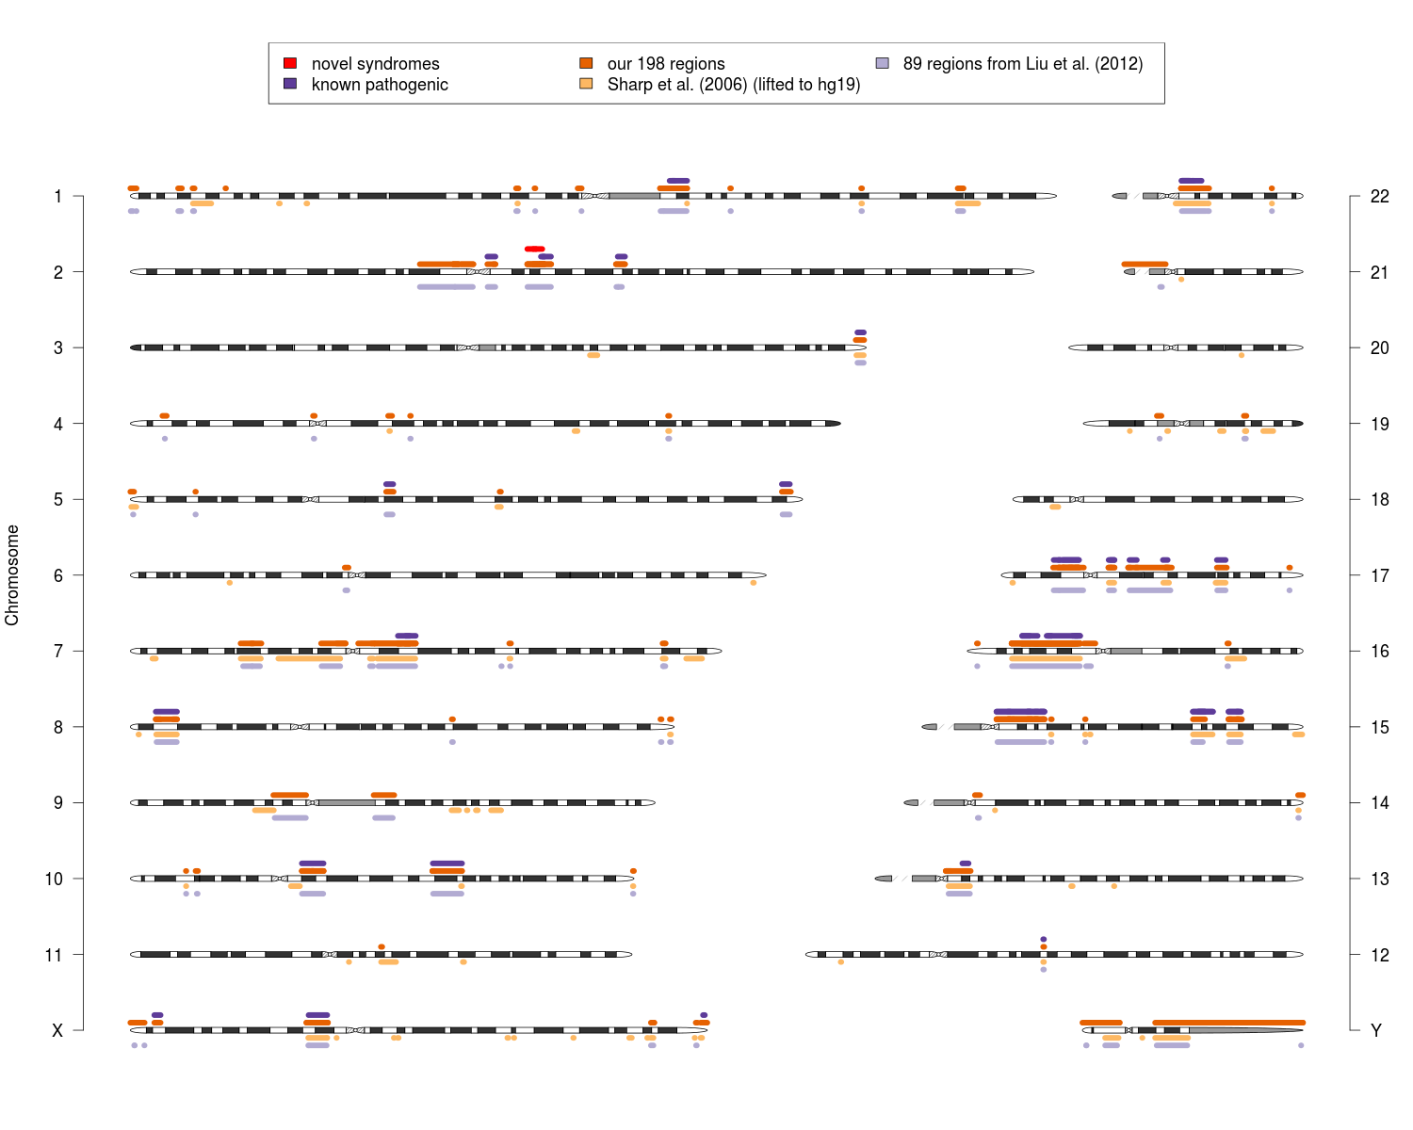
Supplemental Fig. S2. Chromosome ideogram with the previously defined sets of 130 NAHR hotspot regions (Sharp et al. 2005, 2006) (orange) and 89 regions (Liu et al., 2012) (light blue) together with our newly defined 190 NAHR-prone regions (burnt orange). We additionally marked the known pathogenic NAHR-mediated syndromes (purple) and novel syndromes in 2q12.2q13 described in this manuscript (red). Note these three regions are adjacent, and thus are collapsed into one.
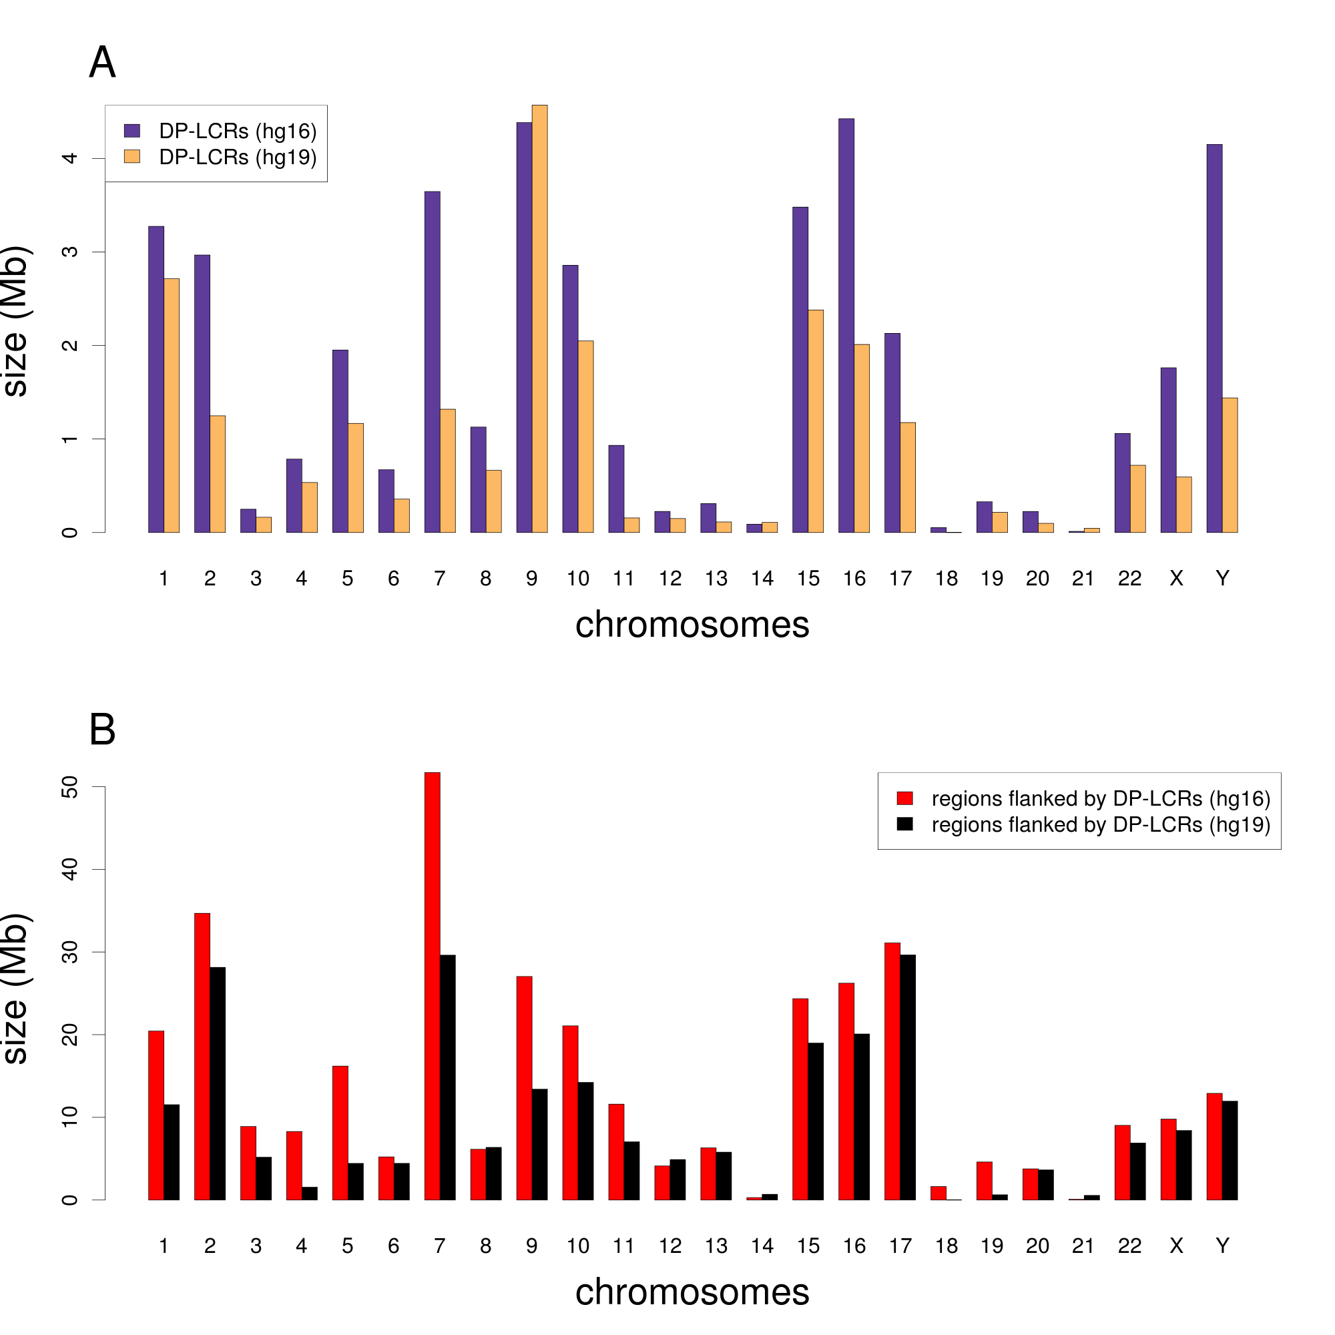
Supplemental Fig. S3. Sizes of chromosome coverage by (A) DP-LCRs greater than 8 kb in size of 95% sequence identity and mapping 50 kb - 10 Mb apart from each other in hg16 (violet) and hg19 (orange). (B) NAHR-prone regions flanked by DP-LCRs, representing potential genome instability in hg16 (red) and hg19 (black). In both cases DP-LCRs are greater than 8 kb in size of 95% sequence identity and mapping 50 kb - 10 Mb apart from each other. For simplicity, in the comparison we resigned from additional restrictions used in the manuscript, i.e. not spanning centromeres and intersecting with genes. Note the difference on both panels between two versions of human genome builds.
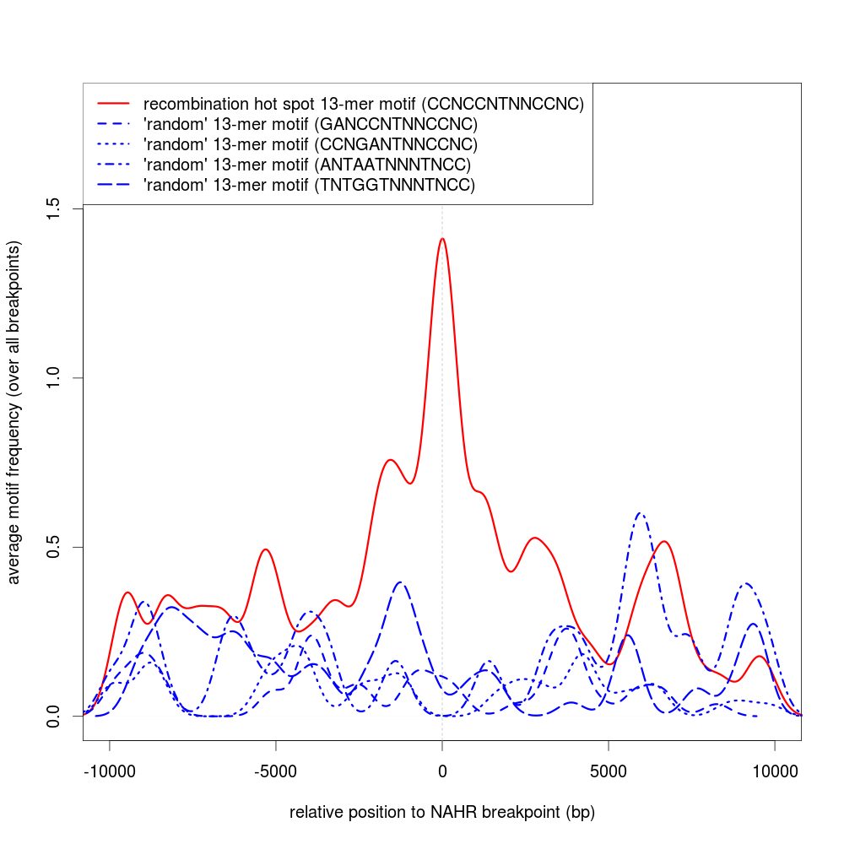
Supplemental Fig. S4. Average distribution of recombination hot spot motif 5’-CCNCCNTNNCCNC-3’ (red line) and other (randomly selected) 13-mer motifs (blue lines) in the 10 kb neighborhood of 64 known NAHR site regions (Supplemental Table S5).

A
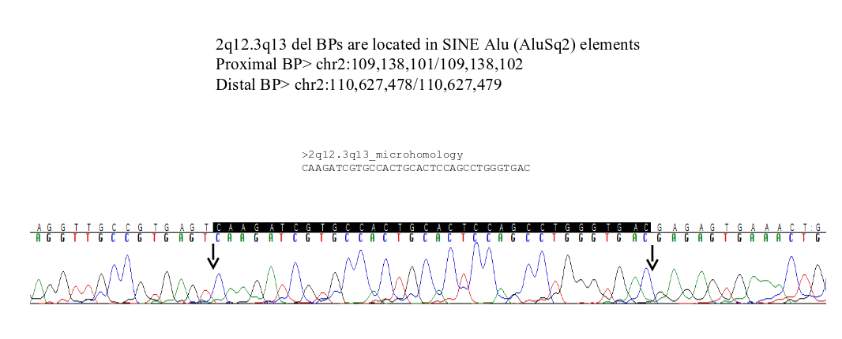
B
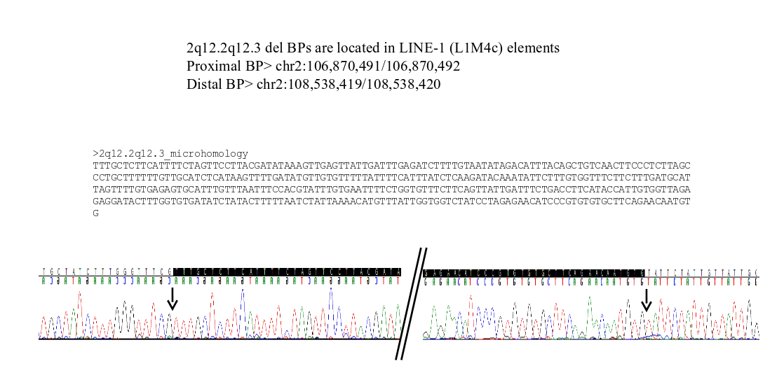

Supplemental Fig. S5. NAHR site microhomologies in chromosome regions (A) 2q12.3q13 and (B) 2q12.2q12.3.

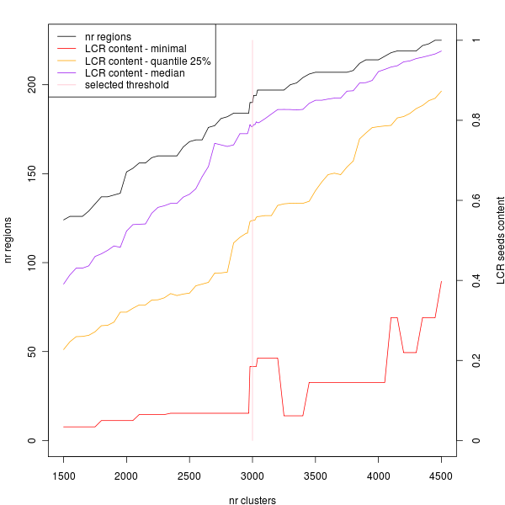
Supplemental Fig. S6. Multiple parameters characterizing LCR clusters as function of different LCR clusters number. Among parameters, we analyzed statistics of LCR content (total percentage of LCR clusters covered by LCR “seeds”, i.e. LCRs itself or unsequenced gaps), and number of NAHR-prone regions. We clearly see how the arbitral choice of cluster number (resulted from pruning hierarchical cluster tree at given length) result in given number of NAHR-prone regions. In pink there is a selected cluster number (3000), yielding 190 NAHR-prone regions.
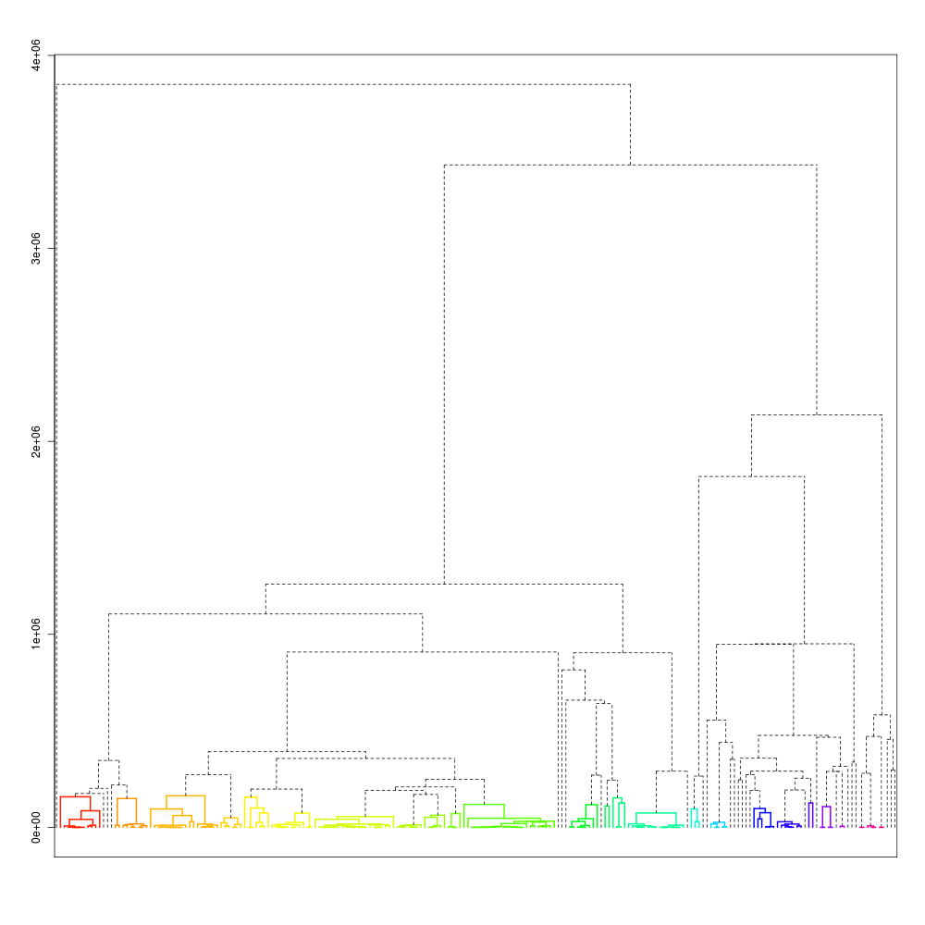
Supplemental Fig. S7. Hierarchical LCR clustering on chromosome 22. We colored 51 LCR clusters obtained by cutting the dendrogram at height 168,229.

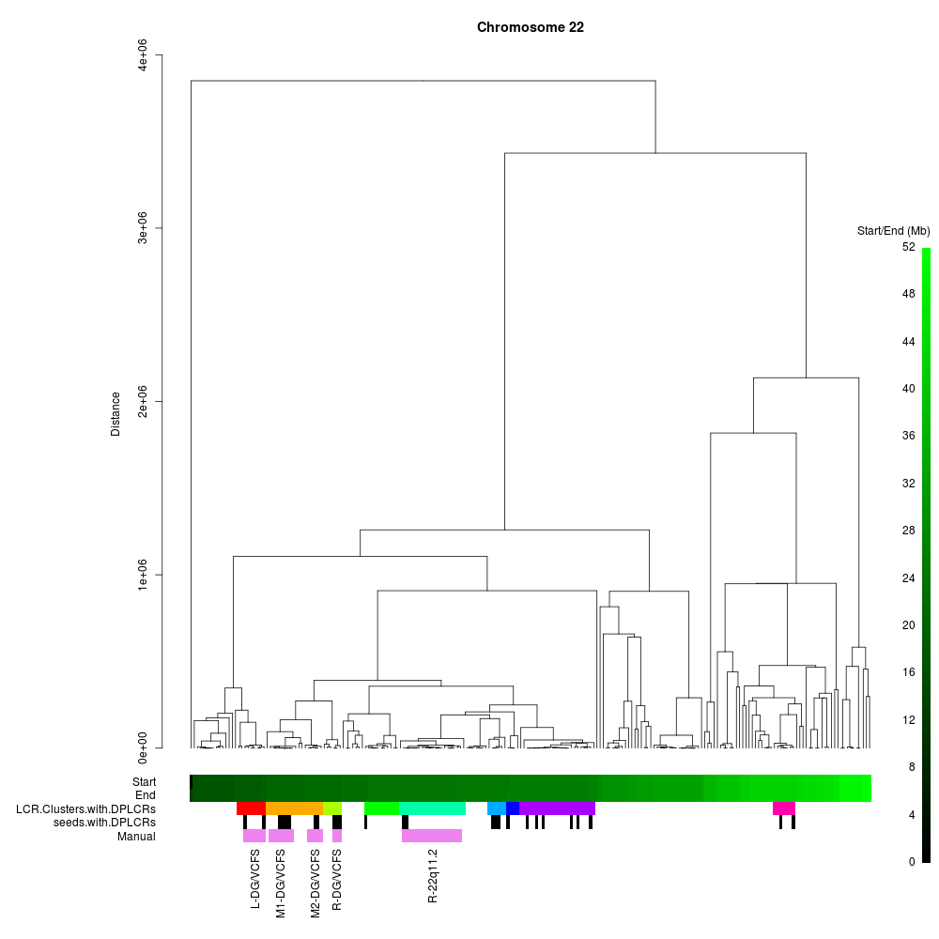
Supplemental Fig. S8. Nine LCR clusters that contain DP-LCRs on chromosome 22. In black-green scale, we show coordinates of start and end of seeds. In addition, we show also five manually selected LCR clusters associated with known pathogenic syndromes (DGS/VCFS and 22q11.2 distal deletion/duplication).

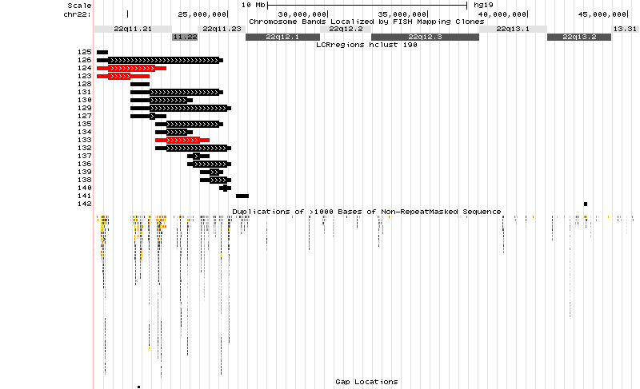

Supplemental Fig. S9. Twenty DP-LCRs-flanked NAHR-prone regions (four of them composed of single LCR cluster) on chromosome 22. In red there are marked three known pathogenic syndromes: DGS/VCFS (small and common) and 22q11.2 distal deletion/duplication.

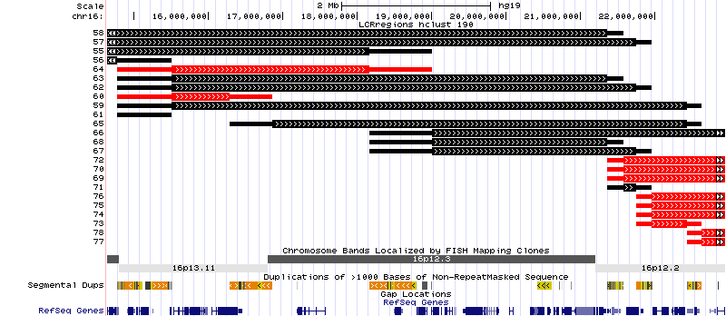

Supplemental Fig. S10. Different configurations of DP-LCRs-flanked NAHR-prone regions on chromosome 16p12.2p13.2. In red there are marked regions associated with known pathogenic syndromes: 16p13.11 deletion/duplication syndromes, small, 16p13.11 deletion/duplication syndromes, large, 16p11.2p12.2 deletion syndrome (7.1 Mb to 8.7 Mb), and 16p12.1 deletion syndrome (520 kb).

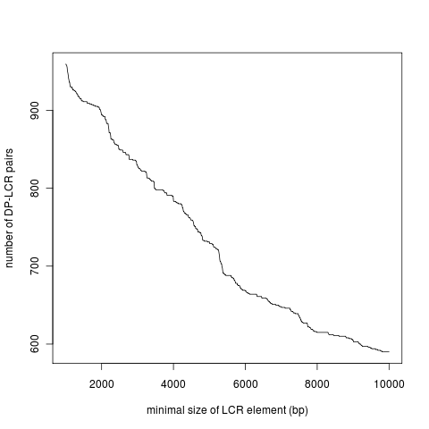

Supplemental Fig. S11. Number of DP-LCRs pairs in relationship with the minimal length of the LCR element.

