The origin, evolution and functional impact of short insertion-deletion variants identified in 179 human genomes
Supplemental Information

Stephen B. Montgomery^{1,2,3,14,16} , David Goode^{3,14,15} , Erika Kvikstad^{4,13,14} , Cornelis A. Albers^{5,6}, Zhengdong Zhang⁷, Xinmeng Jasmine Mu⁸, Guruprasad Ananda⁹, Bryan Howie¹⁰, Konrad J. Karczewski³, Kevin S. Smith², Vanessa Anaya², Rhea Richardson², Joe Davis³, The 1000 Genomes Pilot Project Consortium, Daniel G. MacArthur^{5,11}, Arend Sidow^{2,3}, Laurent Duret⁴, Mark Gerstein⁸, Kateryna D. Makova⁹, Jonathan Marchini¹², Gil McVean^{12,l3}, Gerton Lunter^{l3,16}

¹Department of Genetic Medicine and Development, University of Geneva Medical School, Geneva, 1211, Switzerland. Departments of Pathology² and Genetics³, Stanford University School of Medicine, Stanford, California 94305, USA. ⁴Laboratoire Biométrie et Biologie Evolutive, Université de Lyon, Université Lyon 1, CNRS, INRIA, UMR5558, Villeurbanne, France. ⁵Wellcome Trust Sanger Institute, Wellcome Trust Genome Campus, CB10 1HH, Cambridge, UK. ⁶ Department of Human Genetics, Radboud University Medical Centre, PO Box 9101, 6500 HB Nijmegen, The Netherlands ⁷Albert Einstein College of Medicine, 1301 Morris Park Ave, Price 353A, New York. ⁸Program in Computational Biology and Bioinformatics, Yale University, Bass 426, 266 Whitney Avenue, New Haven, CT 06520, USA. ⁹Department of Biology, The Pennsylvania State University, University Park, Pennsylvania, USA. ¹⁰Department of Statistics, University of Chicago, Chicago, IL 60637, USA. ¹¹Analytic and Translational Genetics Unit, Massachusetts General Hospital, Boston, MA 02114, USA ¹²Department of Statistics, University of Oxford, Oxford, UK. ^{l3}Wellcome Trust Centre for Human Genetics, Oxford OX3 7BN, UK.

¹⁴These authors contributed equally
¹⁵Current address: Peter MacCallum Cancer Centre, East Melbourne, Victoria, 3002 Australia.
¹⁶Corresponding authors: Gerton Lunter (gerton.lunter@well.ox.ac.uk) and Stephen B. Montgomery (smontgom@stanford.edu)

Table of Contents

Supplemental Text 3
1. Three-fold overrepresentation of small indels in the HGMD database 3
2. Alignment and variant calling 3
3. Genotype inference 4
4. Estimation of power and false discovery rates 5
4.1 False discovery rates 5
4.2 False positives are not enriched with TR or HR indels 6
4.3 Estimation of power 7
5. Definition of Homopolymer run (HR), Tandem Repeat (TR), PRedicted hotspot (PR), and Non-repetitive (NR) regions 8
6. Variation of indel mutation rates across the genome 9
7. Enrichment for SNPs but not indels in recombination hotspots 10
8. Local indel rate model 10
9. Template switching results in insertions and palindromic sequence features at NR sites 12
10. Palindromic sequence features induce indels in NR regions 13
11. Polarization of indels 14
12. Genes with high predicted indel mutation rates 14
13. Modeling the incidence of indels across the genome 15
14. No evidence of an effect of biased gene conversion (BGC) on indels 16
15. Derived allele frequency spectra: Detecting signals of purifying selection 17
16. Derived allele frequency spectra are influenced by the number of constrained sites deleted 17
17. Measuring evolutionary constraint at each site in hg18 18
18. Indels and LD 19
19. Indels as variants underlying eQTL and GWAS associations 19
20. Tandem Repeat Analysis 20
Supplementary Tables 23
Supplementary Figures 33

Supplemental Text

Three-fold overrepresentation of small indels in the HGMD database

The 2011.1 release of the HGMD database contains 111,577 variants that have been associated to disease. Of these, 74,835 are single-nucleotide polymorphisms (62,322 missense/nonsense SNPs, 10,504 splicing SNPs, 1,999 regulatory SNPs), and 26,864 are small indels (17,589 small deletions, 7,276 small insertions, 1,653 small indels [defined as co-localized insertion and deletion events resulting in a net gain or loss in nucleotides], 346 repeat variations). The remaining 9,858 events are larger structural variations (gross insertions, duplications, deletions, or complex rearrangements).
This makes the ratio of functional SNPs to indels in the HGMD database about 2.79 SNPs per indel. This is in contrast to the ratio of the neutral single-nucleotide mutation rate to the neutral indel rate, which is about 1:8 (this study; and(1)), an over-representation of indels of about 3-fold. This is consistent with a higher average phenotypic effect of indels compared to SNPs in functional sequence as suggested by the results in this study. Note that the ratio of indel to single-nucleotide substitution rates has frequently been estimated to be as low as 1:14 from species alignments(2, 3) which would imply an even higher over-representation, but these estimates are biased towards low indel rates(1).

Alignment and variant calling

The indel calling strategy we used was similar to the one used for the indel call set that was released as part of the pilot paper of the 1000 Genomes Project(4). The main difference is that here we used Stampy(5) to map all Illumina reads to the reference sequence of NCBI36, while MAQ was used for the 1000 Genomes Project pilot release. The Stampy read mapper is more sensitive for small insertion and deletion events and also has a lower reference bias(5).
We next used the program Dindel(6) to call insertions and deletions shorter than 50-bp from the Illumina low-coverage pilot data of the 1000 Genomes project. Dindel performs a probabilistic realignment of all reads mapped to a genomic region to a number of candidate haplotypes. Each candidate haplotype is a sequence of at least 120-bp that represents an alternative to the reference sequence and corresponds to the hypothesis of an indel event and potentially other candidate sequence variants such as SNPs. By assigning prior probabilities to the candidate haplotypes, the posterior probability of a haplotype and consequently an indel being present in the sample can be straightforwardly estimated. This Bayesian approach makes it possible to model different types and rates of error consistently in a single framework. The assumption is that differences between the read and the candidate haplotype must be due to sequencing errors. In the realignment of a read to a candidate haplotype, we are able to naturally take into account the increased sequencing error indel rates in homopolymer runs, as well as the base-qualities, thus separating contributions of errors from statements about biological differences. We explicitly modeled increasing sequencing errors in homopolymers according to the error model described in Albers et al(6). The process of realigning reads to candidate haplotypes corrects alignment potential artifacts introduced by the read mapper and uncovers further evidence for an indel event. Dindel uses the mapping quality to down weigh the influence of reads that could not be mapped confidently to the reference sequence.
Dindel relies on the read mapper in two important ways. First, since Dindel only performs the realignment locally in windows of ~120-bp, the assumption is that the read mapper has assigned the read correctly to this window with a well-calibrated mapping quality. Second, Dindel requires as input a set of candidate indels, from which the candidate haplotypes are generated; the majority of the candidate indels considered here were provided by a read mapper, as described in the next paragraph.
We also tested a larger candidate indel set than previously. We combined the 8,504,899 candidate indels from the 1000 Genomes Project pilot 1 with candidate indels detected by Stampy. The first set of candidate indels is described in 1000 Genomes Project Consortium et al.(4) and consists of sensitive indel calls from MAQ alignments, a set of indels called using an early version of Stampy, indels called by local reassembly using Pindel(7), and indels inferred from longer 454 reads. The second set of candidate indels consists of all indels that were detected at least twice by the version of Stampy used to produce the alignments for this paper (version 0.92, revision 413). Due to the large number of candidate indels inferred by Stampy, we produced the second candidate set for each population (CEU, YRI, and CHBJPT) independently. In summary, the candidate sets consisted of 17,226,062, 18,648,913 and 15,667,322 indels for the three respective populations.

We used Dindel to call indels in each of the three populations independently using the candidate indel sets described above. All indels called by Dindel were then combined to form a union call set and we subsequently tested all called indels in all populations. We required the indel site to be covered by at least one read on the forward and reverse strand and considered only reads with a mapping quality of at least 20 to reduce the effect of systematic mapping errors. This procedure resulted in a set of site calls.

As a result of using a more sensitive mapper, which increased the number of candidate indels considered, and more lenient filtering, we increased the final number of calls from 1,330,158 to 1,604,491; split out by population the increase is 24.0% for YRI, 14.0% for JPT/CHB, and 20.6% for CEU. Splitting out further by indel type, we find that although the TR class is somewhat over-represented as expected from the more lenient filtering, broadly the increase is equally distributed across all types of indels (Table S9). We later confirmed that the increase is mainly due to an increased sensitivity, and not due to a significant increase in false positives particularly in tandem repeats, by validating a subset of the novel indels (see section 4).

Genotype inference

Because the low average read coverage of each individual’s genome (~4X), genotypes cannot be accurately called directly from read data for each individual separately. Instead, linkage disequilibrium patterns between the individual haplotypes obtained from relatively high-density SNP calls were exploited to infer the missing information(8). To obtain genotype calls, we used Dindel to generate genotype likelihoods for all called indels for imputation using IMPUTE2. This approach iteratively estimates the underlying haplotypes of samples. For each iteration, new estimates of an individual’s haplotypes are sampled conditional upon the individual’s genotypes and the current haplotype estimates of all other individuals. We extended IMPUTE2 to handle genotype likelihoods in the following way. Let D denote the true diplotype (i.e. pair of true haplotypes) at L biallelic loci for the individual being updated in a given iteration. Let R denote the sequence data at the set of L loci being considered. We assume that this data has been condensed into the form of genotype likelihoods(9) so that we have the probabilities P(R | D_{l} = j) at the lth locus. Let H denote the current set of haplotype estimates in all other individuals. We then wish to build a model of the form P(D | R, H). This is done using the same hidden Markov model used in IMPUTE2 that is based on the Li and Stephens model(10). In this model an individual’s diplotype, D, is modelled as a mosaic process of the observed haplotypes H. The hidden states, S, are an ordered sequence of pairs of the known haplotypes in the set H. Transition rates, P(S|H), and emission probabilities, P(D|S), are modelled in the same way as in IMPUTE2 [1]. The full model can then be written down as $P\left(D \right|R, H)= \sum_{S}{P\left(D, S \right|R, H) ∝\sum_{s}{P(R|}}D)P\left(D | S\right)P(S|H)$. Essentially, the only difference of using genotype likelihoods compared to known genotypes is that the emission probabilities from the model are altered to allow uncertain genotypes. We use the forward-backward algorithm to sample from this distribution. In addition we allow for some sites to be phase known by fixing entries of D. This allows us to combine the Dindel genotype likelihoods at indel sites and haplotype data at SNP sites, estimated from the 1000 Genomes pilot project. The SNP sites act as a haplotype scaffold upon which the indel sites are phased. The genotypes at indel sites can then be obtained from the phased haplotypes.

Estimation of power and false discovery rates

4.1 False discovery rates
In order to efficiently obtain an accurate estimate of the false discovery rate of the indel call set, we designed a validation experiment that made use of the information obtained in the 1000 Genomes Pilot project (TGPP) call set, with which our set has considerable overlap. Specifically, we selected calls that are unique to our set, defined as not seen in the TGPP nor in dbSNP129, in such a way that selected indels were predicted to segregate in two specific individuals. We next selected a subset of these calls and designed primers. From those that passed the primer design stage (111), we assessed 60 calls, estimated the FDR in this subset, and combined this with the FDR from the TGPP sets to arrive at an FDR estimate for the full set.
The novel calls will consist of three distinct classes: (i) indels that caused read mapping issues in TGPP data, but were successfully mapped by our pipeline; (ii) indels that were filtered out by the TGPP filters but not ours (primarily, a limit on tandem repeat length context of <10bp, which we did not impose), and (iii) false calls that were successfully rejected by the TGPP pipeline but not by ours.
Because the CEU calls were found to be representative of the other sets in the TGPP, we chose two CEU individuals (NA11918 and NA10851) as validation target. In order to arrive at a subset that is representative for the full set of unique calls, we first selected all unique calls that were predicted to segregate in these individuals. This set was then sub-sampled using rejection sampling to recover the empirical allele frequency distribution of the full unique CEU indel call set.
From this set we selected a subset of calls at random and designed primers, resulting in successful primer design for 111 of these. Primer design was conducted using Primer3 followed by ePCR and Blat to support unique amplification. Following, a nested primer was then selected for sequencing after target amplification. We next Sanger sequenced the forward and reverse strands of 60 of these, in the one or two individuals (NA11918 or NA10851) in which the indel was predicted to segregate. The resulting traces for each indel were independently investigated by three individuals. In all, 36 sites resulted in Sanger reads that supported the call; 12 sites resulted in Sanger reads that either supported only the reference, or supported a different call, and 12 sites could not be called because of low-quality or difficult to interpret Sanger data (see SI for an Excel table detailing the calls). We therefore estimate that among the novel calls, the FDR is 0.25. All sequence traces and calls have been included as supplemental data.
To arrive at a FDR estimate for the complete set, estimates for three non-overlapping subsets should be combined: (i) those common to TGPP and the present set (731,620/881,722; 82.98%); (ii) those common to dbSNP129 and the present set, but not in TGPP (28,913/881,722; 3.28%); and (iii) the novel calls (121,189/881,722; 13.74%). For set (i) we used the FDR estimate from TGPP for the CEU TGPP calls (1.3%); this is possibly a slight overestimate calls in the intersection (i) are supported by two independent read mappings, although the data and the indel call pipelines are identical. For set (ii) we have no direct FDR estimate, but it is likely to be low, as these calls are supported by independent evidence from different sequencing technologies; we chose to use the CEU TGPP estimate of 1.3%. For set (iii) we have found a validation rate of 36/48 equivalent to an FDR of 0.25. Combined this results in an FDR of 4.6%.
We expect the FDR in the other populations to be comparable but not identical to this. For example, the TGPP estimates an FDR of 0.7% for the YRI panel, 1.3% for the CEU panel, and 5.1% for the JPB+CHB panel, and since we use the same set of short sequence data, we expect a similar trend in our call set.

4.2 False positives are not enriched with TR or HR indels
Although these results give confidence in the overall FDR for the indel call set, the possibility that the false positives among the novel calls are concentrated among indels of a particular type needs to be considered. In particular, we did not apply a filter to remove indels in tandem repetitive regions, in contrast to the TGPP calls, leading to a higher sensitivity for this class of indels, but potentially also increasing the FDR specifically for this category.
To exclude this possibility, we tested for an association of validation status with indel type. Among the 48 conclusive validation calls, 12 were false positives, of which 5 were classified as TR indels, and one as a HR indel. Among the 36 true positives, 12 and 6 were classified as TR and HR, respectively. These numbers provide no evidence for a significant association of validation status with indel type, either TR vs. non-TR (p=0.60), TR+HR vs. non-repetitive (p=1.00), or HR vs. non-HR (p=0.36, trending towards depletion among the false positives). This conclusion does not change if the calls that could not be conclusively validated (12/60, of which 1 HR, 5 TR) are all considered false (TR vs. non-TR, p=0.51; TR+HR vs. non-repetitive, p=1.00; HR vs. non-HR, p=0.35 trending towards depletion; all p values relate to a Chi-square test with 1 d.o.f.).

4.3 Estimation of power
To estimate power to detect indels, we used sequences obtained from bacterial F-plasmid (fosmid) clones of ~40kb haploid sequence from the NA12878 1000 Genomes pilot CEU trio child (11). Since these clones were selected to contain structural variation, their direct alignment to the reference genome contains many mismatches. We downloaded the available contigs in BAM format from the 1000 Genomes FTP site (ftp://ftp.1000genomes.ebi.ac.uk/), and filtered them on the basis of the following criteria: (i) they align as a single fragment to the reference, or align as two fragments separated by no more than 60kb; (ii) the fosmid sequence itself was sequenced using Sanger technology (rather than short read shotgun data); (iii) they contain no more than 3 indels and 6 SNPs locally in any 1kb window. We finally identified and removed 3 clones whose sequence overlapped with others (clones ABC12-46343700C15; ABC12-46972900H7; ABC12-7918249H24). After filtering 432 clones remained covering 16.7 Mb. We next called SNPs and indels directly from the CIGAR string and the read sequence, lifted the resulting variants to the NCBI36 assembly, and kept only autosomal variants to allow comparison with our set. This procedure resulted in 3196 SNPs with a transition/transversion ratio of 2.19, and 833 indels with a (reference, unpolarized) insertion/deletion ratio of 1.03.
We next filtered the indels into those that were in principle “callable” by our pipeline, and those that were not. Criteria for callability, and numbers of calls failing the criterion, were:
- Total length of inserted or deleted sequence at most 50bp (18 calls)
- Homopolymeric context not exceeding 10 bp (348 calls)
- Dinucleotide tandem repeat tract length not exceeding 15 bp (78 calls)
- Tandem repeat tract length for units of 3nt or longer, not exceeding 24 bp (57 calls)
These criteria were chosen because of implicit or explicit filters present in our pipeline, and because short read data limits the maximum callable indel length in our analysis pipeline. Our pipeline explicitly remove indels in homopolymers exceeding 10 bp, and by removing minor alleles from multiallelic sites it implicitly partially filter indels in long repeat tracts; the tract length cutoff chosen here correspond approximately to more than 30% of sites being polymorphic, similar to the polymorphism rate at homopolymeric tracts exceeding 10bp (Fig. 1c). Finally, the short read length data does not support very long indels, and we find that our pipeline has virtually no power for indels exceeding 50bp (Fig 1b).
Filtering removes 489 indels (some indels fail more than one criterion), leaving 344 indels. Of these, 255 were present in our call set at identical locations and with exactly matching alleles (74.1%).
While NA12878 part of the CEU population group, it was not part of the TGPP Pilot 1 low-coverage data set, so that some fraction of variants observed in the fosmid data and missed in our callset will in fact be unique to NA12878. To estimate this fraction, we also called SNPs from the fosmid data using the same pipeline, and compared this to 1000 Genomes low-coverage calls (ftp://ftp.1000genomes.ebi.ac.uk/vol1/ftp/pilot_data/release/2010_07/low_coverage/snps/CEU.low_coverage.2010_07.sites.vcf.gz). We find that, of the 3196 autosomal SNPs identified in fosmid data, 2365 were also called in the Pilot 1 SNP release set (by position; allele not checked), or 74.0%. This is very close to the fraction of NA12878 fosmid indels called in from the low-coverage CEU data, indicating that the power to detect indels, in regions and of sizes deemed “callable” as described above, is virtually identical to the power to detect SNPs from this data set using the TGPP SNP calling pipeline.

Definition of Homopolymer run (HR), Tandem Repeat (TR), PRedicted hotspot (PR), and Non-repetitive (NR) regions

In this paper we define a repetitive tract as any DNA sequence segment that consists of at least 2 direct repeats of any DNA segment (“unit”) of length 1 to 24. The last segment does not need to be complete, so that the length of the repetitive tract can be any number of nucleotides, but at least twice the unit length. Repetitive tracts are classified as HR, TR, PR or NR as described below.
Homopolymer regions (HR): We find that homopolymer runs (a repetitive tract consisting of 1-bp units) are strongly enriched with indels. From Figure S1 it can be seen that the (per-bp) rate is an increasing function of the homopolymer run length, and that this rate increases particularly rapidly after length 5. For example, the rate in homopolymers of length 6 is 15x increased compared to complex loci. This is further compounded by the ambiguity of indel placement, making it meaningless to assign indels to any particular nucleotide, but rather assign indels to the entire HR, so that the per-site diversity is even higher. Because of the apparently qualitative jump in indel rate for homopolymers of length 6, and the increased expected incidence of homoplasies in primate alignments at these sites, we defined “homopolymers” to be sites where the homopolymer tract length is 6 or more. (Annotation in VCF file: INFO:HR >= 6)
Tandem repeats (TR): Tandem repeats (TRs) are defined as repetitive tracts with a unit of 2 to 24 bases, and a repetitive tract length exceeding the threshold defined in Table S1. The thresholds for HRs and TRs were arbitrarily chosen so that sites annotated as HR or TR had an indel diversity at least equal to the diversity due to SNPs (blue line in Figure S1). Note that to be identified as a tandem repeat, the repeat unit needs to be repeated exactly at least two times, although a tandem repeat tract does not need to consist of a whole number of repeat units. Note that for longer unit lengths, the enrichment data suggests that tracts consisting of fewer than 2 complete units are already enriched for indels (Figure S1b). N.b., regions or indels annotated as HR were not also annotated as TR. (Annotation in VCF file: INFO:HR < 6 and INFO:IH = “Y”.)
Predicted hotspot regions (PR): We annotated all indels using the model described in the section “Local Indel Rate Model” below. We converted the predicted indel rate λ, modified as described to assign rate 1 to complex sequence, into a (negative) Phred score (10 log₁₀ λ). Loci annotated which the model annotated with Phred score 12 and above are more than 10X enriched with indels (Figure S6). Since these loci are likely to be partially repetitive and therefore indel placement is likely to be ambiguous to some extent, the fold increase in locus heterozygosity is expected to be a multiple of this. We chose the relatively conservative Phred score 12 as our threshold for annotating regions and indels as Predicted Hotspot Regions (PR); for comparison, the model assigned indel Phred scores of 7 or above to tandem repeat regions (as defined above). Note that regions or indels annotated as either HR or TR were not also annotated PR. (Annotation in VCF file: INFO:HR < 6; INFO:IH = “N”; INFO:IR >= 12.)
Non-repetitive regions (NR) and slippage: Regions not annotated as either HR, TR or PR were designated non-repetitive (NR). Indels were likewise annotated. Indels in regions annotated as NR were further subdivided into slippage-associated or CCC (change in copy count) indels (NR, CCC) and non-slippage-associated or non-CCC indels (NR, non-CCC), based on whether the long allele could be obtained from the short allele by a local duplication. (Annotation in VCF file: INFO:HR < 6; INFO:IH = “N”; INFO:IR < 12 for NR indels; then SL = “Y” for NR-CCC indels, SL = “N” for NR, non-CCC indels.)

Variation of indel mutation rates across the genome

We find a very substantial variation of indel rates across the genome, of over 3 orders of magnitude, driven by local tandem (or near-tandem) repetitive sequence features. We here describe how we estimate the enrichment of indels in particular tandem repetitive regions.
Sequencing errors are expected to also be more prevalent in regions of local tandem repetitions, as they are also driven by polymerase slippage events. Our calling algorithms include explicit models of sequencing errors, and estimates of false discovery rates in the mapping/calling pipeline used in the 1000 Genomes Pilot project were low (1.7%, (12)). The pipeline used in this paper is identical to the 1000 Genomes Pilot pipeline, apart from the mapping stage where we use Stampy rather than BWA. The mapper is not expected to introduce a bias in favor of indel errors in tandem repeats. Nevertheless, due to the increased sensitivity of Stampy it remains possible that a fraction of systematic errors have been called as indels. We use human-chimpanzee indels to show that in the regime where we expect that homoplasies due to saturation were not prevalent, our results are in good quantitative agreement with those obtained from reference genome alignments, indicating that the observed indel enrichment is not driven to a substantial degree by sequencing errors.
To assess the variability of rates of indel mutagenesis, we annotated each indel by their homopolymer and local tandem repeat context. We next assigned each indel a repeat unit length and a repeat tract length. The unit length was set to 1 if the indel site was annotated as a homopolymer run, and in that case the tract length was set to the homopolymer tract length. In all other cases, the unit length and tract length was taken from the tandem repeat annotation.
We repeated the same annotation for each nucleotide in the human genome reference, and counted how often each combination of unit length and tract length occurred. We then computed the ‘’indel enrichment’’ as the ratio of observed indels to observed sites, for each combination of unit length and tract length, and scaled this ratio to 1.0 for the case of unit length 1 and tract length 1 (Figure S1a and S1b).
We also extracted alignment gaps from human-chimpanzee alignments (hg18 and panTro2, taken from ftp://hgdownload.cse.ucsc.edu/apache/htdocs/goldenPath/hg18/vsPanTro2/axtNet/), and annotated these based on the sequence context in the human reference. From the counts we again computed enrichments as the ratio of observed gaps in the human-chimpanzee alignments, to the number of observed nucleotide site, in each category, and again scaled these to 1.0 for the case of unit length 1 and tract length 1 (Figure S1c).
We find that the enrichments in both cases are similar (Figure S1d for the enrichment ratios), as expected. The calculated enrichments deviate for longer tract lengths, which is also expected since the chimpanzee substitution-based enrichments saturate for shorter repeat tract lengths because of the higher rate of human-chimp indel substitutions compared to human polymorphisms (Fig. S2).

Enrichment for SNPs but not indels in recombination hotspots

High inferred rates of recombination are associated with increased incidence of SNPs and indels (e.g., this study, Fig S9). This does not necessarily imply that recombination results in an increased incidence of SNP and indel variants, since recombination events can only be inferred in the presence of sequence variation, causing a positive correlation. In addition, normal variation in the time to most recent common ancestor (TMRCA) as one moves along the sequence, as predicted by standard coalescent theory, will cause rates of observable recombinations and local diversity to vary in tandem.
An approach that does not suffer from these biases is to compare regions with and without a recombination hotspot motif(13). Human recombination hotspots are enriched for the degenerate motif CCTCCCTNNCCAC, and loci carrying this motif are thus enriched for recombination hotspots (Figure S3), in a way that is free of ascertainment bias for SNP or indel diversity(12). We chose the 1000 Genomes Pilot 1 CEU panel for SNPs and indels, because the recombination motif has been shown to evolve rapidly, and appears to be polymorphic in the YRI population, but not CEU, so is expected to be more predictive of recombination hotspots in CEU.
We find a small (7.9%) but significant (4.81 sd) enrichment for SNPs around these recombination motifs, which are not seen for a background motif (Fig S4). This allows for the possibility that the recombination process may induce SNP variation nearby the motif site, or alternatively that biased gene conversion drives an excess of SNPs near to the motif towards fixation, thereby also increasing the polymorphism rate. For indels, we do not see a similar enrichment. It should be pointed out that an enrichment of indels of a similar magnitude as of SNPs would not be detectable, owing to the lower rate of indels and the associated higher sampling noise, so that a small indel mutagenic effect or a small effect of indel-biased gene conversion cannot be ruled out.

Local indel rate model

Polymerase slippage is an accepted mechanism for the formation of a class of small indels (14, 15). If a polymerase slippage event occurs, the resulting (say d bp) DNA loop would be stabilized by the presence of sequence identity between the misaligned DNA strands along a stretch of (say k) nucleotides. On the original sequence, this configuration appears as a stretch of (possibly non-contiguous, possibly overlapping) sequence identity over k bp at a displacement of d bp. Based on this observation and other observations mentioned in the main text, we propose the following quantitative model for the local per-bp rate of indels as a result of the presence of local sequence identity:
where λ is the indel rate (suitably normalized), r(d) and m(k) are parameters of the model, and the sum extends over all displacements d for which there exists sequence identity with the current locus over k bp, extending in either direction. The parameters r(d) may be interpreted as proportional to the rate at which polymerase slippage results in re-hybridization at a displacement of d nucleotides, while m(k) may be interpreted as proportional to the probability that this re-hybridization is stable. (We here took the view that if the maximal length over which the d-displaced sequence shows sequence identity with the original sequence is K, then the sum above includes terms for all k≤K. We could instead have opted to include only the term r(d)m(K); this would amount to replacing the parameters m(k) by m’(k) = m(1)+…+m(k).) The parameter λ₀ is the basal indel rate in the absence of any local sequence identity. As we apply the model to diversity data, it does not include a divergence parameter, nor does it include N_{e} as a parameter; for general application the rates should be scaled appropriately. (Here we scale λ so that it refers to relative overrepresentation rather than diversity or genomic incidence, 1 referring to the basal rate in complex sequence.)
We aggregated indel counts both by length of tandem repeat tract t and tandem repeat unit u, and counted the genomic occurrence of such tracts (weighted by their length) as well. For a particular (u,t) tandem, the model predicts an indel rate of
To account for model mis-specification, the observed indel count is modelled as drawn from a Gamma-weighted Poisson distribution (a negative Binomial distribution), where the Gamma distribution has mean λ and standard deviation s=α λ ^{β}, with λ the observed rate and α and β are parameters of the model. This model assigns a likelihood to the observed data; we then used MCMC to obtain estimates of the model parameters and their empirical standard deviations.
Since no indel calls were made in homopolymers over 10-bp, and an expected high rate of homoplasies rendered overrepresentation estimates unreliable for very long tandem repeats, we set thresholds on the tract lengths considered. This in turn rendered r(d) and m(k) unobservable for larger values of d and k, as indicated by an increased empirical standard deviation. We truncated the parameters to 0 where this happened. The parameters obtained from YRI indels is listed in Table S2.
The estimates for the other parameters are λ₀ = 4.5 ± 0.34, α = 0.44 ± 0.03, β = 0.85 ± 0.10. The overdispersion parameters favour a relatively large error for low rates, and indeed the basal rate is estimated at 4.5 rather than 1.0. To compensate for this, we instead used λ₀=1 in annotations. This gives the correct result in the bulk of the genome where indels are not enriched, while a negligible error is made in hotspot regions.

Template switching results in insertions and palindromic sequence features at NR sites
Most of the indels at non-repetitive (NR) sites, and not due to slippage (non-CCC), are in fact deletions: the deletion-to-insertion ratio ranges from 8.44 in CEU to 10.38 in YRI (Table S3). One mechanism to explain the deletions is via double-stranded breaks that are subsequently repaired by the NHEJ pathway; this pathway has a preference for short (~2bp) microhomologies, but does not strictly require them (16); and even when a microhomology is present, this would classify only the shortest deletions as CCC-indels. Polymerase slippage is expected to cause CCC-type indels and would not explain these deletions.
Neither polymerase slippage nor NHEJ obviously explains non-CCC insertions at NR sites, as NHEJ is not known to cause insertions. A possible other mechanism is template switching of the polymerase within the replication fork, which would cause tracts of the reverse strand to be inserted into the nascent strand, before another template switch event would resume normal copying. This mechanism has been shown to operate in viruses(17) and Escherichia coli(18), and has been shown to cause genomic rearrangements(19) and small indels(20) in human. A prediction of this model is that insertions, when caused by this mechanism, would lead to quasi-palindromic sequence repeats.
To test the hypothesis that template switching contributed to non-CCC insertions at NR sites, we looked at the distribution of quasi-palindromes nearby non-CCC insertions at NR sites, and compared these to a null distribution obtained from non-CCC deletion, also at NR sites. Specifically, for each insertion, we looked at the longest quasi-palindromic match from the short haplotype (a window of size 2W around the insertion site on the reference sequence), to the long haplotype (the reference sequence with the relevant sequence inserted at the insertion site, truncated to length 2W+L where L is the number of inserted nucleotides, and centered symmetrically around the insertion site). This match was allowed to occur anywhere within these windows, with one of the haplotypes being reverse-complemented before matching, so that full overlap, partial overlap, true palindromes, and quasi-palindromes (palindromic matches separated by random sequence) were all counted as matches.
For each deletion, we similarly looked at the longest quasi-palindromic match from the short haplotype to the long haplotype; here the long haplotype is the reference sequence of length 2W+L, and the short haplotype is the deleted haplotype of length 2W, where L is the number of deleted nucleotides. This definition is symmetric and no bias is expected under the null model of inserting or deleting random nucleotides.
To optimize the power of this test, the window size W should be chosen to maximize the number of real matches, while minimizing the number of spurious matches due to random sequence identity over short distances. The optimal choice should maximize the difference between the distributions for insertions and deletions. For several choices of windows size we therefore computed the Kullback-Leibler divergence between the empirical distributions obtained for the insertions and deletions, and chose the window size (W=20) that maximized this divergence (see Table S7).
The resulting distributions are significantly different from each other, with a significantly higher mean for the insertion distribution (p < 2.2x10⁻¹⁶, Wilcoxon one-sided rank sum test).
To obtain a conservative lower bound for the fraction of insertions that were putatively caused by template switching, we assumed that none of the deletions were caused by this mechanism. We then modeled the distribution of palindromic match lengths for insertions as a mixture of the “background” deletion distribution, plus a unique distribution for insertions caused by template switching. Since we only have empirical distributions for both, we need to model the sampling variance. To do this, the occupancy of a single length bin with empirical count A was modeled as a Poisson distribution of rate A+1; adding one pseudocount is the limiting behavior of a Bayesian approach starting with a Gamma conjugate prior to the Poisson with parameters α=1 and β0, and assures that zero counts are not treated as fixed. Under this model, the maximum likelihood rate parameters for the Poisson distributions for each bin of the difference distribution were calculated, using only the constraint that rate for each bin be nonnegative. The mixture parameter γ was optimized under the constraint that the likelihood be bounded from below by the arbitrary limit value 10⁻⁵; the dependence of the results on this limit value was negligible.
For W=20 we find a mixture parameter γ=0.848. The difference distribution I - γD, where I and D are the pseudo-palindrome length distributions within the window for insertions and deletions respectively, is listed in table S8. The inferred fraction of insertions that are caused by strand switching, under this model, is 1-γ = 0.152.
It should be noted that the hypothesis that none of the deletions are caused by strand switching is certainly too strict(ref. (20) and the section below), and the fraction 0.152 is likely to be a considerable underestimate.

Palindromic sequence features induce indels in NR regions
Since deletions are also known to be caused by template switching, and induced by quasi-palindromic structures(20), we next looked more generally at the contribution of template switching to non-slippage indels at non-repetitive (NR) sites.
To estimate the fraction of indels caused by template switching, we compared the distribution of quasi-palindromic matches in the vicinity of non-CCC indels at NR sites, to those in the genomic background. Within the genomic background, we only included sites classified as NR.
Since no “alternative allele” is available when collecting statistics for the genomic background, we compared a haplotype consisting of 2W reference nucleotides at a given NR site (W=20), to the same (reverse-complemented) haplotype. To ensure the distributions are comparable, we did the same at non-CCC indels at NR sites, in contrast to the previous analysis where we compared the reference and alternative haplotypes.
We find that the distributions are significantly different, with a higher mean for the indel distribution compared to the background (p < 2.2x10⁻¹⁶, Wilcoxon one-sided rank sum test). At indel sites, quasi-palindromes of length 3-5 are underrepresented by 3.5 – 7.5% compared to the background, whereas for length 6 and above, quasi-palindromes are systematically over-represented by about 10% (see Figure S15); for instance, length-6 quasipalindromes are overrepresented by 11.7 ± 2.3% (95% CI).
Modeling the quasipalindrome length distributions at non-CCC NR indels as a mixture of the background distribution, plus a distribution due to template switching, using the same methodology as described in the previous section, we find a mixture coefficient of 0.944. Under the stated assumptions this suggests that a fraction 1 - 0.947 = 0.053 of non-CCC NR indels have been caused by template switching.

Polarization of indels
To distinguish insertions from deletions, we used four primates from the UCSC Genome Browser’s 44-way Multiz vertebrate alignments for hg18 as outgroups. Sequence from chimp, gorilla, orang-utan and macaque were used to annotate each indel as representing either a derived or the ancestral state. Polarization was only performed when (i) at least 2 of the outgroup sequences aligned to the hg18 locus, (ii) all primate sequences showed concordant alleles, and (iii) the primates’ allele matched either the human hg18 reference or the alternative allele. The alleles were matched within a window that spanned from 5bp leftward of the leftmost possible assignment position of the human indel, to the indel length plus the larger of 5bp or the repeat tract length rightward of the assignment position. Polarization was also not performed when indels were called either in human or in the outgroup species at locations (after left-normalization) other than the location of the human polymorphism under consideration. In matching the alleles, only the indel length and type (insertion or deletion) were used; sequences were allowed to differ to allow for single-nucleotide substitutions.
This procedure emphasizes specificity over sensitivity; in particular, at indel hotspots homoplasies are common, commonly resulting the presence of more than two alleles among the set of alleles consisting of the primate outgroup alleles, the human reference allele and the human alternative allele. In these situations our procedure did not result in a polarization call. As a result, about 50% of calls were polarized (see Table 3 in the main text).

Genes with high predicted indel mutation rates
We used the indel rate model described in the Local Indel Rate section to annotate CDS of protein-coding genes with their predicted indel mutation rate.
To normalize the predicted indel rate inflation above the basal rate to an indel rate per nucleotide and per generation, we used the model to calculate the accumulated non-normalized predicted indel rate across a random sample of 34.21-Mb of human genome sequence (0.1931 indels per generation). The rate of SNP mutations in the same region was calculated from the known mutation rate of 2.5x10⁻⁸ mutations per site per generation (0.8552 SNPs per generation)(21). Finally, the normalization factor was calculated by using the genome-wide indel:SNP ratio of 1:8 estimated in this study (0.125 / (0.1931 / 0.8552) = 0.554).
Genes were obtained from the UCSC knownGenes list (knownGene.hg18.txt.gz). From each gene, defined by its identifier, the longest transcript was chosen, and coding exons were extracted. The accumulated normalized indel rate across exons was calculated for each gene using the model and normalization described above. Genes with a predicted rate exceeding 2x10⁻⁵ were retained (45 genes).
We next removed MUC5B from the list as its transcript overlapped the MUC5AC transcript, and the longest transcript of MUC5B is shorter than the longest MUC5AC transcript. In addition, SSPO was removed, as it contained a large number of frameshift indels (4, 12 and 4 in CEU, YRI and JPT/CHB), and the VEGA gene record of SSPO indicates that the gene is ’’fragmented’’. This resulted in a list of 43 genes (Table S4).
We then annotated each gene by the p value for enrichment with SNPs as reported in the 1000 Genomes Pilot project. This p value was computed by computing the relative rank of the number of SNPs overlapping a transcript within the set of all transcripts contributing to the gene list. Where more than one transcript contributes to a gene, the transcript with the highest overlap with 1000 Genomes Pilot SNPs was taken. The relative rank was reported as a p value, and genes with a p value below 0.05 were excluded from further analysis.
This procedure removed 33/43 genes. Partly this is due to the transcript length itself; for instance the TTN gene is very long and this by itself predisposes it to larger numbers of both polymorphic indels and SNPs. The majority of excluded genes do not fall in this category, and we suspect that these genes have some incorrect transcripts included among their transcript models. Inclusion of incorrect exons into some transcripts will lead to spurious indels and SNPs being included by our pipeline.

Modeling the incidence of indels across the genome

We estimated indel rates for Pilot 1 indels from the 1000 Genomes Project using a logistic regression model that incorporated genic content, conserved noncoding status, repetitive element content, variability in GC, sequence mappability, SNPs and recombination rate. We masked bases that were uncalled or were indel hotspots (having a homopolymer run ≥ 6 or a microsatellite unit length ≥ 5 or microsatellite run ≥ 5 units for unit length of 2 or ≥ 4 units for a unit length of 3 or ≥ 3 for a unit length of 4). For genic content, we used the Gencode v3b reference annotation and stratified by 5’ UTR, protein coding sequence, intron and 3’ UTR. For repetitive element content, we used LINE, SINE, LTR and Transposon annotation from EnsEMBL and TRF annotation from UCSC. Additionally, we added multiple states for homopolymer and microsatellite annotation below our hotspot filter cutoff. Homopolymers of length ≤ 3 where encoded as state 0, of length 4 as state 1 and of length 5 as state 2. Microsatellites followed the logic:
State 0:
Microsatellite unit length == 2 and Microsatellite length < 6
Microsatellite unit length == 3 and Microsatellite length < 6
Microsatellite unit length == 4 and Microsatellite length < 8
State 1:
Microsatellite unit length == 2 and 6 ≤ Microsatellite length < 8
Microsatellite unit length == 3 and 6 ≤ Microsatellite length < 9
Microsatellite unit length == 4 and 8 ≤ Microsatellite length < 10
State 2:
Microsatellite unit length == 2 and 8 ≤ Microsatellite length < 10
Microsatellite unit length == 3 and 9 ≤ Microsatellite length < 12
Microsatellite unit length == 4 and 10 ≤ Microsatellite length < 12

We further included conserved noncoding elements from GERP++, Pilot 1 SNP calls, sequence mappability (using the 1000g pilot annotation) and recombination rates. Recombination rates were modeled at 5 states (0: ≤ 0.2 cM/Mb, 1: 0.2 cM/Mb ≥ x ≤ 1cM/Mb, 2: 1 cM/Mb ≥ x ≤ 5cM/Mb, 3: 5 cM/Mb ≥ x ≤ 10 cM/Mb, 4: ≥ 10 cM/Mb). Background GC content was also added to the model for window sizes of 50 bp and 250 bp. Here, to model the distribution of GC around the mean, we created regression variables for GC windows that were at the following percentiles: ≤1st, ≤10th, ≤35th, ≤45th, background state, ≥55th, ≥65th, ≥90th, ≥99th. Such that a base that was at the 95th percentile would have a state of 000011110 representing that the base exists at the background, above the 55th, 65th and 90th percentile. This encoding allowed us to remove invalid conditions that would otherwise be introduce by assigning a discrete state to a GC bin (for example assuming the behavior of the 65th percentile bin is independent of the behavior of the 55th percentile bin). The logistic regression model was run for every base of each somatic chromosome and stratified based on polarized indel length.
Given the combination of states, we observed characteristic depletion from CDS and within CDS relaxation for non-frameshift indels (Figure 2B). Furthermore, we observed relative depletion in 2n indels for high GC sequence and an enrichment of indels in AT rich sequencing (Figure S7). For repeats, we observed the highest rates in TRF repeats and uniform enrichment across indel length for sequence uniqueness (or mappability) (Figure S8). For recombination rates and SNPs, we observed a slight increase for higher recombination rates and considerable correlation between SNP calls and indel calls likely representing a known increase in SNP call false positives near indels (Figure S9).

No evidence of an effect of biased gene conversion (BGC) on indels

To understand the genetic variability engendered by indels, it is necessary to study the processes of mutation as well as fixation. The probability of fixation of new mutations is affected not only by natural selection, but also by non-adaptive processes, such as biased gene conversion (BGC). Gene conversion is directly associated with the process of recombination, and results from unidirectional exchanges between recombining DNA molecules. This process is said to be biased when some alleles have a higher probability to be the donor during gene conversion events. BGC acts as a molecular drive which results in increased frequencies of donor alleles in a population, thereby enhancing their probability of fixation. A large body of evidence suggests that BGC has a strong impact on the evolution of mammalian genomes, by affecting the segregation of base replacement mutations (i.e. SNPs) (reviewed in (22). This BGC processes affecting SNPs probably results from a bias in the repair of mismatches that occur at heterozygote sites in heteroduplex DNA during recombination (22).
Here we sought to test whether polymorphic indels are also affected by a gene conversion bias. If the repair of gaps in heteroduplex DNA tends to favor long alleles over short alleles, then this should increase the probability of transmission of long alleles in regions of high recombination. Thus, this model predicts that, on average, the derived allele frequency (DAF) of insertion should increase with increasing recombination rate, whereas the DAF of deletion should decrease (or vice versa if gap repair favors the short allele).
To assess the relationship between insertion and deletion allele frequencies and local crossover rates, we focused on indels located in NR contexts (i.e. with a low mutation rate) to limit the risk of polarization errors due to homoplasy. We included only indels for which the minor allele was observed in at least one individual in at least one population (to exclude indels that might correspond to errors in the reference genome). Local crossover rates were obtained from HapMap Phase 2 data (23) and calculated in 5kb windows for each event.
As shown in Figure S10, we did not observe any consistent relationship between the local crossover rates and the mean DAF of insertions or deletions, in any of the three studied populations. We observe an increase in insertion DAF with increasing recombination, which is significant (YRI, P = 2.596e-06; CEU, P=0.019; JPRCHB, P=0.0084). However, this increase is very weak, and we do not observe the corresponding decrease in deletion DAF (Fig. S10). Thus, 1000 Genomes pilot1 data do not provide consistent evidence for biased gene conversion altering the fixation probabilities of indel alleles.

Derived allele frequency spectra: Detecting signals of purifying selection

To evaluate the potential impact of selection, we analyzed the DAF spectra for polarized insertions and deletions, separately, for events observed in each of YRI, CEU, and JPT/CHB populations, individually (Fig S12). Only polymorphic indels for which the minor allele was observed in at least one individual in each population were included. We classified non-repetitive (NR) indels overlapping several annotation categories (Table S6): CDS, UTR, and Intron were categorized using Gencode v3b annotations(24); ancestral repeats (AR)s were defined as DNA elements, LTRs, LINEs and SINEs ancestral to the human-macaque divergence(25); and Conserved non-coding sequences (CNC) were obtained from GERP++ annotations(25, 26). Indels overlapping CDS were further subdivided according to their length as frameshift and non-frameshift (multiple of 3). Synonymous and non-synonymous SNPs identified in 1000 Genomes individuals were included for comparison.

Derived allele frequency spectra are influenced by the number of constrained sites deleted

While the triple bias for indels in coding sequence caused by the triplet nature of the genetic code is well established, little is known about the factors influencing selection against indels in non-coding sequences. In addition to identifying constrained sequence elements, GERP++ also identifies individual sites that are under evolutionary constraint²². Our ability to measure the constraint on each site removed by every deletion in our data allows us to estimate the relative functional impact of deleting different numbers of constrained sites, as constrained sites are likely to be functional. Thus we can address the question of whether the selection against non-coding deletions is directly proportional to the number of constrained sites deleted, or if this relationship displays a more complex pattern. For example, indels within coding exons of any length (except for a multiple of three) are equally deleterious, since deletions of all lengths will led to a frameshift. Our data provide an opportunity to identify if similar patterns exist for deletions of non-coding sequences.
We stratified deletions by the number of evolutionarily constrained sites, i.e., sites with a GERP++ Rejected Substitutions score > 2 (26), and compared the DAF spectra for 2 and 3 bp deletions that delete 0, 1, 2 or 3 constrained sites. Deletions affecting ≥1 constrained sites have lower mean and median DAF than those that do not affect any constrained sites, for both 2 bp (Fig S12A; Kruskal-Wallis p < 2.0 x 10⁻³ for all populations) and 3bp deletions (Fig 2f in main text; K-W p < 1.0 x 10⁻⁶ for all populations), indicative of selection shifting the DAF spectra of deletions that delete constrained sites toward more rare alleles (Figs. S12B). Furthermore, the greater the number of constrained sites deleted, the greater the shift in the DAF spectrum towards rare alleles. The percentage of low DAF (>10%) alleles is proportional to the number of constrained sites deleted for by 2bp deletions (Fig. S12B; Chi-squared p < 1.5 x 10⁻²) for all populations), again demonstrating how strength of selection scales with the number of constrained sites deleted. These results are consistent across all 3 populations, and imply that the number of constrained sites deleted has a significant influence on the strength of selection against short deletions, presumably because deletions that knock out more constrained sites have a larger functional impact. That selection apparently scales roughly linearly with the number of constrained sites affected would argue against pervasive epistatic interactions between proximal deleted functional non-coding sites.

Measuring evolutionary constraint at each site in hg18

GERP++ (26) was run on the 44-way MultiZ/TBA alignments, downloaded from the UCSC genome browser FTP site (ftp://hgdownload.cse.ucsc.edu/goldenPath/hg18/multiz44way/), to obtain site-specific constraint (RS) scores for as much of the human genome as possible²³. All non-mammalian sequences, as well as the human sequence, were removed from the alignment, and only sites where at least 3 mammalian species remained were used to calculate RS scores. The maximum neutral depth of these alignments is 5.82 substitutions/site. Approximately 42% of the human genome was aligned with a depth sufficient for detection of sites having a RS score > 2 (Fig. 2A). All sites that were not aligned to any other mammals or were aligned at an insufficient depth (< 0.5 substitutions/site) were given an RS score of 0. The neutral trees for the whole-genome analysis can also be obtained at the ftp address given above. A set of hg18-specific conserved non-coding sequences was then obtained from this set of site-specific scores by searching for regions enriched in constrained sites (algorithm described in detail in reference (26) ).

Indels and LD

Like SNPs, indels can serve as markers of genetic mutation events, and are expected to behave identically to SNPs in their population dynamics. However, the spectrum of mutation rates is different, leading to higher levels of homoplasy in indels compared to SNPs. Technical issues specific to indels are also expected to lead to a lower overall accuracy of indel genotype calls. Both effects will impact on the taggability of indels by linked SNPs.
Qualitatively the LD patterns of indels follow similar patterns to those of SNPs (Fig S13). For common indels (frequency > 0.05), many indels are well or perfectly tagged by HapMap SNPs, particularly in the CEU and JPT/CHB panels, and slightly less so in the YRI panel, as expected because of the shorter range of LD in that population. The indel class shows more cases with low LD, which is likely caused by the relatively high fraction of hotspots indels leading to homoplasies and reducing linkage. Lower genotyping accuracy would also contribute to this effect.
Stratifying indel calls by frequency and indel type provides further support for these observations (Fig. S16). Again, across frequency bins, indels tend to show somewhat lower mean r² of their best tagging SNP compared to SNPs of comparable frequency. This effect is most pronounced in the TR and PR classes, which together with the HR class form the hotspot indels. By contrast, the non-hotspot NR class shows the best linkage with tagging SNPs, across frequency ranges. However, SNPs show the highest mean tagging SNP r², which may be due to genotyping error.

Indels as variants underlying eQTL and GWAS associations

For eQTL analyses, we assessed 58 CEU individuals for which we had expression data from RNA-Sequencing using previously reported association methods(27, 28). We identified all best associations between variants (indels and SNPs) and exon expression levels, and required that each association was significant at the 0.01 permutation threshold for eQTL discovery.
For Figure 3A, for any class of variants (SNPs, indels, slippage [CCC] indels, complex [NR and non-CCC] indels, insertions, deletions, SNPs in CNCs, indels in CNCs), we identified the best association with exon expression, and recorded the r² in bins of size 0.05. This number was compared to the average number obtained by permutation of the sample identifiers, repeated 100 times. The figure shows the enrichment as the ratio of these two counts.
For Figure 3B, we used known GWA SNPs (NHGRI Catalogue 21/12/10) and aimed to assess the frequency of occurrence of linkage disequilibrium between these SNPs and variants likely to be causal variants. Here, our hypothesis was that protein-coding indels or nonsynonymous SNPs should more frequently be linked to GWA SNPs and for causal variants we considered separately coding indels (frameshift or non-frameshift) and coding SNPs (synonymous or non-synonymous). Rather than setting an arbitrary threshold of LD and asking whether one set exceeds this threshold more often than expected by chance, we computed distributions of r² values for each set, and compared each distributions to appropriately matched r² values (for the matching coding variant class) generated from random SNPs (pseudo-GWA SNPs), as explained in the main text.

Tandem Repeat Analysis
The indels called by Pilot 1 of the 1000 Genomes Project using Dindel (http://sites.google.com/site/keesalbers/soft/dindel) were intersected with a comprehensive list of microsatellites identified in the March 2006 assembly of the human genome (hg18), following (15). Compound (containing several repeated motifs) microsatellites were filtered out, and the final list consisted of simple (containing a single repeated motif) microsatellites and simple portions of interrupted microsatellites. The putative microsatellite-containing indels thus obtained were filtered to retain only those indels that contained repeat number alterations. This resulted in a set of polymorphic microsatellite loci that have undergone expansion or contraction in the populations under consideration. The allele frequencies of the indels were then used to adjust the repeat numbers of these polymorphic microsatellites. The adjusted repeat number was equated to the repeat number of the microsatellite allele created by indel polymorphism if the allele frequency of the indel was greater than or equal to 0.05; it would be equated to that of the hg18 microsatellite otherwise. This allele frequency cut-off ensures that a microsatellite allele is supported by at least 3 individuals in each population (number of samples per indel was in the range of 58-60, 51-52, and 57-58 for >90% of the indels in YRI, CEU, and JPTCHB respectively). The numbers of TRs with 2-4-bp motifs identified in the indel call set are listed in Table S5.

Supplemental References
1. Lunter G (2007) Probabilistic whole-genome alignments reveal high indel rates in the human and mouse genomes. Bioinformatics 23(13):i289-296.
2. Ogurtsov AY, Sunyaev S, & Kondrashov AS (2004) Indel-based evolutionary distance and mouse-human divergence. Genome Res 14(8):1610-1616.
3. Silva JC & Kondrashov AS (2002) Patterns in spontaneous mutation revealed by human-baboon sequence comparison. Trends Genet 18(11):544-547.
4. Eichler EE, et al. (2010) Missing heritability and strategies for finding the underlying causes of complex disease. Nature reviews. Genetics 11(6):446-450.
5. Lunter G & Goodson M (2011) Stampy: a statistical algorithm for sensitive and fast mapping of Illumina sequence reads. Genome Res 21(6):936-939.
6. Albers CA, et al. (2011) Dindel: accurate indel calls from short-read data. Genome Res 21(6):961-973.
7. Ye K, Schulz MH, Long Q, Apweiler R, & Ning Z (2009) Pindel: a pattern growth approach to detect break points of large deletions and medium sized insertions from paired-end short reads. Bioinformatics 25(21):2865-2871.
8. Howie BN, Donnelly P, & Marchini J (2009) A flexible and accurate genotype imputation method for the next generation of genome-wide association studies. PLoS Genet 5(6):e1000529.
9. Nielsen R, Paul JS, Albrechtsen A, & Song YS (2011) Genotype and SNP calling from next-generation sequencing data. Nature reviews. Genetics 12(6):443-451.
10. Li N & Stephens M (2003) Modeling linkage disequilibrium and identifying recombination hotspots using single-nucleotide polymorphism data. Genetics 165(4):2213-2233.
11. Kidd JM, et al. (2010) A human genome structural variation sequencing resource reveals insights into mutational mechanisms. Cell 143(5):837-847.
12. Anonymous (2010) A map of human genome variation from population-scale sequencing. Nature 467(7319):1061-1073.
13. Myers S, Freeman C, Auton A, Donnelly P, & McVean G (2008) A common sequence motif associated with recombination hot spots and genome instability in humans. Nat Genet 40(9):1124-1129.
14. Ellegren H (2004) Microsatellites: simple sequences with complex evolution. Nat Rev Genet 5(6):435-445.
15. Kelkar YD, Tyekucheva S, Chiaromonte F, & Makova KD (2008) The genome-wide determinants of human and chimpanzee microsatellite evolution. Genome Res 18(1):30-38.
16. Guirouilh-Barbat J, Rass E, Plo I, Bertrand P, & Lopez BS (2007) Defects in XRCC4 and KU80 differentially affect the joining of distal nonhomologous ends. Proc Natl Acad Sci U S A 104(52):20902-20907.
17. Luo GX & Taylor J (1990) Template switching by reverse transcriptase during DNA synthesis. J Virol 64(9):4321-4328.
18. Viswanathan M, Lacirignola JJ, Hurley RL, & Lovett ST (2000) A novel mutational hotspot in a natural quasipalindrome in Escherichia coli. J Mol Biol 302(3):553-564.
19. Branzei D & Foiani M (2007) Template switching: from replication fork repair to genome rearrangements. Cell 131(7):1228-1230.
20. Greenblatt MS, Grollman AP, & Harris CC (1996) Deletions and insertions in the p53 tumor suppressor gene in human cancers: confirmation of the DNA polymerase slippage/misalignment model. Cancer Res 56(9):2130-2136.
21. Nachman MW & Crowell SL (2000) Estimate of the mutation rate per nucleotide in humans. Genetics 156(1):297-304.
22. Duret L & Galtier N (2009) Biased gene conversion and the evolution of mammalian genomic landscapes. Annual Reviews of Genomics and Human Genetics 10(1):285-311.
23. The International HapMap Consortium (2007) A second generation human haplotype map of over 3.1 million SNPs. Nature 449:851-861.
24. Harrow J, et al. (2006) GENCODE: producing a reference annotation for ENCODE. Genome biology 7 Suppl 1:S4 1-9.
25. Kvikstad E, Tyekucheva S, Chiaromonte F, & Makova K (2007) A macaque's-eye view of human insertions and deletions: differences in mechanisms. Public Library of Sciences Computational Biology 3(9):e176.
26. Davydov EV, et al. (2010) Identifying a high fraction of the human genome to be under selective constraint using GERP++. PLoS Comput Biol 6(12):e1001025.
27. Montgomery SB, Lappalainen T, Gutierrez-Arcelus M, & Dermitzakis ET (2011) Rare and common regulatory variation in population-scale sequenced human genomes. PLoS Genet 7(7):e1002144.
28. Montgomery SB, et al. (2010) Transcriptome genetics using second generation sequencing in a Caucasian population. Nature 464(7289):773-777.

Supplementary Tables

Table S1. Thresholds for tandem repeat (TR) annotation.

Unit length | Minimum repeat tract length
1 | 6
2 | 9
3 | 11
4 | 13
5 | 14
6 | 16
7 | 18
>= 8 | 18

Table S2. Parameters of the indel rate model obtained by MCMC.
Parameters are: r, the (arbitrarily scaled) rate of a displacement of n bp (left column) occurring; m, the (arbitrarily scaled) probability of a slippage event stabilizing given that the displaced sequences match over n contiguous nucleotides.
distance/size | r | sd(r) | m | sd(m)
1 | 0.40 | .03 | 0.00013 | 0.00015
2 | 0.080 | .002 | 0.00033 | 0.00018
3 | 0.019 | .0009 | 0.0034 | 0.0016
4 | 0.016 | .0008 | 0.0061 | 0.0021
5 | 0.010 | .0008 | 0.0094 | 0.0045
6 | 0.011 | .0008 | 0.037 | 0.011
7 | 0.010 | .0006 | 0.134 | 0.027
8 | 0.014 | .0005 | 0.098 | 0.024
9 | 0.011 | .0008 | 0.172 | 0.032
10 | 0.015 | .0008 | 0.328 | 0.035

Table S3 Characteristics of indels in the YRI, CEU in JPT/CHB cohorts.

YRI
 |  | Slippage-associated
 |  | Hotspot
Statistic | Total | HR | TR | PR | NR, CCC | NR, nonCCC
% genome | 100% | 2.04% | 1.25% | 0.74% | 95.98%
% indels | 100% | 21.6% | 19.3% | 1.7% | 32.4% | 25.1%
G+C % genome | 41.4% | 41.7% | 42.5% | 41.1% | 41.4%
G+C % indels | 33.6 | 17.6 | 31.8 | 35.1 | 36.3 | 38.0
deletion:insertion | 2.20 | 0.63 | 1.27 | 2.44 | 1.54 | 10.38
% polarized | 54.5 | 27.1 | 17.2 | 36.4 | 79.6 | 75.6
average length | 3.2 | 1.5 | 5.0 | 6.3 | 2.1 | 4.3

CEU
 |  | Slippage-associated
 |  | Hotspot
Statistic | Total | HR | TR | PR | NR, CCC | NR, nonCCC
% genome | 100% | 2.04% | 1.25% | 0.74% | 95.98%
% indels | 100% | 22.4 | 23.6 | 1.8 | 29.3 |  | 22.8
G+C % genome | 41.4% | 41.7% | 42.5% | 41.1% | 41.4%
G+C % indels | 34.1 | 19.3 | 31.9 | 36.2 | 38.2 |  | 38.8
deletion:insertion | 1.96 | 0.64 | 1.25 | 2.06 | 1.39 |  | 8.44
% polarized | 49.7 | 25.7 | 16.1 | 33.5 | 78.4 |  | 72.6
average length | 3.3 | 1.6 | 4.9 | 6.6 | 2.2 |  | 4.5

JPT/CHB
 |  | Slippage-associated
 |  | Hotspot
Statistic | Total | HR | TR | PR | NR, CCC | NR, nonCCC
% genome | 100% | 2.04% | 1.25% | 0.74% | 95.98%
% indels | 100% | 22.5 | 23.6 | 1.8 | 29.5 |  | 22.6
G+C % genome | 41.4% | 41.7% | 42.5% | 41.1% | 41.4%
G+C % indels | 33.9 | 18.5 | 32.6 | 36.7 | 37.1 |  | 38.5
deletion:insertion | 2.03 | 0.61 | 1.20 | 2.01 | 1.48 |  | 9.28
% polarized | 50.0 | 25.8 | 16.1 | 33.7 | 78.6 |  | 73.5
average length | 3.3 | 1.6 | 5.0 | 6.6 | 2.2 |  | 4.4

Table S4. Genes with a predicted individual mutation rate exceeding 10⁻⁵ per generation.

Gene | CDS size (nt) | 1000G SNP count p value | Indel rate (x10⁻⁵) | CEU poly | YRI poly | JPT/CHB poly | Frameshift CEU | Frameshift YRI | Frameshift JPT/CHB
DACH1 | 2127 | 0.66 | 2.01
MED15 | 2367 | 0.40 | 2.10 |  | 1
MAML2 | 3471 | 0.11 | 2.40 |  |  | 1
DSPP | 3906 | 0.13 | 2.66
AR | 2763 | 0.70 | 2.67
PRG4 | 4215 | 0.025 | 2.69 | 1 | 1 | 1
MAML3 | 3405 | 0.06 | 2.83 | 1 | 1 | 1
C10orf140 | 2727 | 0.67 | 3.04
C2orf16 | 5955 | 0.14 | 3.97 | 1 | 1 | 1 | 1 | 1 | 1
KDM6B | 5049 | 0.04 | 4.92 | 1
MED12 | 6534 | 0.70 | 5.23
SON | 7281 | 0.04 | 5.38
TCHH | 5832 | 0.05 | 6.76 |  |  | 1
ARID1B | 6696 | 0.29 | 6.77
ZAN | 8436 | 0.0014 | 6.89 | 1 |  | 2 | 1 |  | 2
HTT | 9429 | 0.007 | 7.63 | 2
ZFHX4 | 10716 | 0.007 | 8.09
ALMS1 | 12504 | 0.003 | 8.20 | 1 | 2 | 1
CACNA1A | 7530 | 0.03 | 8.38
MUC2 | 8442 | 0.0004 | 8.40 | 2 |  |  | 1
EP400 | 9372 | 0.03 | 8.84
ANK3 | 13134 | 0.005 | 9.33 | 1 |  |  | 1
ZFHX3 | 11112 | 0.01 | 9.72 |  |  | 1
PCLO | 15429 | 0.01 | 10.13 | 1 | 1 | 1
BSN | 11781 | 0.01 | 10.32 |  | 1 |  |  | 1
TNRC18 | 8907 | 0.007 | 10.72
AHNAK | 17673 | 0.0007 | 11.46
MDN1 | 16791 | 0.002 | 11.80 | 1 |  | 2
UBR4 | 15552 | 0.01 | 11.89 |  |  |  |  |  | 2
MACF1 | 17817 | 0.003 | 12.00
GPR98 | 18921 | 0.0007 | 12.58
MLL2 | 16614 | 0.01 | 13.29
SYNE2 | 20724 | 0.001 | 13.95 |  | 1
AHNAK2 | 17088 | 0.0007 | 13.99
NEB | 19974 | 0.001 | 14.31 |  | 1
RYR1 | 15117 | 0.002 | 15.86
FCGBP | 16218 | 0.003 | 16.72 | 1 | 1 | 1 | 1 | 1 | 1
PLEC1 | 14055 | 0.0008 | 17.63 | 1 |  |  | 1
MUC5AC | 18618 | 0.0001 | 17.94 | 3 | 3 | 3 |  |  | 2
SYNE1 | 26394 | 0.0005 | 19.00
OBSCN | 23907 | 0.0001 | 24.71 | 1 |  |  | 1
MUC16 | 43524 | 0.00002 | 27.21 | 1 | 2 | 2
TTN | 100245 | 0.00004 | 68.95 | 4 | 2 |  | 1
Total: |  |  |  | 24 | 18 | 18 | 8 | 3 | 8

Table S5. The number of di-, tri-, and tetranucleotide tandem repeats identified from indel calls.
 | Total number of polymorphic repeats | Total number of all repeats
YRI | 91330 (0.11%) | 82623025
CEU | 63645 (0.06%) | 102113265
JPTCHB | 53092 (0.05%) | 102122744

Table S6: Indel counts for various DNA contexts.
Class | Total | Polarized | Polymorphic | Insertions | Deletions
UTR5ª | 3687 | 2489 | 2396 | 902 | 1495
CDS | 1691 | 1434 | 1350 | 752 | 599
Intron | 524627 | 288814 | 283750 | 93469 | 191014
UTR3 | 12292 | 7516 | 7359 | 2626 | 4748
AR^{b} | 584326 | 330316 | 324770 | 103167 | 222069
CNC^{c} | 75603 | 54081 | 52901 | 16981 | 35999

a: Gencode v3b annotations were used to classify indels intersecting with UTR, CDS, and Intron.
b: AR, ancestral repeats events defined as NR events overlapping DNA elements, LTRs, LINEs and SINEs ancestral to the hman-macaque divergence.
c: CNC, Conserved non-coding sequences, NR events intersecting Gerp annotated conservation scores in 33-way alignments.

Table S7. Kullback-Leibler divergence between length distributions of pseudopalindromic matches in NR non-CCC insertions vs. deletions, and mixture coefficient, by window size.

W | K-L divergence D_{KL}(del || ins) | γ
10 | 0.0380 | 0.870
20 | 0.0649 | 0.848
30 | 0.0617 | 0.868
40 | 0.0565 | 0.877
50 | 0.0521 | 0.885
Table S8. Pseudopalindromic matches in NR non-CCC insertions and deletions, and inferred mixture distribution

PPL (W=20) | Insertions | Deletions | I- γD | σ
0 | 7 | 44 | 2.5 | 2.9
1 | 95 | 910 | 2.0 | 10.3
2 | 1268 | 11347 | 108.5 | 37.2
3 | 3182 | 32831 | -172.8 | 59.4
4 | 3370 | 33450 | -48.1 | 61.0
5 | 2212 | 19164 | 253.7 | 49.1
6 | 1247 | 8100 | 419.3 | 36.5
7 | 766 | 3367 | 421.9 | 28.3
8 | 471 | 1433 | 324.6 | 22.1
9 | 329 | 576 | 270.1 | 18.3
10 | 214 | 334 | 179.9 | 14.8
11 | 148 | 155 | 132.2 | 12.3
12 | 69 | 103 | 58.5 | 8.4
13 | 31 | 42 | 26.7 | 5.7
14 | 23 | 33 | 19.6 | 4.9
15 | 24 | 21 | 21.9 | 5.0
16 | 7 | 13 | 5.7 | 2.9
17 | 4 | 3 | 3.7 | 2.2
18 | 4 | 3 | 3.7 | 2.2
19 | 3 | 2 | 2.8 | 2.0
20 | 4 | 4 | 3.6 | 2.2
21 | 3 | 1 | 2.9 | 2.0
22 | 3 | 2 | 2.8 | 2.0
23 | 1 | 1 | 0.9 | 1.4
24 | 1 | 0 | 1.0 | 1.4
25 | 1 | 1 | 0.9 | 1.4
26 | 0 | 0 | 0.0 | 1.0
27 | 1 | 0 | 1.0 | 1.4

Distribution of maximum pseudo-palindromic match length (PPL) within windows of size 20, for non-CCC insertions and deletions at NR sites; the inferred mixture distribution for insertions caused by template switching (with scaling chosen so as to sum to the total inferred number of such insertions), and the inferred standard deviation of the mixture distribution count for each bin.

Table S9. Comparison of number of indel calls to the 1000 Genomes Pilot set, by indel category and population.
Population | HR |  | TR |  | PR |  | NRCCC |  | NRnonCCC
 | indels | length | indels | length | indels | length | indels | length | indels | length
CEU | 197697 | 1.57 | 208127 | 4.93 | 11782 | 6.73 | 261280 | 2.22 | 202837 | 4.48
rel. to 1KGP1 | +22% | +6% | +30% | +2% | +17% | -2% | +16% | -3% | +19% | -1%
JPT/CHB | 171317 | 1.55 | 179103 | 5.00 | 10142 | 6.71 | 226105 | 2.21 | 173303 | 4.41
rel. to 1KGP1 | +16% | +5% | +30% | +4% | +15% | -3% | +6% | -3% | +9% | -3%
YRI | 251670 | 1.51 | 225484 | 4.98 | 14234 | 6.45 | 381187 | 2.17 | 295145 | 4.31
rel. to 1KGP1 | +26% | +5% | +33% | +4% | +25% | -0% | +20% | -2% | +21% | +1%

Supplementary Figures

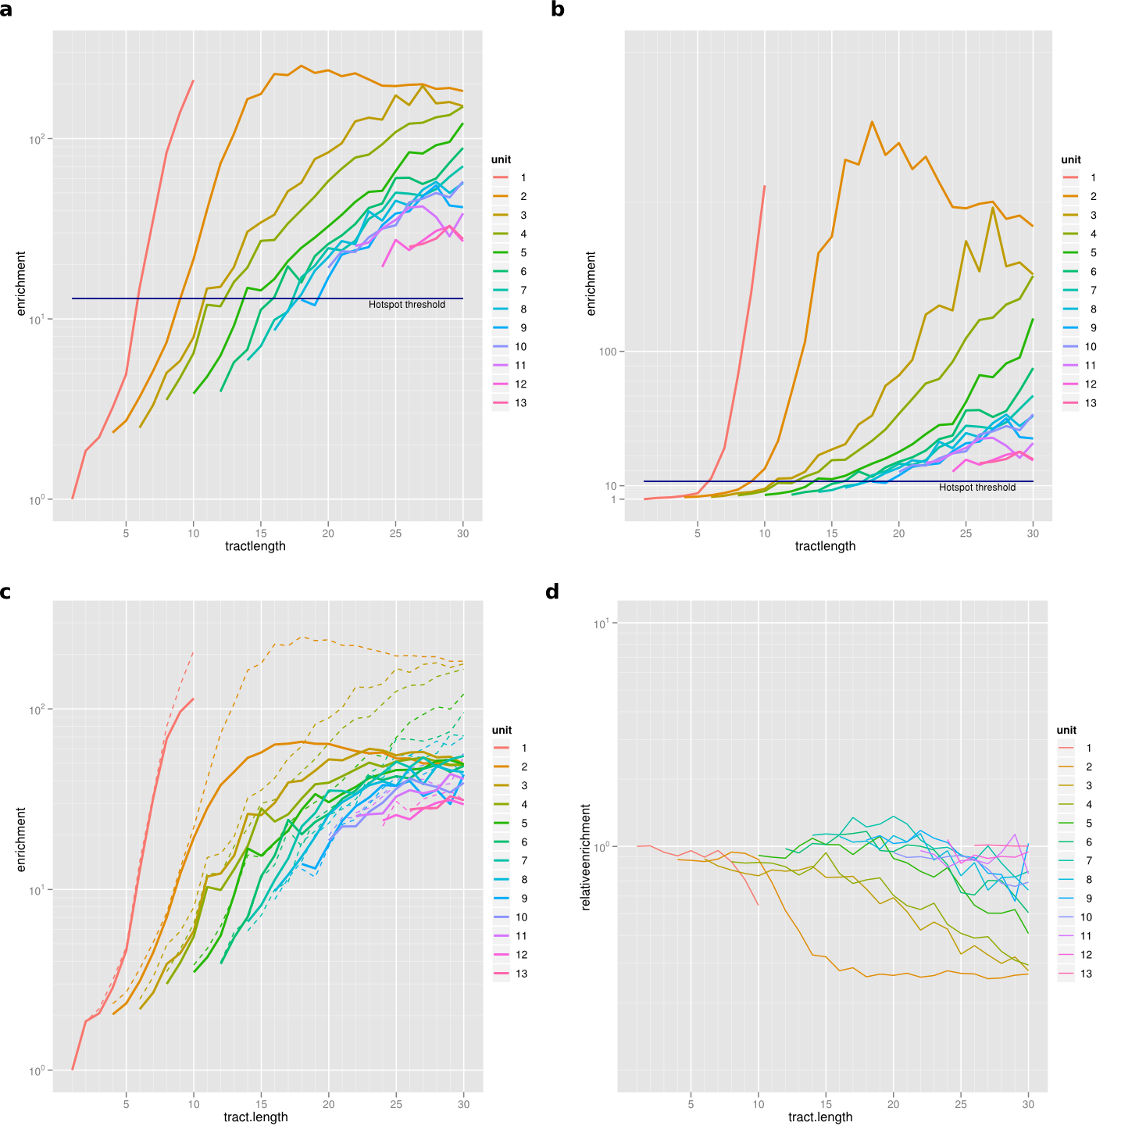

Figure S1. Enrichment of polymorphic indels by repeat tract length and repeat unit. Horizontal axes denotes the repeat tract length; the repeat unit size is color coded. a, relative number of called indels per nucleotide in each category, scaled to 1 for the category with smallest enrichment (1 copy of single nucleotide unit), on a log scale. The blue line indicates the enrichment corresponding to the density of SNPs. b, same on a linear scale. c Enrichment of human-chimp alignment gaps for the same categories. For comparison, the human polymorphism results are shown as dotted lines in the same graph. d Ratio of enrichment of human polymorphic indels to the enrichment of chimp alignment gaps, on a logarithmic scale. The enrichments are very similar where these are not reduced due to saturation.
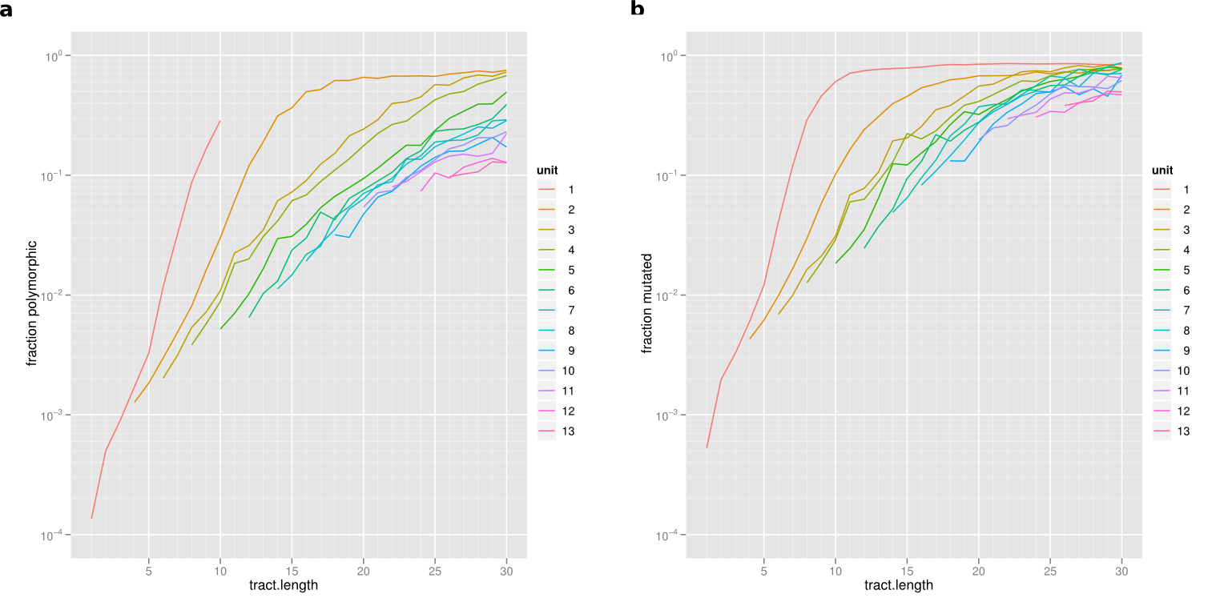
Figure S2. Fraction of tandem repetitive sites showing mutations or polymorphisms. Horizontal axes denotes the repeat tract length; the repeat unit size is color coded. a, fraction of human repeat tracts that are polymorphic, by tract length and unit length. b, fraction of human repeat tracts that are mutated between human and chimp.

Figure S3. Average recombination rate estimated from HapMap data.
Position is indicated relative to the CCTCCCTNNCCAC motif, and relative to the background motif CTTCCCTNNCCAC.

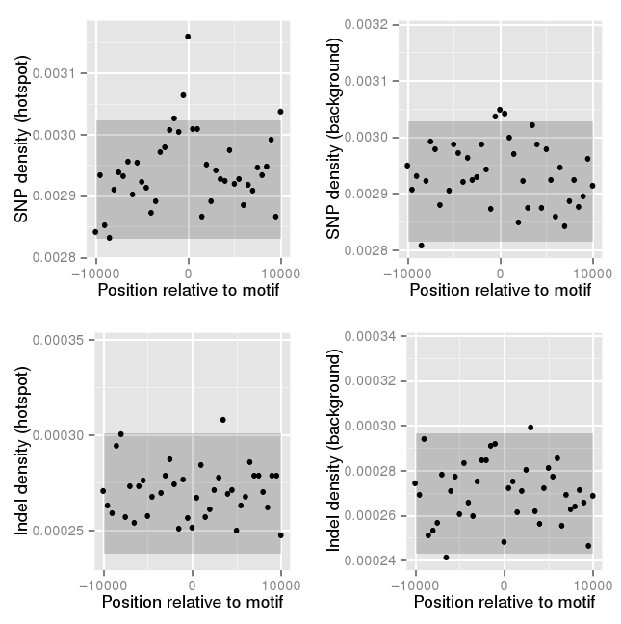

Figure S4. Local density of SNP (top) and indel (bottom) variants in 1000 Genomes Pilot 1 around recombination hotspot motifs
Data from the CEU cohort, and positions are relative to the position of the recombination motif CCTCCCTNNCCAC (left), and to the background motif CTTCCCTNNCCAC (right). Top plots show SNP density, while bottom plots show indel density. In all cases, the Y axis denotes the average density per nucleotide in 300 bp windows, and the shaded rectangle denotes 2 SEM determined from the data with the central 3 bins left out.
A B
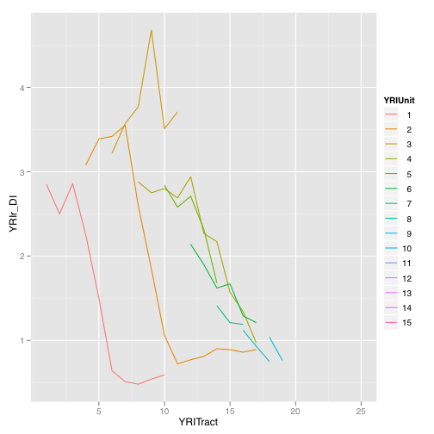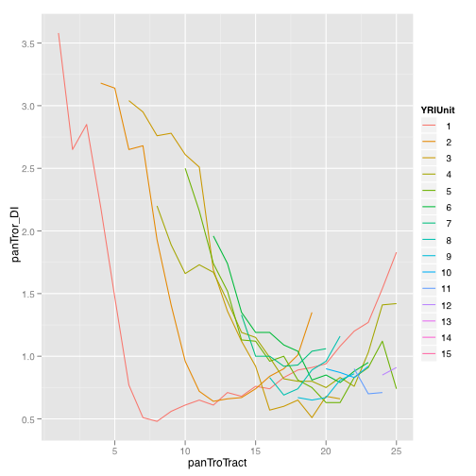
Figure S5. Deletion-to-insertion ratio (rDI) in for indels in the YRI cohort and for indels between the human and chimpanzee references.
The rDI is plotted stratified by repeat tract unit and repeat tract length. Colors indicate the size of the repeat unit (1, red=homopolymers). Only points for which at least 100 insertions were observed were included. YRI polymorphic indels were polarized using the chimpanzee, gorilla, orangutan and macaque genomes as described. Indels observed between the human and chimpanzee reference assemblies were polarized with the same procedure, using gorilla, orangutan and macaque as outgroups.

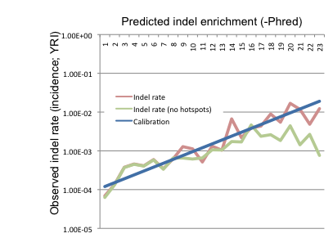

Figure S6. Observed indel enrichment by predicted indel rate
The figure shows the observed enrichment (y axis; incidence of indels in YRI), as a function of the predicted enrichment with indels according to the indel rate model. Shown are both overall enrichment (red line), and enrichment excluding regions used to train the model (annotated as homopolymer or tandem repeat) (green line). A perfectly calibrated model would follow the blue line. Loci with a predicted indel enrichment score of 12 or above are at least 10x enriched with indels, and were annotated as Predicted hotspots (PR).

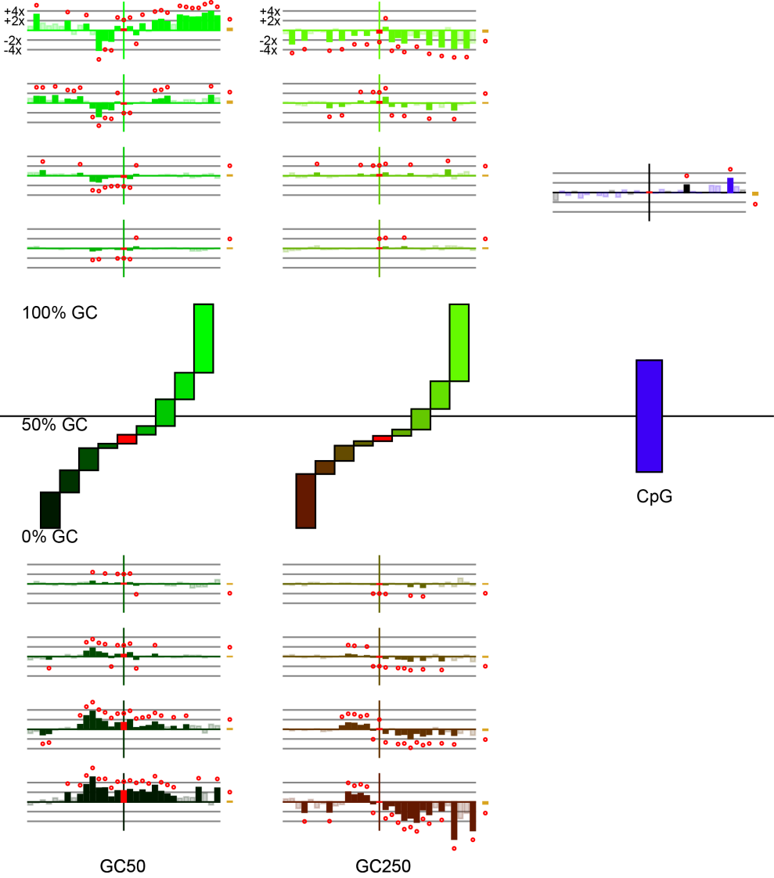
Fig. S7: Modeled Indel rates for GC content and CpG islands
Indel rates modeled with logistic regression demonstrate depletion of 2n indels for insertions and deletions in high GC bins for the GC 250-bp windows and enrichment for AT indels in the GC 50-bp windows. GC windows are color-coded by the average GC content for the corresponding quantile, shown between the sets of plots. Relative rates on a logarithmic scale are displayed from left to right as deletions to insertions of size -15 to 15 where the rate at position 0 is the overall rate for all indels irrespective of size. Relative SNP rates are shown in gold to the right of each plot.
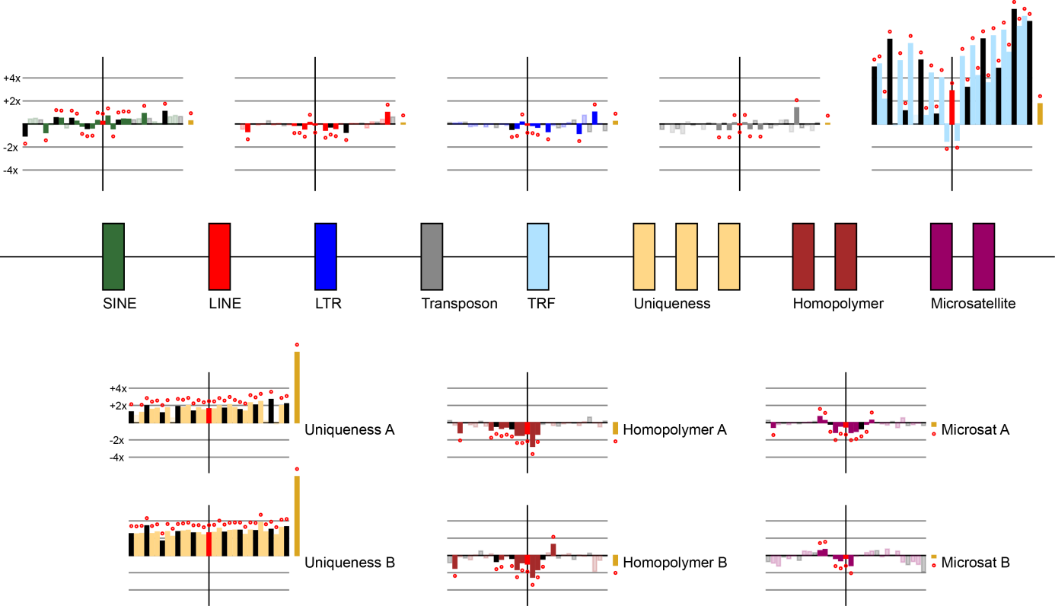
Fig. S8: Modeled Indel rates for repetitive element categories
Indel rates modeled with logistic regression demonstrate enrichment of 2n indels for TRF repeats (simple repeats) and enrichment in regions with reduced sequence uniqueness (Uniqueness(B)<Uniqueness(A)). The depletion of indels in homopolymer regions and microsatellites is due to the removal of regions annotated as HR or TR prior to running the regression, and partly due to our pipeline’s inability to confidently call indels in longer tandem repeat tract. Relative rates on a logarithmic scale are displayed from left to right as deletions to insertions of size -15 to 15 where the rate at position 0 is the overall rate for all indels irrespective of size. Relative SNP rates are shown in gold to the right of each plot.

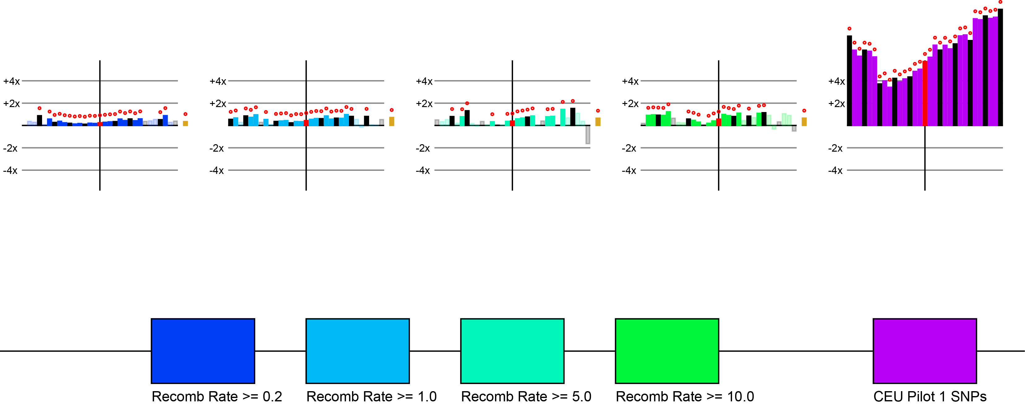
Fig. S9: Modeled Indel rates for recombination rate and SNPs
Indel rates modeled with logistic regression demonstrate slight enrichment of indels with increasing recombination rate and a strong enrichment of indels overlapping SNPs. The latter is suggestive of a known increased false call rate for SNPs near indels. Relative rates on a logarithmic scale are displayed from left to right as deletions to insertions of size -15 to 15 where the rate at position 0 is the overall rate for all indels irrespective of size. Relative SNP rates are shown in gold to the right of each plot.

Fig. S10. Variability in mean derived allele frequency (DAF) as a function of local crossover (CO) rate.
Mean DAF for polymorphic insertions (A) and deletions (B), separately. Shown are frequencies of indels identified in non-repetitive (NR) contexts, segregating in the Yoruba, CEU, and JPT/CHB populations (N=522478, 348942, and 302297, respectively). Local crossover rates were obtained from HapMap Phase 2 data and calculated in 5kb windows for each indel. Error bars correspond to one standard error of the mean.

Figure S11. Derived allele frequency (DAF) spectra for deletions in various genomic contexts. Depicted are the DAF spectra for non-repetitive (NR) indels occurring in several annotation categories. Indels overlapping protein coding sequence were further subdivided according to their length as frameshift and non-frameshift (multiple of 3). Synonymous and non-synonymous SNPs also identified in 1000 Genomes individuals were included for comparison. Error bars represent standard error of expected frequencies (p) from a binomial distribution, where n= number of indels, calculated as (pq/n)^1/2 where q=1-p.

A)
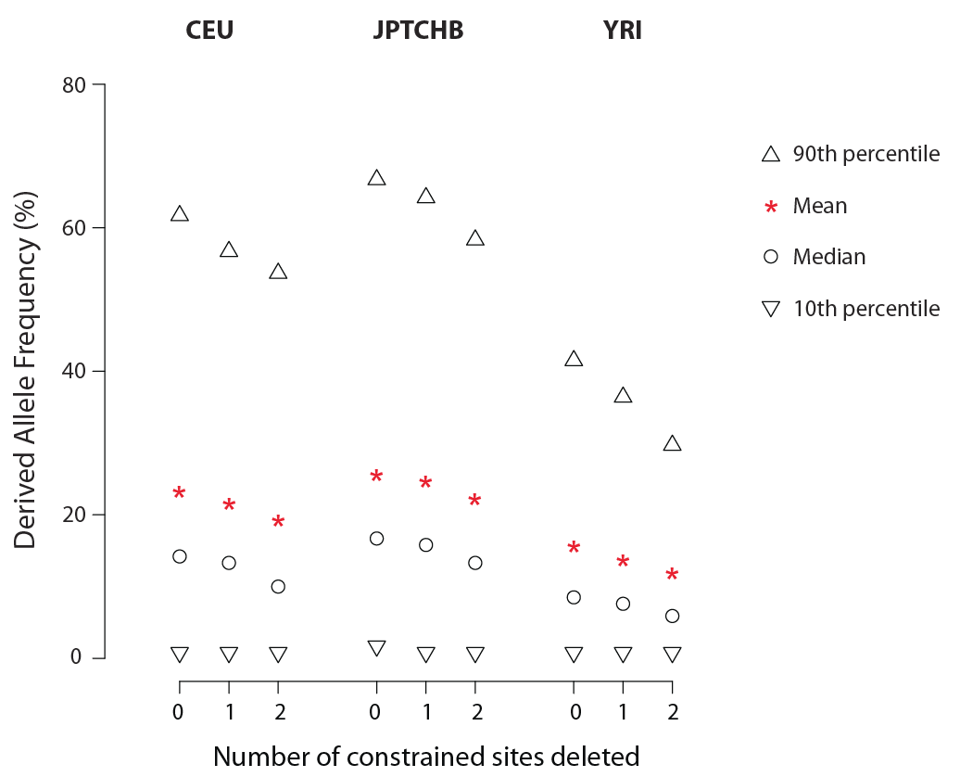
B)
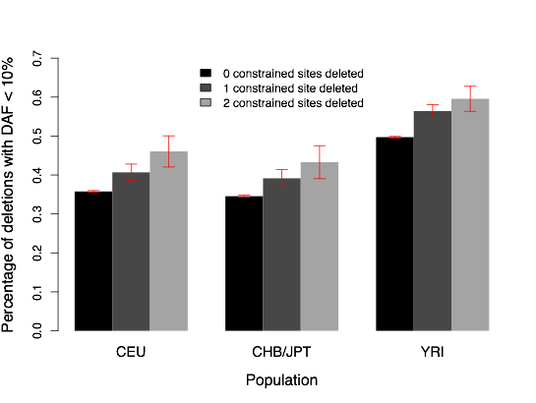
Fig. S12: Selection against deletions is correlated with the number of constrained sites deleted.
A. Mean, median, and 10th and 90th percentile of the derived allele frequency spectrum by the number of constrained sites deleted by a 2bp deletion. B. Percentage of 2bp deletions that delete 0 (black), 1 (dark grey), or 2 (light grey) constrained sites that have a DAF < 10%. Error bars denote 1 SEM. As with 3bp deletions (Fig. 2f), the proportion of low frequency alleles increases with the number of constrained sited deleted.

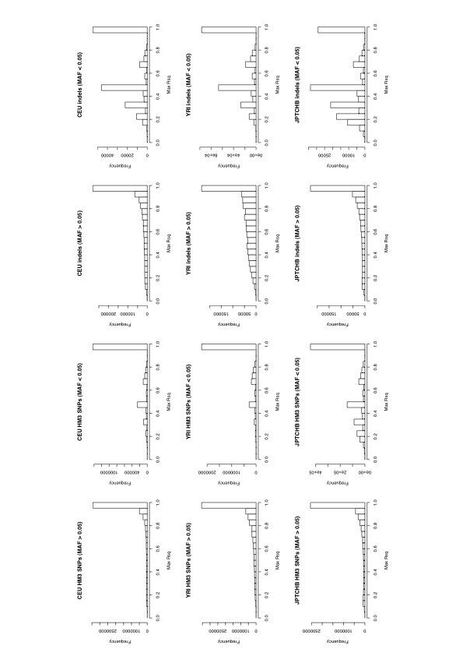

Fig S13. Patterns of linkage disequilibrium of SNPs and indels against HapMap3 SNPs.
Shown is the histogram of maximum r^2 values between SNPs from HapMap3, or indels studied in this paper called on the CEU population, and (other) HapMap3 SNPs. Separate plots are shown for variants above and below a population frequency of 5%. In qualitative terms the plots for SNPs and indels are similar, with both classes of variants showing a large proportion in strong or perfect LD with an(other) HapMap3 SNP. The indel class shows more cases with low LD, which is likely caused by the relatively high fraction of hotspot indels, at which homoplasies will have lowered the average LD.

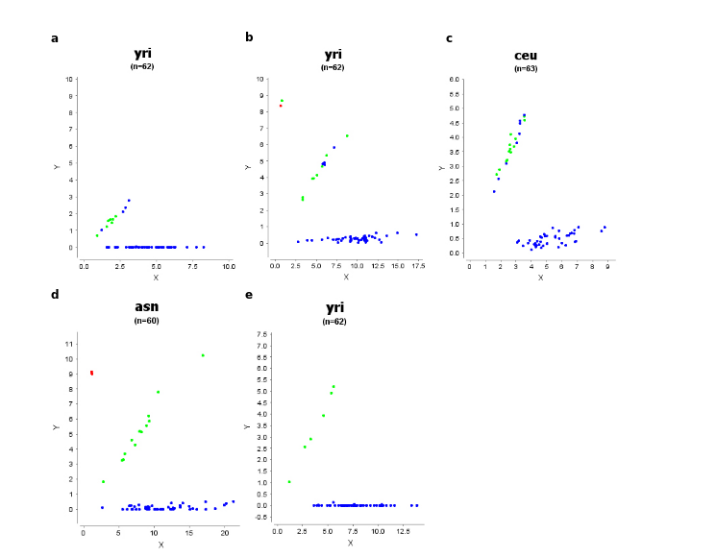
f
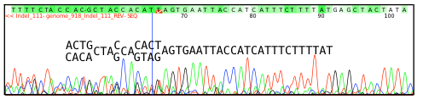
Figure S14. Validation of six indel variants. Plots a-e show genotype intensity plots displaying the results of Sequenom genotyping. Each insert shows the intensity of probes corresponding to the reference (x axis) and non-reference (y axis) alleles for each variant for each of the individuals in a genotyped population; plot f shows the trace plot of a heterozygous insertion call for individual NA10851 (CEU). Plots show results for the following variants (see Table 3 in the main text): a) chr3:99289390:+A; b) chr6:44248032:+GGCTGCC; c) chr22:16602868:-GCCACGCTCAACT; d) chr2:236426153:+CAGG; e) chr13:47565698:-AT. f) chr1:94471556:+AGCAGTAG. In plots a-e, for each variant, the population with the highest called allele frequency is shown. Calls were chosen from those present in our call set as well as the 1000 Genomes pilot project call set, and individual dots are coloured according to their genotypes as called by the 1000 Genomes pilot project: blue, homozygous reference; green, heterozygous; red, homozygous non-reference. Plot f shows the reverse-strand trace around the insertion site; consensus nucleotide calls are shown on top (whiter hues indicating greater confidence), and expected nucleotides or nucleotide pairs are shown in above the trace.

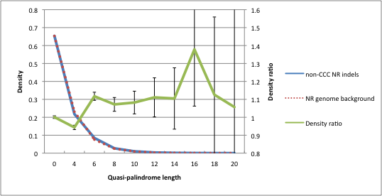

Figure S15. Enrichment of quasi-palindromes in non-CCC NR indels. Shown are the distribution of maximum local quasi-palindromic matches in 40-bp windows (W=20) around non-CCC NR indels (blue), the same distribution across the genome in NR sites (dotted red line), and the pointwise ratio of these distributions (green) with 95% confidence estimates (black whiskers). The data supports a small depletion of quasi-palindromes of length 4 and below, and a ~10% (11.7 +/- 2.3%) enrichment of quasi-palindromes of length 6 and above, within non-CCC NR indels compared to the genomic background. (Odd-length quasi-palindromes were left out because of their relative rarity compared to even-sized ones, a feature of the precise definition of quasi-palindromes used here; these support the general trend but with larger confidence intervals.)
Figure S16. Taggability of indels across classes and frequency bins. Shown are the mean r² of the best tagging SNP for all indels (black), SNPs (dotted line), and various classes of indels (coloured lines, see legend). The best tagging SNP was taken to be the SNP from the 1000 Genomes Pilot 1 set, with minor allele frequency not below 0.05, showing the highest r² with the variant (indel or SNP) under consideration, within a window of 100 kb centered around the variant. We focused on common variants, defined as those with minor allele frequency exceeding 5%. All variants were from the CEU population, and from chromosome 1.

