Supplementary Figure 1.
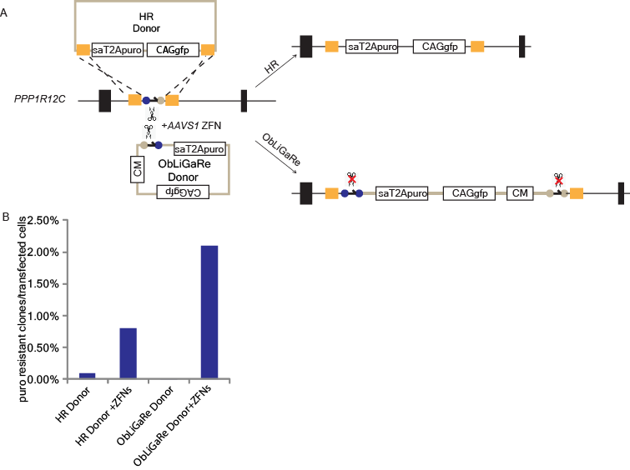
Targeted gene insertion at AAVS1 locus by homologous recombination (HR) or ObLiGaRe.

(A) Strategies of inserting a sa-T2A-puro-GFP cassette at the AAVS1 locus. The HR donor can be inserted in the AAVS1 locus by homologous recombination using the homology arms depicted in yellow. The ObLiGaRe donor can be inserted at the same locus by ligation. In this case the whole plasmid is integrated in the locus as depicted.
(B) Efficiency of the integration at AAVS1 locus by HR vs. ObLiGaRe. The value on y axis represents the percentage of the number of puromycin resistant colonies out of the total number of transfected cells. We randomly selected 4 puromycin resistant clones targeted with the ObLiGaRe donor and described the results in Fig. 1.

Supplementary Figure 2.

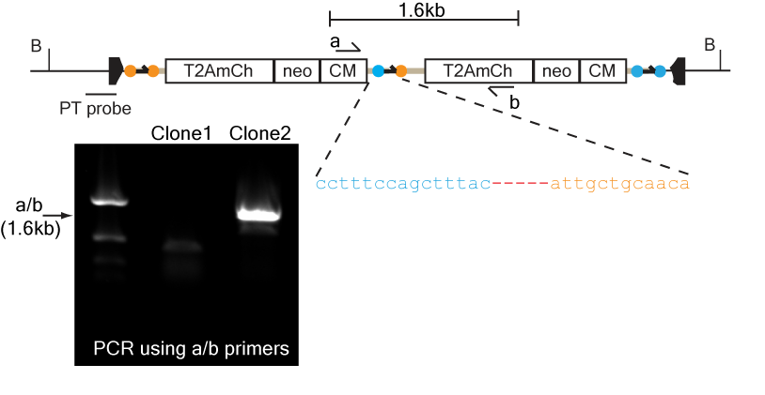
Clone #2 in Figure 2 contained a dimer of inserts in one of the targeted PTEN allele.
Clone #2 had a larger than expected insert in one of the targeted PTEN allele (Fig. 2B). We speculated that this was due to incorporation of two copies of the ObLiGaRe donor in a head to tail configuration (shown above). Based on this hypothesis, we designed PCR primers (a and b) that would amply the junctions between the two donors. We showed that expected PCR products could only be amplified with these primers from genomic DNA of clone #2 but not clone #1 which had single copy of ObLiGaRe donor. We sequenced the PCR product and revealed there were two donors ligated head-to-tail with 5 bp deletion.

Supplementary Figure 3

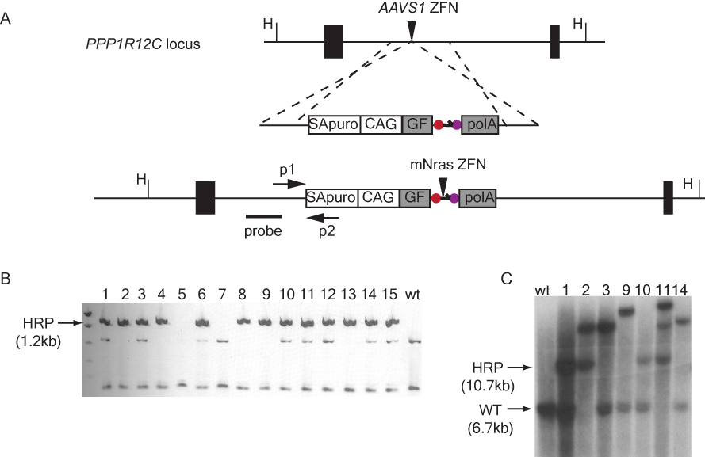
Generate a reporter cell line for monitoring HR vs. ObLiGaRe.
(A) Strategy of inserting the DGF reporter into the PPP1R12C (most commonly known as AAVS1) locus via homologous recombination. Primers used for PCR screening (P1-P2) and probe for Southern blot (probe) are indicated in the map.
(B) Genomic PCR screening of 15 puromycin resistant HCT116 clones for the insertion of the puro cassette at PPP1R12C locus.
(C) Southern blot of the seven clones identified after PCR screening. WT: wild type allele; HRP: homologous recombination product; H: HindIII. Clone#10 was used for the experiments described in Fig. 5.

Supplementary Figure 4

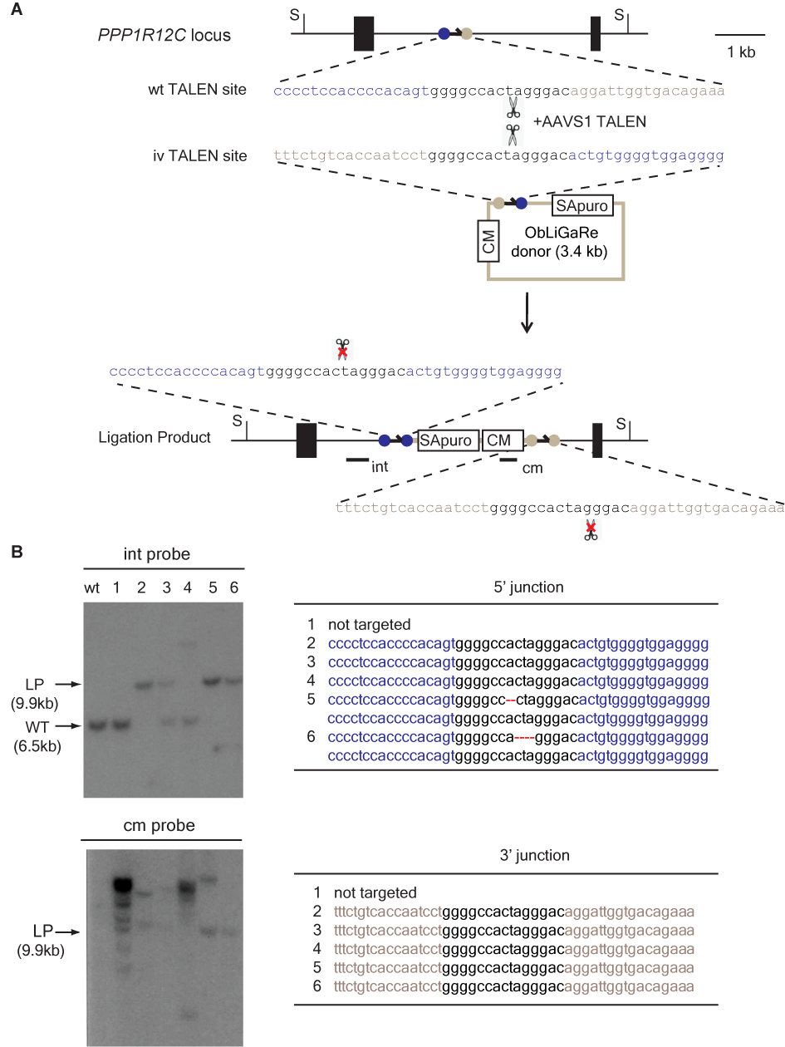

ObLiGaRe using AAVS1 TALEN.
(A) Schematic illustration of ObLiGaRe strategy at PPP1R12C (AAVS1) locus with TALENs. TALENs recognition sites are indicated as grey and blue circles connected with small arrows (cutting sites). The DNA sequence of AAVS1 specific TALENs site (wt) and the ObLiGaRe TALENs site (iv) are shown. The predicted joining sequences after precise end joining between the vector and the genome are indicated.
(B) Southern blot of 6 puromycin resistant clones after ObLiGaRe. LP: the predicted ligation product. The probes are the same as used in Fig. 1. The 5’ and 3’ junction sequences of the 6 clones are shown in the tables on the right. S: SphI.

Supplementary Figure 5
1 atggactacaaagaccatgacggtgattataaagatcatgacatc
M D Y K D H D G D Y K D H D I
46 gattacaaggatgacgatgacaagatggcccccaagaagaagagg
D Y K D D D D K M A P K K K R
91 aaggtgggcatccacggggtacccgccgctatggctgagaggccc
K V G I H G V P A A M A E R P
136 ttccagtgtcgaatctgcatgcgtaacttcagttacaactggcac
F Q C R I C M R N F S Y N W H
181 ctgcagcgccacatccgcacccacacaggcgagaagccttttgcc
L Q R H I R T H T G E K P F A
226 tgtgacatttgtgggaggaagtttgcccgctccgaccacctgacc
C D I C G R K F A R S D H L T
271 acccataccaagatacacacgggatctcagaagcccttccagtgt
T H T K I H T G S Q K P F Q C
316 cgaatctgcatgcgtaacttcagtcacaactacgcccgcgactgt
R I C M R N F S H N Y A R D C
361 cacatccgcacccacacaggcgagaagccttttgcctgtgacatt
H I R T H T G E K P F A C D I
406 tgtgggaggaagtttgcccagaactccacccgcatcggccatacc
C G R K F A Q N S T R I G H T
451 aagatacacctgcggggatcccagctggtgaagagcgagctggag
K I H L R G S Q L V K S E L E
496 gagaagaagtccgagctgcggcacaagctgaagtacgtgccccac
E K K S E L R H K L K Y V P H
541 gagtacatcgagctgatcgagatcgccaggaacagcacccaggac
E Y I E L I E I A R N S T Q D
586 cgcatcctggagatgaaggtgatggagttcttcatgaaggtgtac
R I L E M K V M E F F M K V Y
631 ggctacaggggaaagcacctgggcggaagcagaaagcctgacggc
G Y R G K H L G G S R K P D G
676 gccatctatacagtgggcagccccatcgattacggcgtgatcgtg
A I Y T V G S P I D Y G V I V
721 gacacaaaggcctacagcggcggctacaatctgcctatcggccag
D T K A Y S G G Y N L P I G Q
766 gccgacgagatggagagatacgtggaggagaaccagacccggaat
A D E M E R Y V E E N Q T R N
811 aagcacctcaaccccaacgagtggtggaaggtgtaccctagcagc
K H L N P N E W W K V Y P S S
856 gtgaccgagttcaagttcctgttcgtgagcggccacttcaagggc
V T E F K F L F V S G H F K G
901 aactacaaggcccagctgaccaggctgaaccacatcaccaactgc
N Y K A Q L T R L N H I T N C
946 aatggcgccgtgctgagcgtggaggagctgctgatcggcggcgag
N G A V L S V E E L L I G G E
991 atgatcaaagccggcaccctgacactggaggaggtgcggcgcaag
M I K A G T L T L E E V R R K
1036 ttcaacaacggcgagatcaacttcagatctgagggcagaggaagt
F N N G E I N F R S E G R G S
1081 ctgctaacatgcggtgacgtcgaggagaatcctggcccagactac
L L T C G D V E E N P G P D Y
1126 aaagaccatgacggtgattataaagatcatgacatcgattacaag
K D H D G D Y K D H D I D Y K
1171 gatgacgatgacaagatggcccccaagaagaagaggaaggtgggc
D D D D K M A P K K K R K V G
1216 attcatggggtacccgccgctatggctgagaggcccttccagtgt
I H G V P A A M A E R P F Q C
1261 cgaatctgcatgcgtaacttcagtcagtcctccaacctggcccgc
R I C M R N F S Q S S N L A R
1306 cacatccgcacccacacaggcgagaagccttttgcctgtgacatt
H I R T H T G E K P F A C D I
1351 tgtgggaggaagtttgcccgcaccgactacctggtggaccatacc
C G R K F A R T D Y L V D H T
1396 aagatacacacgggatctcagaagcccttccagtgtcgaatctgc
K I H T G S Q K P F Q C R I C
1441 atgcgtaacttcagttacaacacccacctgacccgccacatccgc
M R N F S Y N T H L T R H I R
1486 acccacacaggcgagaagccttttgcctgtgacatttgtgggagg
T H T G E K P F A C D I C G R
1531 aagtttgcccagggctacaacctggccggccataccaagatacac
K F A Q G Y N L A G H T K I H
1576 ctgcggggatcccagctggtgaagagcgagctggaggagaagaag
L R G S Q L V K S E L E E K K
1621 tccgagctgcggcacaagctgaagtacgtgccccacgagtacatc
S E L R H K L K Y V P H E Y I
1666 gagctgatcgagatcgccaggaacagcacccaggaccgcatcctg
E L I E I A R N S T Q D R I L
1711 gagatgaaggtgatggagttcttcatgaaggtgtacggctacagg
E M K V M E F F M K V Y G Y R
1756 ggaaagcacctgggcggaagcagaaagcctgacggcgccatctat
G K H L G G S R K P D G A I Y
1801 acagtgggcagccccatcgattacggcgtgatcgtggacacaaag
T V G S P I D Y G V I V D T K
1846 gcctacagcggcggctacaatctgcctatcggccaggccgacgag
A Y S G G Y N L P I G Q A D E
1891 atgcagagatacgtgaaggagaaccagacccggaataagcacatc
M Q R Y V K E N Q T R N K H I
1936 aaccccaacgagtggtggaaggtgtaccctagcagcgtgaccgag
N P N E W W K V Y P S S V T E
1981 ttcaagttcctgttcgtgagcggccacttcaagggcaactacaag
F K F L F V S G H F K G N Y K
2026 gcccagctgaccaggctgaaccacaaaaccaactgcaatggcgcc
A Q L T R L N H K T N C N G A
2071 gtgctgagcgtggaggagctgctgatcggcggcgagatgatcaaa
V L S V E E L L I G G E M I K
2116 gccggcaccctgacactggaggaggtgcggcgcaagttcaacaac
A G T L T L E E V R R K F N N
2161 ggcgagatcaacttcagatcttga 2184
G E I N F R S *

Map and Sequence of the expression vectors for ZFNs and TALENs
All the ZFNs and TALENs used in this study were cloned in the same expression vector between a CMV promoter and a BGH pA. All ZFNs pairs were cloned in the same plasmid using a 2A peptide to separate two ZFNs. The 2A peptide sequence (underlined) and the junction between the 2 ZFNs is showed for the AAVS1 ZFNs and is identical for the other ZFNs used.

Supplementary Figure 6
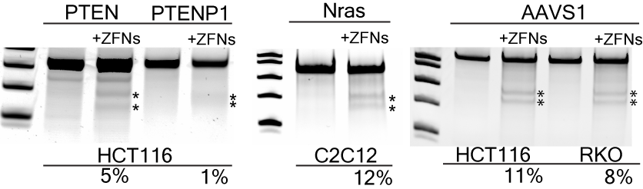

Surveyor® assay of ZFNs used in the study.
The cutting efficiency of ZFNs at the target locus was determined using the Surveyor® assay. The PTEN ZFNs had a higher cutting efficiency at PTEN than at PTENP1 loci in HCT116 cells. In the middle gel, the efficiency of Nras ZFNs cutting in C2C12 was ~12%. The cutting efficiency of AAVS1 ZFNs was ~11% in HCT116 and ~8% in RKO cells. The cutting efficiency of the AAVS1 ZFNs in KBM7 was below the detection limit of the assay due to low transfection efficiency.

Supplementary Table 1

HCT116 | 5’ junction
Sequence 1 | accccacagtggggccacccactgtggggt
Sequence 2 | accccacagtggggccacccactgtggggt
Sequence 3 | -------------gccacccactgtggggt
Sequence 4 | accccacagtggggccacccactgtggggt
Sequence 5 | accccacagtggggccacccactgtggggt
Sequence 6 | accccacagtggggccacccactgtggggt
Sequence 7 | accccacagtggggccacccactgtggggt
Sequence 8 | accccacagtggggccacccactgtggggt
Sequence 9 | accccacagtggggccacccactgtggggt
Sequence 10 | accccacagtggggccacccactgtggggt
Sequence 11 | accccacagtggggcc--------------
Sequence 12 | accccacagtggggccacccactgtggggt
Sequence 13 | accccacagtggggccacccactgtggggt
Sequence 14 | accccacagtggggccacccactgtggggt
Sequence 15 | accccacagtggggccacccactgtggggt

5’ Junction sequences of puromycin resistant HCT116 cells.
HCT116 cells were transfected with the ObLiGaRe donor and AAVS1 ZFN plasmid as described for Fig. 1. Genomic DNA was prepared from pooled puromycin resistant HCT116 cells. The 5’ junction of the insertion was PCR amplified and individual PCR product was sequenced using the TOPO® TA Cloning® strategy and 15 randomly selected sequence reads were listed.

