Supplementary tables and figures

Sex-biased genetic effects on gene regulation in humans

Antigone S. Dimas^{1,2,3}, Alexandra C. Nica¹, Stephen B. Montgomery¹, Barbara E. Stranger^{,4,5,6}, Towfique Raj^{,4,5,6}, Alfonso Buil¹, Thomas Giger¹, Tuuli Lappalainen¹, Maria Gutierrez-Arcelus¹, MuTHER Consortium, Mark I. McCarthy^{2,7,8}, Emmanouil T. Dermitzakis¹.

^{1.} Department of Genetic Medicine and Development, University of Geneva Medical School, Geneva 1211, Switzerland
^{2.} Wellcome Trust Centre for Human Genetics, University of Oxford, Roosevelt Drive, Oxford OX3 7BN, UK
^{3.} Biomedical Sciences Research Center Al. Fleming, 16672 Vari, Greece
^{4.} Department of Medicine, Division of Genetics, Brigham and Women’s Hospital, Boston, MA, 02115, USA
^{5.} Harvard Medical School, Boston, MA, 02115, USA
^{6.} Program in Medical and Population Genetics, Broad Institute of Harvard and Massachusetts Institute of Technology, Cambridge, MA. 02142, USA
^{7.} Oxford Centre for Diabetes, Endocrinology and Metabolism, University of Oxford, Churchill Hospital, Old Road, Headington, Oxford, OX3 7LJ, UK
^{8.} Oxford NIHR Biomedical Research Centre, Churchill Hospital, Old Road, Headington, Oxford, OX3 7LJ, UK

Correspondence should be addressed to ETD (emmanouil.dermitzakis@unige.ch)

Table S1. ANOVA with SNP x sex interaction. TBSD: threshold-based sex discordant. SNP-probes with ANOVA interaction p<=0.05 are designated as sex-biased.

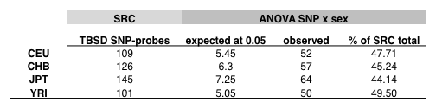

Table S2. Shared eQTL-genes regulated by independent regulatory variants in females (F) and males (M). –logp: –log₁₀p-value.

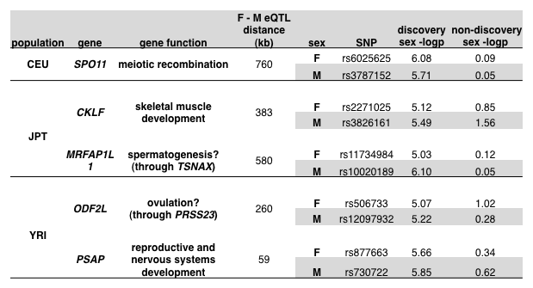

Table S3. Overlap between sex-biased eQTLs and GWAS SNPs.

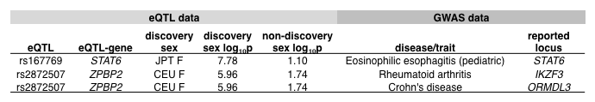

Figure S1. Log₂ gene expression vs. allele for two TBSD eQTL-gene examples in CEU. (A) SH3TC1 is a TBSD eQTL-gene in CEU females (CEU F) with Spearman rho=-0.796 and –log₁₀ p-value=12.212, but not in CEU males (CEU M) (B) where rho= -1.750 and –log₁₀ p-value=0.686. Similarly, PFKFB2 is not an eQTL-gene in CEU F (C) (rho=0.221 and –log₁₀ p-value=0.967, but is an eQTL-gene in CEU M (D) (rho=0.682 and –log₁₀ p-value=7.854).

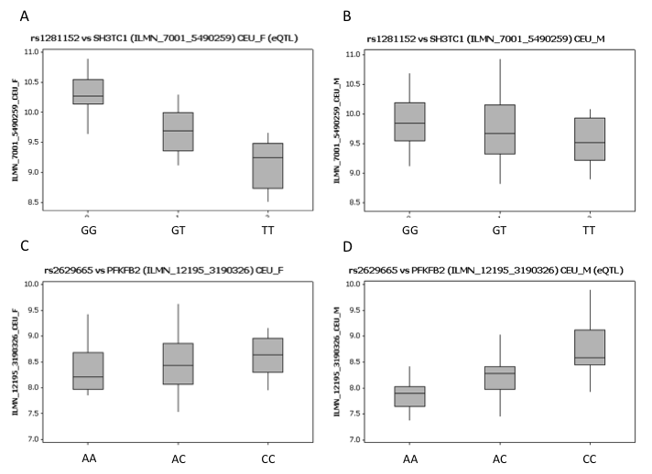

Figure S2. Comparison of –log₁₀ p-values of TBSD SNP-probes identified in the sex-stratified study (left panels) and corresponding SNP-probes in the whole population sample study (right panels). Although there is a power difference between the sex-stratified and whole population sample studies (whole population sample size is almost double the size of each sex-stratified study) the higher-powered whole population sample study is significantly depleted for high –log₁₀ p-values implying that pooling the two sexes dilutes TBSD signals. (A) CEU, (B) CHB, (C) JPT, (D) YRI. Mann-Whitney p-values <10⁻⁴ for all comparisons.

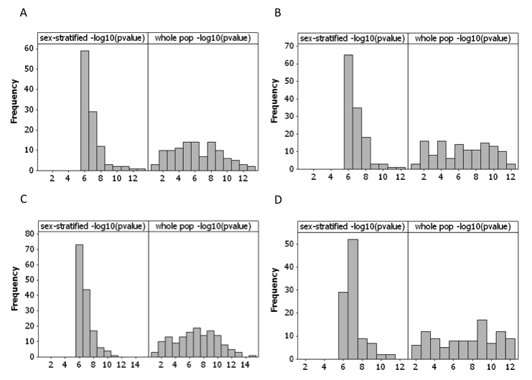

Figure S3. Percent of expression variance explained by ANOVA SNP x sex interaction. Percent variance explained by the SNP x sex interaction term is consistently higher for sex-biased vs. shared eQTL-genes (Mann-Whitney p-values <10⁻⁴ for all populations). This is also the case for sex-biased vs. TBSD eQTL-genes for CEU and CHB (M-W p-value<10⁻⁴ in both cases), JPT (M-W p-value =0.0005) and only in YRI M-W p-value= 0.36. Furthermore, for all populations we observe that M-W p-value for TBSD vs. shared <10⁻⁴ implying that TBSD eQTL-genes display non-negligible sex-differentiated genetic effects. Note: in this case sex-biased eQTL-genes were excluded from TBSD eQTL-genes.

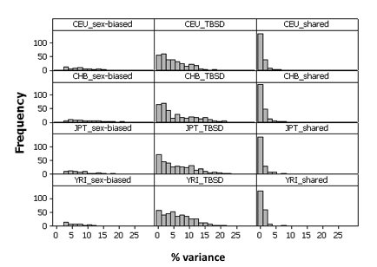

Figure S4. Log₂ gene expression vs. allele, and SNP -log₁₀p-value distribution for SPO11. rs6025625 is an eQTL in CEU females (A) (CEU F Spearman rho=0.613, -log₁₀p-value=6.075) but not in males (B) (CEU M rho=-0.03, log₁₀p-value=0.0918). rs3787152 is not an eQTL in CEU F (C) (rho= 0.018, -log₁₀p-value=0.0483) but is an eQTL in CEU M (D) (rho=0.596, -log₁₀p-value=5.7121). (E) –log₁₀p-value distribution for all SNPs in a 2 MB window centred on SPO11 (black: CEU F, red: CEU M).

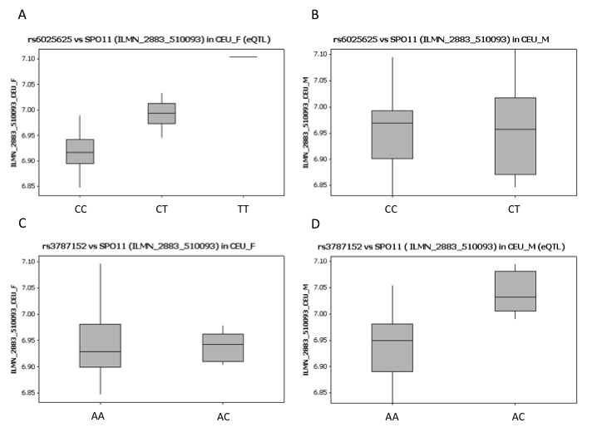
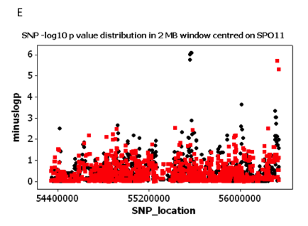

Figure S5. Log₂ gene expression vs. allele, and SNP -log₁₀p-value distribution for CKLF. rs2271025 is an eQTL in JPT females (A) (JPT F Spearman rho=-0.64, -log₁₀p-value=5.125) but not in males (B) (JPT M rho=-0.35, log₁₀p-value=1.557). rs3826161 is not an eQTL in JPT F (C) (rho=-0.23, -log₁₀p-value=0.851) but is an eQTL in JPT M (D) (rho=-0.65, -log₁₀p-value=5.489). (E) –log₁₀p-value distribution for all SNPs in a 2 MB window centred on CKLF (black: JPT F, red: JPT M).

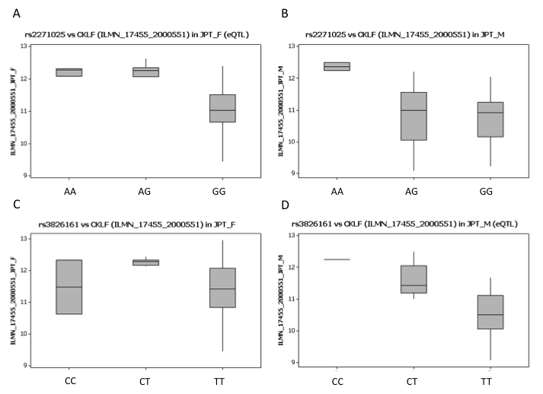
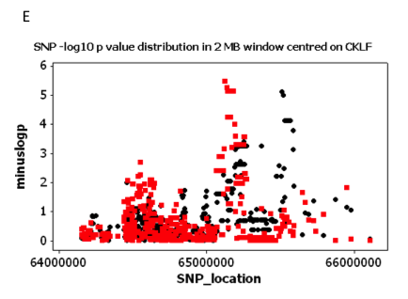

Figure S6. Log₂ gene expression vs. allele, and SNP -log₁₀p-value distribution for MRFAP1L1. rs11734984 is an eQTL in JPT females (A) (JPT F Spearman rho=0.639, -log₁₀p-value=5.032) but not in males (B) (JPT M rho=0.050, -log₁₀p-value=0.123). rs10020189 is not an eQTL in JPT F (C) (rho=-0.022, -log₁₀p-value=0.048) but is an eQTL in JPT M (D) (rho=0.678, -log₁₀p-value=6.101). (E) –log₁₀p-value distribution for all SNPs in a 2 MB window centred on MRFAP1L1 (black: JPT F, red: JPT M). Note: association is with different probes in each sex (JPT F: ILMN_2298_6020332, JPT M: ILMN_9584_6130180).
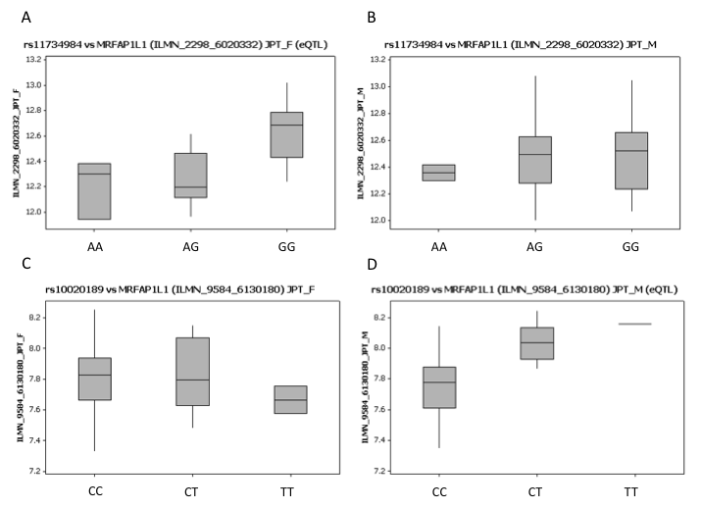
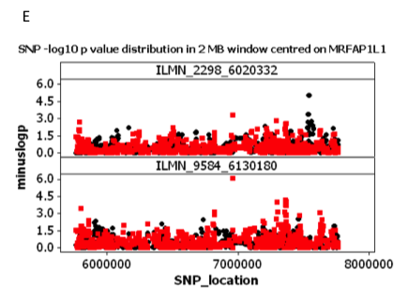

Figure S7. Log₂ gene expression vs. allele, and SNP -log₁₀p-value distribution for ODF2L. rs506733 is an eQTL in YRI females (A) (YRI F Spearman rho=0.570, -log₁₀p-value=5.070) but not in males (B) (YRI M rho=0.226, -log₁₀p-value=1.016). rs12097932 is not an eQTL in YRI F (C) (rho=0.088, -log₁₀p-value=0.276) but is an eQTL in YRI M (D) (rho=-0.568, -log₁₀p-value=5.221). (E) –log₁₀p-value distribution for all SNPs in a 2 MB window centred on ODF2L (black: YRI F, red: YRI M). Note: association is with different probes in each sex (YRI F: ILMN_92465_3060400, YRI M: ILMN_18003_6760095).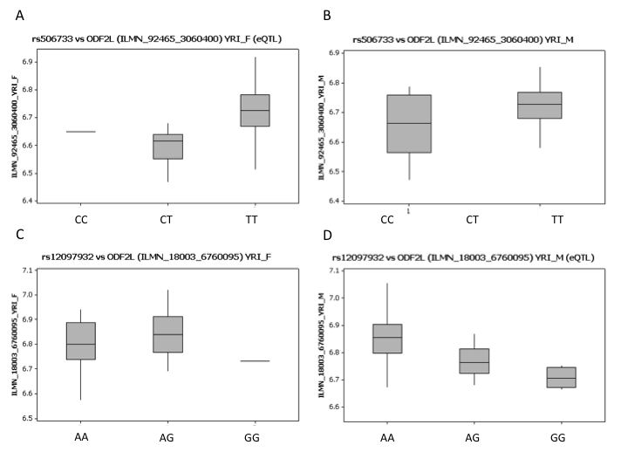
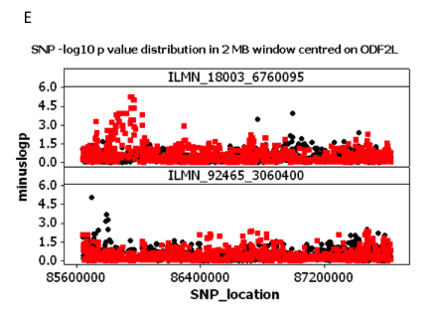

Figure S8. Log₂ gene expression vs. allele, and SNP -log₁₀p-value distribution for PSAP. rs877663 is an eQTL in YRI females (A) (YRI F Spearman rho=0.599, -log₁₀p-value=5.660) but not in males (B) (YRI M rho=-0.102, -log₁₀p-value=0.339). rs730722 is not an eQTL in YRI F (C) (rho=-0.165, -log₁₀p-value=0.624) but is an eQTL in YRI M (D) (rho=0.598, -log₁₀p-value=5.847). (E) –log₁₀p-value distribution for all SNPs in a 2 MB window centred on PSAP (black: YRI F, red: YRI M).
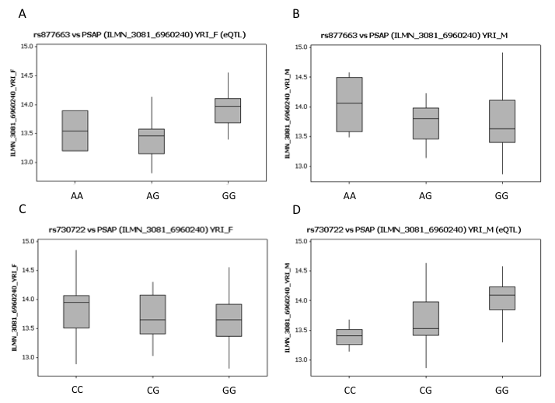
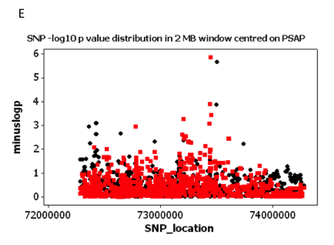

Figure S9. Comparison of the direction of eQTL allelic effects in females and males. The direction of allelic effect (determined by the direction of the Spearman rho) was found to be consistent for eQTLs detected in females and males.

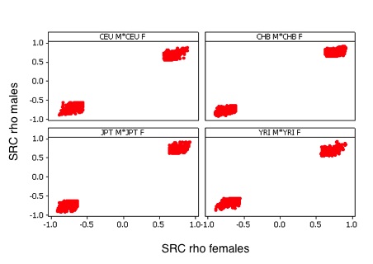

Figure S10. Distance of shared, TBSD, and sex-biased eQTLs to TSS. In all populations, shared eQTLs have higher –log₁₀p-values and tend to cluster around the TSS. TBSD and sex-biased eQTLs show lower –log₁₀p-values and span a greater range of distances from the TSS.

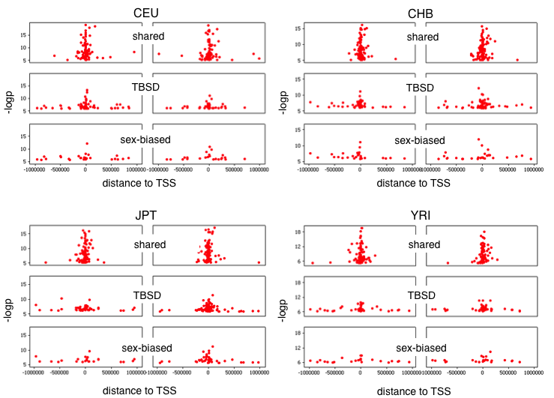

Figure S11. Significance differential across the sexes for eQTL-genes with ANOVA SNP x sex interaction p<=0.05 (sex-biased) and p>0.05. Sex-biased eQTLs show greater log₁₀p-value significance differences across the sexes and span a wider range of distances to the TSS (black: sex-biased; red: eQTLs with ANOVA interaction p>0.05).
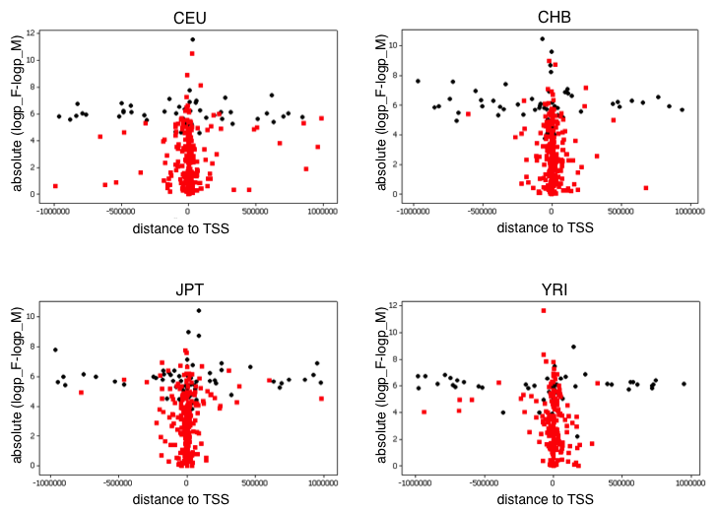

Figure S12. Expression fold change between major and minor allele homozygotes for shared and sex-biased eQTLs. Sex-biased eQTLs show greater expression fold change in the discovery sex. Expression fold change in females (x axis) and males (y axis) for 56 SNP-probes in CHB females (A) and for 61 SNP-probes in CHB males (B). Although sex-biased eQTLs show greater fold change differences in the discovery sex, there are cases of shared eQTLs that also display prominent fold change differences between females and males e.g. i) MLF1IP (fold change: CHB F 1.2; CEU M 0.7), ii) CAV2 (fold change: CHB F 0.9; CEU M 1.8). Expression fold change in females and males for 64 SNP-probes in JPT females (C) and for 82 SNP-probes in JPT males (D). Cases of shared eQTLs that display prominent fold change differences between females and males include i) RBMS2 (fold change: JPT F 1.5; JPT M 1.0), ii) TBC1D4 (fold change: JPT F 1.3; JPT M 2.1). Shared eQTLs: black, sex-biased eQTLs: red.

A B
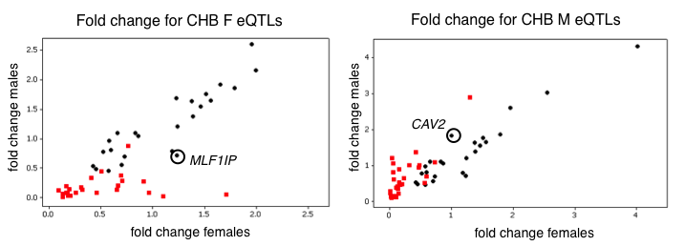

C D
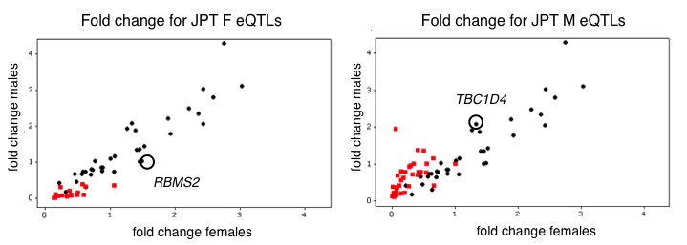

Figure S13. Log₂ gene expression vs. allele, and SNP -log₁₀p-value distribution for STAT6 and ZPBP2. rs167769 is an eQTL in JPT females (A) (JPT F Spearman rho=-0.756, -log₁₀p-value=7.777) for STAT6, but not in males (B) (JPT M rho=-0.274, -log₁₀p-value=1.103). (C) –log₁₀p-value distribution for all SNPs in a 2 MB window centred on STAT6 (black: JPT F, red: JPT M). rs2872507 is an eQTL in CEU females (D) (CEU F Spearman rho=-0.608, -log₁₀p-value=5.963) for ZPBP2, but not in males (E) (CEU M rho=-0.317, -log₁₀p-value=1.738). (F) –log₁₀p-value distribution for all SNPs in a 2 MB window centred on ZPBP2 (black: CEU F, red: CEU M). 