Cohesin regulates tissue-specific expression by stabilising highly occupied cis-regulatory modules
_____________

SUPPLEMENTAL FIGURES
Figure S1. Cohesin binding and RNAP2 pausing.
Figure S2. Cohesin peak shift with respect to sequence-specific factors.
Figure S3. Binding correlations for CTCF and CNC CRMs.
Figure S4. AutoClass CRM clustering results.
Figure S5. Choice of K for K-means CRM clustering analysis.
Figure S6. Correlations between motif score and sequence-specific factor ChIP signal.
Figure S7. All motif score correlations.
Figure S8. Performance results of all motif classifiers.
Figure S9. WT CRMs without TF motifs show preferential ChIP peak loss in Rad21^{+/-} cells.
Figure S10. Motifs and motif statistics.

DATA ACCESSION NUMBER

Data deposited under ArrayExpress accession number E-MTAB-941.

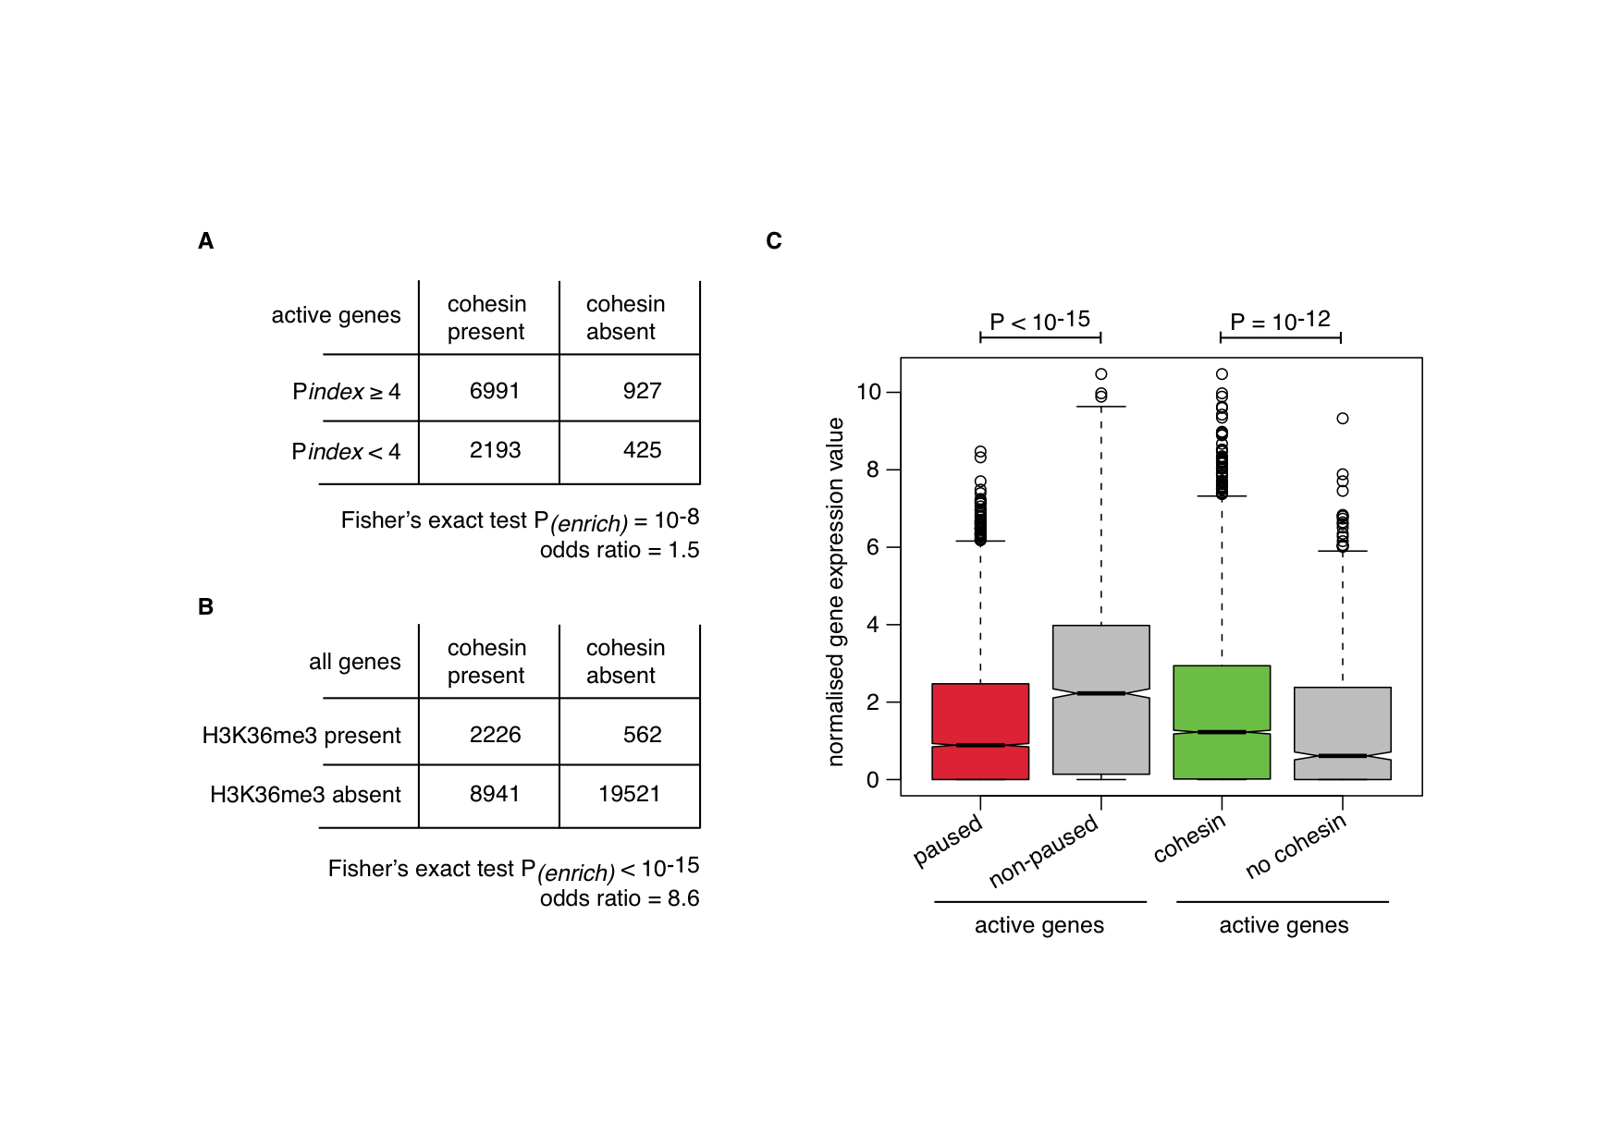
Figure S1. Cohesin binding and RNAP2 pausing. (A) Cohesin binding within promoter regions (≤ 2.5 kb from an annotated TSS) is significantly associated with high RNAP2 pausing indices (Pindex). Pausing indices were calculated as the length normalised ratio between RNAP2 ChIP fragments mapping within 300bp of the TSS and those mapping within the entire gene. We considered only active genes, defined as those with RNAP2 peaks overlapping their TSSs, and defined paused promoters as those having Pindex ≥ 4. (B) Genic H3K36me3 is significantly associated with cohesin-bound promoters genome-wide. (C) Active genes with high RNAP2 pausing indices are associated with lower levels of transcription, whereas cohesin presence at promoters is associated with elevated levels of transcription.

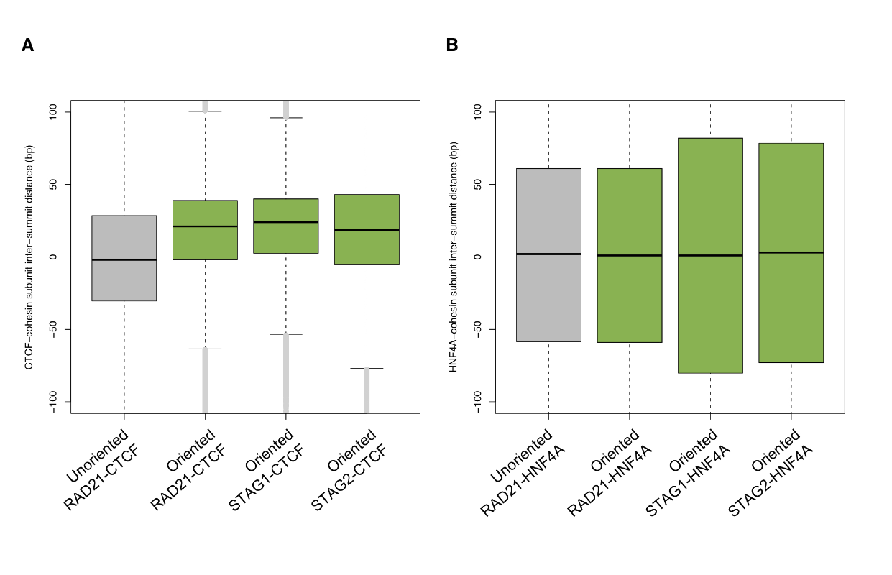
Figure S2. Cohesin peak shift with respect to sequence-specific factors. A significant peak shift, suggesting a direct biochemical interaction between cohesin and CTCF, is not present when compared to all other available TFs at CNCs. (A) At sites where CTCF and cohesin colocalise, we observe a shift in the summit position of all cohesin subunits (RAD21, STAG1, STAG2) with respect to the CTCF summit position when the orientation of the CTCF motif is taken into account. The grey boxplot indicates the genomic distance between summit positions of overlapping RAD21 and CTCF ChIP-seq peaks i.e. the sign of the inter-summit distance is simply a reflection of the chromosomal coordinates of the two summits (unoriented). The green boxplots indicate the genomic distance between summit positions when the orientation (strand) of the best CTCF motif match within its peak was taken into account i.e. the sign of the inter-summit distance is determined by the strand of the best CTCF motif (oriented). (B) On average, cohesin binding events exhibit no shift in summit position with respect to HNF4A, whether oriented on the strand of the best HNF4A motif match or not. Similar results were obtained using ChIP-seq data for the other nine TFs available (not shown).

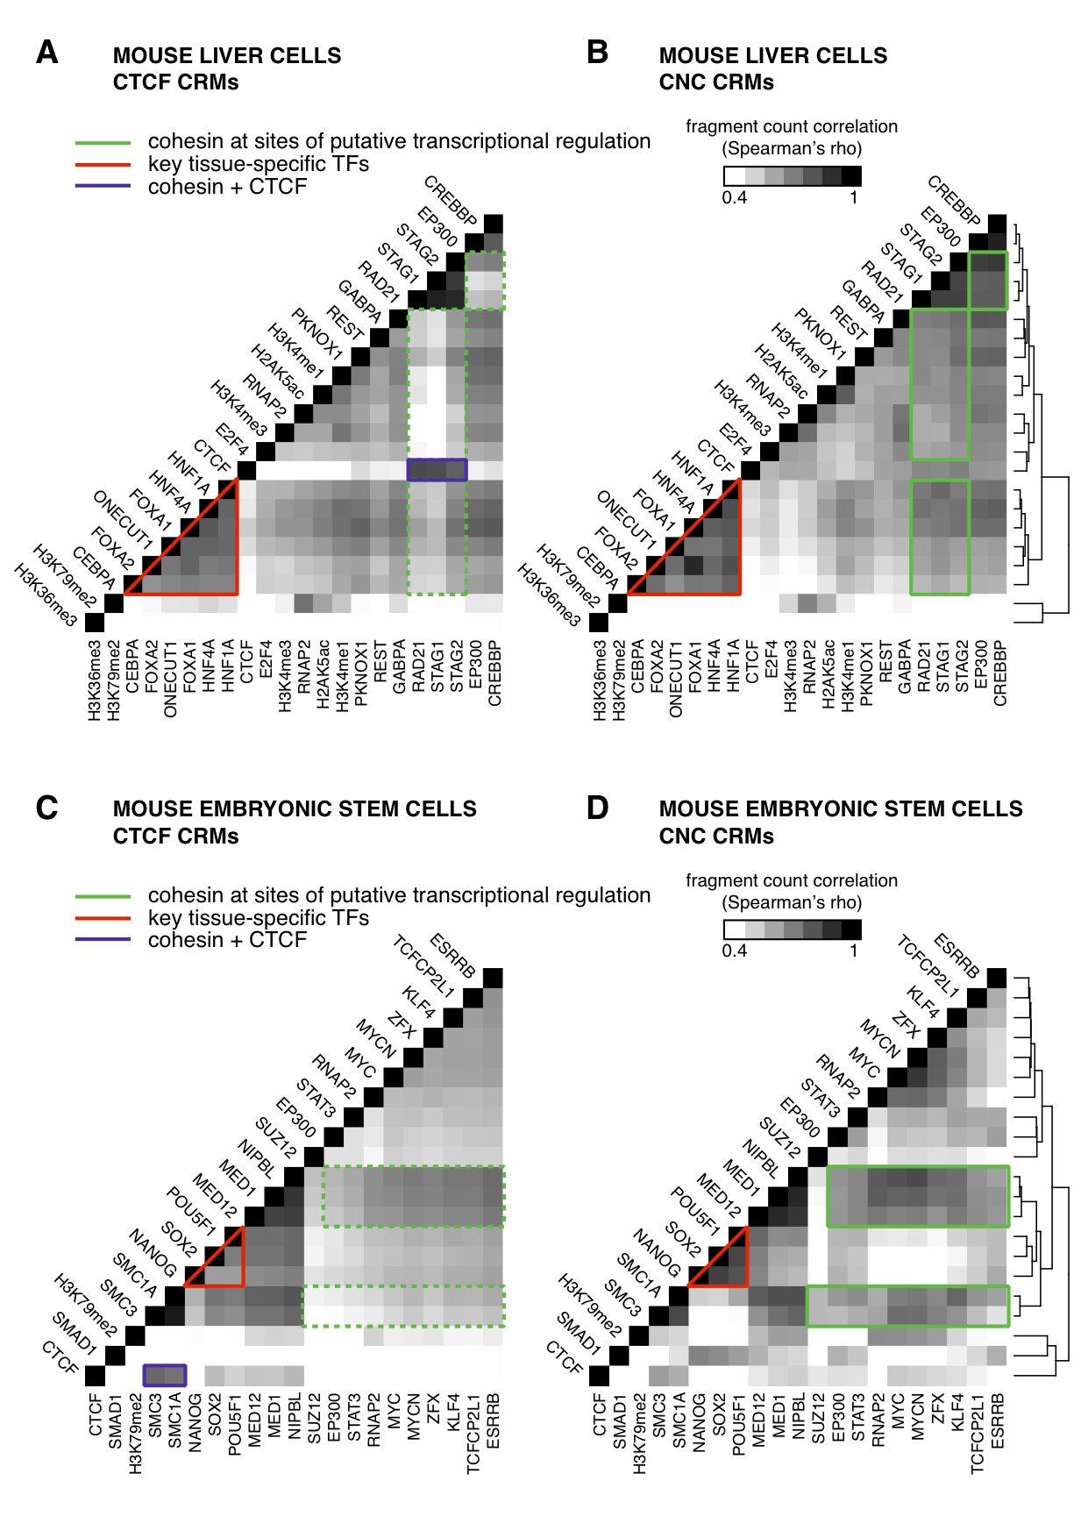
Figure S3. Binding correlations for CTCF and CNC CRMs. The number of ChIP fragments (mapped reads extended to the estimated fragment length) overlapping a given CRM, was used as a measure of binding strength for each dataset. (A) Heatmap visualisation of all pair-wise correlations between all ChIP-seq datasets in mouse liver cells for CRMs containing CTCF. Factors are ordered along both axes based according to B. (B) All pair-wise correlations in mouse liver cells for CRMs containing CNC. Factors were clustered along both axes based on the similarity in their colocalisation profiles. (C) All pair-wise correlations between previously published ChIP-seq datasets in mouse embryonic stem cells for CRMs containing CTCF. Factors were clustered along both axes based on the similarity in their colocalisation profiles. (D) All pair-wise correlations in mouse embryonic stem cells for CRMs containing CNC. Factors are ordered along both axes based according to C.

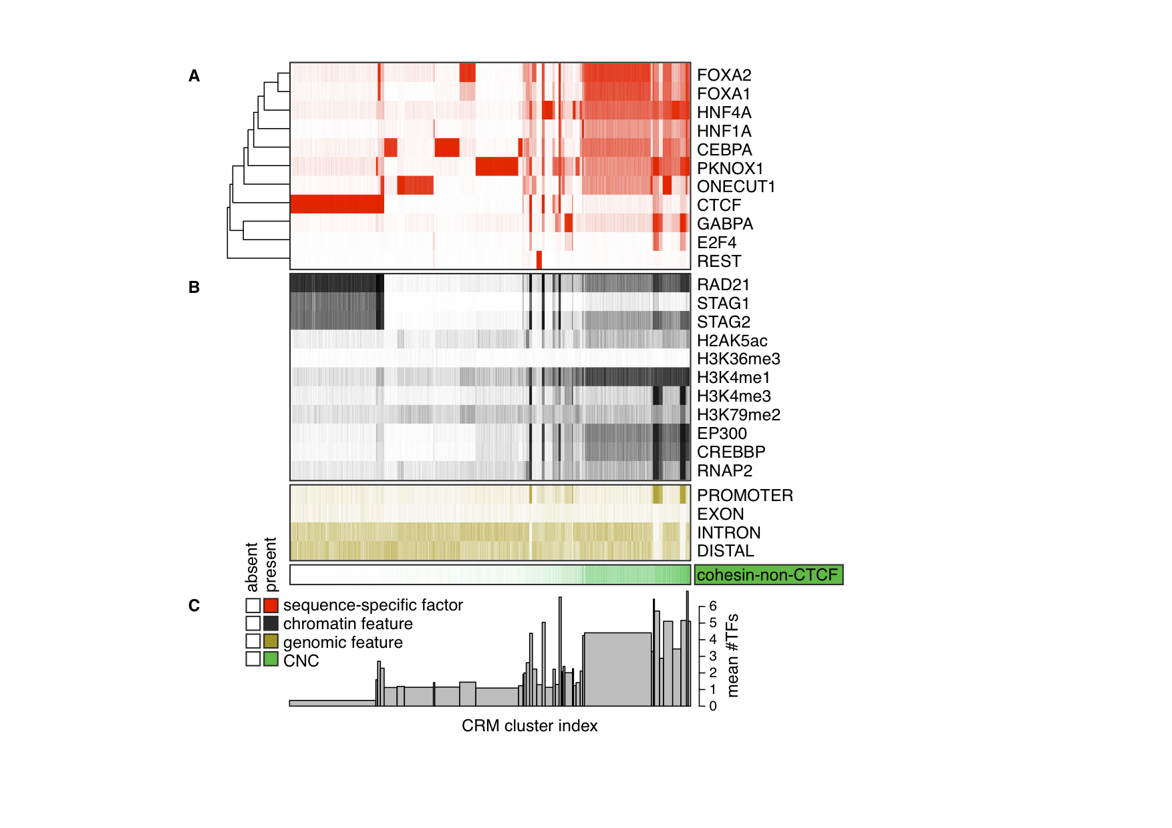

Figure S4. AutoClass CRM clustering results. (A) Results obtained using the AutoClass clustering tool applied to the normalised ChIP enrichment of the eleven sequence-specific factors within 210,067 CRMs, containing ChIP-seq peaks for at least one of these factors. We filtered the clustering results to retain only 142,157 CRMs with class membership posterior probabilities ≥ 0.5 and combined clusters with high correlation (r>0.9) between their median ChIP enrichment profiles. The binary presence/absence of ChIP-seq peaks is displayed and was clustered along the ordinate based on the similarity of their binary occupancy profiles. The clusters were indexed and sorted along the abscissa by the proportion of CRMs with CNC in each cluster (increasing from left to right). (B) The binary presence/absence of ChIP-seq peaks for various chromatin features (non-sequence-specific factors and histone modifications), visualised according to the AutoClass results in A. Genomic location with respect promoters (≤ 2.5 kb from an annotated TSS), exons (overlap with an exon but not a promoter), introns (overlap with a gene but neither an exon nor a promoter), and gene distal regions (elsewhere), is also indicated. The proportion of CRMs with CNC in each cluster is indicated at bottom (increasing from left to right). (C) Barplot indicating the mean number of TFs within each CRM cluster. Bar widths correspond to the number of CRMs within each cluster.
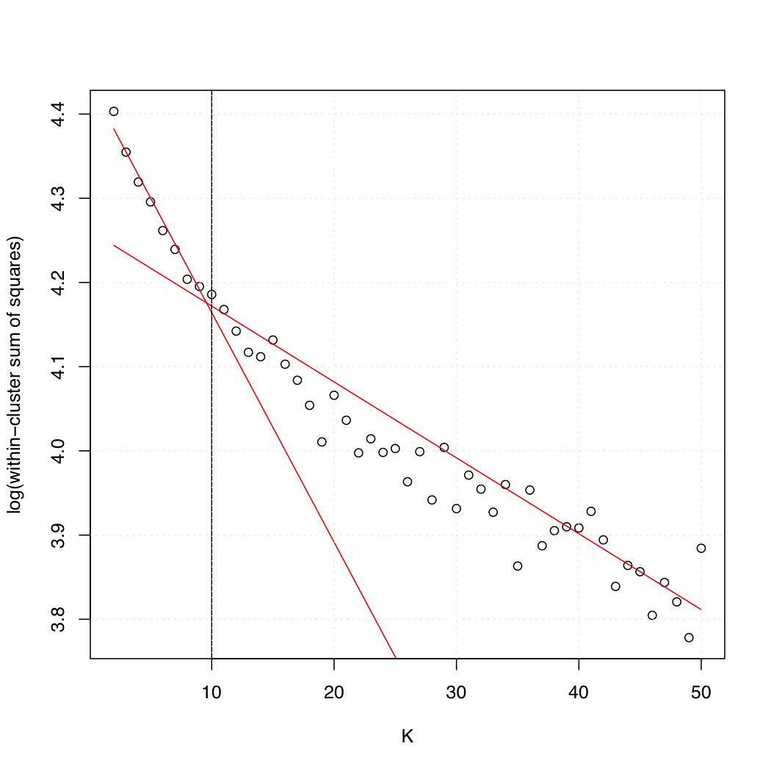
Figure S5. Choice of K for K-means CRM clustering analysis. We ran the K-means clustering algorithm on a random subset of 20,000 CRMs and determined the median within-cluster sum of squares (WCSS) over 10 replicates of each value of K in the range [2-50]. The red lines indicate linear regression results using WCSS values in the range [2-10] and [40-50]. The decrease in WCSS is less pronounced for values of K>10. We therefore used K=10 when clustering the entire dataset.

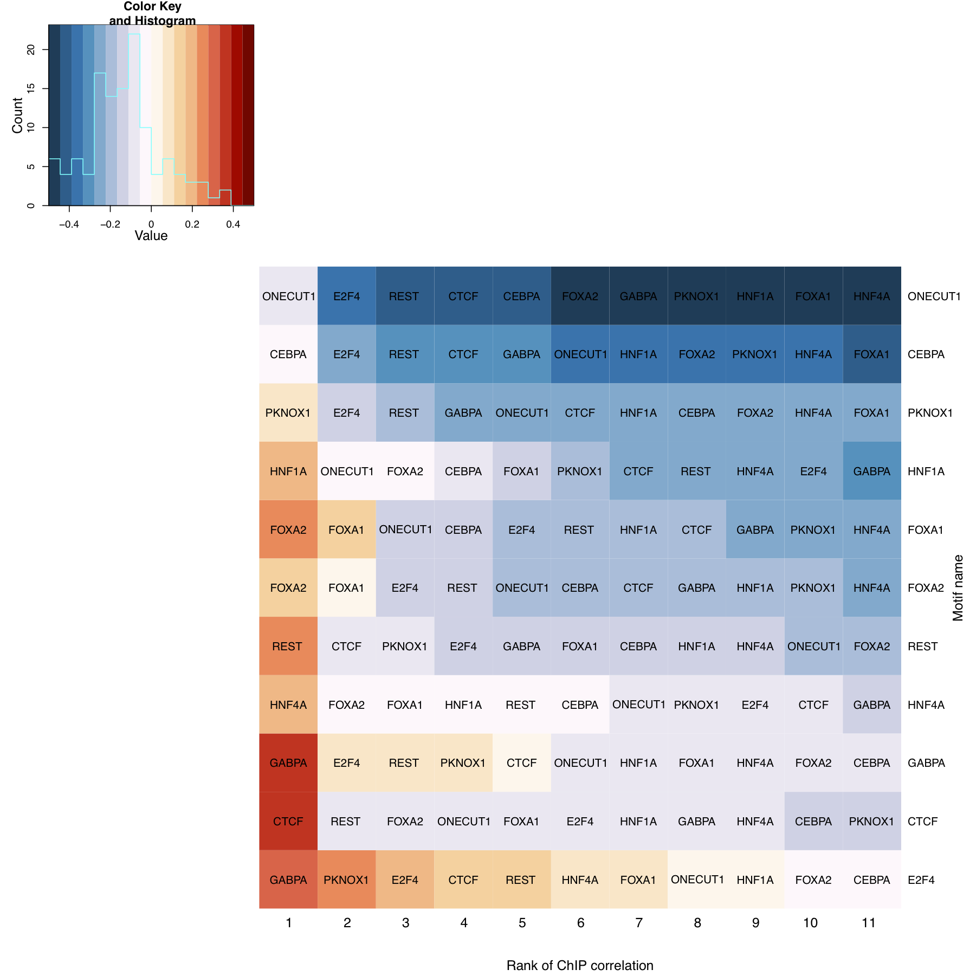

Figure S6. Correlations between motif score and sequence-specific factor ChIP signal (number of ChIP fragments overlapping CRM). For each factor, the motif score correlation (Spearman's rho) was calculated on a restricted set of CRMs that contained a ChIP-seq peak for the same factor. Motifs were ordered by increasing correlation with cohesin ChIP signal (from top to bottom) for consistency with Figure 5. Similarly, all ChIP correlations with each motif are ranked from most strongly positive to negative (from left to right).

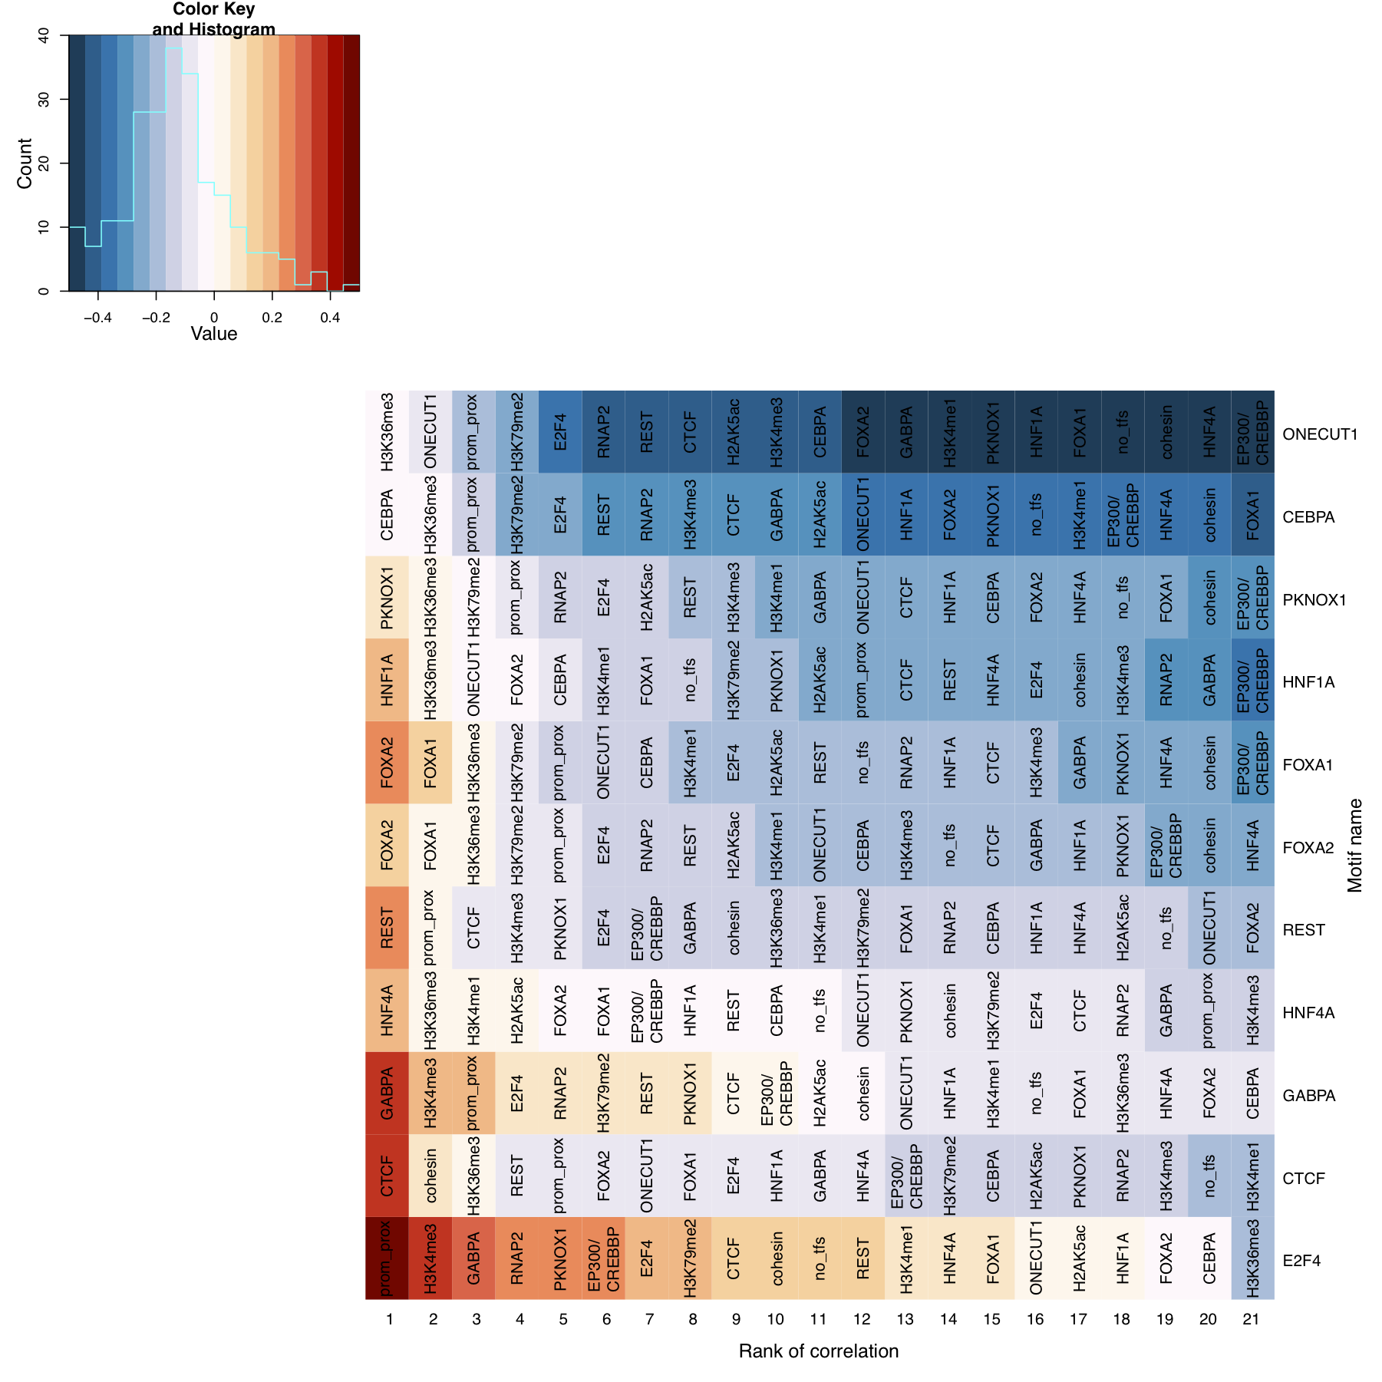

Figure S7. All motif score correlations. For each factor, the motif score correlation (Spearman's rho) was calculated on a restricted set of CRMs that contained a ChIP-seq peak for the same factor. Correlations of each sequence-specific factor's motif score with all available ChIP signals (number of ChIP fragments overlapping CRM), CRM occupancy count (i.e. the number of distinct TFs present) and promoter proximity (distance to the nearest canonical TSS) are shown. Motifs were ordered by increasing correlation with cohesin ChIP signal (from top to bottom) for consistency with Figure 5. Similarly, all correlations with each motif are ranked from most strongly positive to negative (from left to right).

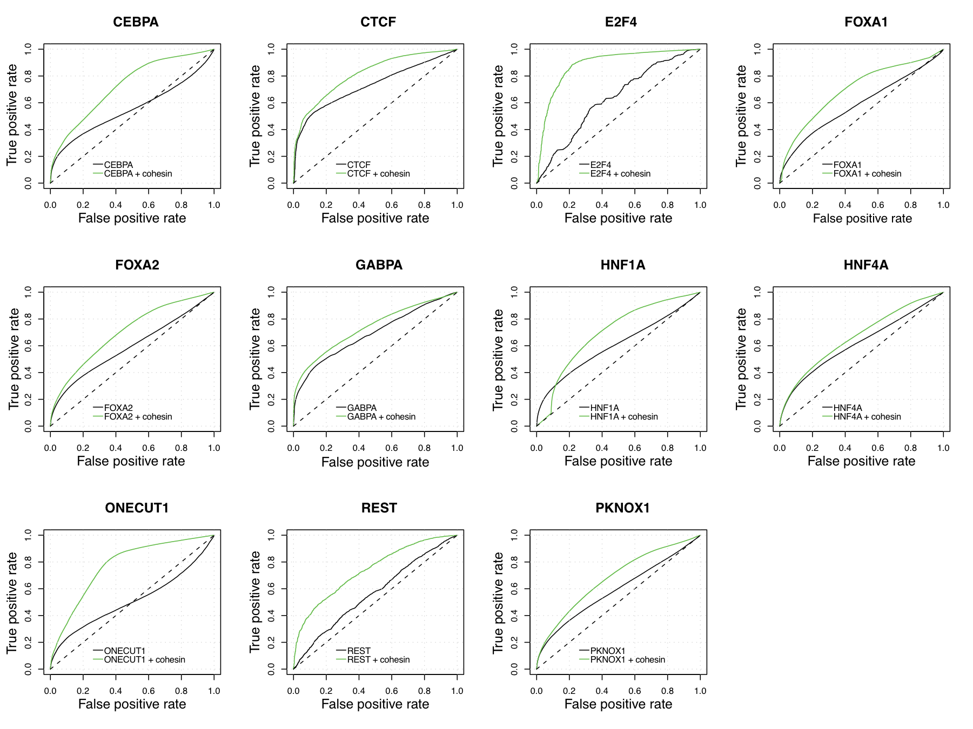

Figure S8. Performance results of all motif classifiers. Ten-fold cross-validation performance results of classifiers trained to predict the presence of high-scoring motif matches using the same factor's ChIP signal with (solid green curve) and without (solid black curve) cohesin ChIP signal information (see inset Legend). Positive deviation from the dashed black line indicates performance exceeding that expected by a random classifier (i.e. area under the curve, AUC=0.5).

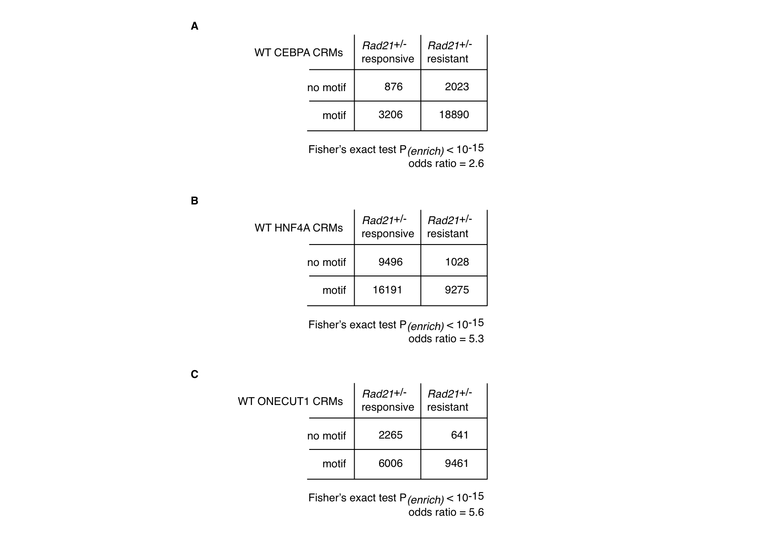
Figure S9. WT CRMs without TF motifs show preferential ChIP peak loss in Rad21^{+/-} cells. Results are shown for CEBPA (A), HNF4A (B) and ONECUT1 (C). Regions considered are CRMs where RAD21 binding was ablated in heterozygous Rad21^{+/-} mouse liver cells (responsive RAD21).

- 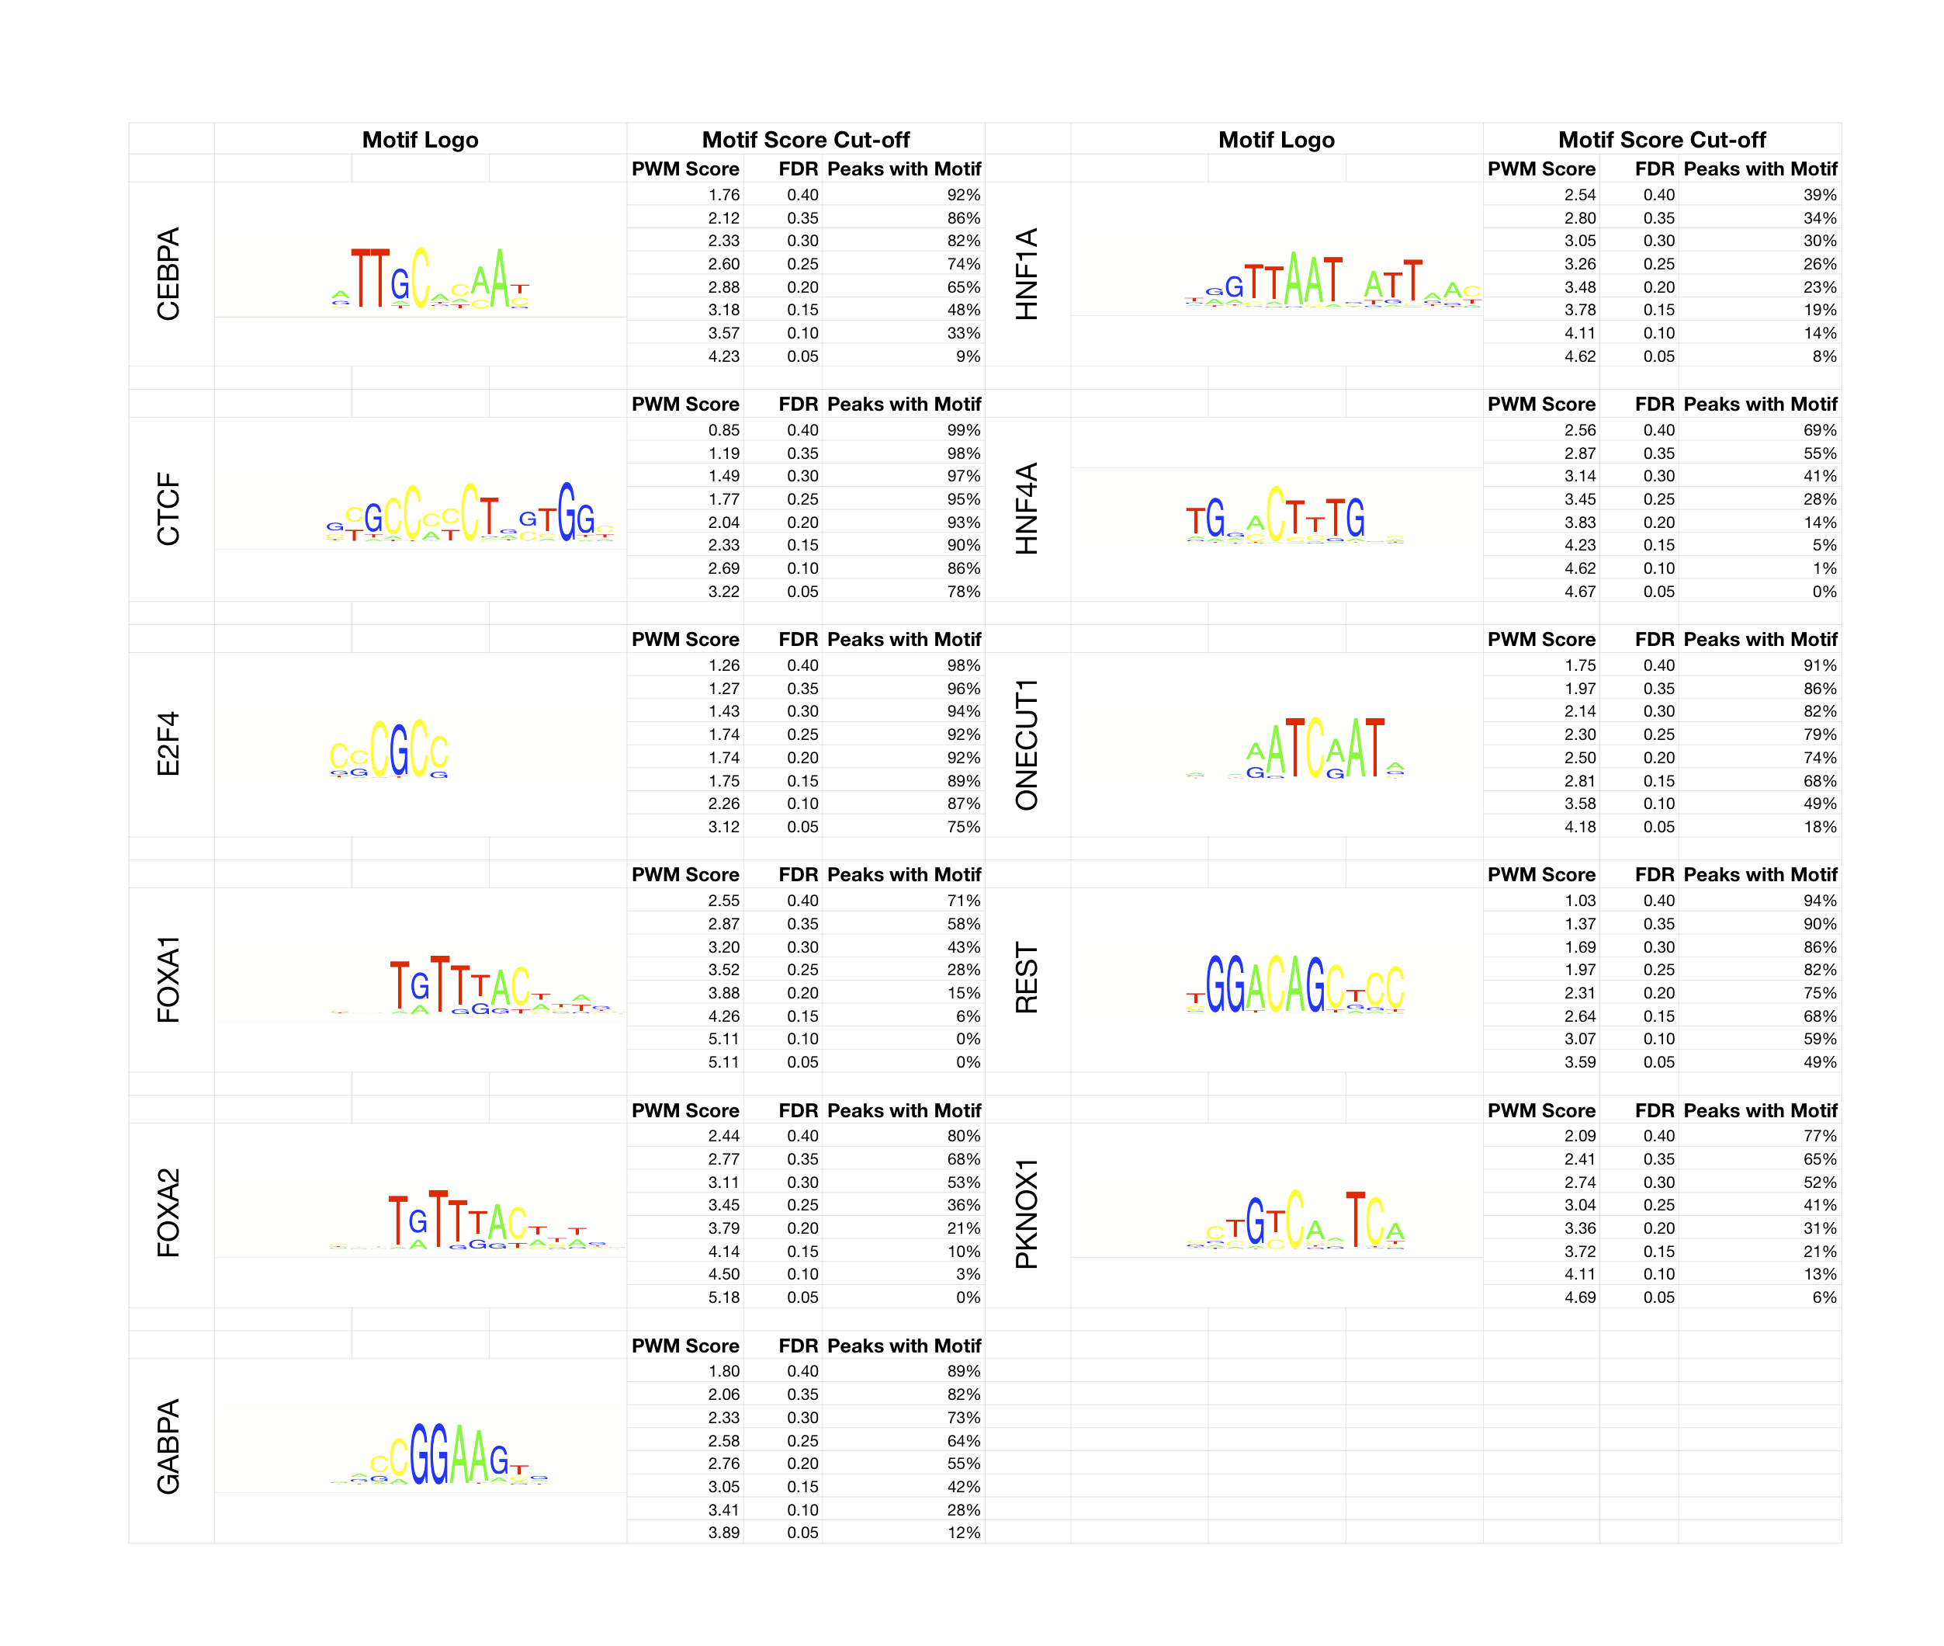

Figure S10. Motifs and motif statistics. The optimal motifs for each sequence-specific factor obtained using ChIP-seq peak sequences as input to MEME/NestedMica (see Methods). We scanned all bound (positive) regions for each factor with the corresponding PWMs to determine the score of the best motif match in each case. We repeated this using equally sized unbound (negative) regions, which were randomly sampled from the repeat- and exon-masked genome. The PWM score cut-off and percentage of (positive) peaks with the motif, are reported for false discovery rates (FDR) of 0.4, 0.35, 0.3, 0.25, 0.20, 0.15, 0.1, 0.05, where FDR=FP/(FP+TP). Motif score cut-offs corresponding to FDR=0.4 were chosen to determine motif presence/absence.

