Annotation of Functional Variation in Personal Genomes Using RegulomeDB
Supplementary Material
Alan P. Boyle, Eurie L. Hong, Manoj Hariharan, Yong Cheng, Marc A. Schaub, Maya Kasowski, Konrad J. Karczewski, Julie Park, Benjamin C. Hitz, Shuai Weng, J. Michael Cherry, Michael Snyder

Supplemental Table 1. Lower RegulomeDB scores show increased enrichment for SNPs which have been found to be associated with disease. We compare lead GWAS SNPs with a random background of SNPs to determine enrichment and significance. The heuristic score provides better enrichment than individual features. In addition, the combination of eQTL information with each category boosts the enrichment justifying the separation of eQTL SNPs into their own category. Because of the low total counts we combine Categories 1a-c (which corresponds to Category 2 + eQTL SNPs) and Categories 1d-e (which corresponds to Category 3 + eQTL SNPs).
 | Observed | Fraction | Expected Fraction | Fold Enrichment | P-value
Category 1a-c | 10 | 0.42% | 0.18% | 2.40 | 0.001477
<= Category 1d-e | 13 | 0.55% | 0.23% | 2.36 | 0.00104
<= Category 1f | 85 | 3.60% | 2.34% | 1.54 | 0.000118
Category 2 | 63 | 2.66% | 1.96% | 1.36 | 0.007499
<= Category 3 | 86 | 3.64% | 2.76% | 1.32 | 0.005899
<= Category 4 | 290 | 12.27% | 9.54% | 1.29 | 1.8E-05
<= Category 5 | 839 | 35.49% | 31.59% | 1.12 | 6.29E-05
<= Category 6 | 1326 | 56.09% | 51.09% | 1.10 | 1.74E-07
PWMs | 688 | 29.10% | 27.67% | 1.05 | 0.043578
DNase HS Sites | 810 | 34.26% | 30.46% | 1.12 | 6.5E-05
DNase Footprints | 178 | 7.53% | 6.15% | 1.22 | 0.002475
TF ChIP | 446 | 18.87% | 15.13% | 1.25 | 6.35E-07
eQTL | 191 | 8.08% | 6.05% | 1.33 | 5.07E-05
Total | 2364

Supplemental Table 2. Average frequency of variants in database features. Using the 69 Complete Genomics genomes there is very little variation among individuals enrichments in each category. A T-test shows that the category difference between homozygous variants and heterozygous variants (with respect to hg19) are highly significant for the cases with the pink background. Shown is the percent coverage in each database feature. On average there are 3,870,827 variants per individual (1,435,617 homozygous and 2,435,210 heterozygous SNPs).
Feature | % Covered Variants | % Cov. In Homo | % Cov. In Het
PWMs | 39.25% | 38.97% | 39.54%
DNase HS Sites | 21.53% | 21.13% | 21.92%
DNase Footprints | 6.15% | 5.88% | 6.42%
TF ChIP | 11.20% | 11.06% | 11.33%
eQTL | 1.29% | 1.34% | 1.24%
Validated | < 0.01% | < 0.01% | < 0.01%
Histone ChIP | 99.55% | 99.43% | 99.67%
dsQTL | < 0.01% | < 0.01% | < 0.01%
FAIRE | 15.14% | 14.91% | 15.37%
Other Annotation | 0.22% | 0.28% | 0.16%

Supplemental Table 3. Average enrichment of variants in significance classes. Using the 69 Complete Genomes there is very little variation among individuals enrichments in each category. A T-test shows that the category difference between homozygous variants and heterozygous variants (with respect to hg19) are highly significant for the cases with the pink background. Shown is the percent coverage in each score category. On average there are 3,870,827 variants per individual (1,435,617 homozygous and 2,435,210 heterozygous SNPs).
Feature | % Covered Variants | % Cov. In Homo | % Cov. In Het
1a | 0.004% | 0.004% | 0.004%
1b | 0.035% | 0.036% | 0.034%
1c | 0.001% | 0.001% | 0.001%
1d | 0.023% | 0.024% | 0.022%
1e | 0.001% | 0.001% | 0.001%
1f | 0.482% | 0.502% | 0.463%
2a | 0.120% | 0.111% | 0.129%
2b | 1.300% | 1.257% | 1.342%
2c | 0.056% | 0.052% | 0.060%
3a | 1.116% | 1.096% | 1.137%
3b | 0.048% | 0.046% | 0.051%
4 | 4.437% | 4.383% | 4.490%
5 | 17.956% | 17.661% | 18.251%
6 | 30.672% | 30.641% | 30.702%

Supplemental Table 4. Minor Allele Frequencies. The table summarizes the distribution of rare, less common and common variants in each of the six categories. Global MAFs for each variant in all six categories were classified as either rare (MAF <= 0.01), less common (0.01 < MAF <= 0.1) or common (0.1 <= MAF < 0.5).

 | Category 1 | Category 2 | Category 3 | Category 4 | Category 5 | Category 6
Rare | 0.05 | 21.51 | 21.48 | 21.66 | 20.90 | 18.11
Less Common | 2.45 | 31.69 | 30.91 | 31.18 | 30.88 | 29.71
Common | 97.50 | 46.80 | 47.60 | 47.16 | 48.22 | 52.18

Supplemental Figure 1. RegulomeDB category annotations with relation to genes. Shown are the enrichment for genic features for each category from RegulomeDB. The group “exon and inton” represents SNPs which are in the different categories because of splice variants. Exonic and Intronic variants make up the majority of Category 1 SNPs.

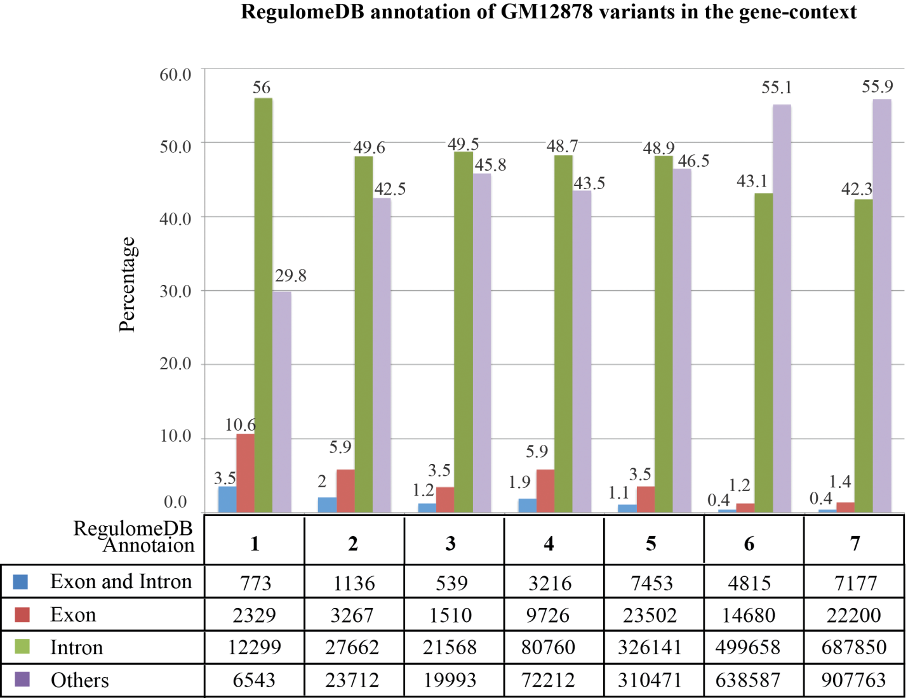

Supplemental Table 5. Half of genes with allele specific expression and damaging mutations also have matched heterozygous RegulomeDB SNVs (matched by eQTL). The table summarizes the genes along with their PolyPhen2 prediction and best matched RegulomeDB variant. Each of these genes has been shown to have allele specific expression by Rozowsky et al. 2011 and contain heterozygous damaging mutations.
Gene | aa pos | aa1 | aa2 | prediction | pph2 prob | pph2 FPR | pph2 TPR | Het RegDB  Category
ADAMTS12 | 1410 | T | I | possibly | 0.647 | 0.0828 | 0.871
AKAP13 | 897 | V | M | possibly | 0.66 | 0.0821 | 0.869
AKAP13 | 2688 | P | L | possibly | 0.669 | 0.0818 | 0.867
AKAP13 | 2708 | P | L | possibly | 0.669 | 0.0818 | 0.867
AKAP13 | 2712 | P | L | possibly | 0.669 | 0.0818 | 0.867
B4GALNT3 | 313 | K | R | possibly | 0.851 | 0.0665 | 0.833
B4GALNT3 | 411 | K | R | probably | 0.99 | 0.0363 | 0.709
BTN2A1 | 207 | V | M | probably | 0.995 | 0.0284 | 0.672 | 1f
C15orf57 | 2 | K | I | probably | 0.959 | 0.0482 | 0.777 | 1f
C15orf57 | 11 | K | I | probably | 0.979 | 0.0425 | 0.744 | 1f
C8orf31 | 39 | L | P | probably | 0.99 | 0.0363 | 0.709 | 1f
CAPN1 | 433 | R | P | probably | 0.992 | 0.0332 | 0.694 | 1a
CAPN14 | 107 | V | M | possibly | 0.865 | 0.065 | 0.829
CAPN14 | 334 | K | N | probably | 0.988 | 0.0377 | 0.716
CAPN14 | 450 | V | I | probably | 0.999 | 0.0058 | 0.135
CDC6 | 441 | V | I | possibly | 0.844 | 0.0671 | 0.835
CEP63 | 651 | S | L | possibly | 0.832 | 0.0682 | 0.838 | 1f
CLEC2D | 23 | L | V | probably | 0.991 | 0.0347 | 0.701 | 1d
DFNA5 | 142 | P | T | possibly | 0.704 | 0.0786 | 0.861 | 1b
DFNA5 | 207 | V | M | probably | 0.996 | 0.0227 | 0.538 | 1b
DMD | 401 | R | H | probably | 1 | 0.0001 | 0.0002
DMD | 404 | R | H | probably | 0.986 | 0.039 | 0.724
DMD | 1737 | R | H | probably | 1 | 0.0001 | 0.0002
DMD | 1741 | R | H | probably | 0.998 | 0.0114 | 0.269
DMD | 1745 | R | H | probably | 1 | 0.0001 | 0.0002
DNASE1L3 | 206 | R | C | probably | 1 | 0.0001 | 0.0002
ENDOD1 | 446 | G | V | probably | 0.978 | 0.0427 | 0.746 | 1f
EVC | 576 | R | Q | probably | 0.994 | 0.03 | 0.679
GDF15 | 48 | S | T | possibly | 0.478 | 0.0962 | 0.89
GIPR | 354 | E | Q | probably | 1 | 0.0001 | 0.0002 | 1b
GMCL1P1 | 440 | C | R | possibly | 0.598 | 0.0867 | 0.877
GOLGA3 | 1185 | K | R | probably | 0.998 | 0.0114 | 0.269
ICAM1 | 241 | G | R | probably | 0.996 | 0.0227 | 0.538
IPO4 | 580 | P | A | probably | 1 | 0.0001 | 0.0002
KIAA1731 | 617 | E | V | probably | 0.99 | 0.0363 | 0.709
KIAA1731 | 2173 | E | A | possibly | 0.936 | 0.0539 | 0.796
KIAA1731 | 2437 | E | V | probably | 0.976 | 0.0431 | 0.75
LTBP4 | 153 | T | M | possibly | 0.791 | 0.0725 | 0.848 | 1f
LTBP4 | 1103 | T | M | possibly | 0.478 | 0.0962 | 0.89 | 1f
LTBP4 | 1140 | T | M | possibly | 0.478 | 0.0962 | 0.89 | 1f
LTBP4 | 1141 | T | M | possibly | 0.478 | 0.0962 | 0.89 | 1f
MDN1 | 3423 | H | Y | possibly | 0.462 | 0.0974 | 0.891 | 1f
MDN1 | 3794 | A | G | possibly | 0.489 | 0.0952 | 0.889 | 1f
MICA | 152 | V | M | probably | 0.967 | 0.0457 | 0.767 | 1f
MICA | 179 | H | L | probably | 0.966 | 0.0459 | 0.768 | 1f
MR1 | 39 | H | R | possibly | 0.545 | 0.0908 | 0.884
MTHFR | 222 | A | V | possibly | 0.531 | 0.0919 | 0.886 | 1d
NBEAL2 | 511 | R | G | possibly | 0.73 | 0.0772 | 0.857
NBEAL2 | 1870 | S | F | probably | 1 | 0.0001 | 0.0002
NBEAL2 | 2054 | S | F | probably | 0.999 | 0.0058 | 0.135
PDIA3P | 207 | R | H | probably | 0.993 | 0.0316 | 0.687
PDIA3P | 344 | R | H | probably | 0.97 | 0.045 | 0.762
PHC3 | 733 | K | E | possibly | 0.653 | 0.0823 | 0.871
PHC3 | 745 | K | E | possibly | 0.459 | 0.0977 | 0.891
PITRM1 | 621 | V | I | possibly | 0.946 | 0.0523 | 0.79 | 1f
RNF213 | 757 | H | D | possibly | 0.873 | 0.0629 | 0.827 | 1d
SLC19A1 | 27 | R | H | probably | 0.987 | 0.0383 | 0.72 | 1f
TCEANC | 193 | S | L | possibly | 0.658 | 0.0821 | 0.869
TEKT4 | 83 | T | M | possibly | 0.9 | 0.0589 | 0.815 | 1f
TEKT4 | 259 | E | K | probably | 1 | 0.0001 | 0.0002 | 1f
TEKT4 | 262 | A | D | probably | 1 | 0.0001 | 0.0002 | 1f
TMBIM1 | 21 | P | L | probably | 0.998 | 0.0114 | 0.269 | 1b
VARS2 | 917 | R | Q | probably | 0.999 | 0.0058 | 0.135 | 1b
ZNF224 | 177 | T | M | probably | 1 | 0.0001 | 0.0002 | 1f
ZNF626 | 65 | M | T | possibly | 0.813 | 0.0699 | 0.842

Supplemental Figure 2. Web-based Interface. Users are able to interface with our database by entering lists of SNVs or regions to identify common SNVs at http://www.RegulomeDB.org/ (A). They are then presented with a sorted list of the most important SNVs (B). These SNVs can be examined for the evidence used to rank them as well as a citation for the evidence.
