Supplementary Text
Simulation of spacer extraction protocol
In order to test the sensitivity and specificity of our spacer detection method, simulations were performed on 150 fully sequenced gut residing bacterial genomes (a subset of the HMP genomes). The genomes were fragmented into 45 million reads (corresponding to the mean number of reads sequenced in an individual in the MetaHIT dataset) of length 75. In order to mimic the microbial composition of the gut, the number of reads sampled for each bacterial species was proportional to its mean abundance across the 124 MetaHIT samples (where bacterial abundance was calculated as described in the Methods section). Next, the spacer detection protocol was used to infer spacers. As described in the Methods section, a spacer was inferred in between significant BLASTn hits to the CRISPR repeat at both ends of the read, or in between a hit at one end and a short "anchor" matching the repeat precisely at the other end.
Different anchor sizes (10, 8 and 6) were tested, yielding a false positive rate of 8.1%, 8.5%, and 10.8%, respectively. Upon manual inspection of the putative erroneous spacers, they all appeared to be bona-fide spacers not detected by piler-cr (Edgar 2007) and were listed on the Integrated Microbial Genome (IMG) browser (Markowitz et al. 2012). Such spacers were often at the beginning or end of the array, or spacers that were part of short arrays completely missed by piler-cr.
On the other hand, the sensitivity (success rate) of the method was 10.9%, 15.6% and 17.5% for anchor sizes of 10, 8, and 6, respectively. Further inspection showed that this low rate derived from CRISPR arrays residing in bacterial species with very low abundance (Fig S1). For the most abundant species, sensitivity exceeded 60%. Indeed, when 180 million reads were simulated (corresponding to the maximal sequencing depth of a sample in the MetaHIT study), the sensitivity of the method (with anchor size of 6) went up to 28%. This suggests that in order to capture the full spacer content of an individual, much deeper sequencing is required. Thus, in order to elevate the sensitivity rate, and since the false positive rate appeared to derive from false negatives of piler_cr, an anchor size of 6 was chosen for the analysis on the metagenomic data.
Examination of coverage thresholds
We sought to survey the different thresholds for defining a phage contig as present in multiple individuals. As described in the Methods section, phage presence was determined by mapping reads from an individual onto each phage contig. Only reads with at least 85% identity spanning at least 80% of the read were retained. A phage was considered present in an individual if at least 70% of the phage-region of the contig, i.e. the region bounded by proto-spacers and phage genes, was covered by such reads.
We first tested the percent coverage threshold required to define a phage as present in a sample. We performed simulations to test how a phage genome, sheared into reads, maps back onto itself. For the simulations, we used phage P22 having a standardly sized genome of 41.7Kb. When shearing the phage genome into 1000 reads of size 75 (representing 180% of the full genome length), the resulting coverage was 70% of the genome due to the Poisson nature of uniform sampling (i.e., some bases are sampled more than once while others are not sampled). When the number of reads was reduced to 500 the coverage dropped to 50% of the genome, and more than 2000 reads resulted in 90% or more of the phage being covered. Thus, 100% coverage of the genome requires a cumulative read length far exceeding the genome length.
Nevertheless, this threshold is to a certain extent arbitrary, as all thresholds are. To test how varying the threshold might impact our principal qualitative conclusions, we tested how more stringent thresholds of coverage would affect phage sharing. We found our results were robust to raising the threshold from 70% coverage of the phage-region to 80%, as we still found that 70% of phages are shared between samples as opposed to the original 78%. When raising the threshold to 90% coverage, 56% of phages were still shared. Our simulations indicated that the drop in the degree of sharing at this stringent threshold was strongly influenced by sequencing depth, particularly since abundance of the same phage could vary more than a 100-fold between samples where it existed. The 70% threshold was thus chosen since we expect the most significant barrier in determining phage existence is the low sequence coverage of phages in human gut microbiota sequencing.
We next tested whether two phylogenetically similar phages (Rohwer and Edwards 2002), phage P22 and phage lambda, were defined as the same phage under the thresholds used in our study. Phage P22 was sheared into 100,000 reads, commensurate with an extremely high sequencing depth, and mapped back onto the phage lambda genome. We tested the percent coverage for differently sized regions in the genome (corresponding to potential phage-regions). Our results showed that for the 22Kb average window size used in our study, the maximal coverage achieved is 12%, while a minimal phage-region of 4000 bases showed a maximal coverage of 56%. Hence, even under very unfavorable conditions for distinguishing between the two phages, it would be extremely unlikely for our criteria to declare them the same.
Finally, we calculated the average identity of reads mapping to contig phage-regions in each relevant sample for all contigs that were shared between samples. On average, reads mapped with 97% identity to the phage genomes, with a 3.6% difference between the sample with the highest average identity (the sample where the contig was assembled; typically 99%) and the sample with the lowest sequence identity (typically 95.4%). We note that this measure cannot be taken as representing global % identity between phages from different samples since our procedures allow up to 30% of the phage-region not to be covered by reads, and in some cases this region may show more divergence among the phage strains.
Interestingly, we noted that reads in the sample where the contig was originally assembled did not always display 100% identity with the contig. This was found to stem from multiple reads covering a given region, some bearing one or two mutations as compared to the phage contig. This suggests that a collection of different phage mutants may coexist within an individual but may also be attributable to sequencing errors.

Assessment of the effect of sequencing depth on the degree of phage sharing reported with Japanese individuals
The gut metagenomic dataset of Japanese origin (Kurokawa et al. 2007) that was used to test phage distribution across geographically distant individuals was sequenced at much lower depth than the MetaHIT samples, and contrary to the VLP datasets (Reyes et al. 2010; Minot et al. 2011) was not specifically enriched for viral reads. Accordingly, this dataset showed reduced coverage of the phage contigs we identified in the MetaHIT data.
In an attempt to assess the effect of sequencing depth on the detected sharing, we first performed a rarefaction by randomly sampling 25%, 50% and 75% of the sequence clones in the Japanese dataset and testing these subsets for phage sharing with the 991 MetaHIT phage contigs. The result was an approximately linear curve (Fig S4), which precludes a reliable projection of expected sharing levels at saturation.
Next, we examined the change in percent coverage (percent of bases covered by any read) of the phage-defined region on each contig as we increased the number of Kurokawa et al (2007) reads through the above-mentioned fractions. We found that, in addition to the 50 contigs that are present when all reads are considered, there are 41 additional contigs whose percent coverage consistently increases by 5% or more as the fraction of reads considered rises from 50% to 75% to 100%. This provides some indication that these contigs may exist in the samples but fail to cross our thresholds due to reduced sequencing depth. Under this assumption, the degree of sharing might rise to levels closer to those reported for the other datasets examined.
We therefore conclude that the actual degree of sharing we detected between the MetaHIT (European) dataset and the Japanese dataset is an underestimate for the actual degree of sharing between the two. It is worth noting that despite these limitations, more than half of the 50 contigs shown to exist in the Kurokawa et al (2007) dataset also existed in at least one of the VLP datasets, establishing the utility of the Kurokawa et al (2007) data in verifying the global distribution of some gut-associated phages.

Figure S1. Sensitivity of the spacer detection method (y-axis) used on 45 million reads as a function of the abundance of the bacterial species (x-axis). The higher the abundance, the higher the success rate of the method.

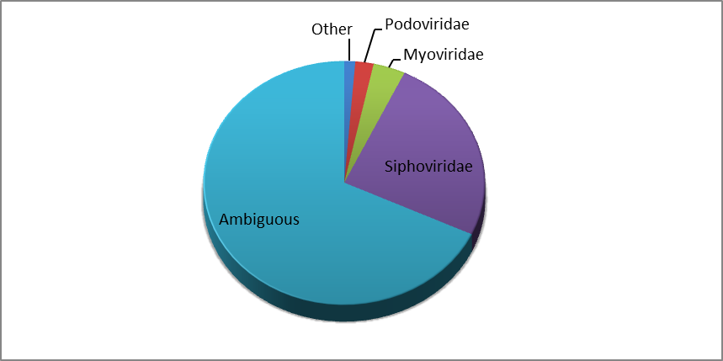
Figure S2. Taxonomic classification of phage contigs to ICTV-defined viral families.

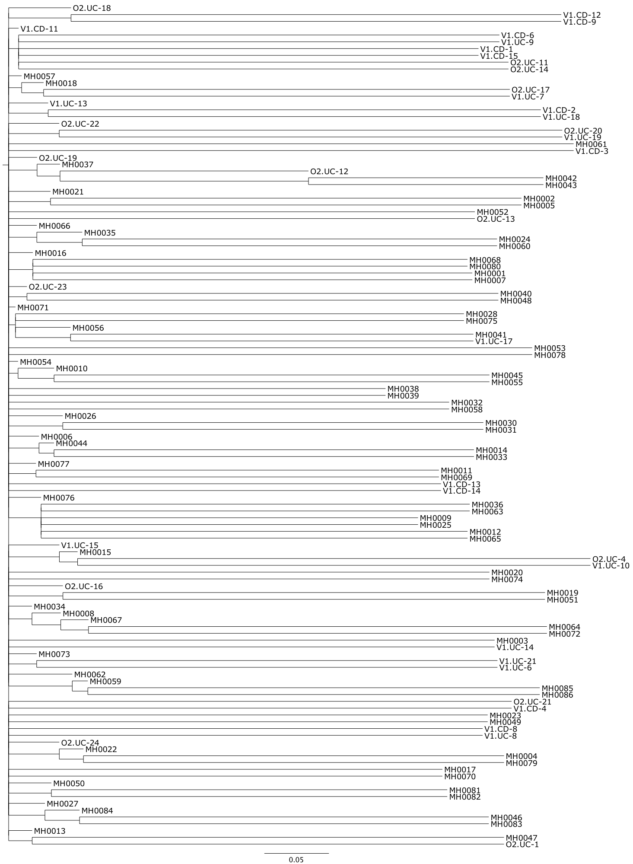

Figure S3. Hierarchical clustering based on dissimilarity matrix of phage contig existence profiles among the 124 MetaHIT samples. Binary asymmetric distance was used to produce the matrix. No coherent clustering is achieved.

Figure S4. Rarefaction curve showing the number of MetaHIT (European) phage contigs shown to exist in Kurokawa et al. (2007) gut metagnomic dataset of Japanese origin (y-axis) as a function of the fraction of sequence clones randomly sampled from that dataset (x-axis).

Sample | Source | Number of spacers identified | # of reads in sample | # of reads mapped to phage contigs | % of reads mapped to phage contigs
MH0001 | Denmark | (short reads) | 45,016,612 | 346,923 | 0.77%
MH0002 | Denmark | 533 | 46,570,095 | 863,679 | 1.85%
MH0003 | Denmark | 746 | 50,384,869 | 1,229,188 | 2.44%
MH0004 | Denmark | (short reads) | 40,288,492 | 873,868 | 2.17%
MH0005 | Denmark | (short reads) | 39,407,333 | 295,075 | 0.75%
MH0006 | Denmark | 573 | 161,184,217 | 1,338,505 | 0.83%
MH0007 | Denmark | (short reads) | 36,956,284 | 788,837 | 2.13%
MH0008 | Denmark | (short reads) | 38,156,496 | 533,038 | 1.40%
MH0009 | Denmark | 717 | 58,452,504 | 685,094 | 1.17%
MH0010 | Denmark | (short reads) | 39,169,850 | 865,753 | 2.21%
MH0011 | Denmark | 591 | 58,503,358 | 615,801 | 1.05%
MH0012 | Denmark | 1017 | 186,062,388 | 3,038,146 | 1.63%
MH0013 | Denmark | (short reads) | 40,028,120 | 1,395,907 | 3.49%
MH0014 | Denmark | 493 | 56,304,766 | 1,359,480 | 2.41%
MH0015 | Denmark | (short reads) | 33,014,675 | 563,124 | 1.71%
MH0016 | Denmark | 493 | 54,396,021 | 920,008 | 1.69%
MH0017 | Denmark | (short reads) | 36,154,362 | 566,117 | 1.57%
MH0018 | Denmark | (short reads) | 36,609,695 | 429,492 | 1.17%
MH0019 | Denmark | (short reads) | 38,856,780 | 658,547 | 1.69%
MH0020 | Denmark | 317 | 45,813,646 | 1,556,212 | 3.40%
MH0021 | Denmark | 334 | 26,258,326 | 572,119 | 2.18%
MH0022 | Denmark | (short reads) | 37,112,508 | 410,557 | 1.11%
MH0023 | Denmark | (short reads) | 37,782,998 | 632,523 | 1.67%
MH0024 | Denmark | 300 | 54,915,985 | 600,394 | 1.09%
MH0025 | Denmark | 672 | 55,604,591 | 514,780 | 0.93%
MH0026 | Denmark | 267 | 37,484,066 | 765,999 | 2.04%
MH0027 | Denmark | (short reads) | 32,377,390 | 619,598 | 1.91%
MH0028 | Denmark | 369 | 55,152,519 | 717,751 | 1.30%
MH0030 | Denmark | 272 | 51,622,803 | 421,930 | 0.82%
MH0031 | Denmark | 507 | 55,540,263 | 351,846 | 0.63%
MH0032 | Denmark | 423 | 50,110,067 | 318,790 | 0.64%
MH0033 | Denmark | 570 | 44,996,133 | 963,421 | 2.14%
MH0034 | Denmark | 159 | 37,400,897 | 303,095 | 0.81%
MH0035 | Denmark | 655 | 49,289,239 | 1,174,235 | 2.38%
MH0036 | Denmark | 355 | 47,706,635 | 551,803 | 1.16%
MH0037 | Denmark | 386 | 42,034,099 | 808,521 | 1.92%
MH0038 | Denmark | 386 | 45,475,391 | 760,557 | 1.67%
MH0039 | Denmark | 508 | 42,717,184 | 727,192 | 1.70%
MH0040 | Denmark | 535 | 44,249,732 | 813,770 | 1.84%
MH0041 | Denmark | 410 | 44,382,480 | 1,230,745 | 2.77%
MH0042 | Denmark | 554 | 43,424,052 | 580,179 | 1.34%
MH0043 | Denmark | 550 | 49,362,253 | 814,125 | 1.65%
MH0044 | Denmark | 435 | 44,864,080 | 1,129,993 | 2.52%
MH0045 | Denmark | 500 | 49,434,301 | 1,068,525 | 2.16%
MH0046 | Denmark | 453 | 35,798,104 | 323,573 | 0.90%
MH0047 | Denmark | 281 | 26,932,064 | 153,960 | 0.57%
MH0048 | Denmark | 497 | 26,972,970 | 442,907 | 1.64%
MH0049 | Denmark | 341 | 30,654,842 | 425,986 | 1.39%
MH0050 | Denmark | 525 | 47,792,033 | 543,964 | 1.14%
MH0051 | Denmark | 406 | 25,963,104 | 389,016 | 1.50%
MH0052 | Denmark | 404 | 28,575,036 | 338,777 | 1.19%
MH0053 | Denmark | 631 | 43,283,564 | 453,001 | 1.05%
MH0054 | Denmark | 418 | 42,262,748 | 796,826 | 1.89%
MH0055 | Denmark | 505 | 47,112,307 | 603,598 | 1.28%
MH0056 | Denmark | 683 | 49,219,471 | 644,997 | 1.31%
MH0057 | Denmark | 357 | 43,050,028 | 723,495 | 1.68%
MH0058 | Denmark | 475 | 49,822,998 | 1,050,582 | 2.11%
MH0059 | Denmark | 522 | 41,025,606 | 803,387 | 1.96%
MH0060 | Denmark | 515 | 41,112,227 | 569,317 | 1.38%
MH0061 | Denmark | 518 | 44,515,482 | 707,090 | 1.59%
MH0062 | Denmark | 468 | 36,809,224 | 779,816 | 2.12%
MH0063 | Denmark | 621 | 45,961,029 | 460,184 | 1.00%
MH0064 | Denmark | 620 | 44,732,297 | 651,725 | 1.46%
MH0065 | Denmark | 529 | 44,579,795 | 421,880 | 0.95%
MH0066 | Denmark | 457 | 36,114,997 | 607,083 | 1.68%
MH0067 | Denmark | 505 | 44,484,637 | 1,241,859 | 2.79%
MH0068 | Denmark | 397 | 43,867,534 | 906,372 | 2.07%
MH0069 | Denmark | 570 | 69,722,220 | 1,189,192 | 1.71%
MH0070 | Denmark | 484 | 47,921,594 | 645,399 | 1.35%
MH0071 | Denmark | 568 | 46,242,273 | 824,875 | 1.78%
MH0072 | Denmark | 402 | 49,286,672 | 1,403,911 | 2.85%
MH0073 | Denmark | 519 | 47,234,201 | 713,726 | 1.51%
MH0074 | Denmark | 472 | 46,030,505 | 494,828 | 1.08%
MH0075 | Denmark | 522 | 47,065,103 | 685,745 | 1.46%
MH0076 | Denmark | 366 | 30,650,106 | 707,170 | 2.31%
MH0077 | Denmark | 588 | 49,660,515 | 723,660 | 1.46%
MH0078 | Denmark | 198 | 26,051,537 | 176,442 | 0.68%
MH0079 | Denmark | 282 | 27,418,899 | 466,629 | 1.70%
MH0080 | Denmark | 483 | 46,590,749 | 907,611 | 1.95%
MH0081 | Denmark | 525 | 47,851,897 | 892,564 | 1.87%
MH0082 | Denmark | 444 | 48,347,954 | 820,066 | 1.70%
MH0083 | Denmark | 525 | 47,903,806 | 1,260,600 | 2.63%
MH0084 | Denmark | 245 | 53,565,815 | 674,915 | 1.26%
MH0085 | Denmark | 151 | 49,434,491 | 671,970 | 1.36%
MH0086 | Denmark | 621 | 55,433,667 | 1,057,895 | 1.91%
O2.UC-1 | Spain | 391 | 42,189,776 | 524,035 | 1.24%
O2.UC-11 | Spain | 403 | 38,507,042 | 447,511 | 1.16%
O2.UC-12 | Spain | 576 | 36,908,526 | 321,741 | 0.87%
O2.UC-13 | Spain | 722 | 43,619,828 | 658,647 | 1.51%
O2.UC-14 | Spain | 458 | 26,942,750 | 276,511 | 1.03%
O2.UC-16 | Spain | 330 | 42,268,974 | 201,806 | 0.48%
O2.UC-17 | Spain | 279 | 40,304,612 | 714,594 | 1.77%
O2.UC-18 | Spain | 435 | 41,907,663 | 415,432 | 0.99%
O2.UC-19 | Spain | 409 | 38,459,550 | 610,698 | 1.59%
O2.UC-20 | Spain | 520 | 38,376,747 | 619,790 | 1.62%
O2.UC-21 | Spain | 410 | 28,054,360 | 469,928 | 1.68%
O2.UC-22 | Spain | 506 | 44,245,030 | 1,695,798 | 3.83%
O2.UC-23 | Spain | 393 | 36,784,558 | 962,644 | 2.62%
O2.UC-24 | Spain | 421 | 41,658,584 | 443,749 | 1.07%
O2.UC-4 | Spain | 487 | 43,263,975 | 495,898 | 1.15%
V1.CD-1 | Spain | 242 | 47,131,739 | 1,271,215 | 2.70%
V1.CD-11 | Spain | 391 | 51,389,665 | 537,274 | 1.05%
V1.CD-12 | Spain | 130 | 40,609,134 | 1,304,360 | 3.21%
V1.CD-13 | Spain | 690 | 42,560,831 | 601,929 | 1.41%
V1.CD-14 | Spain | 683 | 44,023,096 | 1,072,709 | 2.44%
V1.CD-15 | Spain | 237 | 40,560,446 | 1,369,052 | 3.38%
V1.CD-2 | Spain | 217 | 46,703,072 | 433,382 | 0.93%
V1.CD-3 | Spain | 521 | 45,352,742 | 718,372 | 1.58%
V1.CD-4 | Spain | 569 | 42,939,132 | 559,316 | 1.30%
V1.CD-6 | Spain | 260 | 42,483,316 | 779,071 | 1.83%
V1.CD-8 | Spain | 707 | 49,908,306 | 688,315 | 1.38%
V1.CD-9 | Spain | 460 | 47,137,595 | 714,103 | 1.51%
V1.UC-10 | Spain | 658 | 41,725,594 | 690,526 | 1.65%
V1.UC-13 | Spain | 361 | 38,553,580 | 1,197,446 | 3.11%
V1.UC-14 | Spain | 513 | 49,611,323 | 959,633 | 1.93%
V1.UC-15 | Spain | 408 | 46,595,929 | 425,800 | 0.91%
V1.UC-17 | Spain | 568 | 34,437,937 | 416,335 | 1.21%
V1.UC-18 | Spain | 426 | 48,379,265 | 993,140 | 2.05%
V1.UC-19 | Spain | 623 | 49,233,576 | 1,054,273 | 2.14%
V1.UC-21 | Spain | 700 | 46,336,135 | 685,515 | 1.48%
V1.UC-6 | Spain | 839 | 43,150,856 | 561,749 | 1.30%
V1.UC-7 | Spain | 382 | 36,788,540 | 410,829 | 1.12%
V1.UC-8 | Spain | 710 | 46,669,762 | 910,987 | 1.95%
V1.UC-9 | Spain | 512 | 46,906,812 | 552,898 | 1.18%
 | Sum | 52,267
Table S1. Sequencing depth, number of spacers detected and fraction of reads mapping to MGE contigs for each MetaHIT sample.

COG ID | COG function | Number of appearances in bacteria | Number of appearances in phage | Fold enrichment in phage
COG3723 | Recombinational DNA repair protein (RecE pathway) | 101 | 33 | 79.78
COG2842 | Uncharacterized ATPase, putative transposase | 60 | 13 | 61.80
COG1403 | Restriction endonuclease | 102 | 10 | 28.57
COG0175 | 3'-phosphoadenosine 5'-phosphosulfate sulfotransferase (PAPS reductase)/FAD synthetase and related enzymes | 346 | 34 | 28.26
COG0270 | Site-specific DNA methylase | 552 | 60 | 25.43
COG1351 | Predicted alternative thymidylate synthase | 80 | 12 | 24.01
COG1196 | Chromosome segregation ATPases | 921 | 70 | 22.42
COG4570 | Holliday junction resolvase | 186 | 12 | 20.40
COG0740 | Protease subunit of ATP-dependent Clp proteases | 661 | 72 | 20.16
COG0863 | DNA modification methylase | 482 | 44 | 19.37
COG1061 | DNA or RNA helicases of superfamily II | 416 | 33 | 17.57
COG0338 | Site-specific DNA methylase | 280 | 11 | 17.26
COG3481 | Predicted HD-superfamily hydrolase | 168 | 10 | 16.85
COG3757 | Lyzozyme M1 (1,4-beta-N-acetylmuramidase) | 453 | 24 | 16.84
COG0419 | ATPase involved in DNA repair | 451 | 28 | 15.05
COG0553 | Superfamily II DNA/RNA helicases, SNF2 family | 433 | 27 | 13.04
COG0305 | Replicative DNA helicase | 566 | 22 | 12.35
COG1475 | Predicted transcriptional regulators | 950 | 71 | 12.32
COG1484 | DNA replication protein | 868 | 38 | 11.45
COG3969 | Predicted phosphoadenosine phosphosulfate sulfotransferase | 183 | 12 | 10.86
COG0629 | Single-stranded DNA-binding protein | 889 | 46 | 9.85
COG0749 | DNA polymerase I - 3'-5' exonuclease and polymerase domains | 426 | 19 | 9.71
COG1235 | Metal-dependent hydrolases of the beta-lactamase superfamily I | 396 | 15 | 9.25
COG0860 | N-acetylmuramoyl-L-alanine amidase | 811 | 12 | 8.45
COG3344 | Retron-type reverse transcriptase | 491 | 19 | 7.92
COG1397 | ADP-ribosylglycohydrolase | 218 | 11 | 7.65
COG0756 | dUTPase | 384 | 14 | 6.81
COG0468 | RecA/RadA recombinase | 416 | 15 | 6.06
COG0207 | Thymidylate synthase | 345 | 11 | 5.23
COG5545 | Predicted P-loop ATPase and inactivated derivatives | 412 | 11 | 4.77
COG1961 | Site-specific recombinases, DNA invertase Pin homologs | 1534 | 21 | 4.63
COG0358 | DNA primase (bacterial type) | 824 | 15 | 4.27
COG0592 | DNA polymerase sliding clamp subunit (PCNA homolog) | 420 | 10 | 3.65
COG4974 | Site-specific recombinase XerD | 4215 | 35 | 3.38
COG0286 | Type I restriction-modification system methyltransferase subunit | 657 | 12 | 2.75
COG1192 | ATPases involved in chromosome partitioning | 1149 | 12 | 2.33
COG1476 | Predicted transcriptional regulators | 1218 | 10 | 1.36
Table S2. COG functions enriched in the 991 phage contigs identified in this study as compared to gastrointestinal associated bacteria (Methods), aside for phage structural genes.
Sample | "Leader" sequence | First repeat | First spacer | #Reads spanning leader, repeat and spacer
Isolate | CATTGTAAAATATTGCTTTTTTATAGTGCG | GTTTTAATAGATACATGGTGGAATGTGAAT | GCTGTTACCTCTGGCGCTGTGTTGTAGTTATTCACCG | -
MH0009 | CATTGTAAAATATTGCTTTTTTATAGTGCTG | GTTTTAATAGATACATGGTGGAATGTGAAT | ATAATAGCTTCATGGATATTCCGGAAGGCGTAGAC | 5
V1.UC-6 | CATTGTAAAATATTGCTTTTTTATAGTGCTG | GTTTTAATAGATCCATGGTGGAATGTGAAT | ATTGATTCGGATTGTGTGATAAAGAAATATTTATC | 3
V1.UC-10 | CATTGTAAAATACTGCTTTTTTATAGTGCG | GTTTTAATAGATCCATGGTGGAATGTGAAT | TAGTGTCCTGCTTCCCCTGACCGCTGGTAGCGTTC | 7
MH0034 | CATTGTAAAATATTGCTTTTTTATAGTGCTG | GTTTTAATAGATCCATGGTGGAATGTGAAT | GAAGTCACTTGATAACAATGCCGCGGTCATGACCG | 2
MH0063 | CATTGTAAAATATTGCTTTTTTATAGTGCG | GTTTTAATAGATCCATGGTGGAATGTGAAT | CAGTGTAATTGCAGAGAAATATTCAAATCACAAGTT | 4
MH0086 | CATTGTAAAATATTGCTTTTTTATAGTGCG | GTTTTAATAGATCCATGGTGGAATGTGAAT | TCTAAATGAGCAAAAATTTCCATAAATGCAAGATT | 7
Table S3. Comparison of the first spacer in the CRISPR array of Clostridium sp. L2-50 as detected in the sequenced isolate and in six samples of the MetaHIT population which showed an abundance of this bacterial strain. Assembly of the first repeat+spacer unit in the array from each sample was facilitated by reads matching the leader sequence of the isolate reference and their paired-end mates, and validated by reads spanning part of the leader, the repeat and part of the spacer.

Dataset | Contig identifier in dataset | Matching MetaHIT contig identifier | Prevalence in indicated dataset / total individuals | Prevalence in MetaHIT dataset / total individuals
Minot et al | contig00119 | MH0016.scaffold10808_2 | 1/6 | 75/124
Minot et al | contig07718 | MH0059.scaffold26881_8 | 1/6 | 43/124
Minot et al | contig09208 | MH0006.scaffold87784_2 | 1/6 | 33/124
Minot et al | contig09430 | MH0017.scaffold42056_1 | 1/6 | 1/124
Minot et al | contig09440 | V1.UC-14.scaffold34724_1 | 1/6 | 40/124
Minot et al | contig09446 | MH0040.scaffold104579_1 | 2/6 | 32/124
Minot et al | contig09463 | V1.UC-21.scaffold18503_4 | 1/6 | 1/124
Minot et al | contig09466 | MH0055.scaffold24912_1 | 5/6 | 87/124
Reyes et al | Contig_20697 | V1.CD-13.scaffold31449_2 | 1/13 | 6/124
Reyes et al | Contig_20922 | MH0068.scaffold29877_2 | 2/13 | 15/124
Reyes et al | Contig_2194 | O2.UC-17.scaffold35240_2 | 1/13 | 14/124
Reyes et al | Contig_22716 | MH0080.scaffold99874_1 | 3/13 | 4/124
Reyes et al | Contig_22750 | V1.CD-15.scaffold16275_1 | 1/13 | 9/124
Reyes et al | Contig_3218 | O2.UC-22.scaffold1175_6 | 1/13 | 22/124
Table S4a. Prevalence of contigs assembled from fecal VLP sequencing in their original datasets compared to prevalence of the same phage sequences (sequence match >10kb) identified by CRISPR targeting in the MetaHIT dataset. For Minot et al (2011), existence of phage contigs in individuals was determined by mapping of raw sequencing reads pooled per individual across time-points, according to the same procedure used for the MetaHIT data (see Methods). For Reyes et al (2010), existence of phage contigs in individuals as originally reported.

Dataset | Number of individuals in dataset | Number of phage contigs >10kb | Fraction of contigs shared by two or more individuals
MetaHIT | 124 | 991 | 78%
Minot et al | 6 | 73 | 8%
Reyes et al | 13 | 88 | 11%
Table S4b. Fraction of phages not unique to a single individual in the MetaHIT dataset and in VLP sequencing datasets.

References
Edgar RC. 2007. PILER-CR: fast and accurate identification of CRISPR repeats. BMC Bioinformatics 8: 18.
Kurokawa K, Itoh T, Kuwahara T, Oshima K, Toh H, Toyoda A, Takami H, Morita H, Sharma VK, Srivastava TP et al. 2007. Comparative metagenomics revealed commonly enriched gene sets in human gut microbiomes. DNA Res 14(4): 169-181.
Markowitz VM, Chen IM, Palaniappan K, Chu K, Szeto E, Grechkin Y, Ratner A, Jacob B, Huang J, Williams P et al. 2012. IMG: the integrated microbial genomes database and comparative analysis system. Nucleic acids research 40(Database issue): D115-122.
Minot S, Sinha R, Chen J, Li H, Keilbaugh SA, Wu GD, Lewis JD, Bushman FD. 2011. The human gut virome: Inter-individual variation and dynamic response to diet. Genome Res 21(10): 1616-1625.
Reyes A, Haynes M, Hanson N, Angly FE, Heath AC, Rohwer F, Gordon JI. 2010. Viruses in the faecal microbiota of monozygotic twins and their mothers. Nature 466(7304): 334-338.
Rohwer F, Edwards R. 2002. The Phage Proteomic Tree: a genome-based taxonomy for phage. Journal of bacteriology 184(16): 4529-4535.

