Supplementary Tables

Table S1. Representative NHEJ events detected by Illumina ultra deep sequencing from WT/WT ZFN treated cells.
Sequences | Type | Size (bp)
GCTGGTCATCCTCATCCTGATAAACTGCAAAAGGCTGAAGAGCATGACTGACATC | reference
GCTGGTCATCCTCATCCTGATAAACTGCAAAAGGCT | wild-type
GCTGGTC:::::::::CTGATAAACTGCAAAAGGCTGAAGAGCAT | deletion | 9
GCTGGTCA::::::::CTGATAAACTGCAAAAGGCTGAAGAGCA | deletion | 8
GCTGGTCA::::::::::::::AACTGCAAAAGGCTGAAGAGCATGACTG | deletion | 14
GCTGGTCATCC:::::CTGATAAACTGCAAAAGGCTGAAGA | deletion | 5
GCTGGTCATCCT::::::GATAAACTGCAAAAGGCTGAAGAG | deletion | 6
GCTGGTCATCCT::::::::::::::GCAAAAGGCTGAAGAGCATGACTG | deletion | 14
GCTGGTCATCCTCA::CTGATAAACTGCAAAAGGCTGA | deletion | 2
GCTGGTCATCCTCA::::::::AACTGCAAAAGGCTGAAGAGCA | deletion | 8
GCTGGTCATCCTCA:::::::::ACTGCAAAAGGCTGAAGAGCAT | deletion | 9
GCTGGTCATCCTCA:::::::::::::::AAAGGCTGAAGAGCATGACTGA | deletion | 15
GCTGGTCATCCTCATC::GATAAACTGCAAAAGGCTGA | deletion | 2
GCTGGTCATCCTCATC:::ATAAACTGCAAAAGGCTGAA | deletion | 3
GCTGGTCATCCTCATC::::TAAACTGCAAAAGGCTGAAG | deletion | 4
GCTGGTCATCCTCATC:::::AAACTGCAAAAGGCTGAAGA | deletion | 5
GCTGGTCATCCTCATC:::::::::TGCAAAAGGCTGAAGAGCAT | deletion | 9
GCTGGTCATCCTCATC::::::::::::AAAAGGCTGAAGAGCATGAC | deletion | 12
GCTGGTCATCCTCATCCT:::AAACTGCAAAAGGCTGAA | deletion | 3
GCTGGTCATCCTCATCCTG::::::::CAAAAGGCTGAAGAGCA | deletion | 8
GCTGGTCATCCTCATCCTGA::AACTGCAAAAGGCTGA | deletion | 2
GCTGGTCATCCTCATCCTGA::::::::::::::::::AGAGCATGACTGACAT | deletion | 18
GCTGGTCATCCTCATCCTGAT::::::CAAAAGGCTGAAGAG | deletion | 6
GCTGGTCATCCTCATCCTGATA::CTGCAAAAGGCTGA | deletion | 2
GCTGGTCATCCTCATCCTGATAAA:::::::AGGCTGAAGAGC | deletion | 7
GCTGGTCATCCTCATCCTGATAAA::::::::GGCTGAAGAGCA | deletion | 8
GCTGGTCATCCTCATCCTctGATAAACTGCAAAAGG | insertion | 2
GCTGGTCATCCTCATCCTGctgATAAACTGCAAAAG | insertion | 3
GCTGGTCATCCTCATCCTGATatAAACTGCAAAAGG | insertion | 2
GCTGGTCATCCTCATCCTGATgatAAACTGCAAAAG | insertion | 3
GCTGGTCATCCTCATCCTGATtgatAAACTGCAAAA | insertion | 4
GCTGGTCATCCTCATCCTGATctgatAAACTGCAAA | insertion | 5

Representative high quality sequence reads (>99% confidence for each base) obtained by Illumina deep sequencing of the ZFN/ZFNickase target site in the CCR5 locus using genomic DNA obtained from K562 cells treated with CCR5-patch donor and WT/WT ZFNs (ZFN-L-EL + ZFN-R-KK). Missing bases (deletions) are indicated by “:”, whereas inserted bases (insertions) are indicated by non-capitalized letters. The type of mutation (insertion or deletion) and its size (bp) are indicated in the second and third columns, respectively.

Table S2. Sequences of adapters used to prepare samples for Illumina deep sequencing.
Name | Sequence
Bpm strand1-no tag | 5’ ACACTCTTTCCCTACACGACGCTCTTCCGATCTG 3’
Bpm strand2-no tag | 5’ P-GATCGGAAGAGCGTCGTGTAGGGAAAGAGTGT 3’
Bpm-strand1-AAT | 5’ ACACTCTTTCCCTACACGACGCTCTTCCGATCTAATG 3’
Bpm-strand2-AAT | 5’ P-TTAGATCGGAAGAGCGTCGTGTAGGGAAAGAGTGT 3’
Bpm strand1-CCT | 5’ ACACTCTTTCCCTACACGACGCTCTTCCGATCTCCTG 3’
Bpm strand2-CCT | 5’ P-GGAGATCGGAAGAGCGTCGTGTAGGGAAAGAGTGT 3’
Bpm-strand1-GGT | 5’ ACACTCTTTCCCTACACGACGCTCTTCCGATCTGGTG 3’
Bpm-strand2-GGT | 5’ P-CCAGATCGGAAGAGCGTCGTGTAGGGAAAGAGTGT 3’
Xho-strand1 | 5’ P-TCGAGAGATCGGAAGAGCTCGTATGCCGTCTTCTGCTTG 3’
Xho-strand2 | 5’ CAAGCAGAAGACGGCATACGAGCTCTTCCGATCTC 3’

The adapters were prepared by annealing strand1 and corresponding strand2 oligos. One of the Bpm adapters was used together with the XhoI adapter for the adapter ligation reactions to prepare samples for Illumina deep sequencing as described (see Methods).

Table S3. Evaluation of ZFNickase-induced DNA modification at the AAVS1 locus by Illumina deep sequencing.
ZFN-L/R | Total Seq | TI% | gcca_  Ins% | und_Ins  % | Del  % | TI/  all_Indel | TI /  und_Indel
WT/WT | 3797693 | 17.2578 | 12.5954 | 2.8541 | 13.1106 | 0.60 | 1.08
None/none | 3051806 | 0.0033 | 0.0004 | 0.0216 | 0.0012
D450N/WT | 3003047 | 0.7974 | 0.2602 | 0.0704 | 0.0113 | 2.33 | 9.76

K562 cells were transfected with the AAVS1-HindIII donor DNA (see FigS5B legend) with or without the indicated ZFN combinations. Cells transfected with the donor only and donor plus D450N/WT ZFNickases were transfected repeatedly with the same DNA combination every week for four weeks. Cells were collected to prepare genomic DNA 5 days later after the last transfection for Illumina deep sequencing. Only high quality sequence reads (>99% confidence for each base) were included in the analysis to classify sequences as wild-type (WT), insertions (Ins), deletions (Del) or targeted integration (TI). Unexpectedly, sequences containing a defined “GCCA” duplication of the sequence between the ZFN-binding sites (underlined, ACCCCACAGTGGGGCCAGCCACTAGGGACAGGAT, gcca_Ins) represented an unusually high proportion of the total insertions (82%) and of the total indels (44%) in the WT/WT ZFN-treated sample. Due to the abundance of this specific mutation, its potential creation via a different DNA repair pathway (Kvikstad et al. 2007; Russell and Hirata 2008), and thus the potential to skew the data we calculated the TI-to-indel ratio both with (TI/all_Indel) or without (TI/und_Indel) the inclusion of the GCCA-duplications. All_Indel is the sum of all insertions and deletions. Und_Indel is the sum of all undefined insertions (excludes the “GCCA” duplication events) and deletions. The sequences from the control cells (no ZFN-treated) were used to establish the background level of mutations in the assay.
Supplementary Figures

Supplementary Figure 1.
GFP reporter
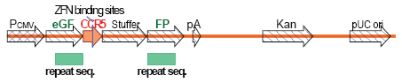
Figure S1. A schematic representation of the reporter used for the mammalian homologous repeat deletion studies. Two fragments of the eGFP open reading frame possessing 430bp of repeated overlapping sequence were interrupted by the insertion of a 300bp fragment of the CCR5 gene containing the CCR5 ZFN binding sites and a 700bp stuffer fragment. The 430bp of eGFP overlap serve to direct DNA repair via excision of the intervening DNA sequence thus restoring the eGFP coding sequence. The repaired eGFP gene can then direct expression of functional eGFP protein under the CMV promoter, which can be detected and quantified by flow cytometry analysis.
Supplementary Figure 2.
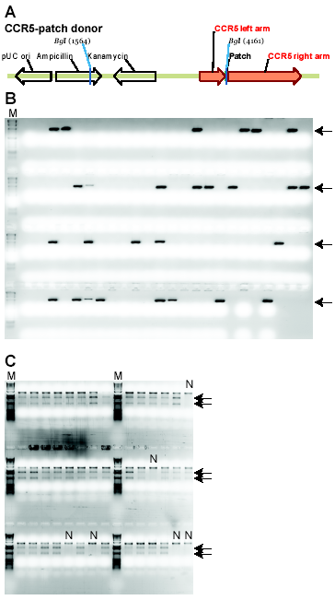
Figure S2. Analysis of single-cell derived clones following nick-induced targeted integration at the CCR5 locus. (A) Schematic representation of the CCR5-patch donor DNA used in this study. The donor DNA is constructed using pCR4-TOPO (Invitrogen) as the vector backbone. The CCR5 left arm and right arm indicate sequences derived from the genomic sequence of the CCR5 locus flanking the CCR5 ZFN binding sites. The left arm is 476 bp long, the right arm is 1428 bp long. DNA sequence at the junction is as follows: acatgctggtcatcctcatcTAGATCAGTGAGTATGCCCTGATGGCGTCTGGACTGGATGCCTCGTCTAGAaaactgcaaaaggctgaaga. The patch (upper case letters) is a 51bp insertion including the original 5bp spacing (bold upper case letters) between the CCR5 ZFN binding sites (underlined lower case letters). The Bgl I restriction enzyme site is indicated in underlined upper case letters. (B) Representative data of “In-out” PCR screening of single cell-derived clones following targeted integration of the RFLP-containing patch at the CCR5 locus. Genomic DNA was isolated from each single-cell derived line using QuickExtract DNA Extraction solution (Epicentre Biotechnologies), the CCR5 locus was PCR amplified using a CCR5 primer (5’-CTGCCTCATAAGGTTGCCCTAAG-3’) located outside the CCR5 homologous region of the CCR5-patch donor and another primer (5’-ACGCCATCAGGGCATAC-3’) within the patch region, and then the PCR products were resolved on a 1% agarose gel. The presence of a PCR band at the expected size (1017bp) indicates a targeted integration event. “M” denotes the gel lane loaded with the DNA ladder. Arrows indicate the expected positions of the amplified PCR products. (C) Representative data from the CCR5 RFLP assay to confirm the targeted insertion of the donor-encoded Bgl I patch sequence in the single cell-derived clones. Genomic DNA from selected clones based on the “In-Out” PCR reactions in panel B were PCR amplified, digested with Bgl I, and then resolved on a 1% agarose gel as described (see Methods). The top band represents uncut WT CCR5, and the lower two Bgl I cleaved bands (indicated by arrows) represent the CCR5 alleles modified by HDR and have had the patch sequence inserted between the 2 CCR5 ZFN binding sites. “N” indicates a negative clone, whereas all other lanes are positive clones that have the patch sequence inserted into the CCR5 locus.
Supplementary Figure 3.

A. CCR5-GFP donor
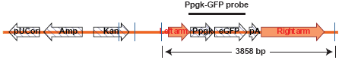
B. WT CCR5 locus
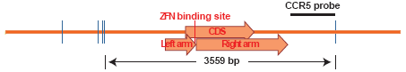
C. CCR5 locus with targeted integration
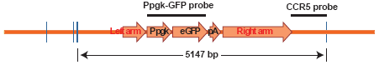
D. WT PGK locus
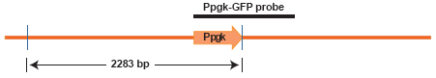
E.
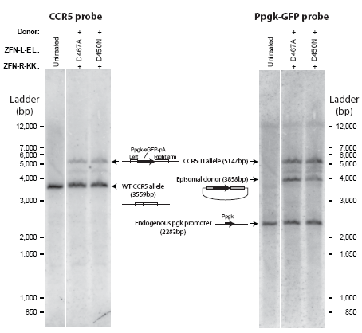
Figure S3. Southern blot analysis confirms nick induced homology-directed gene insertion (A) A schematic representation of the CCR5-GFP donor DNA construct. The donor DNA is constructed using pCR4-TOPO (Invitrogen) as the vector backbone. The left and right arms (homologous sequences) indicate sequences derived from the CCR5 genomic locus flanking the CCR5 ZFN binding sites as described in Fig. S2 except that a 1593 bp eGFP expression cassette (a pgk promoter, an eGFP open reading frame, and a BGH polyA sequence) is inserted between the two CCR5 homologous arms instead of the 51 bp patch. Episomal persistence of the CCR5-GFP plasmid donor can be visualized as a 3585 bp fragment after PvuII digestion (restriction enzyme sites are indicated by crossed blue lines) when detected by a Ppgk-GFP probe. (B) The wild-type endogenous CCR5 locus. A 3559 bp fragment after PvuII digestion can be detected by a CCR5 probe (located outside of the right homologous arm) as indicated. (C) The CCR5 locus with targeted integration of the Ppgk-eGFP-pA sequence. A 5147 bp PvuII-digested fragment of the CCR5 locus with targeted integration can be detected by either the Ppgk-eGFP or CCR5 probe as indicated. (D) The PGK locus. A 2283 bp PvuII-digested fragment of the PGK locus containing the PGK promoter region can be detected by the Ppgk-GFP probe. (E) Southern blot analysis of sorted GFP⁺ cell pools. K562 cells were transfected with the indicated ZFN variants in the presence of the CCR5-GFP donor DNA. GFP⁺ cells were then sorted 4 weeks post-transfection and expanded to obtain genomic DNA (gDNA) for Southern blot. Brifely, 20-25 μg of gDNAs were digested with PvuII overnight and purified by phenol/chloroform extraction. The digested gDNAs were then resolved on 0.8% agarose gel and transferred to a Nytran Super Charge membrane (Schleicher and Schuell) and hybridized with ³²P-labeled Ppgk-GFP (right panel) or CCR5 (left panel, re-hybridized after stripping) probes. The membrane was exposed and scanned using a phosphorimager system (Molecular Dynamics).

Supplementary Figure 4

Figure S4. Genome-wide evaluation of DSB formation in ZFN-treated cells by γH2AFX staining. K562 cells were transfected with CCR5-patch donor in the absence (No ZFN) or presence of the indicated ZFNs or ZFNickases: ZFN-L-EL + ZFN-R-KK (WT/WT), ZFN-L-EL-D450N + ZFN-R-KK (D450N/WT), ZFN-L-EL-D467A + ZFN-R-KK (D467A/WT). Cells were collected at the indicated times post-transfection and subjected to anti-γH2AFX staining and flow cytometry analysis as described (see Methods). The percentage (%) of γH2AFX⁺ cells is indicated in the upper left corner of each overlay histogram. The same marker was set empirically in all single histograms so that untreated cells stained with anti-γH2AFX antibody have ~1% background. The percentage (%) of γH2AFX⁺ cells was calculated by subtracting background (% γH2AFX⁺ cells from the untreated sample) from % γH2AFX⁺ cells in the ZFN/ZFNickase-treated cells.

Supplementary Figure 5.

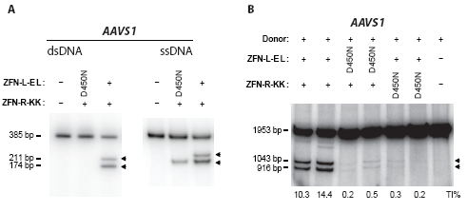
Figure S5. ZFNickases targeting the AAVS1 site generate single-strand breaks and stimulate HDR driven gene insertion. (A) In vitro assessment of nicking activity of the D450N/WT ZFN variants targeting the PPP1R12C gene (also known as the AAVS1 locus). The AAVS1 ZFNs have been described previously (Hockemeyer et al. 2009). A 385 bp fragment of AAVS1 containing the ZFN binding sites was PCR amplified from K562 genomic DNA. The purified PCR products were subjected to in vitro cleavage assay and resolved under non-denaturing (dsDNA, left panel) or denaturing (ssDNA, right panel) conditions (as in Fig.1). The expected sizes of the cleaved products by AAVS1 ZFNs are 211 bp and 174 bp (indicated by arrows). (B) ZFNickases targeting the AAVS1 site drive targeted gene addition by HDR. K562 cells were transfected with the indicated AAVS1 ZFN variants and a RFLP donor plasmid, in which, the 6 bp GGCCAC was replaced with a 12 bp sequence (GGCAAGCTTTAC) to introduce a unique HindIII site (underlined) between the AAVS1 ZFN binding sites (underlined, ACCCCACAGTGGGGCCACTAGGGACAGGAT) flanked with the left (801 bp) and right (835 bp) homologous arms. Genomic DNA was collected 3 days post-transfection and subjected to a RFLP assay. Upon HindIII digestion, a 1043 bp and a 916 bp product will be generated from alleles that have undergone HDR driven targeted integration of the HindIII site containing patch, whereas the full length 1953 bp PCR product will remain undigested from the wild-type allele. The percentage of HindIII-sensitive DNA (indicated by arrows) resulting from targeted integration is indicated below each lane.

Supplementary Figure 6 (Fig.S6)

A. Amino acid sequence of CCR5 ZFN-L-EL:
1 MDYKDHDGDY KDHDIDYKDD DDKMAPKKKR KVGIHGVPAA MAERPFQCRI
51 CMRNFSDRSN LSRHIRTHTG EKPFACDICG RKFAISSNLN SHTKIHTGSQ
101 KPFQCRICMR NFSRSDNLAR HIRTHTGEKP FACDICGRKF ATSGNLTRHT
151 KIHLRGSQLV KSELEEKKSE LRHKLKYVPH EYIELIEIAR NSTQDRILEM
201 KVMEFFMKVY GYRGKHLGGS RKPDGAIYTV GSPIDYGVIV DTKAYSGGYN
251 LPIGQADEME RYVEENQTRN KHLNPNEWWK VYPSSVTEFK FLFVSGHFKG
301 NYKAQLTRLN HITNCNGAVL SVEELLIGGE MIKAGTLTLE EVRRKFNNGE
351 INF

B. Amino acid sequence of CCR5 ZFN-L-EL D450N:
1 MDYKDHDGDY KDHDIDYKDD DDKMAPKKKR KVGIHGVPAA MAERPFQCRI
51 CMRNFSDRSN LSRHIRTHTG EKPFACDICG RKFAISSNLN SHTKIHTGSQ
101 KPFQCRICMR NFSRSDNLAR HIRTHTGEKP FACDICGRKF ATSGNLTRHT
151 KIHLRGSQLV KSELEEKKSE LRHKLKYVPH EYIELIEIAR NSTQDRILEM
201 KVMEFFMKVY GYRGKHLGGS RKPNGAIYTV GSPIDYGVIV DTKAYSGGYN
251 LPIGQADEME RYVEENQTRN KHLNPNEWWK VYPSSVTEFK FLFVSGHFKG
301 NYKAQLTRLN HITNCNGAVL SVEELLIGGE MIKAGTLTLE EVRRKFNNGE
351 INF

C. Amino acid sequence of CCR5 ZFN-L-EL D467A:
1 MDYKDHDGDY KDHDIDYKDD DDKMAPKKKR KVGIHGVPAA MAERPFQCRI
51 CMRNFSDRSN LSRHIRTHTG EKPFACDICG RKFAISSNLN SHTKIHTGSQ
101 KPFQCRICMR NFSRSDNLAR HIRTHTGEKP FACDICGRKF ATSGNLTRHT
151 KIHLRGSQLV KSELEEKKSE LRHKLKYVPH EYIELIEIAR NSTQDRILEM
201 KVMEFFMKVY GYRGKHLGGS RKPDGAIYTV GSPIDYGVIV ATKAYSGGYN
251 LPIGQADEME RYVEENQTRN KHLNPNEWWK VYPSSVTEFK FLFVSGHFKG
301 NYKAQLTRLN HITNCNGAVL SVEELLIGGE MIKAGTLTLE EVRRKFNNGE
351 INF

D. Amino acid sequence of CCR5 ZFN-R-KK:
1 MDYKDHDGDY KDHDIDYKDD DDKMAPKKKR KVGIHGVPAA MAERPFQCRI
51 CMRNFSRSDN LSVHIRTHTG EKPFACDICG RKFAQKINLQ VHTKIHTGEK
101 PFQCRICMRN FSRSDVLSEH IRTHTGEKPF ACDICGRKFA QRNHRTTHTK
151 IHLRGSQLVK SELEEKKSEL RHKLKYVPHE YIELIEIARN STQDRILEMK
201 VMEFFMKVYG YRGKHLGGSR KPDGAIYTVG SPIDYGVIVD TKAYSGGYNL
251 PIGQADEMQR YVKENQTRNK HINPNEWWKV YPSSVTEFKF LFVSGHFKGN
301 YKAQLTRLNH KTNCNGAVLS VEELLIGGEM IKAGTLTLEE VRRKFNNGEI
351 NF
References

Hockemeyer, D., Soldner, F., Beard, C., Gao, Q., Mitalipova, M., DeKelver, R.C., Katibah, G.E., Amora, R., Boydston, E.A., Zeitler, B. et al. 2009. Efficient targeting of expressed and silent genes in human ESCs and iPSCs using zinc-finger nucleases. Nat Biotechnol 27: 851-857.
Kvikstad, E.M., Tyekucheva, S., Chiaromonte, F., and Makova, K.D. 2007. A macaque's-eye view of human insertions and deletions: differences in mechanisms. PLoS Comput Biol 3: 1772-1782.
Russell, D.W. and Hirata, R.K. 2008. Human gene targeting favors insertions over deletions. Hum Gene Ther 19: 907-914.

