Supplementary Material
Table S1 | Data sets with differing levels of genomic and taxonomic inclusiveness.

Figure S1 | Generalizable approach for resolving phylogenomic discord in Amniotes. There are many species-tree methods available. The STAR method we employed in this study is described in ref. 26.
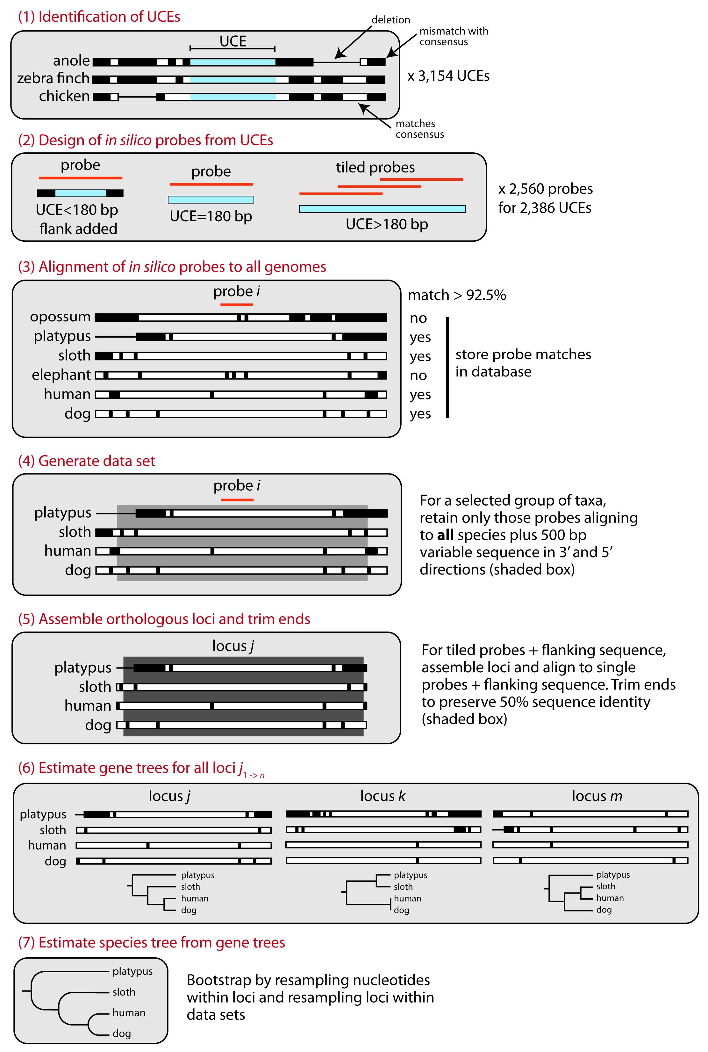
Figure S2 | Mean and 95% confidence interval of the length of loci in base pairs for different data sets. Longer locus lengths for higher genomic coverage data sets likely result from having fewer species with poorly aligning flanking sequence.

Figure S3 | Physical distances (Kbp) between loci in chicken, human, and mouse genomes showing means and 95% confidence intervals for data sets of increasing genomic coverage. Wide genomic distances indicate that loci are likely independently segregating, although epistatic linkage could still affect some loci.

Figure S4 | Saturation plots for (blue) 20 nuclear loci from Springer et al. (2007), (red) flanking regions of UCEs, and (black) core UCEs. Most loci in all categories show little saturation. The higher position of the blue curves reflects higher substitution rates.

Figure S5 | Comparison of STAR and Concatenation trees for the 183 locus, 29 taxa data set. Nodes without PP values in the concatenated tree are 1.0.
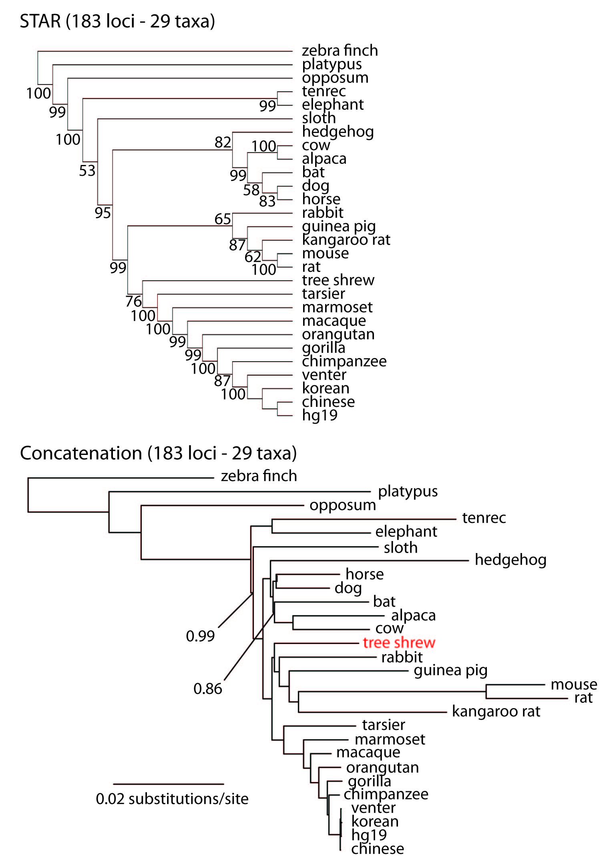

Figure S6 | Comparison of STAR and Concatenation trees for 917 locus, 29 taxa data set. All nodes in the concatenated tree have PP values of 1.0.
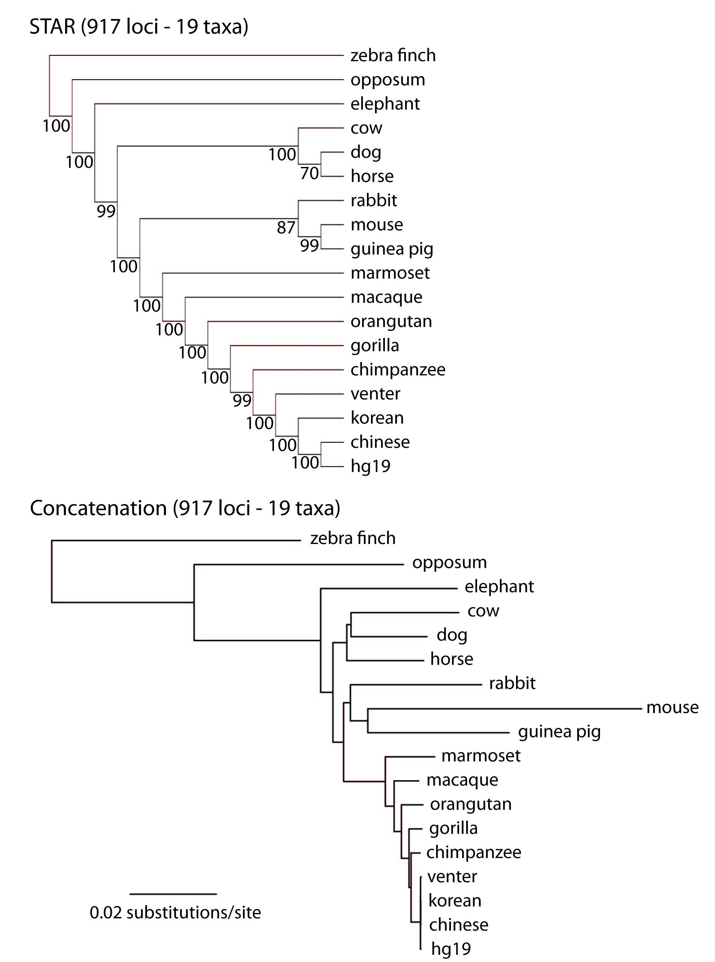

Figure S7 | Discord among gene trees for the 183 locus, 29 taxa data set. a, 162 gene trees visualized after culling 21 gene trees that had especially long branches that skewed the y-axis. b, For better visual separation, 40 gene trees are visualized.
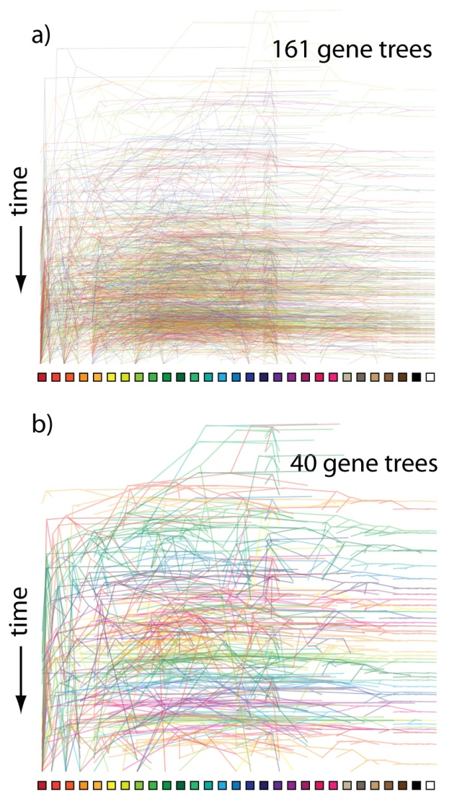

Figure S8 | Comparison of STAR and Concatenation trees for the 29 taxa data set analyzed with the loci from Stephen et al. (2009) separately as well as combined with the original set of 183 loci from our study. All nodes in the concatenated tree have PP values of 1.0 unless indicated.

Figure S9 | Comparison of STAR and Concatenation trees for the 29 taxa data set analyzed with 41 exons separately as well as combined with the set of 444 UCE loci. All nodes in the concatenated tree have PP values of 1.0 unless indicated.
Figure S10 | Decay in the number of unique matches across taxa for probes designed from (A) exons (Coffey 2011) and (B) UCEs. Bars moving left to right show locus counts for groups of increasing degrees of taxonomic inclusiveness and the value on the x-axis shows the final member of the set: (hg19), (hg19, chinese), (hg19, chinese, korean), (hg19, chinese, korean, venter), etc.. Thus, the final taxon on the x-axis (anole) represents the number of exon or UCE probes matching across all 29 taxa (hg19 to anole, inclusive). The count of probes matched (y-axis) is equal to the number of non-duplicate probes identified across ALL members of the set. While the y-axis is different between the two panels, due to the different number of starting loci, note the difference in the steepness of the decline in matched loci – matches to probes designed from exons decrease more rapidly as taxonomic inclusiveness of the group increases . The failure to detect probes designed from exons across broad taxonomic groups has several possible causes: 1) the strict probe-matching parameters used for UCEs may not work well for exons because variation in exons is distributed throughout their extent, as opposed to UCEs, which have a highly conserved core but variable flanks; 2) evolutionarily, exons may be more free to vary than UCEs; 3) exons may be affected by rearrangement more frequently than UCEs, and 4) genome builds of non-primate taxa may have poor coverage or assembly issues that prevent detection of particular exons.

